Hands-On Lab: TrainersApp with React Router

Objectives
- List the features of React Router
- Explain the various routing components

In this hands-on lab, you will learn how to:
- Set up client-side routing with react-router-dom
- Pass route parameters and read them with useParams

Prerequisites
- Node.js
- NPM
- Visual Studio Code

Commands
npx create-react-app trainersapp
cd trainersapp
npm install react-router-dom
npm start

Step 1 — src/trainer.js
class Trainer {
constructor(trainerId, name, email, phone, technology, skills) {
this.TrainerId = trainerId;
this.Name = name;
this.Email = email;
this.Phone = phone;
this.Technology = technology;
this.Skills = skills;
}
}

export default Trainer;

Step 2 — src/TrainersMock.js
import Trainer from "./trainer";

const TrainersMock = [
new Trainer(101, "Aditi Sharma", "aditi.sharma@example.com", "9876543210", "React", ["JavaScript", "React", "Redux"]),
new Trainer(102, "Rahul Verma", "rahul.verma@example.com", "9876501234", "Angular", ["TypeScript", "Angular", "RxJS"]),
new Trainer(103, "Sneha Reddy", "sneha.reddy@example.com", "9876512345", "Java", ["Core Java", "Spring Boot", "Hibernate"]),
new Trainer(104, "Karan Mehta", "karan.mehta@example.com", "9876523456", "Python", ["Python", "Django", "Flask"]),
new Trainer(105, "Priya Nair", "priya.nair@example.com", "9876534567", ".NET", ["C#", "ASP.NET", "Azure"]),
];

export default TrainersMock;

Step 3 — src/TrainersList.js
import React from "react";
import { Link } from "react-router-dom";
import TrainersMock from "./TrainersMock";

function TrainersList() {
return (
<div>
<h2>Trainers List</h2>
<ul>
{TrainersMock.map((trainer) => (
<li key={trainer.TrainerId}>
<Link to={`/trainers/${trainer.TrainerId}`}>{trainer.Name}</Link>
</li>
))}
</ul>
</div>
);
}

export default TrainersList;

Step 4 — src/Home.js
import React from "react";

function Home() {
return (
<div>
<h2>Welcome to Cognizant Academy Trainers App</h2>
</div>
);
}

export default Home;

Step 5 — src/TrainerDetails.js
import React from "react";
import { useParams, Link } from "react-router-dom";
import TrainersMock from "./TrainersMock";

function TrainerDetails() {
const { id } = useParams();
const trainer = TrainersMock.find((t) => t.TrainerId === parseInt(id, 10));

if (!trainer) {
return (
<div>
<h2>Trainer not found</h2>
<Link to="/trainers">Back to Trainers List</Link>
</div>
);
}

return (
<div>
<h2>Trainer Details</h2>
<p><strong>ID:</strong> {trainer.TrainerId}</p>
<p><strong>Name:</strong> {trainer.Name}</p>
<p><strong>Email:</strong> {trainer.Email}</p>
<p><strong>Phone:</strong> {trainer.Phone}</p>
<p><strong>Technology:</strong> {trainer.Technology}</p>
<p><strong>Skills:</strong> {trainer.Skills.join(", ")}</p>
<Link to="/trainers">Back to Trainers List</Link>
</div>
);
}

export default TrainerDetails;

Step 6 — src/App.js
import React from "react";
import { BrowserRouter, Routes, Route, Link } from "react-router-dom";
import Home from "./Home";
import TrainersList from "./TrainersList";
import TrainerDetails from "./TrainerDetails";

function App() {
return (
<BrowserRouter>
<nav>
<Link to="/">Home</Link> | <Link to="/trainers">Trainers</Link>
</nav>
<hr />
<Routes>
<Route path="/" element={<Home />} />
<Route path="/trainers" element={<TrainersList />} />
<Route path="/trainers/:id" element={<TrainerDetails />} />
</Routes>
</BrowserRouter>
);
}

export default App;

Output
Home page
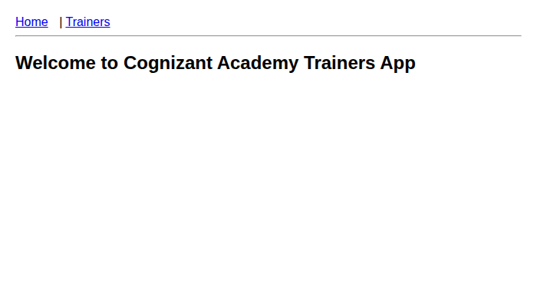
Trainers list page
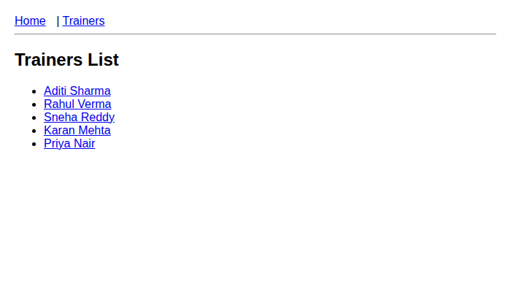
Trainer detail page (/trainers/101)
