**Coding Round – 25th July Frontend**

TIME: 1Hr 30Mins

Develop a weather application dashboard in JavaScript, HTML & CSS only.

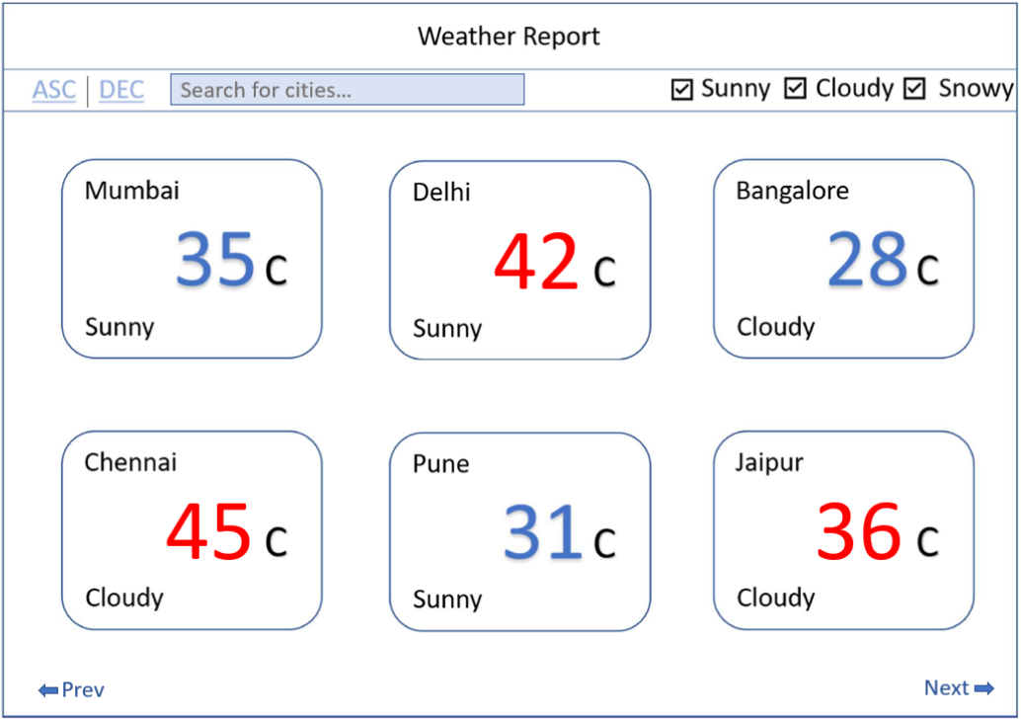

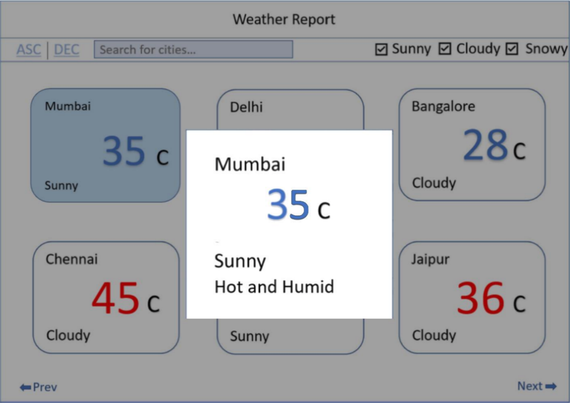

* **Core functionalities**
  + **Fetch data** from the API provided(below) and **render the cards**
  + **Filter** the cards based on the **weatherType** from the API’s metadata
  + Client-side filtering. On initial load all checkboxes are selected.
  + **Pagination** based on the **pageSize** from the API’s metadata.
  + Client-side pagination. Since the complete data is available in the first load.
  + **Sorting** when clicked on the **ASC | DEC** buttons.
  + Client-side sorting of the cards based on the **temperature**.
* **Additional functionalities**
  + **Search** on the city name
  + Client-side search on the **city name** (‘Starts with’ search). While searching it should respect the filters (The checkboxes)
  + Pop up **dialog box** which shows the complete details about that specific city on which it was clicked. Should appear in the center of the screen. It disappears when clicked on the grey transparent region.
  + Change the background colour of the clicked/selected card
  + Temperature value in the card should be based on the temperature colour range given in the metadata.

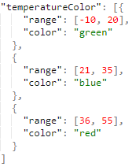 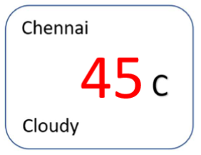

***Things to keep in mind before and while coding:***

* The solution should be coded in vanilla JavaScript, HTML, and CSS.
* No jQuery, bootstrap, ReactJs, Angular or other frameworks are allowed.
* Focus on modularity of code and design of the solution.
* Priority are the **core functionalities**. A working demo is very important.
* Try to match the look and feel of the UI with the given screenshot. We are not expecting pixel perfectness.
* Follow best practices for writing code.
* ES6 syntax is preferred.
* You will be evaluated on functionality, UI design, and code quality.

API : <https://raw.githubusercontent.com/Lokenath/JSON_DATA/master/data.json>

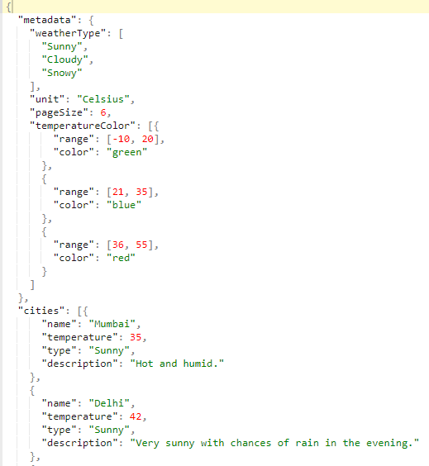

***After 1Hr 30mins do the following***

* **ZIP** the **HTML,JS,CSS** file and change the extension from .**zip** to **.pdf** (Else you will not be able to send the zip file since it has .js file in it)
* Attach the .pdf file and send it to the email id given below. Keep the email subject in the following format: ‘**Your Full Name’** : ‘**Your Mobile Number’**

Email id:56fac863.microsoft.com@amer.teams.ms