Step 1: First Day at Breaking Games
Breaking games data folder:
https://drive.google.com/drive/folders/118NNRHqTz0P6-k5FG7PRcxfTe58OrZH7
Breaking games Holiday Game plan template : https://docs.google.com/document/d/1ZZojey-xbL7LZP0EqqnUtf7sG42_mrKG1pAiFfIffOM/edit?tab=t.0#heading=h.uawrfa9f6n6p

In the first half of the year, Breaking Games spent $37,000 on Facebook ads. Those ads are linked to $61,000 in sales. Did those ads make money?
$61K against $37K looks like profit. But that headline number quietly ignores three things: what the games actually cost to make and ship, the refunds and abandoned carts hiding in the data, and the biggest trap of all — whether those ads truly drove the sales or just took the credit for buyers who'd have come anyway.
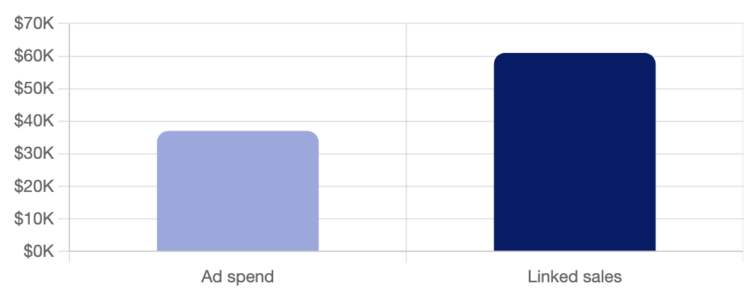

We have more than 100 products listed on our website, but you won't focus on all of them. You'll focus on only a few. Let me show you which slice of the sales you'll actually be working with."
"Breaking Games sells through a few channels — hobby stores, online retailers, conventions, Kickstarter launches — but the data you'll touch is the Shopify side: direct-to-consumer (selling straight to players, no middleman) sales through breakinggames.com. That's where you see the whole path from ad click to purchase. The wholesale and Kickstarter sides run through different systems and aren't in scope."

What does "the Shopify side" mean?
Shopify is the platform that runs Breaking Games' online store — the website where people buy games directly.

The Three Buckets
Jess: Breaking Games' catalog roughly splits into three types of games:
Category | Examples | Buyer | Price Range
Strategy | Dwellings of Eldervale, Coaster Park | Dedicated tabletop hobbyists | $40–$200+
Party / Light | POOP, Sparkle*Kitty, We're Doomed! | Casual / gift buyers | $10–$20
Family | The Game of 49 | Multi-generational play | $20–$40

Each bucket has different economics:
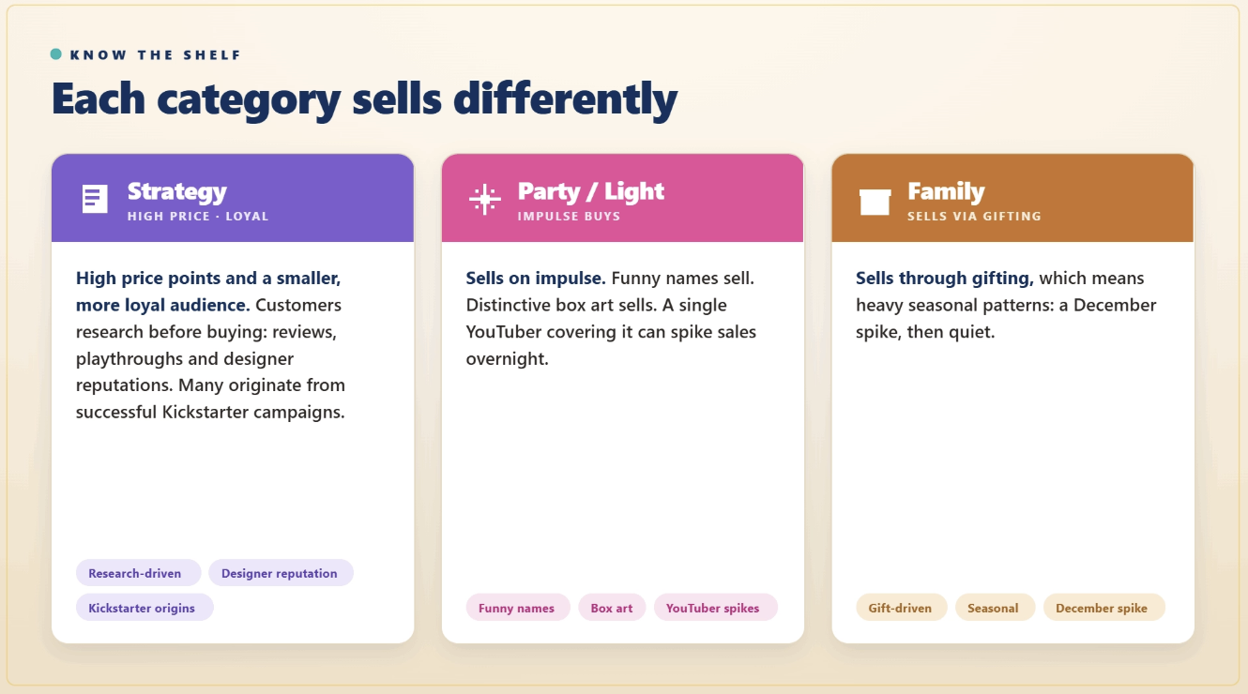

Here's the one thing to carry into every query you write: a $99 strategy box and a $10 party game can't be judged by the same yardstick. Knowing that before you touch the numbers is the instinct that separates an analyst from someone who just runs queries.

The Anchor Products You'll See in the Data
"You've met most of these. In the data, four names do the heavy lifting — Dwellings of Eldervale, Sparkle*Kitty, POOP, and The Game of 49, a family bidding game you haven't seen yet. Learn these as your anchors and the rest of the catalog falls into place around them. And yes, our single most reliable seller is the card game POOP. It outsells games that took years to design. People ask me how I feel about that. I feel great.
Analyst Principle: The Long Tail
Most of the money rides on a few titles. Breaking Games has 117 products, but a handful drive most of the revenue — roughly 20% of products make about 80% of the money. It's a pattern called the long tail: the rest are smaller titles, expansions, accessories, and older games still on the shelf. "117 products" sounds big. It won't, once you know which ones matter.

Try It Yourself
Open breakinggames.com and scroll for a minute or two. Don't write anything down — just look. Notice the spread: a $10-$20 party game like POOP next to a $99 strategy box like Dwellings of Eldervale.
Then do a quick bit of analyst math in your head: how many $10 POOP games does it take to match the revenue of one $100 Dwellings? Once you land on the number, you've got it — that gap is exactly why you can't judge the two the same way.
And if you made your call on the catalog board — which game earns the most — hold onto it. That's your first analyst judgment, and in Week 3, you'll run the real numbers to find out if you were right.

Take the guided tour — it plays itself.
https://smitabudhiaextern.github.io/extern-html-pages/substep-1.1.5-data-explorer.html
It walks you through all six files one at a time: a pointer moves across each column and explains what it means, then flags the quirks to watch for (negative discounts, abandoned carts, the $37,000 hiding in the ad data). Each file ends with a quick one-tap question to check you caught it — no typing, just pick an option. Then click Next for the next file.

Quick reminder — three things the explorer flags that are worth holding onto:
- The customer data is anonymized — on purpose. In shopify_checkouts.csv, real names, emails, and addresses were replaced with placeholders like “Customer 001”. The products, geography, and behavior are real; the people are not.
- The files don't all cover the same window. shopify_orders.csv is July 2025 only, the Meta ad files run Jan–Jul 2025, and shopify_checkouts.csv reaches back to 2016. Don't assume the dates line up across files.
- A few "customers" act like bots — adding the same item over and over in odd amounts. That's the trail you'll follow later.

The Story Hiding Between the Files
Looking at the six files together, there's a story:
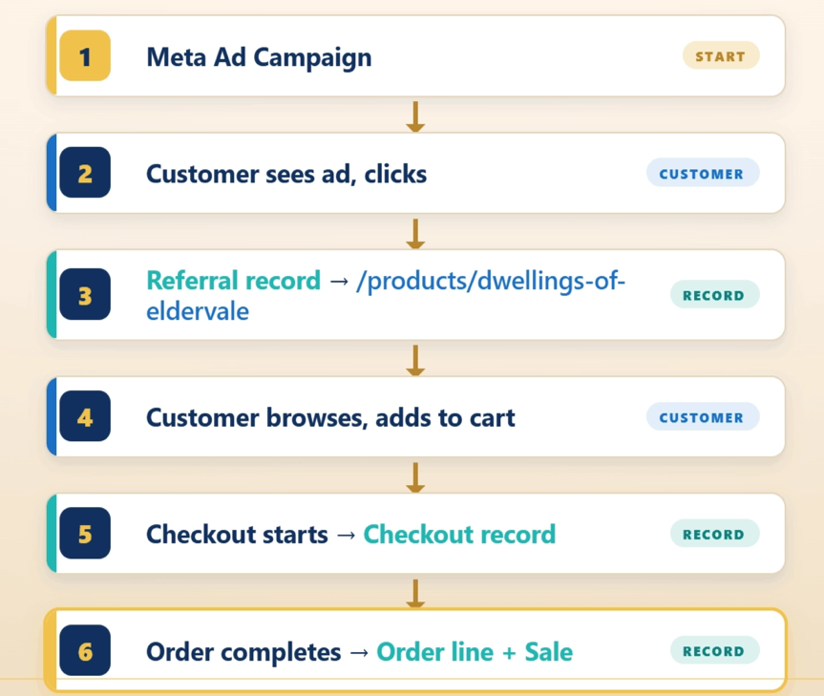
Each step lives in a different file, and none of them share an ID. Some can be linked by product title (which are full of typos and variants). Some can be linked by where a visitor came from, but those have to be cleaned up into one consistent spelling first. Some don't link at all. Nowhere is there a single column that says "this customer came from this campaign."
File | Source | Rows | What It Knows
shopify_sales.csv | Shopify | 99 | Total sales per product (revenue, units, returns)
shopify_orders.csv | Shopify | 254 | Individual orders (one row per line item, July only)
shopify_checkouts.csv | Shopify | 1,367 | Cart sessions, including ones that didn't convert
referrals.csv | Shopify Analytics | 8,712 | Where every site visitor came from
meta_campaigns.csv | Meta Ads Manager | 35 | Facebook + Instagram campaign performance
meta_ad_sets.csv | Meta Ads Manager | 8 | Ad set–level performance (campaigns contain ad sets)

Data drill quiz : https://smitabudhiaextern.github.io/extern-html-pages/substep-1.1.6-read-the-files.html

Step 2: Get the Database Running
VLOOKUP? It's a spreadsheet formula that looks up a value in one sheet and pulls the matching value from another. Handy, but it breaks the moment a column moves or a name changes.
A database fixes all four problems by giving you structured storage and a query language designed for asking questions.
DB Browser for SQLite (sometimes called "DB4S") is a free, open-source desktop app for working with SQLite databases. It gives you:
- A visual interface to browse tables and rows
- A SQL editor for writing queries
- The ability to save and reopen databases as single files

Why a pre-built database (instead of importing the CSVs yourself)? In a real analyst role, you'd usually be handed an existing database to query, not raw exports. Skipping the import step lets you focus on the actual learning (SQL and database design) instead of fighting CSV encoding quirks for an hour. If you ever want to practice the import skill on your own, the six raw CSVs are right there in the Drive folder.

Step 3: Ask Your First Question
The Shape of Every Query You'll Write
Step back and look at what you built. Every "show me X" query this week is the same five pieces, and they always go in this order:

SELECT cols
FROM table
WHERE filter
ORDER BY col
LIMIT n;

You can leave out the middle pieces (no WHERE, no ORDER BY, no LIMIT) and the query still runs. SELECT and FROM are required; the rest are optional. But you can't rearrange them. WHERE always comes before ORDER BY, which always comes before LIMIT. Memorize the order, not a hundred queries.

Top sellers out of shopify_sales
SELECT product_title, total_sales
FROM shopify_sales
WHERE net_items_sold > 50
ORDER BY total_sales DESC
LIMIT 10;

Totalling up games revenue
SELECT product_type, COUNT(*) AS n_products, ROUND(SUM(total_sales), 2) AS revenue
FROM shopify_sales
GROUP BY product_type
ORDER BY revenue DESC;

Game | 82 | 51412.92
Game Accessory | 10 | 9055.1
 | 4 | 294.01
game | 1 | 188.01
Toy | 1 | 84.78
Gift | 1 | 50.51

Game (capital G, 82 products) and game (lowercase g, 1 product) are sitting as two separate categories. Nothing is broken; the data just got typed two different ways.
Now fix it. When a value is spelled inconsistently, you standardize it across every row with UPDATE.

UPDATE shopify_sales
SET product_type = 'Game'
WHERE product_type = 'game';

The campaign results and a bunch of them came back blank. Are those zero, or did we just never record them? Because that completely changes the average I'm about to send up.
That blank is not a zero. In SQL, an empty cell is NULL, which means "not recorded," not "the value is zero." A campaign that never ran has no results to record. A campaign that ran and flopped would have a result of 0. Those are different facts, and the blank is what keeps them apart.

Here's the part that trips people up, and it's worth proving to yourself rather than taking my word for it. You can't match a blank with =.

SELECT COUNT(*) FROM meta_campaigns WHERE results IS NULL;

SELECT COUNT(*) FROM meta_campaigns WHERE results = 0;

What you should see: The first returns 29, the second returns 0 — a blank never equals anything, not even zero, so you match it with IS NULL, never = NULL.

The Average That Changes Depending on What a Blank Means
what are the average results per campaign? Watch what the blanks do to it.

SELECT AVG(results) FROM meta_campaigns;

Here's where the NULL bites. meta_campaigns has 35 rows, but only 6 recorded a result. AVG silently skips the 29 blanks and divides by 6, not 35. So this isn't "average per campaign," it's "average per campaign that actually ran." The blanks fell out of the math without a word.

So the question becomes a decision, not a calculation: should the 29 dead campaigns count as zeros? If you decide a campaign that never ran is worth zero results, you turn the blanks into zeros first with COALESCE, then average.

SELECT AVG(COALESCE(results, 0)) FROM meta_campaigns;

COALESCE(results, 0) reads as "use results, but if it's NULL, use 0 instead." Now all 29 blanks count as zeros, so the average divides by 35, not 6, and the number drops hard. Same data, two answers, 211,597 versus 36,274, and the only thing that changed is what you decided a blank should mean.

One honest note: neither number is a clean business metric to ship on its own. The point isn't the figure, it's the decision behind it, NULL or zero, and the denominator it quietly sets (6 versus 35). That decision is yours to make on purpose, not the database's to make for you by accident.

For contrast, run the total instead of the average:
SELECT SUM(results), SUM(COALESCE(results, 0)) FROM meta_campaigns;
What you should see: Both come back 1,269,584.0, identical.

SUM already ignores blanks, so adding zeros changes nothing; 29 extra zeros don't move the total. NULLs bite AVG (they shrink the denominator) but not SUM. Knowing which is which is the difference between a total you trust and an average you accidentally lie with.
So: a blank means unknown, not zero. Decide what it should mean for the question you're answering, before you trust the number it produces.

These three are real and live in breaking_games.db right now. Knowing them up front saves you an afternoon of confusion later.
Quirk | Where it shows up | What to do
Case mismatch (Game vs game) | shopify_sales.product_type | UPDATE … SET … WHERE to standardize the value, as you just did
Blanks / NULLs | meta_campaigns.results (and other recorded-or-not columns) | Match with IS NULL, decide zero-or-unknown, use COALESCE(col, 0) when a blank should count as zero
Pipe-delimited variant names | shopify_sales.product_title (14 rows like Expancity \| Family Strategy City Building Game \| 2-4 Players) | Leave them for now; you can split on \| to pull the clean product name when you need it later

Out in messier real-world data you'll also meet stray leading/trailing spaces (TRIM(col) fixes those) and encoding artifacts where accented characters render as garbage. Neither exists in this clean dataset, so treat them as things to watch for elsewhere, not bugs to hunt here.

You can write SELECT queries. That's the foundation. But here's the uncomfortable truth: typing SQL is not the analyst skill that matters most in 2026. The skill that matters most is deciding what to ask and verifying the answer when you get it back. That's where Claude comes in. This week's most transferable career skill starts right here.

How to Brief Claude
Bad prompt:
"Write me a SQL query for the top products."

Claude will guess what you mean. The result will probably be wrong, and you won't know it. There are two ways to ask, and both work, so pick whichever feels easier.

Way 1 — Tell Claude what's in your table. Claude can't see your file unless you describe it, so you give it the table name and all its column names, then ask your question. Here's a sample message:
I'm using DB Browser for SQLite. My table shopify_sales has these columns: product_title, product_vendor, product_type, net_items_sold, gross_sales, discounts, returns, net_sales, taxes, total_sales. Find the top 10 best-selling products by units sold (net_items_sold), showing the product name (product_title). Give me just the SQLite query.
(Those are the real columns in shopify_sales — you can see them listed under the table in DB Browser's Database Structure tab.)

Way 2 — Upload your file and let Claude read it. This time you hand Claude the actual file, so it finds the columns itself and you don't have to type them out. In the Claude chat, click the paperclip (📎) button, upload breaking_games.db (the same file you opened in DB Browser), then send a message like:
I've uploaded my database breaking_games.db. Look at the tables inside, then write me the query for the top 10 best-selling products by units sold. Give me just the SQLite query.

Claude Move: The Schema Brief (If you are not uploading the database)
Save this as a template you can paste into Claude at the start of any new conversation:
I'm working with a SQLite database for an indie board game publisher (Breaking Games).
The relevant tables are:
- shopify_sales (99 rows): aggregated sales per product. Columns: product_title (TEXT), product_type (TEXT), net_items_sold (INTEGER), gross_sales (REAL), net_sales (REAL), total_sales (REAL).
- referrals (8,712 rows): every site visit. Columns: referrer (TEXT), landing_page (TEXT), pageviews (INTEGER), conversion_rate (REAL).
- [Add other tables as needed]
My question is: [...]
Saving this template means you don't have to retype the schema every time. Every project you'll add to it.

- Claude is a co-pilot: it does the typing, you do the thinking and the verification
- The Co-Pilot Workflow has 5 steps: frame → brief → read → run → iterate
- The single most important AI skill is briefing Claude with proper context (schema, row counts, the specific question)
Q1: Top 10 products by units sold this period.

SELECT product_title,SUM(net_items_sold) AS total_units_sold
FROM shopify_sales
GROUP BY product_title
ORDER BY total_units_sold DESC
LIMIT 10;

Answer:

product_title | total_units_sold
Dwellings of Eldervale - Oracle Hex Tile | 178
Dwellings of Eldervale - LEGENDARY Upgrade Kit | 175
Dwellings of Eldervale - Minotaur Mercenary Mini Expansion | 135
Dwellings of Eldervale - Shapeshifter Mercenary Mini Expansion | 134
Dwellings of Eldervale 2nd Edition: Standard | 129
Dwellings of Eldervale - Wooden Upgrade Treasure and Trove Tokens | 127
We're Doomed! | 104
Dwellings of Eldervale - DELUXE Upgrade Kit | 89
MIXTAPE | 83
The Big Box of Magic | 46

The Dwellings of Eldervale line dominates unit sales, with the Oracle Hex Tile (178 units) and LEGENDARY Upgrade Kit (175 units) leading. Seven of the top ten sellers are Eldervale products, showing the franchise drives most of the store's volume.

Q2: Top 10 products by total revenue.

SELECT product_title,SUM(total_sales) AS total_revenue
FROM shopify_sales
GROUP BY product_title
ORDER BY total_revenue DESC
LIMIT 10;

Answer:

product_title | total_revenue
Dwellings of Eldervale 2nd Edition: Standard | 13323.56
Dwellings of Eldervale - LEGENDARY Upgrade Kit | 12514.05
Dwellings of Eldervale - DELUXE Upgrade Kit | 5014.81
We're Doomed! | 3810.47
Dwellings of Eldervale - Wooden Upgrade Treasure and Trove Tokens | 2586.22
The Big Box of Magic | 1920.14
Dwellings of Eldervale - Exclusive Game Mat | 1874.13
MIXTAPE | 1733.39
Dwellings of Eldervale - Minotaur Mercenary Mini Expansion | 1370.38
Dwellings of Eldervale - Shapeshifter Mercenary Mini Expansion | 1361.17

Dwellings of Eldervale 2nd Edition: Standard is the top revenue earner at ~$13.3K, followed closely by the LEGENDARY Upgrade Kit at ~$12.5K.

Q3: How many products are in the catalog?

SELECT COUNT(DISTINCT product_title)AS products_count
FROM shopify_sales;

Answer:
products_count
99

The catalog contains 99 distinct products.

Q4: What was the total Meta ad spend?

SELECT SUM(spend_usd) AS total_spentOn_meta_ads
FROM meta_campaigns;

Answer:

total_spentOn_meta_ads
37200.94

Total Meta advertising spend for the period was $37,200.94.

Q5: How many unique checkout sessions started?

SELECT COUNT(DISTINCT name) AS unique_checkout_sessions
FROM shopify_checkouts;

Answer:

unique_checkout_sessions
1062

1,062 unique checkout sessions were started during the period.

What's Still Missing
If you tried to answer this question right now ("For Dwellings of Eldervale, how many people came from Facebook, added it to their cart, and bought it?"), you'd run into a wall.

That question requires three tables to talk to each other:
[referrals] → who came from Facebook?
↓
[shopify_checkouts] → did they add it to cart?
↓
[shopify_sales] → did they actually buy?
Right now, those three tables don't know about each other. They share product names (sort of) and referrer domains (sort of). But they don't share IDs, and the product-name matching is fuzzy.

