PROJECT 2: Designing your first Database
Step 1: The Customer Journey Problem
Objective
See firsthand why scattered data is a real problem. Trace one customer's full journey, from ad click to purchase, by hand across four tables. By the end, you'll feel the pain that the rest of the Project's design work fixes.

The Scenario
A customer clicks a Facebook ad. Lands on a product page for Dwellings of Eldervale. Adds it to their cart. Buys it. That whole journey lives in four different files, and not one of them shares an ID with the others. Right now, you can't trace a single customer end-to-end. And out of 117 products in the catalog, Mike (Head of E-Commerce) can't tell you which are making money. This Project fixes both.
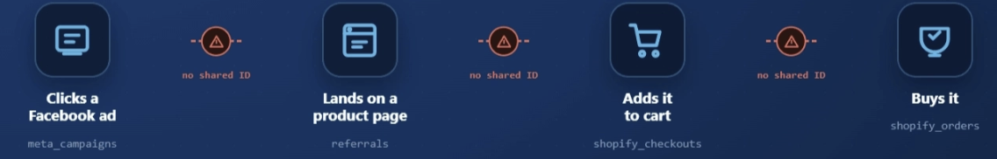
What You'll Walk Away With
By the end, you'll have turned Breaking Games' messy data into real answers:
- All your scattered data pulled into one clean, organized place.
- One shopper's full path, start to finish: the ad they clicked → the page → the cart → the sale.
- A ranked list of all 99 games, from best seller to worst.
- A quick way to check how any game is doing, in seconds.
- A clear call on what to reprint: print a lot, print a little, or stop.

The idea is simple: trace a single customer from their first touch (where they came from) all the way to their purchase (or non-purchase). Across the four files where that journey lives:
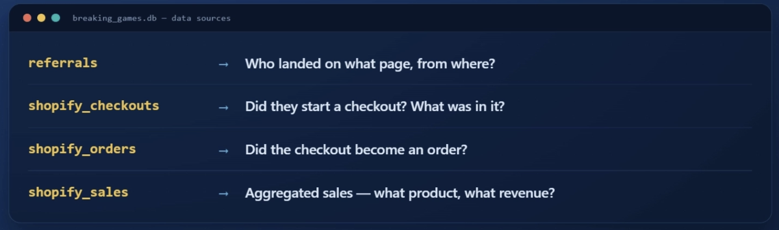
When this works, you can ask things like:
- "For Dwellings of Eldervale, what fraction of buyers came from Facebook ads?"
- "Of all Sparkle\Kitty pageviews from Instagram, how many turned into sales?"*
- "Which referral source has the highest conversion rate?"

Why It Was Hard
Here's why they couldn't do it with spreadsheets:
- No shared IDs. The referral data uses URL slugs like dwellings-of-eldervale-standard-edition-element. The sales data uses titles like Dwellings of Eldervale 2nd Edition: Standard. The checkout data uses the same title but with a variant suffix after a |. None of them shares a single product ID.
- Different grains. shopify_sales is one row per product. shopify_orders is one row per line item. referrals is one row per (referrer × landing page) pair. To compare them, you have to aggregate or filter to a common grain.
- No way to follow a customer across systems. A visitor in referrals is just an anonymous session. A customer in shopify_checkouts has an email but no session ID. The link is gone.
- Spreadsheets can't JOIN. VLOOKUP can fake it for simple cases, but the moment you have three or four tables involved, the formulas become unmaintainable. Jess's #REF! errors weren't her fault. The tool was wrong for the job.

What You're Going to Do Instead
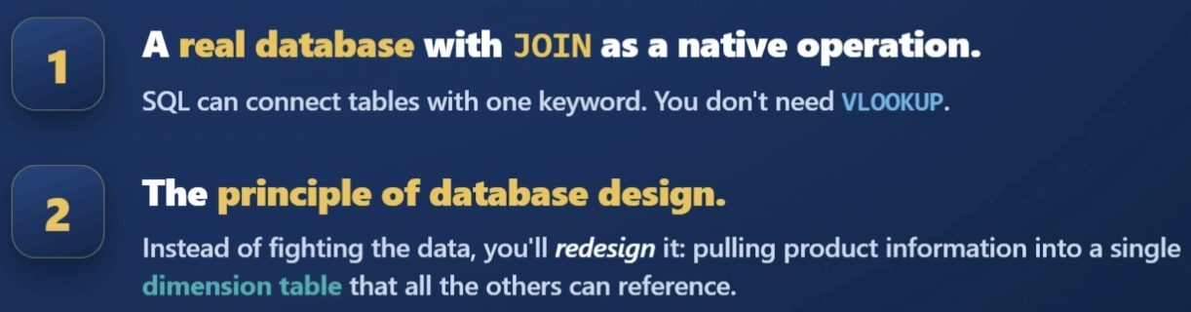

Mike, the Head of E-Commerce, dropped $37,000 on Facebook ads and wants one number back: for Dwellings of Eldervale, what's the conversion rate from Facebook traffic? Jess, your mentor, chased that same answer in 2023 and hit a wall. Here's why. In this module you'll follow one product, Dwellings of Eldervale, through all four tables and watch exactly where the trail goes cold.
Stitching together data from systems that were never built to talk to each other is the everyday job of an analyst. Nail this, and you've got a real interview answer for "how do you join messy data from different sources?"
Follow One Product
The customer journey has five stages and lives in four tables. Watch one product, Dwellings of Eldervale, as it moves through each one. We'll pick up its trail in every table and see how far we can chase it before the link breaks.
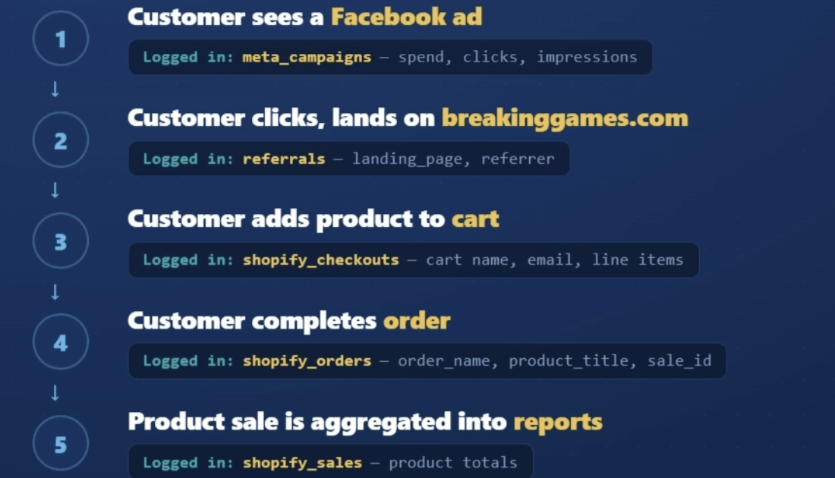
To answer Mike's question, you'd have to start at Stage 1 and walk all the way to Stage 4. At each step, you connect one table to the next. Let's try it with Dwellings of Eldervale and see where it falls apart.

Stage 1: The Facebook Ad
The ad spend lives in meta_campaigns. Here's what we can see:
campaign_name | spend_usd | link_clicks
Sparkle_Kitty_Awareness | 987.00 | 1,212
Klask Videos | 0.00 | NULL
This is rolled up per campaign. We can see how much was spent and how many people clicked. But we can't see which click became which visit on the site. There's no shared code linking a click here to a visit in the next table. (A shared code is a value that follows the same product or customer from one file to the next.) So the trail to Dwellings of Eldervale already goes cold.
The best we can do is correlate — make an educated guess from a pattern. Visits tagged referrer = 'facebook' are probably from these ads. But we can't trace one click to one purchase.

Stage 2: The Visit
The visit lands in referrals. Each row is one referrer paired with one landing page. Here's our product:
referrer | landing_page | conversion_rate
facebook | /products/dwellings-of-eldervale-standard-edition-element | 0.0007
google | /products/sparkle-kitty | 0.011
That 0.0007 conversion rate is about 7 buyers for every 10,000 visits — tiny.
Good news: this row had 62,447 pageviews, and the landing page tells us it's Dwellings of Eldervale. The clean name at the end of that web address — dwellings-of-eldervale — is called the slug.
Bad news: there's no customer here. No email, no code that follows this visitor forward. So when we move to checkout, we start fresh. The trail goes cold again, because nothing ties this visit to a specific buyer.

Stage 3: The Cart
The cart shows up in shopify_checkouts. Now we finally get a customer:
name | email | lineitem_name
#44051427229743 | customer_001@example.com | Dwellings of Eldervale 2nd Edition: Standard| Standard
#44051427229744 | customer_002@example.com | Sparkle*Kitty Nights
Same game, new label: a slug in Stage 2, a title here. That mismatch is part of the problem. And notice the | Standard tag stuck on the end — that's the variant suffix, an extra label tacked onto the product name.
Finally, an email. But the referrals table never captured one, so nothing ties this cart back to the visit. The trail to Stage 2 is broken.

Stage 4: The Order
The completed sale lands in shopify_orders. One row per line item:
day | order_name | product_title | total_sales
2025-07-01 | BREAKING-GAMES-57826 | Dwellings of Eldervale 2nd Edition: Standard | 89.99
2025-07-01 | BREAKING-GAMES-57826 | (shipping) | 12.50
The sale closed: order BREAKING-GAMES-57826, 2025-07-01, $89.99. End of the journey.
But this table carries no email and no cart name from Stage 3 — so there's no way back to the checkout, the visit, or the ad. The trail to Dwellings of Eldervale goes cold one last time.

The Wall
Now you understand what Jess hit. The data is almost connectable. Every neighbor pair shares something:
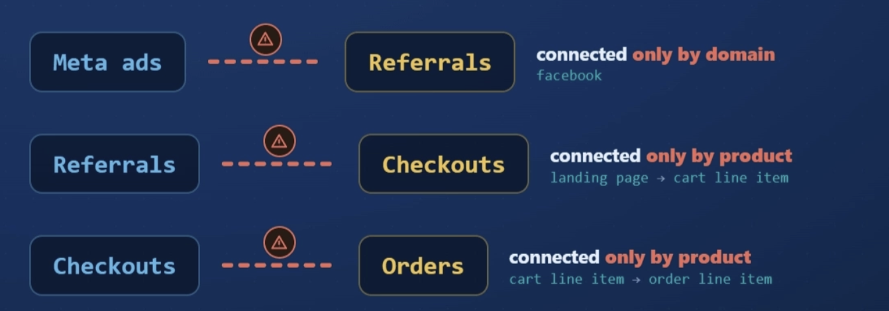
But none of these links are clean. They're all fuzzy guesses. Without one clean product code shared across all four tables, you can't reliably trace Dwellings of Eldervale from ad to sale.

The Fix Is Coming
In this Project, the fix you'll build is a dimension table called dim_product. A dimension table is one clean reference table: one row per product, a unique product ID — the clean shared code that kept going missing — and a clean product slug (the short name from the web address, like dwellings-of-eldervale). Every other table will point to it by that shared ID.
Once that's in place, three of the four fuzzy links above turn into clean joins (a join just means matching rows from two tables by a shared value). The Facebook → Referral link still needs extra work — that's a Project 3 problem, you won't touch that here.

Quick Recap
- The customer journey spans 4 tables; no two share a clean ID
- The fuzzy links (slug-to-title, domain-to-referrer) are why Jess's spreadsheet approach failed
- Designing dim_product next will fix three of those links; the fourth (ads → traffic) is a Project 3 problem
- In an interview, this is your answer to "how do you join messy data from different systems?" — you can name the fuzzy-link problem and the dim_product fix

What's Next
Next you start building the fix: giving every product one clean ID — the primary key — so these tables finally connect where you just watched them break. Across this Project you'll build a clean product database and a data-backed reorder recommendation worth showing off

Step 2: Primary Keys, Foreign Keys, Why They Matter
Objective
Right now, your four tables don't connect, because the same game is written a different way in each one. In this step, you'll fix it: how to give every product one clean ID (a primary key), how to link tables together (foreign keys), and why one clean product list, called a dimension table, is what the rest of your tables connect to. Then you'll build that table, dim_product, and finally, line up your products with your sales.

The next few modules are the toolkit that fixes it: primary keys (this one), then foreign keys, then designing the product table itself. At the end of this Step, you build that fix — the one Jess never finished — and it's what finally lets the team answer the $37K ad question.
It starts here. How do you connect tables? You give every product one clean ID. That ID is called the primary key, and it's what finally lets the database tell every product apart.
https://smitabudhiaextern.github.io/extern-html-pages/substep-2.2.1-primary-keys.html
A primary key has to be unique and stable, and a synthetic integer ID — one the database makes up itself, instead of reusing real data like a name or price — beats any name, title, or price.
Here's what that looks like in the database you're building:
CREATE TABLE dim_product (
product_id INTEGER PRIMARY KEY AUTOINCREMENT,
product_title TEXT NOT NULL,
product_slug TEXT
);

PRIMARY KEY AUTOINCREMENT does two things at once: it marks product_id as the unique identifier, and it tells SQLite to automatically assign the next available integer when you insert a new row. Every product gets a clean, unique, stable ID with no effort on your part. (The product_slug column is just the URL-friendly version of the title — like dwellings-of-eldervale — which you'll fill in later; ignore it for now.)
What If A Row Is Already Unique?
Predict first: shopify_orders.order_name (like BREAKING-GAMES-57826) is different for every order, and shopify_sales is identified by its product_title. One of those would make a safe primary key and one wouldn't — which is which? Decide, then read on.
In some tables, there's a natural unique identifier already. For example, shopify_orders.order_name (like BREAKING-GAMES-57826) is already unique per order. You could use that as a primary key without inventing a new ID.
But for shopify_sales, the natural ID would be product_title, and the interactive just showed why that's a bad choice. So we'll create a dim_product table with a synthetic ID, and reference it from the sales table.

A primary key uniquely identifies a row in one table. But the magic of relational databases is connecting tables together. That's what foreign keys do — and they're the second tool in the kit you're building to finish the fix Jess never got to: one product, one ID, everywhere, so you can finally link the tables that wouldn't connect.
https://smitabudhiaextern.github.io/extern-html-pages/substep-2.2.2-foreign-keys.html
A foreign key is a column in one table that holds the primary key value of a row in another table. It's how you say, "this row belongs to that one over there."
Once foreign keys are in place, querying gets dramatically more powerful.
SELECT dp.product_title, ss.net_items_sold, ss.total_sales
FROM shopify_sales ss
INNER JOIN dim_product dp ON ss.product_id = dp.product_id;

What "dim" And "fact" Mean
You'll hear me say dimension and fact tables constantly. The split is simple: a dimension describes what something is (one row per thing, small and stable), while a fact records what happened (one row per event, and it keeps growing).
Dimensions describe. Facts record.
https://smitabudhiaextern.github.io/extern-html-pages/substep-2.2.2-dim-vs-fact.html
The plan — follow one game through it. You're turning messy product data into one clean table, dim_product, with one row per game. Take Dwellings of Eldervale: first, you design the table (decide what each row stores about a game), then fill it so every game gets its own ID number — Dwellings of Eldervale becomes #1. Next, you clean its title into a tidy web version (dwellings-of-eldervale), and finally you connect your sales table so each sale points to #1 instead of spelling out the full name. This module does the first two; the next does the last two; the Task is where you run it all.
What dim_product Will Contain
Before you write any SQL, decide what columns belong in dim_product. The principle:
Anything that describes a product, intrinsic to the product, goes here. Anything that varies by sale, by customer, or by date does NOT go here.
https://smitabudhiaextern.github.io/extern-html-pages/substep-2.2.3-which-column-belongs.html
apply the same instinct to your real dim_product. For our purposes:
Column | Type | Why
product_id | INTEGER | Primary key (auto-generated)
product_title | TEXT | The full product name as it appears in Shopify
product_slug | TEXT | A slug — a clean, lowercase, hyphenated version of the title (the kind you see in a web address). You'll use it later to match products to the referral and landing-page data.
category | TEXT | Strategy / Party / Family / Other (you'll fill this in later)

The slug earns its spot because it's part of what the product is: its web address never changes from sale to sale, and later it's the thread that links each product back to the Facebook referral data. Price, units, and revenue change with every sale, so they live in the fact tables.

How To Populate It
You have 99 distinct products in shopify_sales already. The easiest way to populate dim_product is to copy it over. First, create the empty table:
-- Step 1: Create the table
CREATE TABLE dim_product (
product_id INTEGER PRIMARY KEY AUTOINCREMENT,
product_title TEXT NOT NULL,
product_slug TEXT,
category TEXT
);

Then, as a separate step, populate it from the data you already have:
-- Step 2: Populate it from existing data
INSERT INTO dim_product (product_title)
SELECT DISTINCT product_title FROM shopify_sales;

That's the INSERT INTO … SELECT DISTINCT pattern — grab every distinct title, drop one row per title into dim_product. You'll reuse it a lot. After it runs:
- 99 rows in dim_product
- product_id auto-assigned (1 to 99)
- product_title filled in
- product_slug and category still NULL (you'll fill those next)
Ninety-nine products, one clean table — every game Mike keeps asking you about, finally in one place.

Adding The Slugs
Here's the satisfying part: you're about to watch a messy title like Sparkle*Kitty Nights: Deluxe turn into a clean sparklekitty-nights-deluxe — in seconds.
A slug is the clean, lowercase, hyphenated web address version of a title.
https://smitabudhiaextern.github.io/extern-html-pages/substep-2.2.3-slugify-machine.html
A slug = lowercase + no punctuation + spaces become hyphens.
Here's the same set of steps as one SQL statement you run across every product:
UPDATE dim_product
SET product_slug = LOWER(
REPLACE(REPLACE(REPLACE(product_title, ' ', '-'), ':', ''), '*', '')
);

the rest keep stray characters (pipes, parentheses, accents and an exclamation mark) and need a quick hand-fix. That's expected, and fine for analytics.

Linking Back To Fact Tables
dim_product is the menu — one row per game, each with its own product_id. Your fact tables (shopify_sales, shopify_orders, shopify_checkouts) are the order tickets: they still name each product by its full title, not its number. Linking means adding a product_id column to each fact table and filling in the matching number from dim_product — writing the number on the ticket. Once that's done, you can JOIN the tables and trace a sale back to the ad that drove it. Until then, dim_product just sits there, unused.

-- Step 1: Add the column
ALTER TABLE shopify_sales ADD COLUMN product_id INTEGER;

-- Step 2: Populate it by matching titles
UPDATE shopify_sales
SET product_id = (
SELECT product_id FROM dim_product
WHERE dim_product.product_title = shopify_sales.product_title
);

That's a correlated subquery: for every row in shopify_sales, it looks up that product's matching product_id in dim_product and stores it. Claude writes the syntax — your job is to know what correct looks like and verify it: run SELECT COUNT(*) FROM shopify_sales WHERE product_id IS NULL; and you want to see 0 (Every sale is now linked).
That clean, zero-NULL result is the shopify_sales case — its titles match dim_product exactly. shopify_orders and shopify_checkouts store product names in different formats (longer marketing titles; checkouts uses a lineitem_name field)

After this runs, every row in shopify_sales has a product_id pointing to a dim_product row. The two tables are now linked.

Why This Is The Design Move
This is the difference between answering Mike's "which ads sold which games?" in two minutes and rebuilding your spreadsheets every time he asks something new. One clean table, connected to the rest, is what makes that speed possible:
Without dim_product | With dim_product
JOINs match on fragile product-name strings | JOINs use clean integer foreign keys
Categorize? Update every fact table | Categorize once, in one place
New product info → edit several tables | New product info → edit one table
Product details copied everywhere | Data is normalized — one copy, one source of truth
That's what database design is: deciding where each piece of information lives, and connecting tables through stable IDs instead of fragile names.
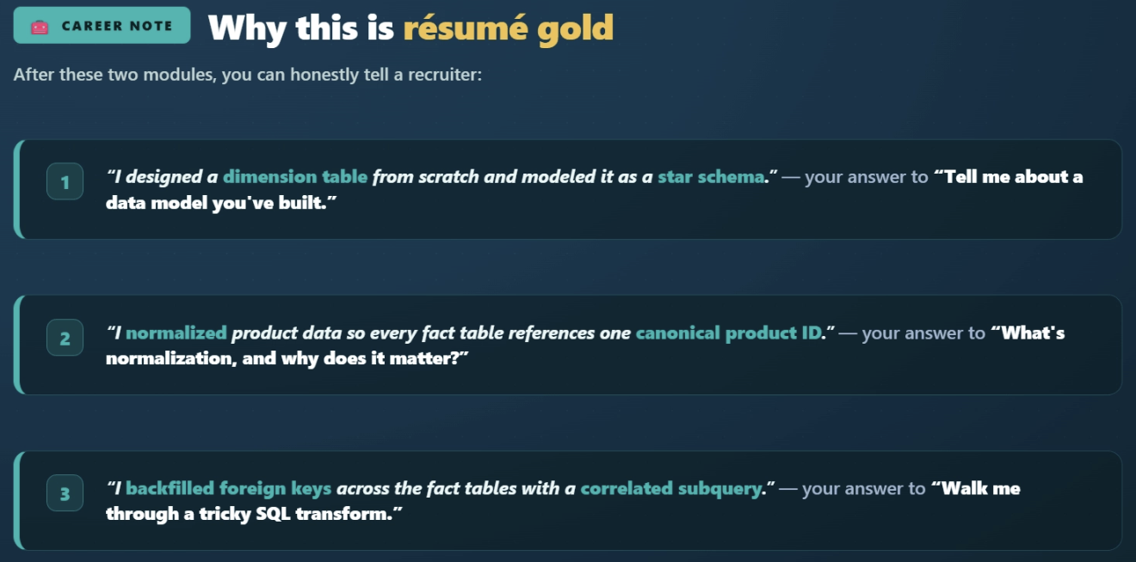

Test on the join
SELECT ss.product_id, dp.product_title, ss.net_items_sold, ss.total_sales
FROM shopify_sales ss
INNER JOIN dim_product dp ON ss.product_id = dp.product_id
ORDER BY ss.total_sales DESC
LIMIT 5;
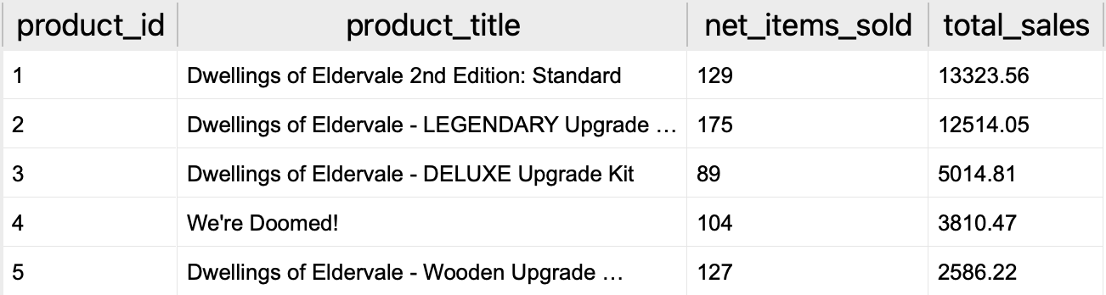

Document The Decision And Submit Your Work
Open your Holiday Game Plan and go to section 2.1: Schema diagram and section 2.2: The dim_product design decision. This is the part an analyst gets paid for: not just running the query, but writing down the design choice so the next person understands it.

Add:
- A short ASCII diagram or sketch showing how dim_product connects to shopify_sales via product_id
- A 2–3 sentence note on why you chose the columns you did for dim_product (and what you deliberately left out — price, units, revenue)
- The final JOIN query from Step 5 and a screenshot of its top 5 results

(Your category column is still empty — that's expected. You'll fill it in a later Step; for now just include it in your schema diagram and note it as a planned column.)

Step 3: JOIN — Putting It All Together
Master INNER and LEFT JOINs by using them to trace real customer journeys. Learn how to iterate with Claude when a query is close but wrong. By the end, you'll have built joined queries that answer questions no single table could.

There's more than one kind of JOIN, and the one you choose changes what shows up.
which Breaking Games products sit in the catalog without selling. LEFT JOIN is how you find them — which is why, in analytics, you'll reach for it more often than INNER JOIN.

Understanding Join in Breaking Games Data
dim_product:
shopify_sales (after Step 2):
product_id | product_title
1 | Dwellings of Eldervale 2nd Edition
2 | Sparkle*Kitty Nights
3 | POOP
4 | Coaster Park

product_id | product_title | net_items_sold
1 | Dwellings of Eldervale 2nd Edition | 129
3 | POOP | 412
(For illustration, SparkleKitty and Coaster Park don't appear in this sample sales data.)

INNER JOIN: Only Show Matches
An INNER JOIN returns only rows where the JOIN condition is true on both sides. If a product appears in dim_product but not shopify_sales (or vice versa), it's excluded.
SELECT dp.product_title, ss.net_items_sold
FROM dim_product dp
INNER JOIN shopify_sales ss ON dp.product_id = ss.product_id;

Result (using the illustration above):
product_title | net_items_sold
Dwellings of Eldervale 2nd Edition | 129
POOP | 412

Only two rows. Why? INNER JOIN only includes rows where there's a match on both sides. Sparkle*Kitty and Coaster Park appear in dim_product but not in shopify_sales, so they're excluded.
Use INNER JOIN when: you only want results where data exists in both tables.

LEFT JOIN: Show Everything from the Left, Match if You Can
A LEFT JOIN returns every row from the left table, plus the matching row from the right table when one exists. When there's no match, the right-side columns come back as NULL.
SELECT dp.product_title, ss.net_items_sold
FROM dim_product dp
LEFT JOIN shopify_sales ss ON dp.product_id = ss.product_id;

Result:
product_title | net_items_sold
Dwellings of Eldervale 2nd Edition | 129
Sparkle Kitty Nights | NULL
POOP | 412
Coaster Park | NULL
All four products show up. The two without sales have net_items_sold = NULL.

Use LEFT JOIN when: you want every row from one table, regardless, and want to know when there's no match. This is incredibly useful for finding what's missing.

Finding Products With No Sales
SELECT dp.product_title
FROM dim_product dp
LEFT JOIN shopify_sales ss ON dp.product_id = ss.product_id
WHERE ss.product_id IS NULL;

In simple language: "show me every product in dim_product, attempting to match a sale. Where there's NO match (ss.product_id IS NULL), keep the row."

https://smitabudhiaextern.github.io/extern-html-pages/substep-2.3.1-spot-the-join-bug.html

With no ON, SQL pairs every left row with every right row — a Cartesian product

Every table you add is one more JOIN, and it brings one more column. That's all a multi-table join is.
Now do the same walk on your real tables — dim_product, shopify_sales, and referrals — adding one JOIN at a time and watching a new column appear at each step.
https://smitabudhiaextern.github.io/extern-html-pages/substep-2.3.3-build-a-join.html

Two things that walk showed you:
- Each JOIN brings in one more table, each with its own ON condition.
- The referrals match uses || to glue strings together, then LIKE to find the slug inside the landing-page text — a loose match. On the real data, many products won't line up with a referral row, so they come back with 0 pageviews. That's expected; you'll tighten it in Project 3.

SELECT dp.product_title, ss.net_items_sold
FROM dim_product dp
LEFT JOIN shopify_sales ss
ON dp.product_id = ss.product_id
LEFT JOIN referrals r
ON r.landing_page LIKE '%'||dp.product_slug||'%'

Query 1: Products with sales but mysterious origins
Find products that have rows in shopify_sales but don't appear to have referral traffic matching their slug.
Brief Claude with the relevant schema (use the Schema Brief template from Week 1). Get a query. Read it. Run it. Iterate if needed.

SELECT COUNT(*) AS products_with_no_traffic
FROM dim_product dp
INNER JOIN shopify_sales ss ON dp.product_id = ss.product_id
LEFT JOIN referrals r ON r.landing_page LIKE '%' || dp.product_slug || '%'
WHERE r.landing_page IS NULL;

Query 2: Products with traffic but no sales
The opposite case: products in dim_product that have referral records but no sales rows. These are the underperformers: traffic comes in, nobody buys.
This is one of Mike's nightmare questions, and you're going to be able to answer it.

SELECT COUNT(DISTINCT dp.product_id) AS products_traffic_no_sales-
FROM dim_product dp
INNER JOIN referrals r ON r.landing_page LIKE '%' || dp.product_slug || '%'
LEFT JOIN shopify_sales ss ON dp.product_id = ss.product_id
WHERE ss.product_id IS NULL;

Query 3: The full story
For each product, return:
- product_title
- total_sales
- total_pageviews (sum across all referral rows that mention this product's slug)
- a ratio of pageviews to units sold (pageviews / net_items_sold, with safe handling for zero)
This is the closest you'll get to a real "what's actually working" view this week. Bring it home.

SELECT dp.product_title,
ss.total_sales,
ss.net_items_sold,
SUM(r.pageviews) AS total_pageviews,
CASE
WHEN ss.net_items_sold > 0
THEN ROUND(SUM(r.pageviews) * 1.0 / ss.net_items_sold, 1)
ELSE NULL
END AS pageviews_per_unit
FROM dim_product dp
LEFT JOIN shopify_sales ss ON dp.product_id = ss.product_id
LEFT JOIN referrals r ON r.landing_page LIKE '%' || dp.product_slug || '%'
GROUP BY dp.product_title
ORDER BY ss.total_sales DESC;

In the last Task, your query came back with about 58 products that wouldn't connect to their web traffic — more than half your catalog, including your best sellers. That wasn't a mistake in your SQL. It's what real data looks like. Let's look at why.

Real-World Join Match Rates
In a perfect world, every row in every table would match cleanly across the schema. The reality:
Join | Realistic match rate | Why it's not higher
dim_product → shopify_sales (foreign key) | 100% (you built it from these rows) | Nothing to miss
dim_product → referrals (slug LIKE) | ~52–68% | Auto-generated URL slugs add edition words and drop punctuation unpredictably
dim_product → shopify_orders (exact title) | ~64% | 92 of 254 order rows have a blank product_title (shipping/summary rows)
dim_product → shopify_checkouts (line-item name) | ~52% | Checkouts store lineitem_name, not a title — many carry price or edition tags
Those numbers come from running this exact pipeline against the real Breaking Games data. The ~52% slug match isn't a bug. It's what data looks like when slugs are generated automatically by Shopify and follow inconsistent rules.

A match in the 50–65% range is normal for messy real-world tables. Chasing 100% is usually wasted effort.

Where Match Rates Go Wrong
A few common reasons for matches to fail:
- Decorated line-item names. The base product is the same; the extra text is the variant. Strip those tags before matching.
- Blank product titles. In shopify_orders, 92 of 254 rows have an empty product_title — they're shipping and summary lines, not product lines. They can't match dim_product, and they shouldn't.
- URL slug rules. Shopify generates slugs from titles but its rules are weird. Apostrophes, asterisks, and ampersands disappear in unpredictable ways.
- Historical products. Some products in referral data are games that were renamed, retired, or never published. They show up in referrals but not in current sales.

When to Investigate, When to Move On
The rule of thumb: first check whether the non-matches share a clear cause. If they do, take the win.
If a chunk of rows fails for the same reason, you can name — blank titles, price tags on line-item names, slugs with edition words — that's the messy edge of real data, not a broken query. Worth understanding, not worth obsessing over. If the non-matches look random with no pattern you can explain, then dig in: maybe you're matching the wrong columns or your slug rules are off.

Step 4: The Reorder Pressure
Objective
Understand Mike's reorder problem and the Nov 1st deadline. Frame the analytical questions you'll need to answer to give him a recommendation. No SQL yet; just clarity on the question.

- Mike's current method: highlight a printout. Works on 15 products, breaks at 117.
- His blind spots are the middle, the tail, conversion rates, and traffic without sales: exactly what SQL is good at surfacing.
Where Mike's Method Breaks Down
His method works for 15 products. It holds at 30. At 117, it quietly breaks. Take his printout one question at a time — one click each, the answer revealed right after.

None of this makes Mike wrong. He's a sharp operator stuck with a bad tool

What a KPI Is (and Isn't)
Which game is doing better — POOP or Dwellings of Eldervale?
POOP sold 410 copies last quarter; Dwellings sold 320. If "better" means popular, POOP wins. But Dwellings made $42,000 to POOP's $4,100 — if "better" means money, it's Dwellings, and it's not close.
Same two games, opposite answers. The only thing that changed is which number you looked at.
That's all a KPI — Key Performance Indicator — really is: the one number you pick to judge whether something's working. The hard part isn't the formula; most are one line of SQL. It's choosing the right number for the question, and spotting when a good-looking number changes nothing. That judgment is what separates an analyst from a chart-maker, and it's exactly what Mike's reorder call needs.
For Mike's reorder decision — picking which of 117 games to reprint before Nov 1 — no single KPI is enough. Revenue tells you what made money. Units tells you what was popular. AOV (average order value) tells you whether your top sellers are cheap-and-many or expensive-and-few. Conversion rate tells you whether traffic is being well-used.
You need a small set of KPIs, each one answering a different angle of the same question.

The fastest way to feel the difference is to use them. Work through the picks below — each one is a quick gut-call with the answer revealed right after. It warms up on a pizza shop, then gets to the hard part: telling a vanity number from one that would actually change Mike's reprint list.
https://smitabudhiaextern.github.io/extern-html-pages/substep-2.4.2-pick-the-kpi.html

it's picking the RIGHT number for the question you're actually asking.

AOV (average order value) — the money per item. Margherita earns $10 an order; Deluxe earns $50 an order. Same revenue, totally different story: one shop runs on volume, the other on a few high-ticket sales. AOV is the number that tells them apart.

A vanity metric feels good to report. An actionable metric actually changes what you'd do next.
vanity metric — it feels good to report but doesn't change a decision. The test for any metric: “what would I do differently because of this number?” If the honest answer is “nothing specific,” it's vanity.

Mike has to choose which of 99 games to reprint before the Nov 1 deadline. Which number should LEAD the decision?
Start with what made money (revenue) and what was popular (units sold). Those lead. Then layer in AOV and conversion rate for the full picture — but revenue and units are what put a game on the reprint list in the first place.

The vocabulary you just earned
Revenue -> Total dollars earned. What made money.
Units sold -> How many sold. What was popular.
AOV -> Dollars per item. Cheap-and-many vs pricey-and-few.
Conversion rate -> Of visitors, how many bought. How efficient the traffic is.
Long-tail share -> How concentrated revenue is across products.

Pick the number that answers the question. Actionable over vanity.

The Five KPIs for This Project
KPI | How to calculate | What it tells you
Revenue | SUM(total_sales) per product | What made money. The starting point of every reorder conversation.
Units sold | SUM(net_items_sold) per product | What was popular. Differs from revenue when price points vary widely.
AOV (avg order value) | SUM(total_sales) / SUM(net_items_sold) | How much each unit earned. High AOV = premium product; low AOV = volume play.
Conversion rate | orders / pageviews (joined across tables) | How efficient the traffic is. Low conv. rate + high traffic = something to investigate.
Long-tail share | Sum of bottom-80% revenue / total revenue | How concentrated revenue is. Tells you how aggressively you can prune.

Quick Recap
- A KPI is a number that tells you if something is working; pick the right one for each question
- This Project's working set: revenue, units, AOV, conversion rate, long-tail share
- Vanity metrics make you feel good; actionable metrics change decisions. Mike's report needs the second kind

Turn the KPIs Into Reorder Questions:
The KPIs told you what to measure — revenue, units, AOV, conversion rate and long-tail share. Now you turn those numbers into the handful of questions your analysis actually has to answer before Mike commits the print run.

You've got the five numbers now. But a list of numbers isn't a plan — you can stare at revenue and units all day and still not know what to print. The trick is knowing which questions those numbers are there to answer.

- Which games are the money-makers — top on revenue and moving real units
- Which games pull real traffic but barely convert? Lots of page views, almost no sales. That's not a reprint question; that's a fix the page question.
- Which games are dead weight, bottom of the catalog on both revenue and units? That's your long-tail.
- AOV — which games are cheap-and-many versus premium-and-few? It won't change whether we print something, but it changes how we bundle and price it.

The Four Reorder Questions
Here they are in one place — the questions your SQL has to answer next, and the KPIs each one leans on.
# | The question | KPIs it uses | The decision it points to
1 | Which games are the money-makers — top revenue and units — that we can't run out of for Black Friday? | Revenue, units sold | Print heavy
2 | Which games pull real traffic but barely convert — lots of page views, few sales? | Conversion rate, pageviews | Promote / fix the page — don't reprint
3 | Which games are dead weight — bottom on both revenue and units? | Long-tail share, revenue, units | Print light / skip
4 | Which games are cheap-and-many vs premium-and-few, in a way that changes how we bundle them? | AOV | Pricing / bundling read

Questions 1 to 3 are the three buckets your recommendation will sort every game into; question 4 is the pricing nuance that rides alongside them.
- Three of them sort every game into print-heavy, fix-don't-reprint, or cut — the fourth is an AOV pricing read
- Every good reorder question ends in a move: print more, print less, or fix

Step 5: Aggregation — Summing Up the Story
Objective
Learn GROUP BY, COUNT, SUM, AVG, and HAVING: the SQL building blocks that turn rows into answers. By the end, you'll have a product performance table ranking every Breaking Games product by revenue and units sold.

GROUP BY — Collapsing Rows Into Answers
What you haven't done yet is the rolling up, turning piles of rows into the few summary numbers Mike's questions actually need.

gather every row that shares a value, then crush each pile down to one summary row — is exactly what GROUP BY does. The word for crushing a pile down to a single number (add it up, count it, average it) is aggregate — it just means "roll up / combine."

SELECT product_type, COUNT(*) AS n_products
FROM shopify_sales
GROUP BY product_type;

https://smitabudhiaextern.github.io/extern-html-pages/substep-2.5.1-group-by-collapse.html

- "How many orders did each pizza get?" Count the lines in the pile. That's COUNT. Margherita has 2 orders, Pepperoni has 2, Veggie has 1.
- "How much money did each pizza bring in?" Add up the totals in the pile. That's SUM. Margherita = $12 + $12 = $24, Pepperoni = $15 + $15 = $30, Veggie = $14.
- "What's a typical order worth for each pizza?" Average the totals in the pile. That's AVG. Margherita averages $12, Pepperoni $15, Veggie $14.

SELECT
product_type,
COUNT(*) AS n_products,
SUM(total_sales) AS total_revenue,
AVG(total_sales) AS avg_sale
FROM shopify_sales
GROUP BY product_type;

One prediction before you look. Game is the big pile — 82 products. Game Accessory is tiny — only 10. Which one do you think has the higher typical sale (the higher AVG)? It's tempting to say the big pile, but read the AVG column below and check yourself.

Here's what those 99 rows collapse into:
product_type | COUNT (products) | SUM (revenue) | AVG (typical sale)
Game | 82 | $51,412.92 | $626.99
Game Accessory | 10 | $9,055.10 | $905.51
(blank '') | 4 | $294.01 | $73.50
game | 1 | $188.01 | $188.01
Toy | 1 | $84.78 | $84.78
Gift | 1 | $50.51 | $50.51
Same six piles you saw in the last module, now with money attached. If you guessed the small pile, you were right: Game Accessory has only 10 products, but its typical sale ($905.51) beats Game's ($626.99) — fewer products, but pricier ones. The size of the pile tells you nothing about the typical sale inside it. That's the kind of thing Mike can't see from a raw row dump — it only shows up once you aggregate.

HAVING — Filtering Groups
WHERE filters the rows before you group them; HAVING filters the groups after.

Which product types brought in more than $5,000?
SELECT product_type, SUM(total_sales) AS revenue
FROM shopify_sales
GROUP BY product_type
HAVING SUM(total_sales) > 5000
ORDER BY revenue DESC;

- WHERE = filter the raw rows, before grouping.
- HAVING = filter the piles, after grouping and aggregation.
GROUP BY to make the piles, COUNT, SUM, and AVG to put numbers on them, and HAVING to keep only the piles that matter. Now you put them together

-- Top 25 products by revenue. Include columns for Total sales, units sold, AOV
SELECT
product_title,
total_sales,
net_items_sold,
ROUND(total_sales/net_items_sold,2) AS AOV,
ROW_NUMBER() OVER (ORDER BY total_sales DESC) AS revenue_rank
FROM shopify_sales
WHERE net_items_sold > 0
ORDER BY total_sales DESC
LIMIT 25;

Step 6: From Numbers to Decisions
Objective
Cross-check Claude, find products with traffic but no sales, design your fact_product_performance summary table, build the reorder recommendation, and prepare to defend it. This is the final Step of the Project and the home of its second design move.
https://smitabudhiaextern.github.io/extern-html-pages/substep-2.6.1-spot-the-lie.html

The Three Checks
Jess gave you the instinct at the coffee machine; the interactive showed you the trap. Here's what each move looks like when you actually run it — so you can reach for them deliberately:
- Hand-count a small subset and compare. Pull the top few rows, add them up yourself, and check that Claude's total lands in the right zone. Suppose Claude claims $61,085 in total revenue — pull the top 5 products, eyeball their sum, add the next handful, and confirm you're climbing toward $61K, not $610K or $6K.
SELECT product_title, total_sales
FROM shopify_sales
ORDER BY total_sales DESC
LIMIT 5;

- Cross-check with a different aggregation path. Reach the same number a second way. If two independent paths agree, your confidence jumps.
SELECT SUM(net_sales) + SUM(taxes) AS rebuilt_total
FROM shopify_sales;
-- should land on the same total Claude reported

- Check the grain — is each event summed exactly once? This is the subtle one. Suppose you ask, "What's the total revenue from carts that included Dwellings of Eldervale?" If the query sums a column that repeats across rows, the same money gets counted more than once and the total balloons. Before trusting any sum, ask: Is each underlying event being added exactly once?

Claude Move: Trust, Then Verify
After Claude returns an aggregate query, paste this back:
"Before I trust this number, walk me through how you'd verify it with a different query path. Then describe what the right answer should be approximately, given that total Breaking Games revenue is around $61K."
If Claude can describe a verification path AND a plausibility check, the query is probably right. If it can't, run it under suspicion.

what share comes from just your top ten games?
SELECT
product_title,
ROUND(total_sales, 2) AS revenue,
ROUND(100.0 * total_sales / (SELECT SUM(total_sales) FROM shopify_sales), 1) AS pct_of_total
FROM shopify_sales
ORDER BY total_sales DESC
LIMIT 10;

You can feel the reorder buckets forming already. Before you commit to them, it helps to see the curve — and decide where you'd draw the line.
https://smitabudhiaextern.github.io/extern-html-pages/substep-2.6.2-where-the-revenue-lives.html

This pattern — a few items making most of the total, with a long tail that barely moves — is called the long tail, or a Pareto distribution. Being able to spot it and name it is a senior analyst move; it signals you've read more than one dataset.

Which Games Get Clicks But Don't Sell?
So far, you've only looked at what sold. Now you also look at what got attention — how many people visited each game's page.

That uncovers two hidden groups the bestseller list never shows you:
- Games lots of people visit but almost nobody buys → something's off (price, the page, out of stock). Don't cut these — look into them.
- Games barely anyone sees, but the few who do buy → hidden winners. Push these with more visibility.
A "what sold" list misses both, and both change what you'd tell Mike to reprint or promote.

The traffic data's messy. Only about half the games line up cleanly with a page, so treat the numbers as a rough direction, not an exact count. Honestly, that mess is half of what's bugging.
pull traffic and sales together

SELECT
dp.product_title AS game,
ss.net_items_sold AS units_sold,
(SELECT COALESCE(SUM(r.pageviews), 0)
FROM referrals r
WHERE r.landing_page = '/products/' || dp.product_slug) AS pageviews
FROM dim_product dp
JOIN shopify_sales ss ON ss.product_title = dp.product_title
ORDER BY pageviews DESC;

In simple language, the query is just three instructions:
- For every game, pull how many units it sold.
- For every game, find its own web page — /products/ plus its slug — and add up the visits to it.
- Line both numbers up side by side, one row per game, the most-visited on top.
If you can say those three steps, you can ask Claude to write it — the SQL is just those steps in the database's language.

A few rows you'll see when you run it:
Game | Pageviews | Units sold
We're Doomed! | 20,316 | 104
Trellis | 6,052 | 13
Dwellings of Eldervale – Oracle Hex Tile | 793 | 178
Master Thief | 639 | 18
Look at the gap between the top two and the bottom two. We're Doomed! and Suddenly Stoned pull huge traffic but only sell in the dozens, so they get lots of clicks and few buyers. Oracle Hex Tile and Master Thief barely get seen, yet almost everyone who lands sells through. That's one table holding two completely different stories, and neither one shows up on the bestseller list.

About that "messy" warning Jess gave you: only a game whose slug lines up exactly with a /products/ page gets a traffic number, and roughly half of them do. The other half comes back blank — a slug that didn't match, a page named differently. So read these as a direction, not a precise count. You won't fix this now — cleaning up messy attribution is a job of its own, and it's exactly what the next project takes on. For now, just keep it in the back of your mind: noticing that a number is only half-complete, and flagging it instead of trusting it blindly, is what analyst thinking looks like.
https://smitabudhiaextern.github.io/extern-html-pages/substep-2.6.3-traffic-vs-sales-quadrant.html

What are Summary Tables?
Over the last couple of modules, you learned how to measure each game's share of the revenue, and how to line up its traffic against its sales. This module brings those numbers together into one table. That might sound like a recap, but it's really a step up: instead of computing each answer one at a time, you build a single table that holds them all, and you design it once so you never have to run those queries again. This table is the foundation your final reorder recommendation runs on.

The Principle to Build a Good Summary Table
A good summary table follows three rules. Work through the interactive below to see each one.
https://smitabudhiaextern.github.io/extern-html-pages/substep-2.6.4-summary-table-rules.html

A good summary table follows three rules.
Get these right, and you can answer most questions just by reading the table, instead of writing a new query.
- One row per game. Add up all of a game's sales into a single line.
- One column per question. If you ask something a lot, save the answer instead of recomputing it.
- Do the slow work once. If a number takes a slow query, run it once and keep the answer.
What you put in (or leave out) is a real choice with consequences. Too few columns: you'll JOIN again later, defeating the purpose. Too many: the table becomes brittle when source data changes. The right answer is "the columns that answer the questions you've already written down."

What You've Already Asked
Earlier, you wrote down the questions Mike needs answered to decide what to reprint. Everything you've worked out in this Step traces back to those questions — and they point to a handful of numbers your table should at least hold:
- Per-product revenue and units (anchor numbers)
- A per-product AOV (you keep recomputing it)
- Per-product pageviews (the traffic side of the story)
- Some way to slice traffic by source (Facebook vs everything else, at least)
Those aren't the answer. They're a starting list. The actual columns are for you to decide in the Task.

The Trade-Off
A summary table is a saved copy of the answers, so it comes with one catch and one big win:
- The catch: it's a snapshot. If the numbers underneath change, the table is out of date until you build it again.
- The win: it's fast and simple. A question that used to need a multi-table query now reads straight off one table, and you can't fumble the math, because you only did it once.
For Mike's reorder rec, there's no real downside. The data isn't changing during this Project.

🧰
Career note: A small, purpose-built table like this, one that powers a specific report, is called a mart. Being able to explain why you chose each column in a mart is the moment you stop sounding like a SQL learner and start sounding like an analytics engineer.

Design Your Summary Table
This is the second piece of architecture you're owning in this Project. The first (dim_product) was your introduction to dimension tables. This one is your first summary table design. By the end, you'll have designed and built fact_product_performance — the table your reorder recommendation runs on.

Follow the Steps Below

Step 1 — Decide Your Columns
The first step is to decide the columns in your table. Since you are doing it for the first time, we will help you decide the columns.
Work through the interactive below — each reorder question points to the column that answers it.
https://smitabudhiaextern.github.io/extern-html-pages/substep-2.6.5-design-your-columns.html

Which games made the most money? -> total_sales
Are the games getting lots of ad clicks actually selling? -> total_pageviews,net_items_sold
You keep computing revenue ÷ units to see how much each sale is worth, and you'll do it for every game, every time. What's the move? -> Store once as AOV column

Step 2 — Build the Table
-- drop fact_product_performance table if existis
DROP TABLE IF EXISTS fact_product_performance;

-- create fact_product_performance table
CREATE TABLE fact_product_performance AS
SELECT
dp.product_id,
dp.product_title,
COALESCE(ss.total_sales, 0) AS total_sales,
COALESCE(ss.net_items_sold, 0) AS net_items_sold,
CASE
WHEN COALESCE(ss.net_items_sold, 0) > 0
THEN ROUND(ss.total_sales * 1.0 / ss.net_items_sold, 2)
ELSE 0
END AS aov,
COALESCE((
SELECT SUM(r.pageviews)
FROM referrals r
WHERE r.landing_page = '/products/' || dp.product_slug
), 0) AS total_pageviews
FROM dim_product dp
LEFT JOIN shopify_sales ss ON ss.product_id = dp.product_id;

-- check
SELECT COUNT(*) FROM fact_product_performance; -- expected: 99
SELECT * FROM fact_product_performance ORDER BY total_sales DESC LIMIT 3;

Build the Reorder Recommendation
which games should we reprint for the holidays? You'll sort the games into three groups (reprint a lot, reprint a little, don't reprint) and write a one-line reason for each. This list is the centerpiece of your Holiday Game Plan.
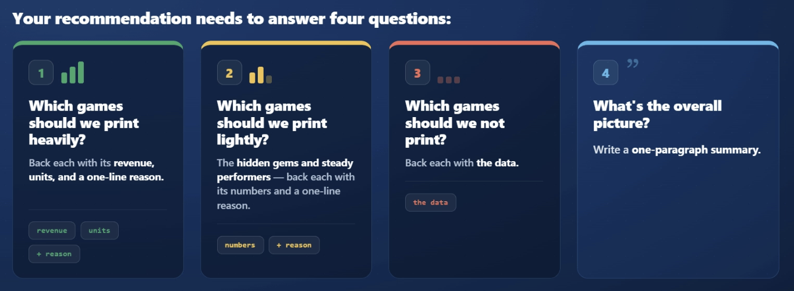

Pull Your Three Lists.
You're aiming for roughly 10 games to print heavy, 5 to print light, and 3 to not print. The three queries below pull those lists for you.
Query 1 of 3 — Print heavy. Your flagships: the top sellers you reorder confidently.
SELECT product_title, total_sales, net_items_sold, aov, total_pageviews
FROM fact_product_performance
WHERE total_sales > 0
ORDER BY total_sales DESC
LIMIT 10;

Query 2 of 3 — Print light. The next tier: ranks 11–15 by revenue — proven sellers that didn't make the flagship list.
SELECT product_title, total_sales, net_items_sold, aov, total_pageviews
FROM fact_product_performance
WHERE total_sales > 0
ORDER BY total_sales DESC
LIMIT 5 OFFSET 10;

Query 3 of 3 — Don't print. Your clear cuts: the weakest revenue lines of the whole period.
SELECT product_title, total_sales, net_items_sold, total_pageviews
FROM fact_product_performance
ORDER BY total_sales ASC
LIMIT 10;

Why none of these queries filter on total_pageviews: the slug-to-URL match behind that column only works for about half the catalog, and when it misses, the column reads 0 — including for the entire Dwellings of Eldervale line, whose store URLs don't follow the title pattern. A 0 there means couldn't measure, not that nobody visited. So traffic rides along as context for your write-ups, but it never decides which bucket a game lands in. Letting a maybe-broken number make the decision is how a real bestseller ends up in the cut pile.

Defending Your Numbers
https://smitabudhiaextern.github.io/extern-html-pages/substep-2.6.7-survive-the-mike-grill.html

- Be ready for three questions on every recommendation: where did it come from, is it exact or an estimate, and what would change your mind.
- To re-run a number, you reopen the saved query in DB Browser and press run. You don't write SQL from memory.
- Show the denominator, round wisely, and name your estimates out loud.

1. "Where Did This Number Come From?"
For any number in your recommendation, you should be able to do three things:
- Name the table and column it came from.
- Describe the filter (for example, "sales between Jan 1 and Jul 29").
- Re-run the saved query in DB Browser and get the same number back.
That last one is less scary than it sounds. You are not writing SQL from memory. You already saved this query earlier in the Step. You just open it again and press run, and the same number appears. All you are showing is that it reproduces.

2. "What If This Estimate Is Off?"
This is the robustness check. Some of your numbers are exact and some are estimates. Mike needs to know which is which.
- Exact numbers come straight from the data. Revenue from total_sales is exact, because every sale recorded its dollar amount.
- Estimates are numbers you had to piece together. Matching pageviews to sales is an estimate because the data doesn't reliably tell you which visit led to which order.

Do not invent a precision figure to sound confident. Instead, say plainly which numbers are estimates and why the recommendation still holds. For example: "Revenue is exact. The pageview-to-sales number is an estimate. Even if that estimate is off, this game still sits well below the reorder line, so the decision doesn't change."

3. "What Would Change Your Mind?"
This is the senior analyst question. If you can answer it, you understand your own analysis. If you can't, you have over-committed to a conclusion.
Right now, you can only tell which ad a buyer clicked by guessing from pageviews, which is unreliable. So a good answer names the data you wish you had: "If we had data showing which ad each buyer actually clicked, the Meta ad picture might change enough to move two campaigns from 'cut' to 'keep.' That's the next thing I'd build."

