PROJECT 2: Designing your first Database
$37,000 spent on Meta ads. Sales of $61,000. Did it work? Mike has a budget review with the founder and needs a number. In this Project, you'll design your own channel taxonomy for dim_referrer to tame 421 messy referral source strings, learn channel attribution, CTR, CPC, and ROI math, and connect Facebook ad spend to actual revenue using the data you have. By the end of the Project, you'll deliver a Q4 ad allocation plan: which campaigns to keep, which to cut, where the new dollars go.

Step 1: Understand the Ad Data and the Questions to Ask
Objective
Understand where the $37K in Meta ads went, what the referral data tells you, and what questions Mike actually needs answered for his Q4 budget review. Frame the analysis before writing any SQL.
The Scenario
$37,200 spent on Meta ads. $61,085 in sales. Mike has a budget review with Shari and a question he can't answer: Did the ads work? More importantly, where should Q4 dollars go? Same campaigns at higher volume? Different ones entirely? A whole new channel? Right now, nobody knows because nobody can connect campaign spend to actual revenue.
You'll sort the 421 different places visitors came from into a handful of clear groups (like Facebook, Google, and direct visits), learn the simple math that separates a good ad from a money-waster, and hand Mike a plan he can defend in his budget review.
https://smitabudhiaextern.github.io/extern-html-pages/project-3-explained-for-kids.html
- Find the real question
- Sort the visitors into piles -> Put them into neat piles so they're easy to count.
- Do the money math -> was it cheap and worked great ⭐, or expensive and did nothing
- Tell Mike — nicely -> Some posters didn't work.
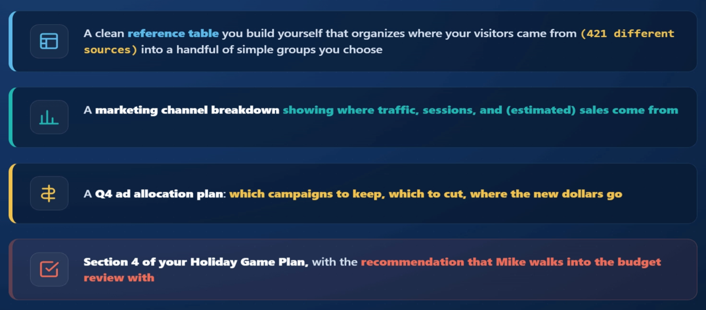
find out where Breaking Games' traffic really comes from.
SELECT
COALESCE(NULLIF(referrer, ''), 'direct') AS referrer,
SUM(pageviews) AS pageviews
FROM referrals
GROUP BY referrer
ORDER BY pageviews DESC
LIMIT 15;

- the biggest source is direct.
- There are 421 distinct referrers total.

What Each Channel Actually Means
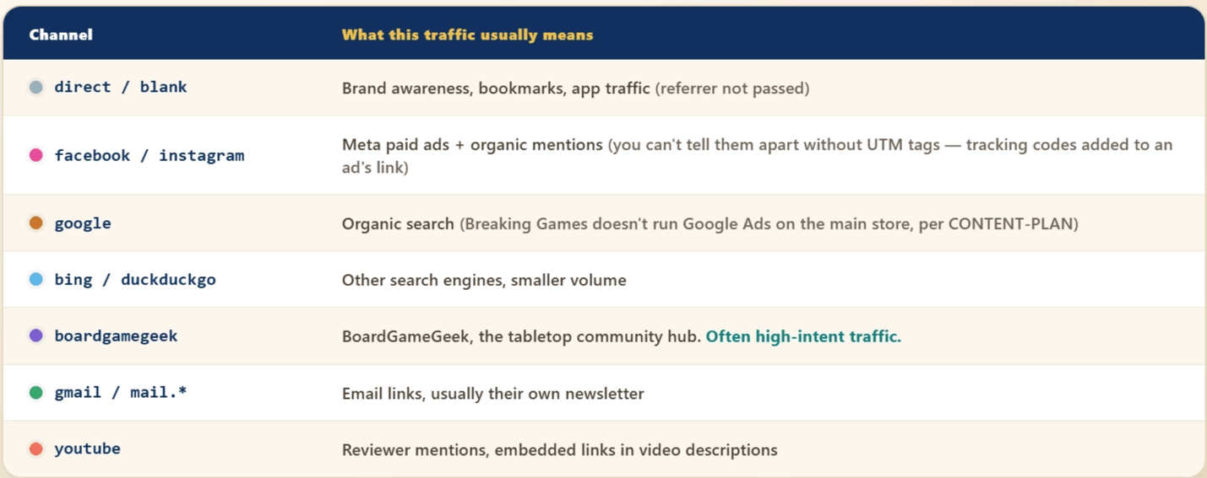
The "421 Referrers" Problem
The raw referrer column contains things like:
- facebook (the clean one)
- m.facebook.com (mobile)
- l.facebook.com (link shim from Facebook Messenger)
- fb.me (short link)
- lm.facebook.com (Lite mobile)
All five of those are Facebook traffic. In aggregate, they should sum together. In the raw data, they're five separate rows.
Multiply that pattern across every channel (google, news.google.com, images.google.com, etc.) and you get to 421 distinct referrer strings, most of which collapse into about 5–8 meaningful channels.

Breaking Games has 421 distinct raw referrers in referrals, but only about 5–8 meaningful channels

The Meta Ads Data Tour
Why This, Why Now?
Where did people come from? That was the last module. You looked at the website visitors and which "door" they came through — Facebook, Google, typing the address, and so on. This is about the people showing up.

What did the ads actually cost and do? That's this module. Now you open the ad records: how much money each ad spent, how many people saw it, how many clicked. This is about the money Mike paid.

The Hierarchy: Campaigns Contain Ad Sets
Meta organizes ads in three levels:
Campaign → Ad Set → Ad
(objective) (audience) (creative)

You have data on the first two:
- meta_campaigns: 35 rows. One per campaign for the period. Top-level objectives like "drive purchases" or "build awareness."
- meta_ad_sets: 8 rows. A level below; these are the audience-targeting groups within campaigns. Far fewer ad sets than campaigns means most campaigns ran a single ad set.
You don't have ad-level data. That's the next level down and Meta export limits often cut it off.

meta_campaigns has 19 columns — most matter, a few don't. Hover any column below to see what it means; the highlighted ones are the ones you'll lean on.
https://smitabudhiaextern.github.io/extern-html-pages/project-3-meta-columns.html

Only 6 of the 35 campaigns recorded a result, and each one counted something different:
Campaign | What results counted (result_indicator) | results | cost per result
Traffic: TOF | landing-page views | 39,419 | $0.22
MAT Test: Dwellings | landing-page views | 17,753 | $0.24
MAT Test: We're Doomed | landing-page views | 3,540 | $0.39
Sales: ATC | add-to-carts | 291 | $4.96
Sales: Advantage+ | purchases | 97 | $70.76
Reach: Retargeting | people reached | 1,208,484 | $1.33
Read down the cost-per-result column: $0.22, then $4.96, then $70.76, then $1.33. You can't rank these. $0.22 is the cost of one page view; $70.76 is the cost of one purchase. It's the same column measuring six different things. That's why you always read result_indicator first. It tells you what results actually counted for that campaign.

SQL Query for the Spend Breakdown
Now that you know what's trustworthy, you open Claude and work out a query to see where the $37K actually went. Here's what you came up with:
SELECT
delivery_status,
COUNT(*) AS n_campaigns,
ROUND(SUM(spend_usd), 2) AS total_spend
FROM meta_campaigns
GROUP BY delivery_status
ORDER BY total_spend DESC;

delivery_status | n_campaigns | total_spend
active | 4 | 30028.12
inactive | 31 | 7172.82

Most of the $37K will be in the small handful of campaigns that actually ran. Many campaigns will show $0 spent (created but never delivered).
Pull only the campaigns that produced a result. The obvious way to write that is
WHERE results IS NOT NULL AND results <>''

Quick Recap
- meta_campaigns is the top level (35 rows); meta_ad_sets is a level below (8 rows)
- spend_usd, impressions, clicks are reliable; results means a different thing per campaign, and its blanks are empty strings, not NULL
- There's no clean link to shopify_sales; you can correlate Meta activity to revenue but not attribute precisely

A sharp question names a slice, a measure, and the decision it drives — and the data can actually answer it. Mike walks you through four calls he has to make. Pick the sharp one for each.
https://smitabudhiaextern.github.io/extern-html-pages/project-3-frame-the-question.html
the $37K Facebook bet,
which campaigns to cut or keep,
which channel sends buyers, and
which product pages are leaking.

Where Q4 budget goes
- We spent $37,200 on Facebook ads this period, and I'm about to set the Q4 budget for our biggest quarter. Shari will ask me straight out whether that money was worth it and where the next dollar should go. I need a question I can put real numbers against, not a gut feeling.
For the Facebook channel, what did we pay per pageview, and how does its checkout rate compare to other channels?
A slice (the Facebook channel), a measure (cost per pageview and checkout rate), and a decision (does Facebook earn more Q4 budget). Answerable from spend plus traffic.

Cut or keep campaigns
- I've got 35 campaigns in the account and most are switched off. Before Q4 I want to keep the ones that pulled their weight and stop re-running the rest. The tricky part: each campaign was built to do a different thing, so I can't just rank them all on one number.
Among campaigns with the same objective, which have the lowest cost per result, and should any paused ones come back for Q4?
A slice (same-objective campaigns), a measure (cost per result), and a decision (cut, keep, or revive). Answerable inside meta_campaigns for the campaigns that report a result.

Which channel to lean into
- Facebook sends us far more visitors than anywhere else, so on a traffic chart it always looks like the winner. But traffic isn't money, and I care who actually buys. If a smaller channel quietly converts better, I'd rather feed that one in Q4.
For each channel, what share of its pageviews reach checkout, so I can see which sends buyers, not just browsers?
A slice (each channel), a measure (checkout rate), and a decision (which channel to lean into). Answerable from referrals — checkouts divided by pageviews.

Which product pages to fix
- We send ad traffic to specific product pages, and I think some of them are leaking. Plenty of visits land, but the sales don't follow. I want to know which product pages pull traffic without turning it into sales, before we spend more in Q4
Which product pages get heavy pageviews but a low checkout rate?
A slice (each product page), a measure (pageviews and checkout rate), and a decision (which pages to fix). Answerable from referrals by the /products/ path.

Step 2: Find Which Channels Convert Best

Objective
Learn attribution math (first-touch vs last-touch), design your own channel taxonomy for dim_referrer, and practice planning the design in one Claude session before implementing it in another. By the end, the channel categories Mike's Q4 conversation runs on are categories you defined.

What Is Attribution?
"How much revenue did Facebook drive?" is the most common question in marketing. For Breaking Games it matters most of all, because Facebook and Instagram are where almost all of the ad money went. Mike needs an answer before he sets the Q4 budget, so you need to know how to work through it.
The technical name for this is attribution: deciding which channel gets credit for a sale. There are a few different ways to assign that credit, and choosing the wrong one is how careful analysts end up with numbers that mislead the team. This module is here to help you understand attribution before you touch the data.

Mike (Head of E-Commerce): "I just need one number before I set the Q4 budget. How much did Facebook actually drive? We spent $37,200. Did it come back, or not?"
It sounds like a simple question. It is one of the hardest to answer honestly.

The Path a Customer Takes Before Buying
A customer rarely sees one ad and buys on the spot. Their path usually touches several channels over days:
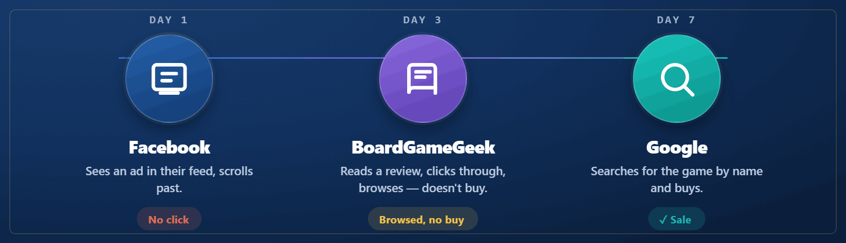
That sale: whose was it? Facebook created the awareness, BoardGameGeek delivered the visit, and Google closed the deal. The answer depends on which attribution model you use.

The Main Models
There are a handful of common attribution models, and each one splits the credit differently. The fastest way to feel the difference is to watch one sale counted five ways. Work through the interactive below: one $30 pizza-night order, three little nudges, five models. Reveal each one and watch the credit move.
https://smitabudhiaextern.github.io/extern-html-pages/project-3-attribution-models.html
The model you pick changes the story the numbers tell.
The big lesson: none of the models is the "right" one. The model you pick changes the story the numbers tell, so you choose it on purpose and say which one you used.

What You'll Pick for Breaking Games
Here's the catch: Breaking Games' data can't run any of those models cleanly. To split credit across a customer's path, you'd need to follow one customer from nudge to nudge, and the data doesn't track that:
- No journey across visits. Each row in referrals is a summary of one referrer and landing page, not one person.
- No UTM tags. UTM tags are hidden labels on a link that tie a click back to a specific ad. Breaking Games never used them, so a Facebook click carries nothing forward to the sale.
- No link from a visit to a purchase. Someone who visits twice and buys once shows up as separate rows in separate tables.
So you can't say "this Facebook ad caused this sale." What you can say is "this much Facebook traffic happened, and this much in sales happened in the same period." That's a correlation, not true attribution, and you'll say so out loud.

For Mike's Q4 plan, you'll use what the data actually supports:
- Facebook pageviews (from referrals)
- Facebook spend (from meta_campaigns)
- Cost per pageview (spend ÷ pageviews)
- Whether sales were higher when Facebook activity was higher (a directional signal, not proof)
That's honest and useful. It's the approach a senior analyst would actually take here.

How to Sort 421 Traffic Sources into Channels
In the last module, you learned the honest limit of this data: you can compare channels (Facebook vs. Google vs. Direct), but you can't trace one ad to one sale. There's one catch before you can even do that comparison. The raw data doesn't have clean channels yet. It has 421 different referrer spellings, and five of them (facebook, m.facebook.com, fb.me, and more) are all just "Facebook."
This module builds the small lookup table that fixes that: dim_referrer. Its whole job is to say, for every messy referrer, which clean channel it belongs to.

What dim_referrer Contains
So you need a place to write those decisions down. That place is dim_referrer, a lookup table. A lookup table does one simple thing: you give it a messy value (m.facebook.com) and it hands back the clean answer (Facebook). You build it once, and every future query just asks it.
dim_referrer is that grouping, written down as a table. The messy scribbles are your 421 referrers; the clean buckets are your channels.

The table has just three columns. Here's what each one holds, using one real Facebook variant as the example:
Column | In plain words | Example
referrer | The messy value exactly as it appears in the raw data (one row per distinct spelling) | m.facebook.com
channel | The clean bucket you decide it belongs to | Facebook
channel_type | Whether that channel was paid for, came in free, or is your own | Paid
Read a row left to right: "the referrer m.facebook.com belongs to the Facebook channel, which is Paid traffic." You write one row like that for every distinct referrer. The columns are fixed and easy; the decisions (which referrer goes in which bucket) are the real work, and that's the Task.

For channel_type, most companies use three labels: Paid (you spent money on it, like Facebook ads), Organic (free traffic, like a Google search or a BoardGameGeek mention), and Owned (your own channels, like Direct visits or your email list).

https://smitabudhiaextern.github.io/extern-html-pages/project-3-taxonomy-rules.html

"Grouping your referrers into channels" has a name: a taxonomy. It just means your chosen set of buckets and the rule for what goes in each. A good one follows three plain rules.

Buckets should be worth telling apart.
Don't split hairs: google and g.co are both Google, so they go in one bucket. But don't over-merge either. Lumping Facebook ads (which you paid for) together with Google searches (which came in free) hides the one thing Mike cares about, which is whether the ad money worked. A good bucket is one you'd actually want to see on its own line in a report

Every referrer gets a home.
All 421 referrers must land in exactly one bucket, none left out. An "Other" bucket for the odd long-tail ones is fine. A referrer that matches no bucket at all is not, because it silently vanishes from your totals.

Build the buckets Mike will actually use.
The point is answering Mike's Q4 question. If he needs to compare money spent on Facebook against free traffic from search, those must be separate buckets. If a distinction doesn't help a decision, don't create it.

There are two industry-standard starting points:
- Google Analytics default channel groups (Paid Search, Organic Search, Display, Paid Social, Social, Email, Affiliates, Referral, Direct)
- Custom taxonomies that map to a specific company's spend categories
For Breaking Games (small indie, no Google Ads, heavy Meta spend, community-driven), neither standard fits exactly. That's why the Task asks you to design yours.

The Skeleton of the Build
DROP TABLE IF EXISTS dim_referrer;

CREATE TABLE dim_referrer (
referrer TEXT PRIMARY KEY,
channel TEXT,
channel_type TEXT
);

INSERT INTO dim_referrer (referrer)
SELECT DISTINCT COALESCE(NULLIF(referrer, ''), 'direct') FROM referrals;

-- Then UPDATE statements (one per channel) that apply YOUR taxonomy
UPDATE dim_referrer SET channel = ?, channel_type = ?
WHERE referrer IN (?, ?, ?, ...);
Verifying Your Taxonomy
Once the table is built, you check your own work: did every referrer really land in a sensible bucket, or did something slip through? This one query answers that.

SELECT channel, COUNT(*) AS n_referrers
FROM dim_referrer
GROUP BY channel
ORDER BY n_referrers DESC;

What You Need to Decide
You're designing the channel taxonomy for dim_referrer. Two decisions are yours:
- The categories themselves — how many, what names, what each one means
- The mappings — which raw referrer strings go into each category
The rules (from the previous Training): buckets should be worth telling apart, every referrer gets a home, and you build the buckets Mike will actually use for Q4.

Step 1: Look at the Actual Data
Before you design anything, see what you're working with. Run this and study the top 50:
SELECT
COALESCE(NULLIF(referrer, ''), 'direct') AS referrer,
SUM(pageviews) AS pageviews
FROM referrals
GROUP BY referrer
ORDER BY pageviews DESC
LIMIT 50;

Step 2: Plan Your Taxonomy in a Claude Chat (5 min)
Open a fresh Claude chat. Copy the 50-row result from the query you just ran in Step 1 and paste it into the chat, so Claude can see your actual referrers — it can't see your database on its own. Then ask:
"Below are the top 50 referrers by pageviews for an indie board game e-commerce store (Breaking Games). I'm designing a custom channel taxonomy that will power Q4 ad allocation decisions. Based on these referrers, propose 5–7 channel categories. For each, give it a name, define what it includes, and explain why this granularity helps with Q4 spend decisions specifically." (Paste your 50-row result from Step 1 right underneath the prompt.)

Step 3: Build dim_referrer with Your Taxonomy
Now switch to a fresh Claude chat (implementation, not planning). Give Claude three things: (1) the schema (referrer, channel, channel_type), (2) your final taxonomy, and (3) the referrer list from Step 1, so it knows the exact strings to match. Then ask it to write the UPDATE statements that apply your taxonomy, one per channel.

DROP TABLE IF EXISTS dim_referrer;

CREATE TABLE dim_referrer (
referrer TEXT PRIMARY KEY,
channel TEXT,
channel_type TEXT
);

INSERT INTO dim_referrer (referrer)
SELECT DISTINCT COALESCE(NULLIF(referrer, ''), 'direct') FROM referrals;

-- Your UPDATE statements here, one per channel category
-- (Generated by Claude based on YOUR taxonomy)
...

-- Catch-all (always last)
UPDATE dim_referrer SET channel = 'Other', channel_type = 'Other'
WHERE channel IS NULL;

-- Verify nothing is unmapped:
SELECT channel, channel_type, COUNT(*) AS n_referrers
FROM dim_referrer
GROUP BY channel, channel_type
ORDER BY n_referrers DESC;

If "Other" is your largest bucket, your rules missed something important. Iterate. If any row has NULL channel, your catch-all didn't catch — fix it.

My code :
-- Step 2: Build dim_referrer
DROP TABLE IF EXISTS dim_referrer;
CREATE TABLE dim_referrer (
referrer TEXT PRIMARY KEY,
channel TEXT,
channel_type TEXT
);

INSERT INTO dim_referrer (referrer)
SELECT DISTINCT COALESCE(NULLIF(referrer, ''), 'direct') FROM referrals;

-- Paid Social
UPDATE dim_referrer SET channel = 'Paid Social', channel_type = 'Paid'
WHERE referrer IN ('facebook', 'instagram', 'meta');

-- Organic Search
UPDATE dim_referrer SET channel = 'Organic Search', channel_type = 'Organic'
WHERE referrer IN ('google', 'bing', 'duckduckgo', 'yahoo!', 'yandex',
'brave', 'ecosia', 'baidu', 'chatgpt', 'perplexity');

-- Direct
UPDATE dim_referrer SET channel = 'Direct', channel_type = 'Owned'
WHERE referrer = 'direct';

-- Community
UPDATE dim_referrer SET channel = 'Community', channel_type = 'Organic'
WHERE referrer IN ('boardgamegeek', 'boardgamearena', 'reddit', 'kickstarter',
'gencon', 'paxsite', 'mensamindgames', 'printplaygames',
'boardlife', 'megacatstudios', 'spieletastisch', 'mapyourshow',
'youtube', 'tiktok', 'pinterest', 'nextdoor', 'linkedin',
'nytimes', 'rafalreyzer', 'brokescholar');

-- Email
UPDATE dim_referrer SET channel = 'Email', channel_type = 'Owned'
WHERE referrer IN ('klaviyo', 'gmail', 'deref-gmx', 'office', 'live');

-- Catch-all (always last)
UPDATE dim_referrer SET channel = 'Other', channel_type = 'Other'
WHERE channel IS NULL;

-- verify
SELECT channel, channel_type, COUNT(*) AS n_referrers
FROM dim_referrer
GROUP BY channel, channel_type
ORDER BY n_referrers DESC;

-- check
SELECT d.referrer, SUM(r.pageviews) AS pageviews
FROM dim_referrer d
JOIN referrals r ON d.referrer = COALESCE(NULLIF(r.referrer, ''), 'direct')
WHERE d.channel = 'Other'
GROUP BY d.referrer
ORDER BY pageviews DESC
LIMIT 20;

Connecting Referrals to Campaigns
You just built dim_referrer and sorted all 421 referrers into your own channels. Now you put it to work. Mike wants to know what the Facebook money actually bought, so you'll connect ad spend (meta_campaigns) to traffic (referrals). The two tables don't share an ID, so you'll connect them through the channel you just labeled, and stay honest about what that can and can't tell you.

you first need to understand how to connect spend to traffic when the two tables have no shared ID.
https://app.extern.com/externships/579/modules/3721d028-b9f4-81c5-8f45-ecaa49bb56a4/steps/3721d028-b9f4-816f-bacc-f8d70ef7ea03/substeps/3931d028-b9f4-8030-a746-f53f603cc019

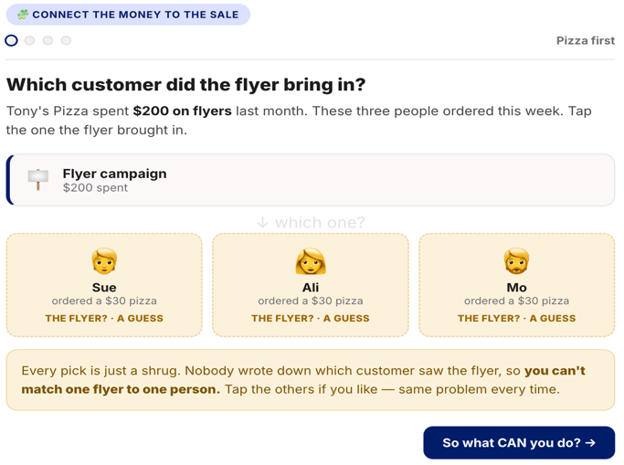
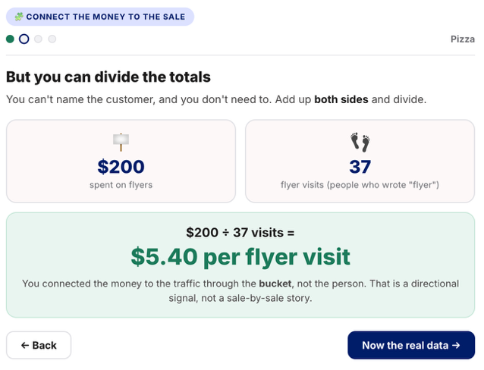

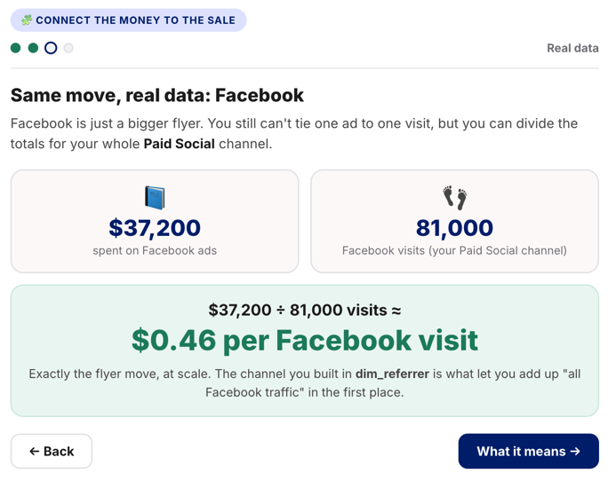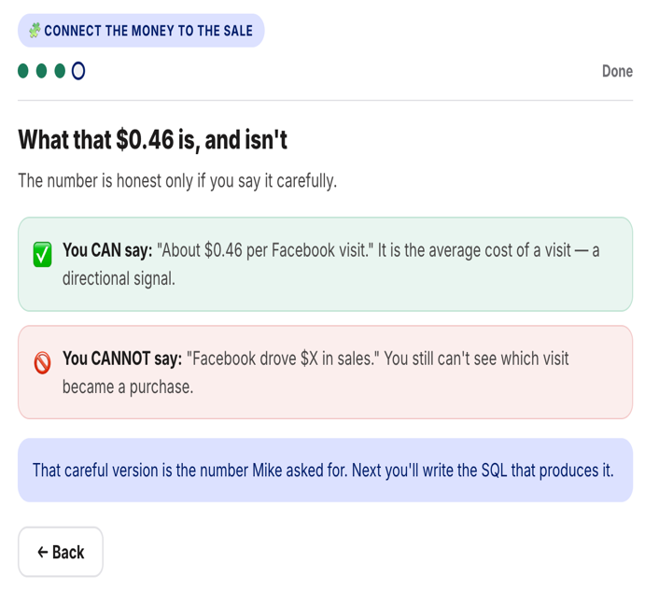

you can't tie one Facebook ad to one visit, but you can add up all the Facebook spend, add up all the Facebook traffic (your Paid Social channel from dim_referrer), and divide. The result is a directional signal — what a Facebook visit cost on average, not a sale-by-sale story. Here's the SQL that produces it.

What Will the SQL Query Look Like?
WITH fb_spend AS (
SELECT ROUND(SUM(spend_usd), 2) AS total_spend
FROM meta_campaigns
WHERE delivery_status IN ('active', 'inactive') -- ran at some point
),
fb_traffic AS (
SELECT
SUM(r.pageviews) AS pageviews,
SUM(r.checkout_sessions) AS checkouts
FROM referrals r
JOIN dim_referrer dr ON COALESCE(NULLIF(r.referrer, ''), 'direct') = dr.referrer
WHERE dr.channel = 'Paid Social'
)
SELECT
fs.total_spend,
ft.pageviews,
ft.checkouts,
ROUND(fs.total_spend / NULLIF(ft.pageviews, 0), 4) AS cost_per_pageview,
ROUND(fs.total_spend / NULLIF(ft.checkouts, 0), 2) AS cost_per_checkout_session
FROM fb_spend fs, fb_traffic ft;

In plain words, the query does three things:
- Adds up all the Facebook ad spend (the fb_spend part).
- Adds up all the Facebook traffic — pageviews and checkouts — by matching referrals to your Paid Social channel (the fb_traffic part).
- Divides spend by traffic to get cost per pageview and cost per checkout.

total_spend | pageviews | checkouts | cost_per_pageview | cost_per_checkout_session
37200.94 | 90978 | 113 | 0.4089 | 329.21
Roughly $0.41 per Paid Social pageview, and $329 per checkout session that came from a paid social visit. You still cannot say "$329 per acquired customer" — you don't know which of those checkouts were completed. You cannot say "Facebook drove $X in sales" — there's no link between a visit and a purchase. Directional, never causal.

Which Products Got the Facebook Traffic?
The last query looked at Facebook as a whole. This one zooms in: which individual products got the Facebook traffic, and did they actually sell?
if a product is near the top for Facebook visits but near the bottom for units sold, that's a real signal worth chasing.

SELECT
dp.product_title,
COALESCE(SUM(CASE WHEN dr.channel = 'Paid Social' THEN r.pageviews END), 0) AS fb_pageviews,
COALESCE(ss.net_items_sold, 0) AS units_sold,
COALESCE(ROUND(ss.total_sales, 2), 0) AS revenue
FROM dim_product dp
LEFT JOIN referrals r ON r.landing_page LIKE '%' || dp.product_slug || '%'
LEFT JOIN dim_referrer dr ON COALESCE(NULLIF(r.referrer, ''), 'direct') = dr.referrer
LEFT JOIN shopify_sales ss ON ss.product_id = dp.product_id
GROUP BY dp.product_id, dp.product_title, ss.net_items_sold, ss.total_sales
HAVING fb_pageviews > 100
ORDER BY fb_pageviews DESC
LIMIT 15;

Tip: "When you find a product with high Facebook traffic and low sales, screenshot the product page and the ad creative side by side. Half the time, the disconnect is obvious: the ad shows the Legendary edition; the page sells the Standard. The fix is a click."
- The per-product view surfaces ad/page mismatch: high traffic + low conversion = something to investigate

Marketing Channel Breakdown
In Design Your Channel Taxonomy, you built dim_referrer, your own set of labels for where traffic comes from. In Connecting Referrals to Campaigns, you learned how to tie ad spend to the traffic each channel brings in. Now you roll both of those into one summary table, a single row per channel that shows its pageviews, checkouts, conversion rate, and cost. That one table is what Mike reads first in his Q4 budget review, because it shows at a glance which channels earn more ad money and which don't.

Follow the Steps Below
Step 1 — Build the Channel Table
Write a query that produces one row per channel with:
Column | Description
channel | From dim_referrer.channel
pageviews | Sum of referrals.pageviews for this channel
checkouts | Sum of referrals.checkout_sessions for this channel
conversion_rate | checkouts / pageviews
spend_usd | For paid channels in your taxonomy (whatever you called your paid social bucket): sum of meta_campaigns.spend_usd. NULL for organic / owned channels.
cost_per_pageview | spend_usd / pageviews (paid channels only)

WITH meta_spend AS (
SELECT ROUND(SUM(spend_usd), 2) AS total_spend
FROM meta_campaigns
)
SELECT
dr.channel,
SUM(r.pageviews) AS pageviews,
SUM(r.checkout_sessions) AS checkouts,
ROUND(100.0 * SUM(r.checkout_sessions) / NULLIF(SUM(r.pageviews), 0), 3) AS checkout_rate_pct,
CASE
WHEN dr.channel = 'Paid Social' THEN (SELECT total_spend FROM meta_spend)
WHEN dr.channel = 'Other' THEN NULL -- holds Google ad networks; spend exists but isn't visible
ELSE 0 -- verified no ad spend
END AS spend_usd,
CASE
WHEN dr.channel = 'Paid Social'
THEN ROUND((SELECT total_spend FROM meta_spend) * 1.0 / NULLIF(SUM(r.pageviews), 0), 4)
ELSE NULL
END AS cost_per_pageview
FROM referrals r
JOIN dim_referrer dr
ON COALESCE(NULLIF(r.referrer, ''), 'direct') = dr.referrer
GROUP BY dr.channel
ORDER BY pageviews DESC;

channel | pageviews | checkouts | checkout_rate_pct | spend_usd | cost_per_pageview
Direct | 153759 | 360 | 0.234 | 0
Paid Social | 90978 | 113 | 0.124 | 37200.94 | 0.4089
Organic Search | 80565 | 384 | 0.477 | 0
Community | 3836 | 9 | 0.235 | 0
Other | 2573 | 12 | 0.466
Email | 1839 | 9 | 0.489 | 0

Step 2 — Rank Channels by Checkout Efficiency
The first table lines every channel up side by side, but a big channel like Facebook can bury a small one that converts far better. This second query ranks channels by how efficiently their pageviews turn into checkout sessions, so a small-but-high-converting channel like BoardGameGeek shows up on its own instead of hiding behind Facebook's larger, lower-converting traffic.

The query below returns, per channel, the share of pageviews that became checkout sessions, sorted highest first:

SELECT
dr.channel,
SUM(r.pageviews) AS pageviews,
SUM(r.checkout_sessions) AS checkouts,
ROUND(100.0 * SUM(r.checkout_sessions) / NULLIF(SUM(r.pageviews), 0), 3) AS conv_pct
FROM referrals r
JOIN dim_referrer dr ON COALESCE(NULLIF(r.referrer, ''), 'direct') = dr.referrer
GROUP BY dr.channel
HAVING SUM(r.pageviews) > 100
ORDER BY conv_pct DESC;

channel | pageviews | checkouts | conv_pct
Email | 1839 | 9 | 0.489
Organic Search | 80565 | 384 | 0.477
Other | 2573 | 12 | 0.466
Community | 3836 | 9 | 0.235
Direct | 153759 | 360 | 0.234
Paid Social | 90978 | 113 | 0.124

Paid Social ranks last at 0.124%. It carries the second-highest traffic volume in the catalog — 90,978 pageviews — but converts at roughly a quarter of Organic Search's rate. Organic Search produced 384 checkout sessions from 80,565 pageviews at no ad cost, while Paid Social produced 113 from more traffic and $37,200.94 in spend.
Email shows the highest rate at 0.489%, but on only 9 checkouts — a single session shifts it several positions, so it should be treated as a signal to investigate rather than a result. The same caution applies to Community (9 checkouts) and Other, which is a residual bucket rather than an actionable channel.
The reliable comparison is Organic Search against Paid Social. Both carry enough volume to trust, and the gap between them is the central finding: the store's paid traffic is its least efficient traffic.

Step 3: The ROI Story
Objective
Learn the marketing math (CTR, CPC, ROI) and apply it to every Meta campaign. By the end, you'll have a Q4 ad allocation plan: what to keep running, what to cut, where new dollars should go.

How to Tell if an Ad Worked: CTR, CPC, ROI
You just built the channel breakdown — the big picture of where traffic and money go across all your channels. Now you zoom in on the ads themselves. To judge a single campaign, you lean on three numbers: CTR, CPC, and ROI. Knowing which one to use when is the difference between a recommendation that lands and one that gets picked apart.

The channel breakdown tells where the money goes, and Facebook is the biggest paid channel. Now we go one level deeper: which Facebook ads actually earned that spot. He pulls you over to his screen, where the Meta dashboard is open. It's a wall of columns like CTR, CPC, CPM, ROAS, frequency, and reach.
the three numbers that actually tell you whether an ad worked, and why most of the others on his screen can mislead you.

The Three Most Important Marketing Metrics
Three numbers do most of the work when you judge an ad:
CTR (is it grabbing attention?),
CPC (what does each visitor cost?), and
ROI (did it actually make money?).
The interactive below walks all three on a single pizza flyer, so the formulas are concrete before you meet the real data.

CTR · Click-Through Rate
CTR measures how well the ad grabs attention. Higher is better.
CTR = walk-ins ÷ views

CPC · Cost Per Click
CPC measures how expensive each visitor is. Lower is better.
CPC = spend ÷ walk-ins

ROI · Return on Investment
ROI measures whether the ad actually made money.
ROI = (money back − money spent)

A high CTR can still lose money — Tony's flyer grabbed attention but didn't pay off. That's why you read all three. For Breaking Games, CTR and CPC are already computed in meta_campaigns. ROI is the hard one, because you can't see which sale came from which ad.

Here's the same thing as a cheat sheet, plus one bonus metric (CPM) you'll occasionally see:
Metric | Formula | What it tells you
CTR (Click-Through Rate) | link_clicks / impressions | How compelling the ad creative is. Higher = more relevant to the audience.
CPC (Cost Per Click) | spend_usd / link_clicks | What you're paying for each visitor. Lower = better efficiency.
ROI / ROAS | (revenue - spend) / spend (ROI) or revenue / spend (ROAS) | The big-picture efficiency. Hardest to compute honestly without true attribution.
CPM (Cost Per Mille / 1000 impressions) — bonus, occasional | spend_usd * 1000 / impressions | What you're paying to be seen. Useful when comparing across audience sizes.

How to Find CTR and CPC with a SQL Query
Both CTR and CPC are already sitting in your meta_campaigns table (ctr_link and cpc_usd). Meta computed them for you, so you don't calculate them by hand — you just read them.

SELECT
campaign_name,
spend_usd,
impressions,
link_clicks,
ROUND(ctr_link * 100, 3) AS ctr_pct,
ROUND(cpc_usd, 2) AS cpc_usd
FROM meta_campaigns
WHERE link_clicks > 0
ORDER BY ctr_link DESC
LIMIT 10;

In plain words: this pulls the 10 campaigns with the highest CTR, and for each one shows what you spent, how many people saw it (impressions), how many clicked (link_clicks), the CTR as a percent, and the cost per click. It's a fast way to eyeball which ads got the most attention and what each click cost.
One thing to remember: the ctr_link column stores CTR as a decimal, not a percentage. For example, a value of 0.005 means 0.5%. To display CTR as a percentage in your report, multiply it by 100. So, 0.005 × 100 = 0.5%.
Reading CTR Numbers
On its own, a CTR number doesn't tell you whether an ad did well. Is 0.8% good? You can't say until you know what's normal for this kind of store. For tabletop and hobby e-commerce on Meta, here are the rough goalposts:
- Below 0.5% CTR: weak. The ad isn't resonating.
- 0.5–1.5% CTR: average. Acceptable but not exciting.
- Above 1.5% CTR: strong. Worth scaling up.
- Above 3% CTR: exceptional. Investigate what's working and replicate.
Treat these as a guide, not gospel. Your audience and price points move the numbers.

Reading CPC Numbers
Industry CPC for tabletop/specialty product on Meta tends to land in the $0.50–$2.00 range. Outside that band, look closer:
- Below $0.50: very cheap. Either you're reaching a low-intent audience (likely won't convert), or you've found a real bargain.
- $0.50–$2.00: normal range.
- Above $2.00: expensive. Could be a niche, high-quality audience, or could be wasted spend.
Pair CPC with conversion rate. Cheap clicks that don't convert are worse than expensive clicks that do.

ROI: Did the Ad Money Come Back?
CTR and CPC are about clicks. ROI asks the bigger question: for every dollar you spent on ads, how many came back?
- ROAS (Return on Ad Spend) = revenue ÷ spend.
  - "$1.60 back for every $1 spent" is a ROAS of 1.6.
- ROI = (revenue − spend) ÷ spend.
  - The same idea, written as a gain or loss percent.

The catch — you've hit it before. To compute ROI honestly, you'd need to know which sales came from which ad. Breaking Games' data can't tell you that. It's the same attribution wall from the start of this Step, so you can't report a true ROI.

What you can report is a directional version: over the period the ads ran, how did sales track against spend? Label it clearly as an estimate and state the assumption behind it. For example:
"Breaking Games spent $37K on Meta ads while total sales were $61K in the same period. If we generously credit Facebook with 30% of those sales, that's about $18K back on $37K spent — a rough ROI of roughly −50%. The real number depends on that attribution assumption."
It's a mouthful, but it's honest and it holds up. That's the version a senior analyst would actually put in front of Mike.

- CTR (engagement) and CPC (efficiency) are both pre-computed in meta_campaigns; use them directly
- Tabletop CTR benchmark: 0.5–1.5% is average; above 1.5% is strong
- ROI in this dataset is directional; always name the attribution assumption behind it

Which Campaigns Worked, Which Didn't
You just learned the three numbers that tell you whether an ad worked. Now you point them at all 35 of Breaking Games' Meta campaigns and turn them into a ranked list: which to keep, which to cut, and a reason next to each. This module is the set of queries that gets you there, and how to read what each rank is telling you.

this module teaches you a small set of SQL queries. Three of them rank all 35 campaigns three different ways — cheapest per result, most engaging, and highest volume — and a fourth surfaces the campaigns to cut. Learn those four, and you'll have the keep/cut list Mike needs, with a reason behind every call.

The Right Ranking Question
"Which campaign worked best?" is a trick question. Worked best by what measure? You need to look at three angles:
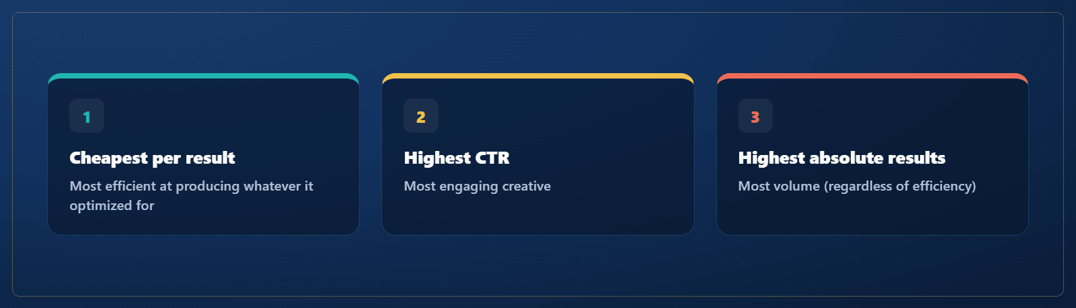

A campaign at the top of one list may be at the bottom of another. Both signals matter.
Now that you know what you're ranking for, look at the SQL that produces each list. The first three queries cover the three angles above; the fourth surfaces the campaigns to cut.

Most Efficient (Lowest Cost Per Result)
SELECT
campaign_name,
delivery_status,
spend_usd,
results,
ROUND(cost_per_result, 2) AS cost_per_result_usd
FROM meta_campaigns
WHERE results IS NOT NULL AND results > 0
AND delivery_status IN ('active', 'inactive')
ORDER BY cost_per_result ASC
LIMIT 10;

This surfaces the campaigns that drove conversions the cheapest. Keep running these at minimum; maybe scale them up.

campaign_name | delivery_status | spend_usd | results | cost_per_result_usd
*DA | Traffic TOF | active | 8634.89 | 39419.0 | 0.22
DA | MAT Test | Dwellings | Traffic - LPV | inactive | 4344.57 | 17753.0 | 0.24
DA | MAT Test | We're Doomed | Traffic - LPV | inactive | 1386.31 | 3540.0 | 0.39
DA | Reach | Retargeting | active | 1612.34 | 1208484.0 | 1.33
DA | Sales | ATC | inactive | 1441.94 | 291.0 | 4.96
* DA | Sales | Advantage Plus Campaign | active | 6863.81 | 97.0 | 70.76

Highest CTR (Most Engaging)
SELECT
campaign_name,
impressions,
link_clicks,
ROUND(ctr_link * 100, 3) AS ctr_pct,
spend_usd
FROM meta_campaigns
WHERE impressions > 1000 -- exclude noise from low-volume campaigns
AND ctr_link IS NOT NULL
ORDER BY ctr_link DESC
LIMIT 10;

High-CTR campaigns have strong creative. Even if they didn't convert at a high rate, the ad itself is doing its job. The creative is reusable in other campaigns.

campaign_name | impressions | link_clicks | ctr_pct | spend_usd
DA | Sales | ATC | 62944 | 1578.0 | 250.699 | 1441.94
DA | MAT Test | Dwellings | Traffic - LPV | 1079628 | 18936.0 | 175.394 | 4344.57
*DA | Traffic TOF | 2944482 | 41343.0 | 140.408 | 8634.89
* DA | Sales | Advantage Plus Campaign | 452387 | 4507.0 | 99.627 | 6863.81
DA | Sales | 1019145 | 8592.0 | 84.306 | 12917.08
DA | MAT Test | We're Doomed | Traffic - LPV | 498759 | 3880.0 | 77.793 | 1386.31
DA | Reach | Retargeting | 1518347 | 1481.0 | 9.754 | 1612.34

Highest Volume (Most Results)
SELECT
campaign_name,
spend_usd,
results,
ROUND(cost_per_result, 2) AS cost_per_result_usd
FROM meta_campaigns
WHERE results IS NOT NULL AND results > 0
ORDER BY results DESC
LIMIT 10;

These are the workhorses. They may not be the cheapest per result, but they produce the most overall.

campaign_name | spend_usd | results | cost_per_result_usd
DA | Reach | Retargeting | 1612.34 | 1208484.0 | 1.33
*DA | Traffic TOF | 8634.89 | 39419.0 | 0.22
DA | MAT Test | Dwellings | Traffic - LPV | 4344.57 | 17753.0 | 0.24
DA | MAT Test | We're Doomed | Traffic - LPV | 1386.31 | 3540.0 | 0.39
DA | Sales | ATC | 1441.94 | 291.0 | 4.96
* DA | Sales | Advantage Plus Campaign | 6863.81 | 97.0 | 70.76

The Bottom (Campaigns to Cut)
SELECT
campaign_name,
delivery_status,
spend_usd,
impressions,
link_clicks,
results,
ROUND(cost_per_result, 2) AS cost_per_result_usd
FROM meta_campaigns
WHERE spend_usd > 100 -- ignore campaigns that barely ran
AND (
(results IS NULL OR results = 0) -- no conversions
OR (cost_per_result > 100) -- absurdly expensive
OR (ctr_link < 0.001 AND impressions > 10000) -- weak CTR at scale
)
ORDER BY spend_usd DESC;

campaign_name | delivery_status | spend_usd | impressions | link_clicks | results | cost_per_result_usd
DA | Sales | active | 12917.08 | 1019145 | 8592.0

These are the candidates to cut from the Q4 plan. They spent meaningful money for poor outcomes. (Sanity check: review each before committing, because there may be a brand-awareness reason or a paused-mid-launch context Mike will surface.)

A Crucial Caveat: Awareness vs Conversion Objectives
Some campaigns were optimized for awareness (reach, impressions, video views) rather than conversions. They won't have meaningful results numbers, but that doesn't mean they failed. They may have been doing the job they were set to do.

Check result_indicator to see what each campaign was optimizing for. Don't penalize a brand-awareness campaign for not producing purchases.

SELECT
result_indicator,
COUNT(*) AS n_campaigns,
ROUND(SUM(spend_usd), 2) AS total_spend
FROM meta_campaigns
GROUP BY result_indicator;

result_indicator | n_campaigns | total_spend
 | 29 | 12917.08
actions:landing_page_view | 3 | 14365.77
actions:offsite_conversion.fb_pixel_add_to_cart | 1 | 1441.94
actions:offsite_conversion.fb_pixel_purchase | 1 | 6863.81
reach | 1 | 1612.34

This query groups every campaign by what it was optimizing for (its result_indicator) and shows how many campaigns and how much money sit under each objective. It lets you see at a glance how much of the $37K went to awareness campaigns versus conversion campaigns, before you judge any single one.

Tip: "If a campaign's name has 'Awareness' or 'Reach' in it, don't grade it on cost-per-purchase. Grade it on CPM or reach. The recommendation should respect what the campaign was actually trying to do."

- Rank campaigns three ways: efficiency (cost per result), engagement (CTR), volume (total results)
- The bottom is campaigns that spent money but produced no results, very expensive results, or weak CTR at scale
- Always check the campaign's objective (result_indicator) before grading. Don't penalize awareness campaigns for not converting

Build the Q4 Ad Allocation Plan
Over the past few months, Breaking Games spent about $37,000 on Facebook ads, not on one ad, but on 35 different campaigns. Some of them worked well and brought in buyers cheaply. Others ate money and brought in almost no one. Nobody has gone through them one by one to sort the winners from the losers yet.

What You'll Hand In now says what each pile means and does, not just its name:
- Keep: the ads that worked… Leave them running, and maybe spend a little more on the very best ones.
- Cut: … Turn them off. Every ad you turn off hands money back to spend somewhere better.
- New idea: where that freed-up money should go instead. This one is your judgment call…
…then explains how each pick is backed (one number + one sentence) and what the closing math is (cut money = new-idea money).

The roughly $37K Meta budget gets re-allocated based on what you write here

Sample plan :
https://docs.google.com/document/d/1qQUFZfrD37rCKxJqx9Mtrtk2eB9hRadCP4xafEngvKQ/edit?tab=t.0
Step 1 — Know Your Three Buckets
Every campaign you look at goes into one of three piles:
- ✅ Keep running — campaigns that worked (cheap per result, or strong CTR). You can suggest scaling the best ones up.
- ✂️ Cut or pause — campaigns that spent money without much to show. Cutting these frees up budget.
- 💡 New idea — where that freed budget should go: a channel or campaign that isn't running yet.
That's the whole plan in one line: keep what works, cut what doesn't, and move the freed money somewhere better.

https://docs.google.com/document/d/1lI83DNKisbjvyXGcQcUohNmCjuipnqsZFEre-R5vcQM/edit?tab=t.0

