PROJECT 4 – Investigating Breaking Games’ cart Abandonment
Over 1,000 unfinished checkout sessions sit in Breaking Games' export. That's real money walking away. But some of those "customers" are clearly bots. Across 4 Steps spanning 2 weeks, you'll generate hypotheses about why customers (and bots) abandon, learn pattern detection, design a clean_checkouts view that filters noise from every future query, and recalculate the real abandonment rate. By the end of the project, you'll deliver a diagnosis report that separates signal from noise, plus recommendations the team can fix before the holiday rush.

Step 1: The Abandonment Mystery
Understand what cart abandonment means, what fields the checkout table holds, and what real money is walking away. Brainstorm hypotheses with Claude before testing them with SQL.

The Scenario
1,062 unfinished checkout sessions sit in Breaking Games' export. Only 93 orders were completed in July. Run the naive math and you get a 91% abandonment rate — far above industry norms, and worth investigating. But that number hides two problems: the checkout file reaches back years further than you'd guess, and not every "checkout" in it is a real customer. Some carts behave in ways that suggest bots, fraud, or test traffic. Before Breaking Games can fix the abandonment problem, you need to separate signal from noise.
This Project is detective work. You'll surface the patterns behind abandonment, identify probable bot activity, design a clean_checkouts view that hides the noise from every future query, and recalculate the real abandonment rate.
By the end of this Project, you'll have:
- A written list of bot-detection rules: clear signs that tell a real shopper from a bot or test order
- A clean_checkouts view: a saved filter that removes bad checkouts from every query you run after this
- A real abandonment rate: the honest number once bots are removed, and how it compares to the raw one

Career note: "Find anomalies in user behavior data" is the actual pattern behind fraud detection, content moderation, and product analytics. The skills you build in this Project (defining heuristics, validating them, building views) transfer directly to a wide range of analytics and data science roles.

What Cart Abandonment Actually Is
"Cart abandonment" is one of those terms thrown around without precision. Before you measure it for Breaking Games, you should understand exactly what it does and doesn't capture, and why the industry's favorite benchmark (70%) isn't really comparable across stores.

Cart Abandonment Rate = [1 - (Completed Purchases / Total Carts Created)] x 100

Total carts created or started
In SQL terms, for Breaking Games:
SELECT
(SELECT COUNT(DISTINCT name) FROM shopify_checkouts) AS carts_started,
(SELECT COUNT(DISTINCT order_name) FROM shopify_orders) AS completed_orders,
ROUND(100.0 * (1 -
(SELECT COUNT(DISTINCT order_name) FROM shopify_orders) * 1.0 /
(SELECT COUNT(DISTINCT name) FROM shopify_checkouts)
), 1) AS abandonment_pct;

The raw answer for Breaking Games' data: roughly 91% abandonment.
carts_started | completed_orders | abandonment_pct
1062 | 93 | 91.2

Why 91% Is Misleading
Three reasons that number is suspicious:
- shopify_orders only covers July 2025. shopify_checkouts reaches all the way back to October 2016 — more than half its carts predate 2025. You're comparing nine years of carts to one month of orders. The real rate is unknowable until you match the windows.
- "Carts started" includes bots. Every unfinished checkout back to 2016 is in the data, including suspicious ones with 12 items in a single line. Real customers don't behave that way.
- "Completed" isn't even in this table. Check financial_status: it's blank on every row. This export only contains carts that never finished — completions live in shopify_orders, a different file on a different clock. Any completion math needs both tables and a matched window.
These three together mean the 91% headline number is directionally interesting but not precise. The work in this Project is to make it more precise.

What the Industry Says About Benchmarks
Baymard's research, the most-cited cart abandonment study, reports around 70% average abandonment across e-commerce. Some caveats:
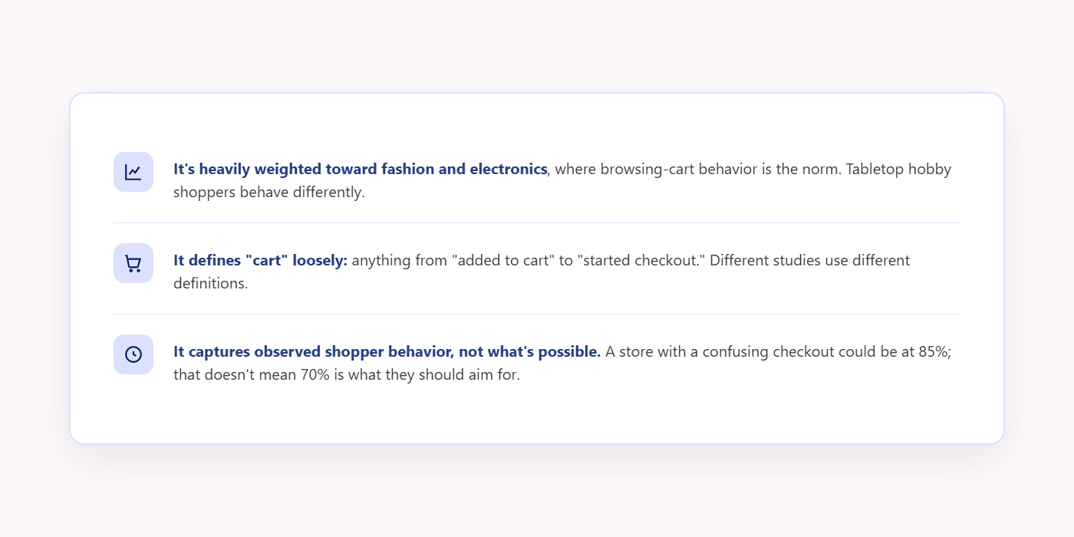
Use industry benchmarks for context, not as a target. Your goal is to understand why people abandoned and what's fixable.

The Reasons People Actually Abandon
A reasonable set of hypotheses for Breaking Games, ranked roughly by likelihood:
https://smitabudhiaextern.github.io/extern-html-pages/substep-4.1.2-reasons-people-abandon.html
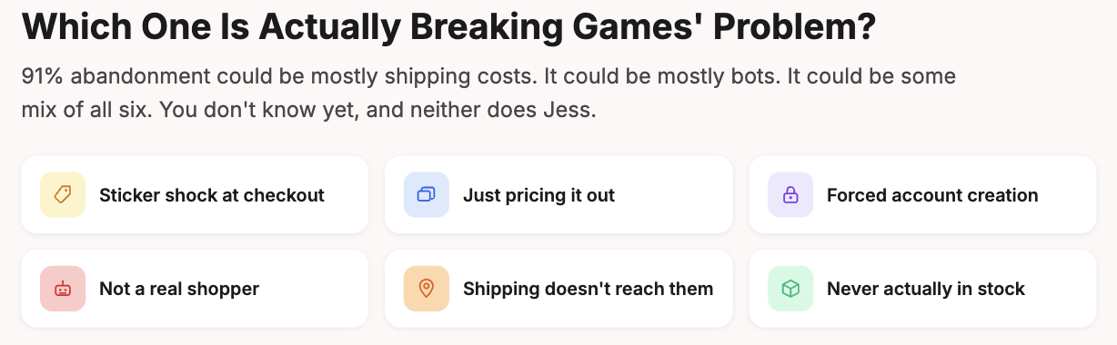

Quick Recap
- Raw abandonment math says 91%, but the checkout file spans 2016–2025 while orders cover only July 2025 — the comparison is badly uneven
- Industry benchmarks (70%) are context, not targets; different shoppers behave differently
- Hypothesize before measuring: shipping cost, comparison shopping, bots, geography, friction

Anatomy of the Checkout Table
shopify_checkouts has 32 columns. Most of them you don't need. A handful are gold for the abandonment investigation. This module is the field guide.

shopify_checkouts.csv is the record of every checkout session Breaking Games' store has ever started, whether or not it turned into a sale. Each row logs one product from one shopper's cart: what they were buying, how much it cost, where they were shipping to, and when they started checking out. It's the rawest, most complete record you have of who almost bought something.

One cart can span several rows. Cart #44044248383535, for example, shows up as two rows: one for a copy of Trellis, another for two copies of MIXTAPE. Both rows share the same cart ID — they're the same checkout — but each row is really just one product.

That's why COUNT(*) gives you 1,367 but COUNT(DISTINCT name) gives you 1,062. The first counts line items; the second counts unique carts.
https://smitabudhiaextern.github.io/extern-html-pages/checkout-table-columns-reference.html

The pattern that matters: only name, email, customer_id, customer_name, created_at, vendor, and every lineitem_* field repeat on every row of a cart. Everything else — total, subtotal, shipping, geography, discounts, and the rest — populates once, on the first line item, then goes blank. Deduplicate on name before you aggregate any of the other fields.

A Quick Orientation Query
Before you test any specific hypothesis, it helps to see the shape of the whole dataset first: how many carts, how many customers, how the numbers spread out.

SELECT
COUNT(DISTINCT name) AS unique_carts,
COUNT(*) AS line_items,
COUNT(DISTINCT email) AS unique_emails,
ROUND(AVG(lineitem_quantity), 2) AS avg_qty_per_line,
MAX(lineitem_quantity) AS max_qty,
COUNT(DISTINCT billing_country) AS countries
FROM shopify_checkouts;
unique_carts | line_items | unique_emails | avg_qty_per_line | max_qty | countries
1062 | 1367 | 1049 | 1.5 | 12 | 51

SELECT name, MAX(total) AS cart_total FROM shopify_checkouts GROUP BY name;

- One row per line item; name is the cart identifier; count distinct names for "carts"
- Useful columns for abandonment: financial_status, shipping, lineitem_quantity, created_at, geography

Step 2: Finding Real Patterns
you understand Shopify checkout, it's time for you to do some analysis, just to understand what kind of analysis is required.
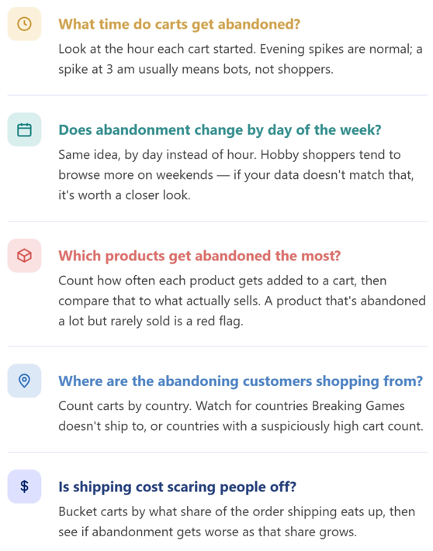

Time-of-Day Patterns
created_at records the exact moment a checkout started, down to the second (for example, 2025-07-29 08:20:35 -0400). But we don't need that much detail. We just want to know: was it 8 AM? 2 PM? So we're going to zoom out and grab only the hour.”

SELECT
substr(created_at, 12, 2) AS hour_of_day,
COUNT(DISTINCT name) AS carts_started
FROM shopify_checkouts
GROUP BY hour_of_day
ORDER BY hour_of_day;

hour_of_day | carts_started
00 | 34
01 | 18
02 | 15
03 | 32
04 | 31
05 | 27
06 | 28
07 | 35
08 | 41
09 | 38
10 | 62
11 | 60
12 | 78
13 | 78
14 | 40
15 | 45
16 | 53
17 | 46
18 | 47
19 | 61
20 | 47
21 | 46
22 | 55
23 | 45

Look at the shape. Most real e-commerce traffic peaks in the evening (US time). If you see spikes at 3 am or even distribution across all hours, that's not normal customer behavior. That's bots or automated traffic.

Hour of day is one signal. Day of week is another. Let's check that next.

Day-of-Week Patterns
Same idea as before, but instead of pulling out the hour, this query pulls out the day of the week. SQLite doesn't have a simple "day name" built in, so the query uses strftime('%w', ...) to get a number for the day (0 for Sunday, 1 for Monday, and so on), then a CASE statement turns that number into a readable name like "Mon" or "Fri".

SELECT
CASE strftime('%w', substr(created_at, 1, 10))
WHEN '0' THEN 'Sun'
WHEN '1' THEN 'Mon'
WHEN '2' THEN 'Tue'
WHEN '3' THEN 'Wed'
WHEN '4' THEN 'Thu'
WHEN '5' THEN 'Fri'
WHEN '6' THEN 'Sat'
END AS day_of_week,
COUNT(DISTINCT name) AS carts
FROM shopify_checkouts
GROUP BY day_of_week
ORDER BY strftime('%w', substr(created_at, 1, 10));

day_of_week | carts
Sun | 134
Mon | 157
Tue | 158
Wed | 167
Thu | 177
Fri | 143
Sat | 126

Per-Product Abandonment
Which products are getting added to carts the most? Use line-item-level data (since we want product names). Imagine a receipt. The order is the whole receipt. Each line item is one line on that receipt — one product. If we want to know which products are popular, we need to look at those individual lines, not just the receipt total.

SELECT
lineitem_name,
COUNT(DISTINCT name) AS carts_containing,
SUM(lineitem_quantity) AS total_units_added
FROM shopify_checkouts
WHERE lineitem_name IS NOT NULL
GROUP BY lineitem_name
ORDER BY carts_containing DESC
LIMIT 20;

lineitem_name | carts_containing | total_units_added
Secret Hitler | 78 | 90
We're Doomed! | 64 | 97
Sparkle*Kitty | Family-Friendly Pattern Recognition Card Games | 3-8 Players | 63 | 63
Dwellings of Eldervale: MINOTAUR MINIATURE | 45 | 45
Sparkle*Kitty Princess Palette Card | 43 | 43
Dwellings of Eldervale - Oracle Hex Tile | 42 | 43
Dwellings of Eldervale - LEGENDARY Upgrade Kit | 42 | 43
Dwellings of Eldervale: ALL EDITIONS - Legendary - $199.99 | 39 | 39
Inhuman Conditions | 36 | 37
MIXTAPE | 32 | 65
Klask | 32 | 41
Dwellings of Eldervale - MINOTAUR MINIATURE | 27 | 30
Dwellings of Eldervale 2nd Edition: Standard | 24 | 35
Dwellings of Eldervale: ALL EDITIONS - Deluxe - $149.99 | 23 | 23
Dwellings of Eldervale - Wooden Upgrade Treasure and Trove Tokens | 22 | 22
Dwellings of Eldervale - Shapeshifter Mercenary Mini Expansion | 21 | 21
Rise of Tribes: The Mesa Hex Tile (Base Game Required) | 20 | 20
Poop: Brown Bag Combo | Family Friendly Card Game | 2-10 Players | 20 | 55
Dwellings of Eldervale: ALL EDITIONS - Legendary | 20 | 20
Rise of Tribes - Deluxe Upgrade (Base Game Required) | 19 | 44

Geography
Location can explain a lot of otherwise-confusing abandonment. A customer in a country Breaking Games doesn't ship to was never going to complete the order, no matter how good the checkout experience is.

SELECT
billing_country,
COUNT(DISTINCT name) AS carts
FROM shopify_checkouts
GROUP BY billing_country
ORDER BY carts DESC
LIMIT 15;

billing_country | carts
US | 530
 | 450
CA | 48
DE | 28
GB | 26
MX | 16
AU | 16
CH | 12
FR | 11
ES | 10
DK | 7
SE | 5
NL | 5
PL | 4
NZ | 4

Watch for:
- Countries Breaking Games doesn't ship to (auto-abandonment)
- Countries with disproportionately high cart counts but small population (could be bot farms)
- The US-vs-international split (helps with shipping cost analysis)

Geography raises a related question: even for customers you do ship to, is the shipping bill itself the problem?

Shipping Cost as a Driver
A reasonable hypothesis: high shipping cost → abandonment. We think expensive shipping might scare people away. But '$10 shipping' means different things on a cheap order vs an expensive one. So instead of looking at the dollar amount, we look at shipping as a percentage of the order — then group those percentages into buckets like 'low,' 'medium,' 'high' and see if abandonment goes up as the bucket gets more expensive.

SELECT
CASE
WHEN shipping = 0 THEN '0 (free)'
WHEN shipping / NULLIF(subtotal, 0) < 0.10 THEN '1: <10%'
WHEN shipping / NULLIF(subtotal, 0) < 0.25 THEN '2: 10-25%'
WHEN shipping / NULLIF(subtotal, 0) < 0.50 THEN '3: 25-50%'
ELSE '4: >50%'
END AS shipping_ratio_bucket,
COUNT(DISTINCT name) AS carts
FROM shopify_checkouts
WHERE subtotal > 0
GROUP BY shipping_ratio_bucket
ORDER BY shipping_ratio_bucket;

shipping_ratio_bucket | carts
0 (free) | 412
1: <10% | 88
2: 10-25% | 119
3: 25-50% | 221
4: >50% | 222

Quick Recap
- GROUP BY isn't just for revenue; it's how you find behavioral patterns (time, day, product, geography, shipping)
- Look at the shape of distributions, not just top/bottom rows
- Anomalies in time-of-day or day-of-week distribution are a strong bot signal

The "Doesn't Add Up" Reflex
how to spot when something in the data doesn't add up, and how to tell a real problem from a false alarm.

https://smitabudhiaextern.github.io/extern-html-pages/pattern-detection-5-queries.html

Pattern 1
Real e-commerce traffic has clear daily and weekly rhythms: busy at lunch, busy in the evening, quiet overnight. On Breaking Games' real data this looks healthy: carts peak around lunchtime and evening, and go quiet overnight. That's the pattern you want to see: one class of automation ruled out.

Pattern 2
The same email, too many times. A repeat customer is normal. A repeat customer with 30 carts and zero purchases is not.

--Repeat carts by email
SELECT
email,
COUNT(DISTINCT name) AS cart_count
FROM shopify_checkouts
WHERE email IS NOT NULL
GROUP BY email
HAVING cart_count > 5
ORDER BY cart_count DESC
LIMIT 20;

Comes back empty here: the busiest email in the export has 3 carts. A legitimate finding, not a broken query: you've just ruled out a whole class of bot behavior.

Pattern 3
Cart values that don't make sense. Carts with extreme lineitem_quantity (6+ of the same product) deserve a second look. Sometimes it's a real reseller; most of the time it's automation or test data.

SELECT
name, email, lineitem_name, lineitem_quantity, total
FROM shopify_checkouts
WHERE lineitem_quantity > 5
ORDER BY lineitem_quantity DESC;

This query returns 30 rows, topping out at the real max of 12: customer_1009@example.com's cart, two line items of "GAME of PHONES," both quantity 12. Notice total is blank on that cart's second line item: only the first line item of a multi-item cart carries the cart-level total.

Pattern 4
Carts that violate physical constraints. If a cart was created at 3:47:01 AM and another by the same email at 3:47:09 AM in a different country, that's not a human. A single email tied to multiple billing countries is almost always test data or fraud.

SELECT
email,
COUNT(DISTINCT billing_country) AS countries,
COUNT(DISTINCT name) AS carts
FROM shopify_checkouts
WHERE email IS NOT NULL
GROUP BY email
HAVING countries > 1
ORDER BY countries DESC;

This query comes back empty: no single email is tied to more than one billing country in this data. That's a legitimate finding, not a broken query, you've just ruled out a whole class of fraud/test-data behavior. Write it down and move on.

Pattern 5
Data older than the story it's tellingEvery table has a time range, and it rarely matches the question you're asking.

SELECT substr(created_at, 1, 4) AS year, COUNT(DISTINCT name) AS carts
FROM shopify_checkouts
GROUP BY year
ORDER BY year;
Confirmed on the real data: carts reach back to 2016, 2021 spikes to 272 carts, and 551 of the 1,062 total carts (52%) predate 2025. Any rate computed against this year's orders was never comparing like with like.

A reusable 3-step dig
Once you've confirmed a finding is real and material, dig deeper with sequential queries. Replace [pattern] with your condition, e.g. lineitem_quantity > 5.

Forensic 3-step template
-- Step 1: How widespread is the pattern?
SELECT COUNT(*) FROM shopify_checkouts WHERE [pattern];

-- Step 2: Who exhibits it?
SELECT email, COUNT(*) FROM shopify_checkouts WHERE [pattern]
GROUP BY email ORDER BY 2 DESC;

-- Step 3: What's the impact if we exclude it?
SELECT COUNT(DISTINCT name) FROM shopify_checkouts WHERE NOT [pattern];

Three queries, one pattern, a clear before-and-after.

