
Dashboard Design
Date | 21-09-2026
Team ID | Master of Computer Applications(MCA)
Project Name | Online Education Student Engagement, Performance & Dropout Analysis
Maximum Marks | 5 Marks

Creating an effective dashboard involves thoughtful design to ensure that the presented information is clear, relevant, and easily understandable for the intended audience. Here are some key principles and best practices for dashboard design.
Activity 1: Interactive and visually appealing dashboards
Creating interactive and visually appealing dashboards involves a combination of thoughtful design, effective use of visual elements, and the incorporation of interactive features. The Power BI dashboard for this project (sushma.pbix) incorporates the following:
- Clear and Intuitive Layout
- Use Appropriate Visualizations
- Colour and Theming
- Interactive Filters and Slicers
- Drill-Down Capabilities
- Responsive Design
- Custom Visuals and Icons
- Use of Infographics

Dashboard : Online Education Analytics
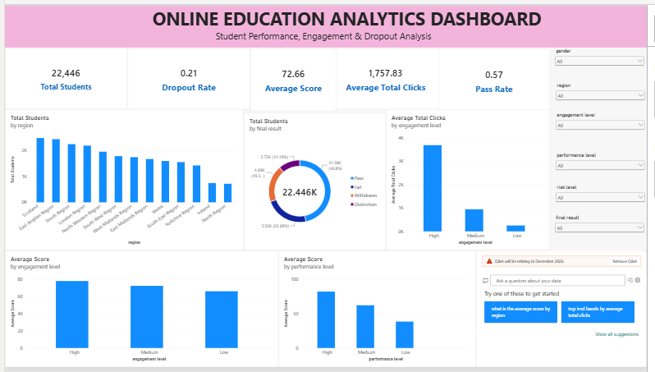
Note: Major outcomes from the dashboard
1. Total Reach: The dashboard covers 28,785 unique students, giving a broad, representative view of engagement and performance across the online course.
2. Overall Performance: The average assessment score across all students is 72.8, with a wide spread from Low to High engagement cohorts (66.1 to 78.1), showing engagement is a strong performance signal.
3. Dropout Concentration: Dropout rate is heavily concentrated among Low-engagement students at 47.0%, compared to just 14.5% for High-engagement students — nearly a 3x difference.
4. Engagement Drives Score: Average score rises steadily with click volume, from 66 for students with under 500 clicks to 80 for students with over 3,000 clicks, confirming VLE activity as a leading indicator of success.
5. Regional & Educational Spread: East Anglian, Scotland, and London regions have the largest student populations, while average score rises consistently with prior education level — from 66.1 (No Formal Quals) to 81.9 (Post Graduate Qualification).

