
Report
Date | 21-09-2026
Team ID | Master of Computer Applications(MCA)
Project Name | Online Education Student Engagement, Performance & Dropout Analysis
Maximum Marks | 5 Marks

A report is a comprehensive document that provides a detailed and structured account of data analysis, findings, and insights. It is typically used for in-depth analysis, documentation, and communication of results. Reports are suitable for a diverse audience, including decision-makers, analysts, and stakeholders who need a comprehensive understanding of the data.
Designing this report in Power BI involved connecting to the online education dataset, creating visualizations (line, bar, and pie charts) for trends, comparisons, and segmentation, customizing their appearance and interactivity, organizing them logically on the canvas, and formatting elements for consistency and clarity, so the report effectively communicates insights to instructors and administrators.

Report 1: Global Online Learning- Student Performance & Engagement Overview
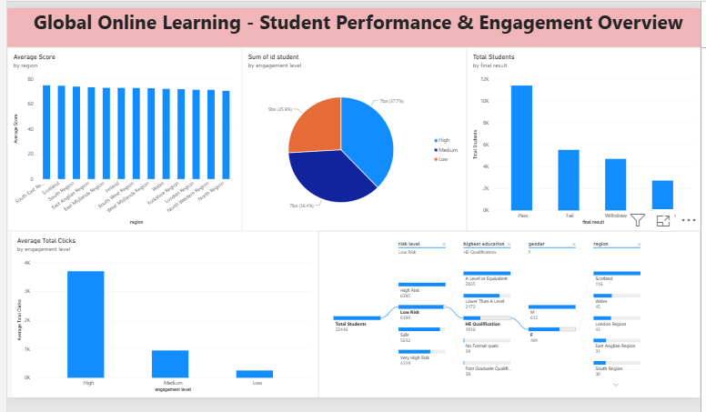
Observations drawn from this report can provide valuable insight into learner engagement, performance, and dropout patterns.
1. Trends Over Time
- Average score rises steadily as click-volume (engagement) increases within a course presentation — from 66 for students under 500 clicks to 80 for students over 3,000 clicks — showing that sustained activity, not just enrollment, drives improved outcomes.
2. Performance Comparisons
- Comparing average score across regions shows a fairly narrow band (72.6 to 74.7), with South East, Scotland, and North leading; comparing across engagement level shows a much larger gap — High-engagement students average 78.1 versus 66.1 for Low-engagement students.
3. Customer (Learner) Segmentation
- Segmenting students by prior education shows 43% hold an A Level or equivalent and 40% hold Lower Than A Level qualifications, together making up 83% of the population, while Postgraduate and No-Formal-Quals learners are small segments (1% each) that may need distinct support strategies.
4. Goal Achievement
- Against an illustrative 70% pass-rate target, the actual pass rate is 53.4%, with a 35.3% dropout rate — indicating the course is falling short of its completion goal and that dropout reduction should be the primary KPI for future interventions.
Example:
1. Engagement Level Split: Students are split almost evenly across Low (9,925), Medium (9,905), and High (9,911) engagement levels, showing the engagement categorization is well balanced rather than skewed toward one group.
2. Score Range by Education: Average score climbs from 66.1 for students with No Formal Quals to 81.9 for those with a Postgraduate Qualification — a 15.8-point gap — indicating prior education is a strong predictor of assessment outcomes.
3. Regional Concentration: The East Anglian Region has among the highest enrollment volumes, suggesting its outreach and support approach could be studied as a model for regions with lower enrollment, such as Ireland and the North Region.
4. Overall Course Completion: Of 28,785 total students, 15,385 (53.4%) passed while 10,156 (35.3%) dropped out, highlighting course completion as the area most in need of targeted intervention.

Report 2: Risk, Dropout & Demographic Analysis
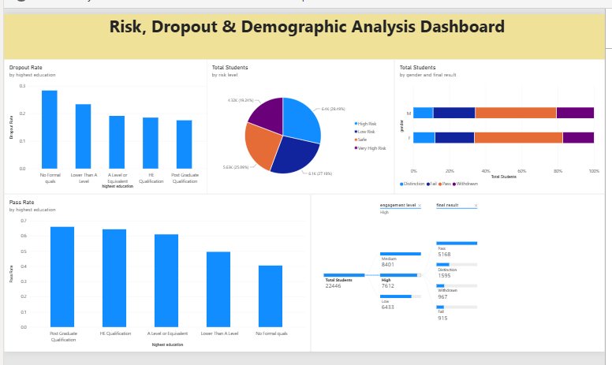
Observations drawn from this dashboard:
1. Dropout Rate by Prior Education:
● Dropout falls steadily as prior education rises: about 28% for students with No Formal quals, about 24% for Lower Than A Level, about 20% for both A Level and HE Qualification, and about 18% for Post Graduate learners. Students with no formal qualifications drop out about 1.5 times as often as post-graduates.
2. Pass Rate by Prior Education:
● The pass rate mirrors this pattern: about 67% for Post Graduate, 65% for HE Qualification, 62% for A Level, 50% for Lower Than A Level and only about 42% for No Formal quals, a gap of roughly 25 percentage points between the highest and lowest groups.
3. Risk Profile:
● High Risk (28.5%) and Very High Risk (19.18%) students together total 10,691, nearly 48% of all learners. Low Risk (27.2%) and Safe (25.12%) make up the remaining, just over half.
4. Gender and Final Result:
● Outcomes are broadly similar for both genders, but women do slightly better: about 49% of female students Pass compared with about 45% of male students, and about 17% of women Withdraw compared with about 21% of men. Distinction rates are close (about 11–12%).
5. Engagement and Final Result:
● For High-engagement students the decomposition tree shows Pass (5,168), Distinction (1,595), Withdrawn (967) and Fail (915). About 78% finish with a Pass or Distinction and only about 22% fail or withdraw, compared with roughly 40% across all students on Dashboard 1. High engagement is therefore associated with about half the rate of failure or withdrawal.
Key Insights and Recommendations
● Engagement is closely linked to success. Highly engaged students fail or withdraw about half as often, so the 14,810 students at Medium or Low engagement should be the focus of reminders, nudges and more interactive content.
● Prior education matters more than region. Regional average scores differ by only a few points, while dropout and pass rates vary widely with prior education. Support such as bridging modules, mentoring and study-skills sessions should target learners with No Formal quals or Lower Than A Level.
● Prioritise high-risk learners. With 10,691 students (about 48%) at High or Very High risk, early-warning alerts and adviser follow-ups should be triggered as soon as engagement drops.
● Monitor continuously. The interactive drill-downs allow advisers to filter by region, education, gender and engagement level and to act on the segments that need attention.

