CAPM – Backend, FIORI app- to view leave requests, Build apps- for to send request, build process automation – flow to approve the leave request, SAP BTP Cloud foundary to deploy Fiori app, SAP build workzone to deploy sap build apps.

First created CAPM project with entities.

namespace leavemanage;

entity Employee {

  key ID         : String;

  name           : String;

  email          : String;

  leaveBalance   : Integer;

  manager        : Association to Manager;

}

entity Manager {

  key ID         : String;

  name           : String;

  email          : String;

  employees      : Composition of many Employee on employees.manager = $self;

}

entity LeaveReq {

  key ID         : UUID @default.uuid;

  emailID       : String;

  startDate      : Date;

  endDate        : Date;

  type           : String;

  status         : String;

  reason         : String;

}

Then used this entities to display in Fiori app and database is hana.

App deployment and connection to hana database - <https://github.com/sushma688/MyHanaApp_working>

Standlone app router is added and steps are mentioned in above url.

After deployment, destination needs to created in sap btp cockpit.

If we want to access in build applications then created destination with srv url. If we want to create use build process workflow.

And build apps page

I have taken the mail id and displayed – whoever logged in to the build apps app.

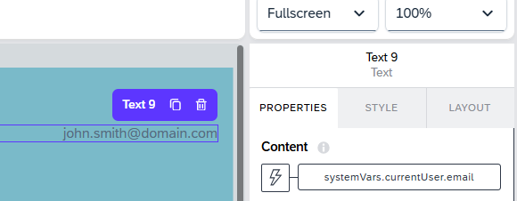

First create a data type in build process automation

Add properties inside it.

Now create business process workflow

Next add an API trigger in it by using data type.

Next create a form for approval

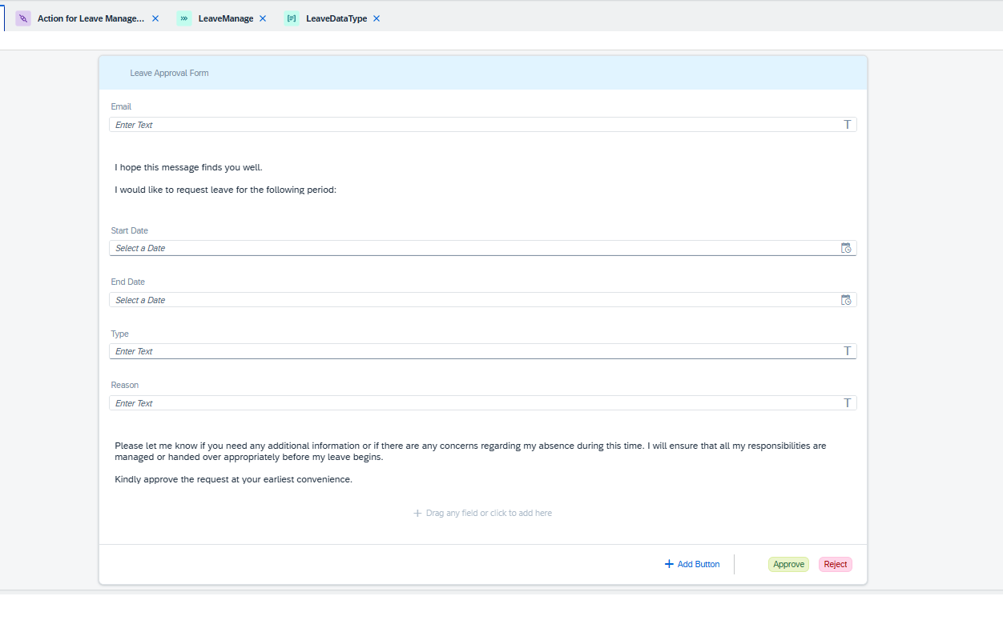

Mapped all the values from trigger to this form

And on approving, triggered the capm action

To call action in business process work flow, create action project and destination in btp and build apps as well

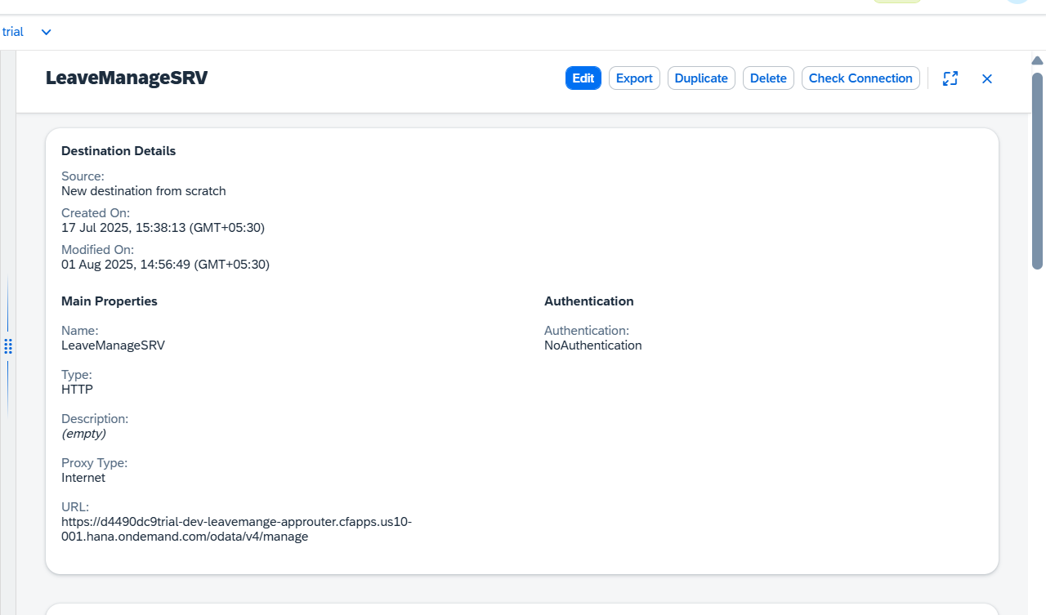

Like above

Upload edmx file of metadata of capm her, then it will create action project. After that select the actions in the metadata and save.

Deploy and publish to library

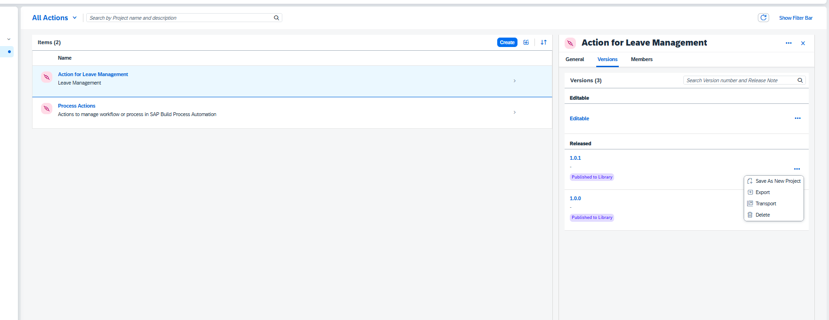

Then only it will be visible in business process work flow to add.

Now add in workflow as action and provide inputs inside it

And now it is sending the post call to capm hana database and updates in hana.

Then it will be visible in Fiori.

If rejects also same action will be called but with the status as rejected.

After doing all the release changes and deploy the changes. Publish to library then only it will be visible in build apps

Enable the process here in integration.

This also u need to add here.

Add destination in btp for this and then add in sap build apps

Create a instance for business process workflow and then create a service key for it. Then you will get credentials to create a destination.

Now how to trigger from build apps to business process workflow

Now enable it in build apps to use it.

To use in build apps, created a destination with srv url and displayed the entries from capm.

Need to add destination in it and add data entities

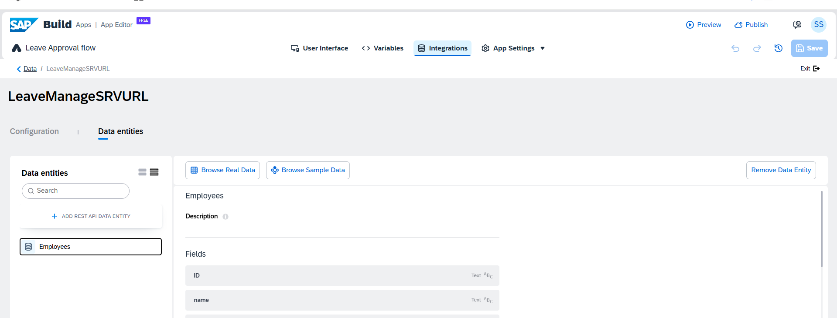

Relative path is

/odata/v4/manage/Employees

Now we can use capm entities in sap build apps.

Now create a variable by taking the trigger from build process work flow after enabling the leave manage.

After creating variable, then map the input fields there.

For send request

For the employees to be displayed in the build apps from capm app

Create a variable from the existing schema and entities. And employees entity from capm.

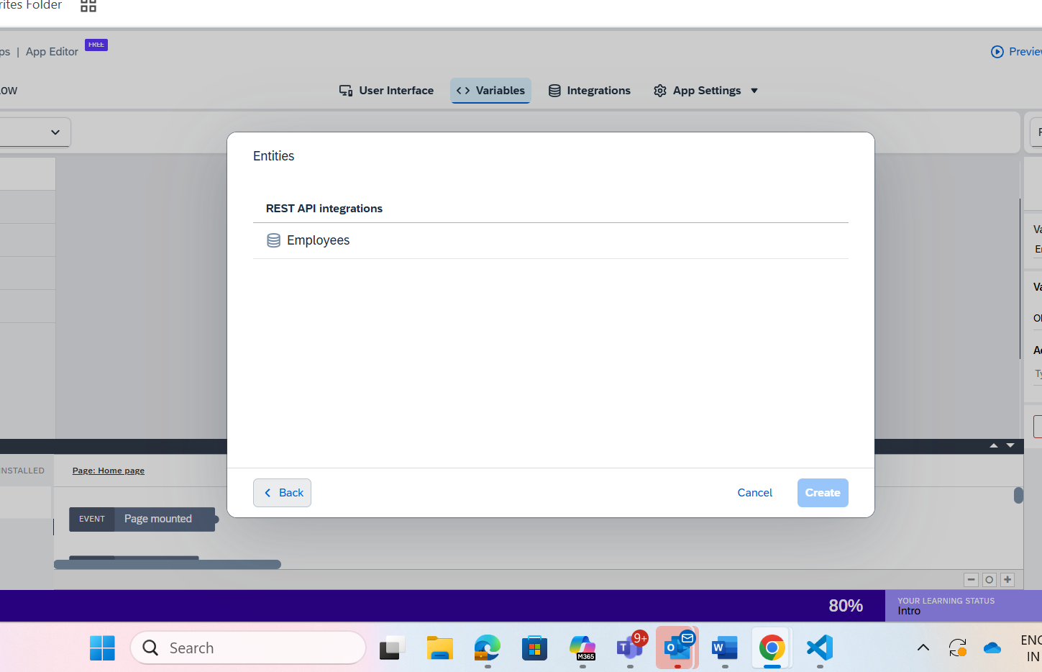

Now it triggers business process workflow. And approval mail from workflow to capm action.

And then updates Fiori app.

And now deployment of Fiori app to btp is already given - <https://github.com/sushma688/MyHanaApp_working.git>

And deployment of build apps to workxzone

It will deploy to HTML5 applications. And will be visible in sap btp.

Leave manage app - <https://github.com/sushma688/leavemanage.git>

This blog belongs to

Build apps and build process work flow files are uploaded in <https://github.com/sushma688/leavemanagebuildapps.git>