1.Comprehensive Assignment Problem Statement: 1. Implement below Program using Java Concepts a. Create a class name as ReadAnWriteDate b. Read the data from Excel Sheet (Use Apache POI) and should have below columns and should contain data Name, Courses, Fee Kirk, Java, $100 Dan, Python, $100 c. Use Collections concept to store the reading data and display it in console.

package library;

import java.io.File;

import java.io.FileInputStream;

import java.util.Iterator;

import org.apache.poi.ss.usermodel.Cell;

import org.apache.poi.ss.usermodel.CellType;

import org.apache.poi.ss.usermodel.Row;

import org.apache.poi.xssf.usermodel.XSSFSheet;

import org.apache.poi.xssf.usermodel.XSSFWorkbook;

public class ReadAnWriteDate {

String xlfilePath = "E:\\Selenium Projects\\TestData.xlsx";

XSSFWorkbook wb;

XSSFSheet sheet;

public ReadAnWriteDate ()

{

try {

FileInputStream fis= new FileInputStream(new File(this.xlfilePath));

System.out.println("File Input Stream Created successfully");

wb = new XSSFWorkbook(fis);

sheet = wb.getSheetAt(0);

}

catch(Exception e)

{

e.printStackTrace();

}

}

public void readSheetData()

{

Iterator<Row> rows = sheet.iterator();

while(rows.hasNext())

{

Row currRow = rows.next();

Iterator<Cell> cells = currRow.cellIterator();

while(cells.hasNext())

{

Cell currCell = cells.next();

CellType cType = currCell.getCellType();

String value = "";

if(cType == CellType.STRING)

{

value = currCell.getStringCellValue();

System.out.println("Value for cell:"+value);

}

else if(cType == CellType.NUMERIC)

{

value = ""+ currCell.getNumericCellValue();

System.out.println("Value for cell:"+value);

}

}

}

}

public static void main(String args[])

{

ReadAnWriteDate xl = new ReadAnWriteDate();

xl.readSheetData();

}

}

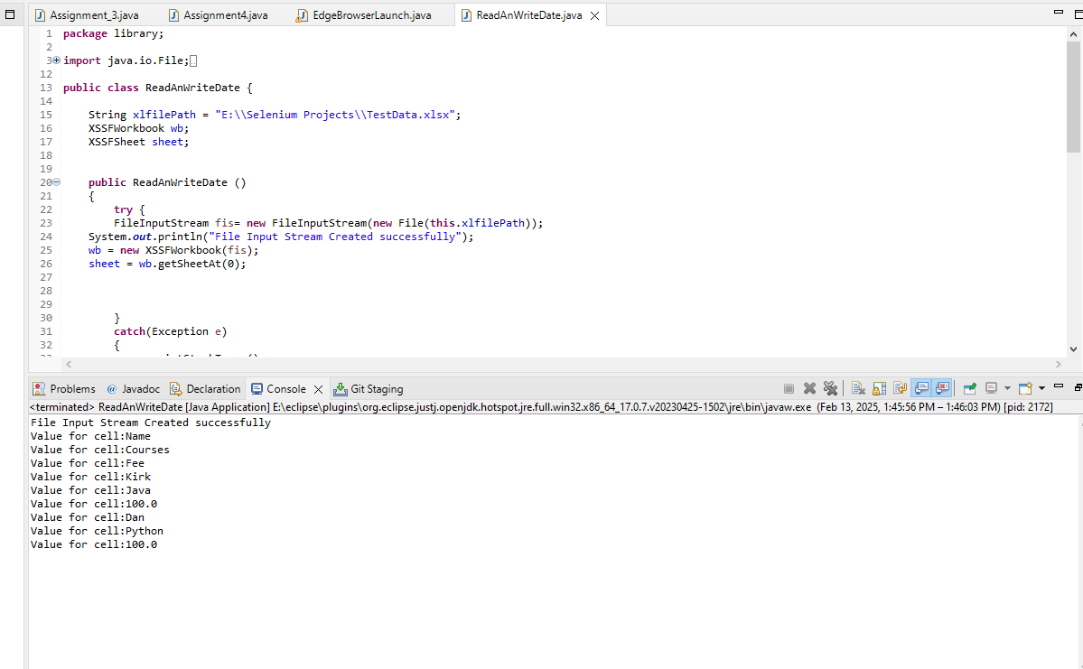

2. Implement below program using Python. a. Create a class Name as ReadAndWriteData b. Read the Data from CSV File and should have below three Columns and should contain data Name, SkillSet, Experience Kirk, Java, 10 Years Dan, Python, 5 Years c. Build a Data Structure to display the data, which contains in CSV File

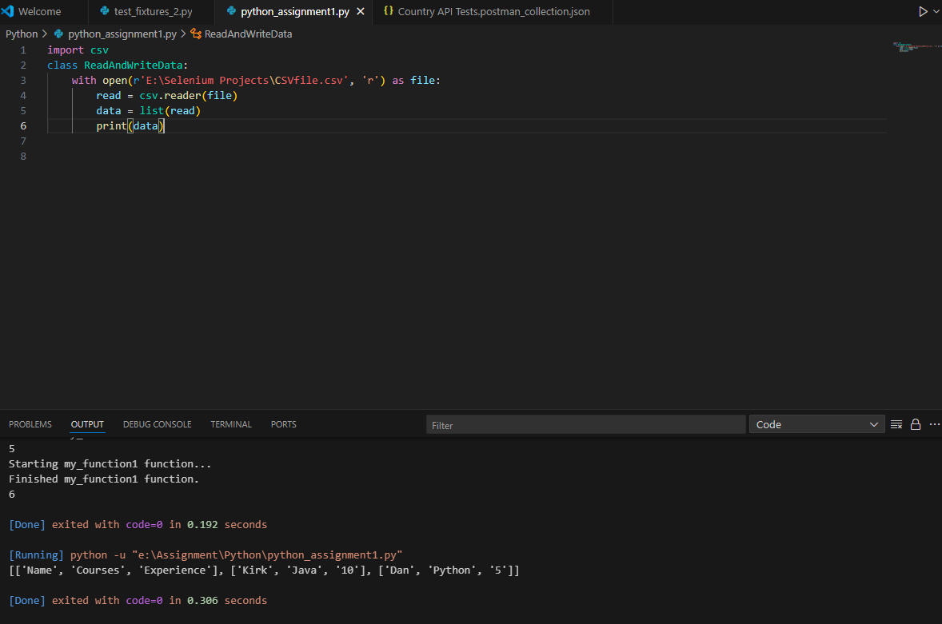

3. Launch a below browser in Chrome and verify below conditions using Selenium (Use XPaths to Identify Web Elements) with Java https://www.automationanywhere.com/ a. Automation Anywhere logo should be present b. Verify Request demo button is present and verify if it is clickable or not c.

package library;

import java.time.Duration;

import org.openqa.selenium.By;

import org.openqa.selenium.WebDriver;

import org.openqa.selenium.chrome.ChromeDriver;

import org.openqa.selenium.support.ui.ExpectedConditions;

import org.openqa.selenium.support.ui.WebDriverWait;

//Launch a below browser in Chrome and verify below conditions using Selenium (Use XPaths to Identify Web Elements) with Java https://www.automationanywhere.com/

//a. Automation Anywhere logo should be present //b. Verify Request demo button is present and verify if it is clickable or not

public class Assignment_3 {

public static void main(String[] args) throws InterruptedException {

WebDriver driver = new ChromeDriver();

driver.manage().window().maximize();

driver.get("https://www.automationanywhere.com/");

driver.manage().timeouts().implicitlyWait(Duration.ofSeconds(5));

boolean cookies = driver.findElement(By.id("onetrust-accept-btn-handler")).isDisplayed();

if (cookies == true) {

driver.findElement(By.id("onetrust-accept-btn-handler")).click();

}

boolean logName = driver

.findElement(By.xpath("//img[@src='/sites/default/files/images/default-images/logo-aa-new.svg']"))

.isDisplayed();

System.out.println("logo is present " + logName);

boolean requestDemo = driver

.findElement(By.xpath("//a[@class='coh-link coh-style-solid-orange-button btn-link']")).isDisplayed();

System.out.println("Request Demo button is avalilable " + requestDemo);

WebDriverWait wt = new WebDriverWait(driver, Duration.ofSeconds(6));

wt.until(ExpectedConditions

.elementToBeClickable(By.xpath("//a[@class='coh-link coh-style-solid-orange-button btn-link']")));

driver.close();

}

}

4. Launch a below browser in Chrome and verify below conditions using Selenium (Use XPaths to Identify Web Elements) with Java https://www.automationanywhere.com/ Verify below list is present on home page and click on each and every link and verify that it is navigating to the proper page a. Products b. Solutions c. Resources d. Beyond RPA e. Company

package library;

import java.time.Duration;

import org.openqa.selenium.By;

import org.openqa.selenium.WebDriver;

import org.openqa.selenium.edge.EdgeDriver;

public class Assignment4 {

public static void main(String[] args) throws InterruptedException {

System.setProperty("webdriver.edge.driver", "E:\\Selenium Projects\\msedgedriver.exe");

System.setProperty("webdriver.http.factory", "jdk-http-client");

WebDriver driver = new EdgeDriver();

driver.manage().window().maximize();

driver.manage().timeouts().implicitlyWait(Duration.ofSeconds(5));

driver.get("https://www.automationanywhere.com/");

boolean cookies = driver.findElement(By.id("onetrust-accept-btn-handler")).isDisplayed();

if (cookies == true) {

driver.findElement(By.id("onetrust-accept-btn-handler")).click();

}

for (int i = 0; i <= 4; i++) {

System.out.println(driver.findElements(By

.xpath("//ul[@class='coh-menu-list-container coh-unordered-list menu-level-1 coh-ce-646fa54d']/li"))

.get(i).getText());

// driver.findElements(By

// .xpath("//ul[@class='coh-menu-list-container coh-unordered-list menu-level-1 coh-ce-646fa54d']/li"))

// .get(i).click();

// System.out.println(driver.getTitle());

// driver.navigate().back();

}

driver.close();

}

}

5. Implement 3 and 4 Programs using TestNG Concepts and write it using @Test annotation. And add TestNG Attributes – priority, enabled and timeOut to run the programs. Run the program with enabled attribute value as either true or false Run the program with timeOut Attribute values And run 3 and 4 Programs from TestNG.xml file and verify the generated test reports.

package library;

import java.time.Duration;

import java.util.Iterator;

import java.util.Set;

import org.openqa.selenium.By;

import org.openqa.selenium.Keys;

import org.openqa.selenium.WebDriver;

import org.openqa.selenium.chrome.ChromeDriver;

import org.openqa.selenium.edge.EdgeDriver;

import org.openqa.selenium.support.ui.ExpectedConditions;

import org.openqa.selenium.support.ui.WebDriverWait;

import org.testng.annotations.Test;

public class Assignment5 {

@Test(enabled = true)

public void enableTrueCase() throws InterruptedException {

System.setProperty("webdriver.edge.driver", "E:\\Selenium Projects\\msedgedriver.exe");

System.setProperty("webdriver.http.factory", "jdk-http-client");

WebDriver driver = new EdgeDriver();

driver.manage().window().maximize();

driver.manage().timeouts().implicitlyWait(Duration.ofSeconds(5));

driver.get("https://www.automationanywhere.com/");

boolean cookies = driver.findElement(By.id("onetrust-accept-btn-handler")).isDisplayed();

if (cookies == true) {

driver.findElement(By.id("onetrust-accept-btn-handler")).click();

}

boolean logName = driver

.findElement(By.xpath("//img[@src='/sites/default/files/images/default-images/logo-aa-new.svg']"))

.isDisplayed();

System.out.println("logo is present " + logName);

boolean requestDemo = driver

.findElement(By.xpath("//a[@class='coh-link coh-style-solid-orange-button btn-link']")).isDisplayed();

System.out.println("Request Demo button is avalilable " + requestDemo);

WebDriverWait wt = new WebDriverWait(driver, Duration.ofSeconds(6));

wt.until(ExpectedConditions

.elementToBeClickable(By.xpath("//a[@class='coh-link coh-style-solid-orange-button btn-link']")));

driver.close();

}

@Test(priority = 1)

public void priority1Case() throws InterruptedException {

System.setProperty("webdriver.edge.driver", "E:\\Selenium Projects\\msedgedriver.exe");

System.setProperty("webdriver.http.factory", "jdk-http-client");

WebDriver driver = new EdgeDriver();

driver.manage().window().maximize();

driver.manage().timeouts().implicitlyWait(Duration.ofSeconds(5));

driver.get("https://www.automationanywhere.com/");

boolean cookies = driver.findElement(By.id("onetrust-accept-btn-handler")).isDisplayed();

if (cookies == true) {

driver.findElement(By.id("onetrust-accept-btn-handler")).click();

}

for (int i = 0; i <= 4; i++) {

System.out.println(driver.findElements(By

.xpath("//ul[@class='coh-menu-list-container coh-unordered-list menu-level-1 coh-ce-646fa54d']/li"))

.get(i).getText());

}

driver.close();

}

@Test(timeOut = 5000)

public void timeoutCase() throws InterruptedException {

System.setProperty("webdriver.edge.driver", "E:\\Selenium Projects\\msedgedriver.exe");

System.setProperty("webdriver.http.factory", "jdk-http-client");

WebDriver driver = new EdgeDriver();

driver.manage().window().maximize();

driver.manage().timeouts().implicitlyWait(Duration.ofSeconds(5));

driver.get("https://www.automationanywhere.com/");

boolean cookies = driver.findElement(By.id("onetrust-accept-btn-handler")).isDisplayed();

if (cookies == true) {

driver.findElement(By.id("onetrust-accept-btn-handler")).click();

}

for (int i = 0; i <= 4; i++) {

System.out.println(driver.findElements(By

.xpath("//ul[@class='coh-menu-list-container coh-unordered-list menu-level-1 coh-ce-646fa54d']/li"))

.get(i).getText());

// String clickOnLink = Keys.chord(Keys.CONTROL,Keys.ENTER);

}

boolean requestDemo = driver

.findElement(By.xpath("//a[@class='coh-link coh-style-solid-orange-button btn-link']")).isDisplayed();

System.out.println("Request Demo button is avalilable " + requestDemo);

WebDriverWait wt = new WebDriverWait(driver, Duration.ofSeconds(6));

wt.until(ExpectedConditions

.elementToBeClickable(By.xpath("//a[@class='coh-link coh-style-solid-orange-button btn-link']")));

driver.close();

}

@Test(enabled = false)

public void automationanywhere1() throws InterruptedException {

System.setProperty("webdriver.edge.driver", "E:\\Selenium Projects\\msedgedriver.exe");

System.setProperty("webdriver.http.factory", "jdk-http-client");

WebDriver driver = new EdgeDriver();

driver.manage().window().maximize();

driver.manage().timeouts().implicitlyWait(Duration.ofSeconds(5));

driver.get("https://www.automationanywhere.com/");

boolean cookies = driver.findElement(By.id("onetrust-accept-btn-handler")).isDisplayed();

if (cookies == true) {

driver.findElement(By.id("onetrust-accept-btn-handler")).click();

}

boolean logName = driver

.findElement(By.xpath("//img[@src='/sites/default/files/images/default-images/logo-aa-new.svg']"))

.isDisplayed();

System.out.println("logo is present " + logName);

boolean requestDemo = driver

.findElement(By.xpath("//a[@class='coh-link coh-style-solid-orange-button btn-link']")).isDisplayed();

System.out.println("Request Demo button is avalilable " + requestDemo);

WebDriverWait wt = new WebDriverWait(driver, Duration.ofSeconds(6));

wt.until(ExpectedConditions

.elementToBeClickable(By.xpath("//a[@class='coh-link coh-style-solid-orange-button btn-link']")));

driver.close();

}

}

6. Create a Maven Project and implement all the programs in Maven Project and add Apache POI dependency in pom.xml and run all the programs using Maven Commands

7. Create a branch name as comprehensive_basic_2 in GitHub and implement all the above programs in that branch and push the code into the same branch. Share the GitHub details to evaluate. Write the git commands accordingly

<https://github.com/sushmaYashi/ComprehesiveBase2/tree/master/src/main/java/library>

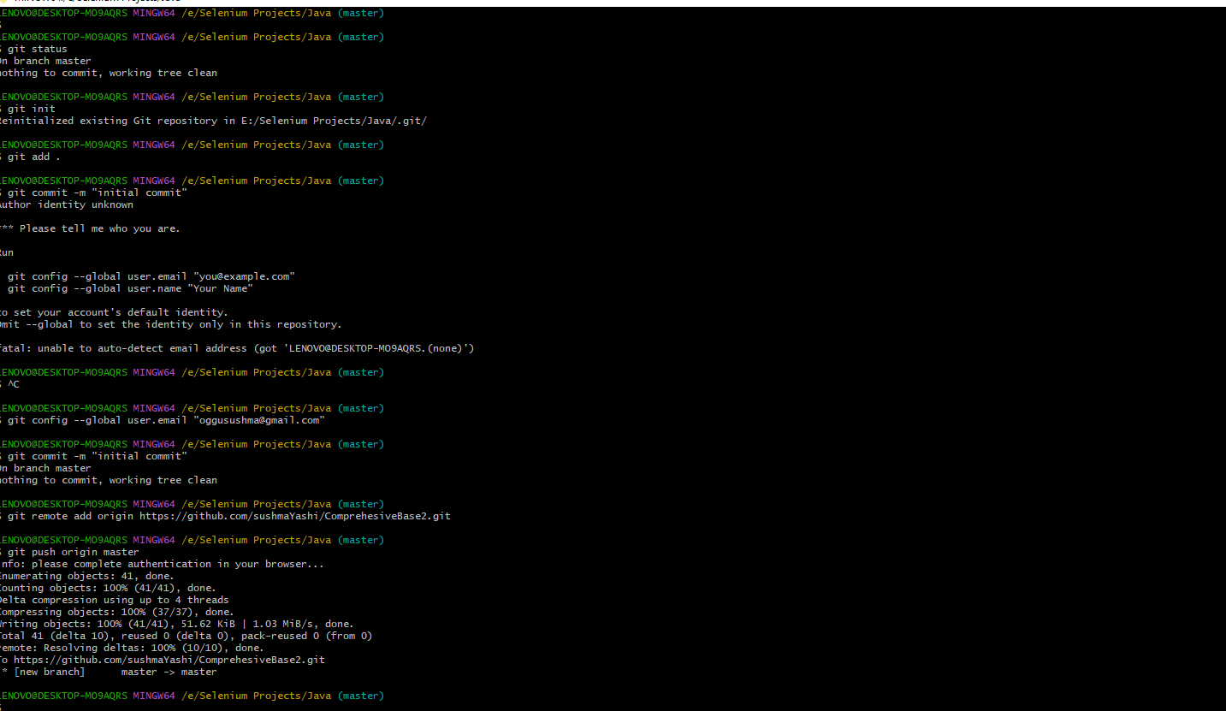

8. Create a collection in Postman and create positive and negative cases for below API. And use get method to get valid responses. Verify the HTTP Status Codes, while running Positive and Negative Test Cases. To validate the HTTP Status Codes and responses use Assertions concept in PostMan <https://restcountries.com/v3.1/name/India>

Note: Please inform to us if this API is not working as it’s an open source API. We will update it accordingly

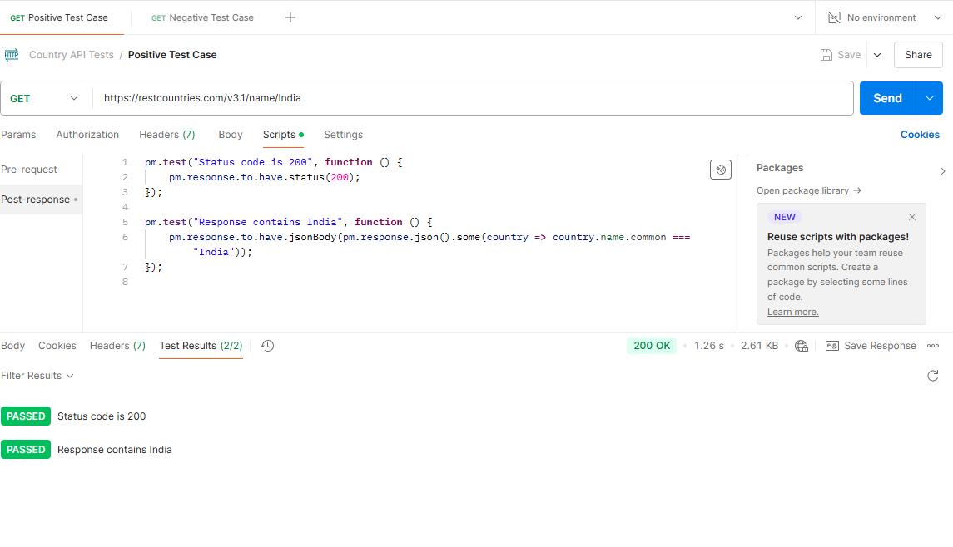

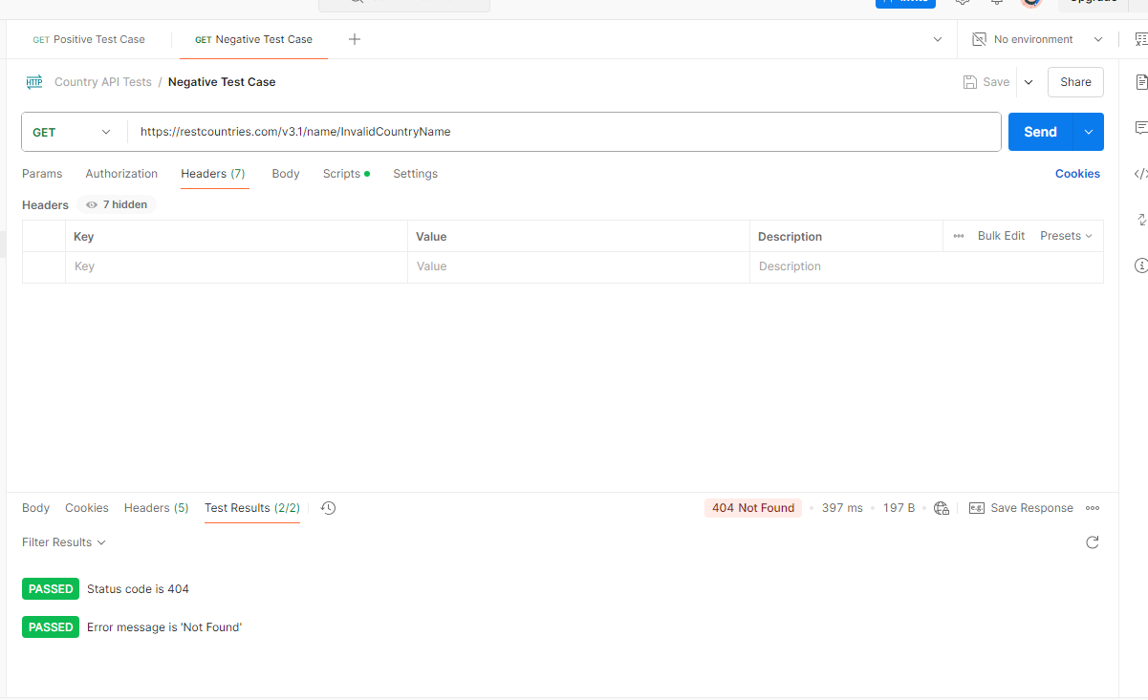

9. Implement below steps in JMeter

1. Create a Test Plan 2. Create a Thread Group and Add Number of Threads (Count is 2) 3. Add HTTP Request (Use https protocol) and URL as https://www.w3schools.com/ 4. Add HTML Assertions 5. Add Error Threshold as zero 6. Add Warning Threshold count 7. Run the Script

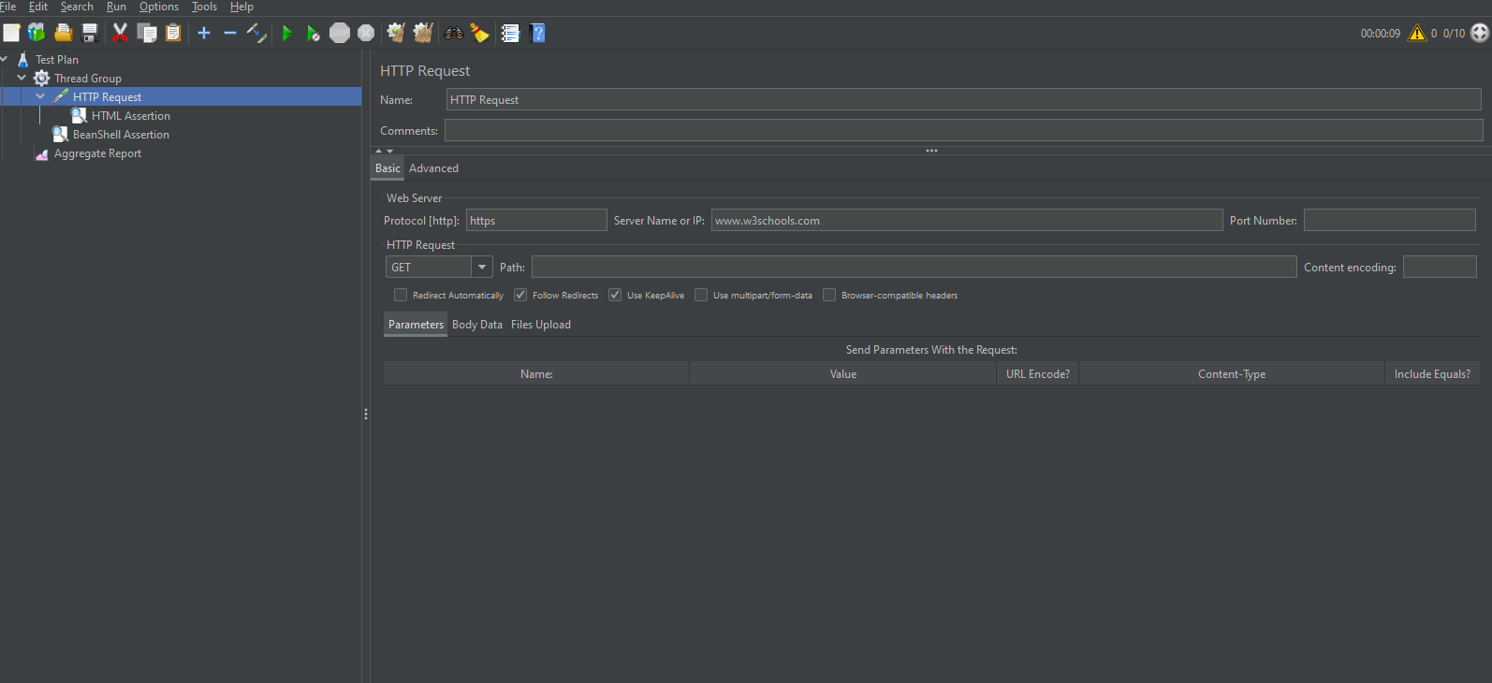

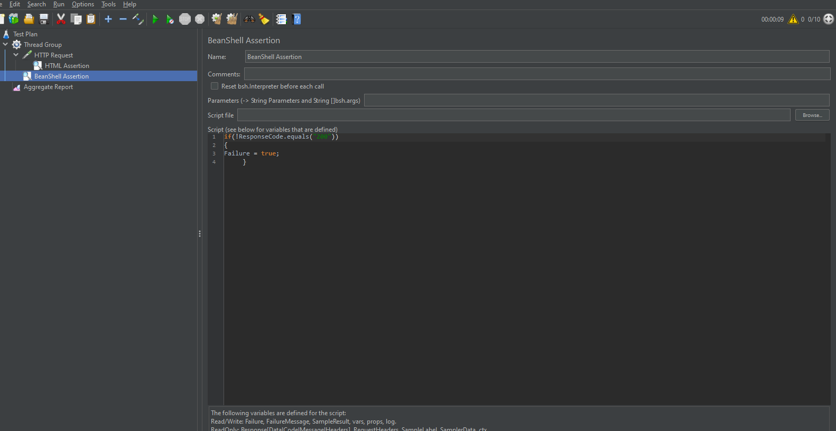

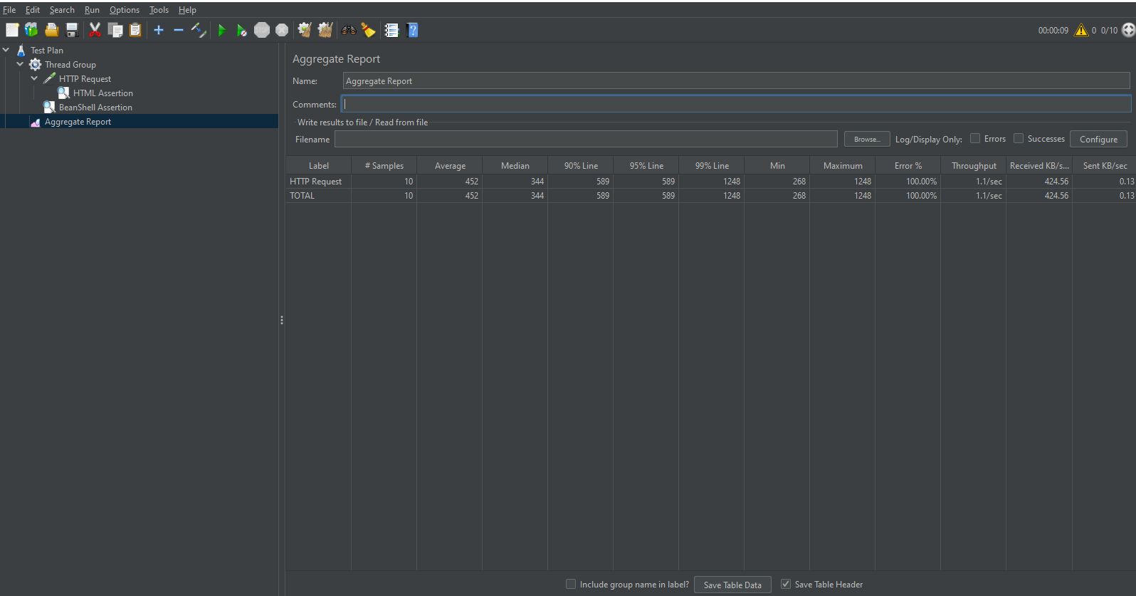

10. Create a Test File Names as test_fixtures_2.py in Visual Studio Code Implement data fixtures using decorator, which returns dictionary type of data. And for each fixture, write corresponding test function

class test_fixtures_2:

    def log(func):

        def wrapper(*args, **kwargs):

            print(f"Starting {func.__name__} function...")

            result = func(*args, **kwargs)

            print(f"Finished {func.__name__} function.")

            return result

        return wrapper

    @log

    def my_function(x, y):

        return x + y

    @log

    def my_function1(x,y):

        return x*y

    result = my_function(2, 3)

    print(result)

    result = my_function1(2, 3)

    print(result)