CASCODE CURRENT MIRROR ANALYSIS IN 180-nm CMOS
A Project Based Learning Report Submitted in partial fulfilment of the requirements for the award of the degree

of

Bachelor of Technology
in The Department of ECE
ASIC AND FPGA(23EC2237F), ANALOG VLSI(23VLS3101A), INTEGRATED SYSTEM DESIGN AUTOMATION(23SDEC10A)

Submitted by
2310040060: M. SOWMYA
2310040091: N. SRIJA
2310040112: K. SUSHMA
2310049143: B. SRIJA

Under the guidance of
Dr. Ngangbam Phalguni Singh and Dr. Vijay Rao Kumbhare



Department of Electronics and Communication Engineering
Koneru Lakshmaiah Education Foundation, Aziz Nagar
Aziz Nagar – 500075
NOV - 2025.

Abstract

Current mirrors play a central role in analog and mixed-signal integrated circuits, serving as fundamental building blocks in biasing networks, amplifiers, operational transconductance amplifiers (OTAs), and analog signal-processing architectures. As technology continues to scale and performance requirements become increasingly stringent, the need for accurate current replication, high output resistance, low noise, and efficient power consumption becomes more critical. Among the diverse current mirror topologies, the cascode current mirror stands out for its superior gain characteristics and robustness against channel-length modulation. This project focuses on the systematic analysis, design, and performance evaluation of cascode current mirrors using Cadence Virtuoso in a UMC 180-nm CMOS process, with emphasis on gain, noise behavior, and overall power efficiency.

The central objective of this study is to quantify how the cascode configuration improves intrinsic gain, enhances output resistance, and affects noise performance relative to the basic and Wilson current mirrors. In the cascode structure, the addition of an auxiliary transistor increases the effective output resistance by stacking device impedances, thereby drastically reducing variations in output current caused by fluctuations in output voltage. This mechanism effectively mitigates channel-length modulation and leads to enhanced current accuracy, which is critical in high-precision analog systems. Using Cadence Virtuoso’s schematic design environment, we designed transistor-level models based on BSIM3v3 equations provided by the foundry PDK, allowing realistic extraction of intrinsic device parameters. Biasing conditions were optimized to ensure all transistors remained in strong saturation region, maximizing output resistance and linearity.

Small-signal analysis was performed to evaluate the incremental gain of the mirror. The study revealed that the cascode current mirror exhibits a significant increase in output impedance—often by one to two orders of magnitude—when compared to the simple mirror. This enhancement directly translates to a higher voltage gain in circuit blocks where the mirror serves as an active load. Simulation results from AC analysis confirmed the theoretical expectation: the gain improved due to series stacking of transistor output resistances (r_o). Furthermore, design trade-offs involving headroom limitations were explored. Since cascading increases the number of stacked devices, the allowable output voltage swing reduces, posing restrictions in low-voltage systems. This constraint was thoroughly analyzed under supply voltages ranging from 1.2 V to 1.8 V, demonstrating that the cascode structure remains practical in 180-nm technology where supply rails are relatively higher than in advanced CMOS nodes.

Noise performance is equally critical in analog circuits, especially where the current mirror forms part of sensitive biasing or readout networks. Through Cadence Virtuoso’s noise analysis capabilities, we examined the thermal and flicker noise contributions of the cascode topology. Results showed a reduction in flicker noise propagation to the output node due to the isolating effect of the cascode transistor, which lowers the influence of low-frequency noise from the input device. However, stacking devices introduces additional thermal noise sources, making the noise trade-off complex. A detailed comparison with the simple and Wilson mirrors showed that while the cascode mirror generally offers improved noise characteristics at mid to high frequencies, careful selection of device dimensions is required to suppress flicker noise in low-frequency applications. Increasing device area was seen to reduce 1/f noise but at the cost of higher parasitic capacitance and increased chip area. These trade-offs were quantified through parametric sweeps of transistor widths and lengths, highlighting optimal sizing strategies for applications requiring low noise and high output resistance simultaneously.

Power consumption formed the third major axis of the study. While current mirrors inherently consume static power proportional to their bias current, the topology determines the associated voltage headroom and thus the minimum achievable supply voltage. Simulation data from transient and DC operating point analyses revealed that although the cascode mirror consumes similar current as a basic mirror for a given bias point, it requires a higher minimum supply voltage due to transistor stacking. This additional voltage requirement can indirectly increase power consumption in low-voltage environments. The study therefore identifies a crucial design compromise: maximizing gain and accuracy comes at the cost of reduced voltage headroom, potentially limiting power-efficient operation. Despite this, the cascode structure remains highly suitable in applications where precision outweighs strict power constraints. The project quantified these relationships by measuring power dissipation across several bias currents and supply voltages, providing a clear map of operational efficiency.

The final stage of the project involved layout design and post-layout simulations using extracted parasitic RC parameters. Layout strategies such as common-centroid structure, dummy transistors, and minimizing mismatch through careful symmetry were implemented. Post-layout results confirmed the robustness of the cascode mirror even under parasitic loading, with only minor degradation in output resistance and noise metrics. These findings further highlight the practicality of deploying cascode mirrors in moderate-resolution analog circuits such as data converters, sensor front-ends, and analog bias blocks.

In summary, this project demonstrates that the cascode current mirror provides substantial improvements in gain and output resistance, making it highly advantageous for high-precision analog designs.
Table of Contents

S.NO | DESCRIPTION
1. | ABSTRACT
2. | INTRODUCTION
3. | LITERATURE SURVEY
4. | METHODOLOGY
5. | EXPERIMENTS
6. | RESULTS
7. | CONCLUSION & FUTURE WORK
8. | REFERENCES

Title (Font size 24)

Introduction

1.1 Background and Motivation
Current mirrors form one of the most essential building blocks in analog and mixed-signal integrated circuit (IC) design. They are widely used in biasing networks, operational amplifiers, reference generators, current-steering circuits, and data-converter architectures. Their primary function is to replicate a reference current with high accuracy and stability, ensuring consistent performance across different circuit stages. In CMOS analog design, the accuracy and reliability of a current mirror directly influence the linearity, gain, noise performance, and overall efficiency of the system. With the increasing demand for low-power, high-precision analog circuits, understanding the behavior and limitations of current mirrors in modern semiconductor processes has become more important than ever.
As technology nodes scale down, device dimensions shrink and analog designers face new challenges. Short-channel effects, channel-length modulation, reduced output resistance, and increased flicker noise degrade the accuracy and stability of basic current mirror structures. This motivates the exploration of alternative topologies that can overcome these limitations. Among these, cascode current mirrors are widely recognized for their ability to significantly enhance output resistance, improve gain, and reduce the effect of channel-length modulation. These advantages make cascode structures suitable for high-performance analog circuits, especially in 180-nm CMOS technology where moderate supply voltages allow the stacking of transistors without severe headroom limitations.

1.2 Importance of Cascode Current Mirrors in Analog Design
The cascode current mirror is an extension of the simple two-transistor mirror, designed to achieve higher accuracy and improved performance. By stacking an additional transistor in the output branch, the effective output resistance is increased by more than an order of magnitude. This ensures that the output current remains nearly constant even under variations in output voltage, which is especially important in circuits where the mirror operates as an active load or current source.
In addition to improved output resistance, cascode topologies also offer enhanced gain, better isolation between nodes, and reduced signal distortion. These characteristics make them suitable for precision applications such as operational transconductance amplifiers (OTAs), voltage-references, current-steering DACs, and sensor interface circuits. Moreover, in mixed-signal designs, where analog accuracy must coexist with digital switching noise, the inherent noise-reduction properties of cascode mirrors provide significant performance benefits.

1.3 Challenges in Gain, Noise, and Power Optimization
Although cascode current mirrors offer superior performance, they come with inherent trade-offs that must be carefully analyzed. One major drawback is the increased voltage headroom requirement. With more transistors stacked between the supply rails, the allowable signal swing at the output node is reduced. This becomes critical in low-voltage environments, where transistor overdrive voltages cannot be compromised without entering weak inversion or risking device saturation.
Noise performance also becomes a significant challenge. While the cascode device can suppress low-frequency noise from the input transistor, the additional devices contribute their own thermal and flicker noise. Achieving an optimal balance between device sizing, noise performance, and output resistance requires detailed analysis and simulation. Furthermore, since analog circuits typically consume static power through bias currents, optimizing the power-performance trade-off is crucial, particularly for battery-operated and portable systems.

1.4 Role of Cadence Virtuoso in CMOS Analog Design
To analyze these trade-offs effectively, industry-standard EDA tools like Cadence Virtuoso are widely used. The Virtuoso design environment provides schematic capture, simulation, layout design, and post-layout verification through tools such as Spectre, ADE XL, and QRC extraction. In this project, Cadence Virtuoso with a 180-nm CMOS PDK is used to model the cascode current mirror accurately. This process technology offers a good balance between device scalability, manageable short-channel effects, and sufficient supply voltage, making it suitable for academic research and industrial mixed-signal applications.
Through DC operating-point analysis, AC small-signal analysis, transient behavior inspection, noise simulation, and power estimation, Cadence produces reliable results that closely represent real silicon behavior. Layout techniques such as common-centroid placement, interdigitated transistors, and dummy structures help mitigate mismatch, ensuring the fabricated circuit performs close to simulated values.

1.5 Objective and Scope of the Study
The primary objective of this work is to perform a detailed study of gain, noise, and power characteristics of cascode current mirrors designed in 180-nm CMOS technology. The study includes:
- Designing the simple, Wilson, and cascode current mirrors in Cadence Virtuoso
- Performing DC, AC, transient, and noise simulations
- Evaluating the improvement in output resistance and gain offered by cascode structures
- Analyzing noise behavior over frequency
- Studying power consumption across different bias conditions
- Exploring trade-offs in voltage headroom, device sizing, and precision
- Implementing the layout and conducting post-layout parasitic analysis
This comprehensive evaluation will provide a deeper understanding of the limitations and advantages of cascode mirror design, enabling optimized circuit performance for analog and mixed-signal applications.

- Literature Survey

2.1 Overview of Current Mirrors in Analog IC Design
Current mirrors have been extensively studied for decades due to their fundamental role in analog and mixed-signal circuit design. Early studies focused on the simple two-transistor current mirror, which provides a basic yet effective means of replicating reference currents. Its simplicity and low-area implementation made it widely used in operational amplifiers, bias networks, current references, and current-steering circuits. However, as CMOS technologies scaled down, the limitations of simple mirrors—particularly poor output resistance, mismatch-induced inaccuracy, and sensitivity to channel-length modulation—became more pronounced.
Researchers have therefore explored a variety of improved mirror architectures. Most academic works emphasize the need for high output resistance and low current variation with output voltage. These goals inspired the development of modified topologies, such as the Wilson mirror, improved Wilson mirror, regulated cascode mirror, and gain-boosted mirrors. Each topology attempts to overcome one or more weaknesses of the basic mirror, typically at the cost of extra complexity and power consumption. Literature suggests that among all of these, the cascode mirror provides one of the best trade-offs between complexity and performance, making it a widely used topology in analog CMOS design.

2.2 Limitations of the Simple Current Mirror
The simple current mirror is often used as the baseline for performance comparison. However, classical works have shown that its output resistance is limited by the finite drain–source resistance (r_o) of MOSFETs. As channel-length modulation increases in deep-submicron technologies, the effective output resistance decreases, resulting in significant current error. Several studies highlight that even small variations in output voltage can cause noticeable deviations in output current, making the simple mirror unsuitable for high-accuracy and high-gain analog circuits.
Additionally, the simple mirror exhibits relatively high flicker and thermal noise, especially when device dimensions are small. Mismatch between the two transistors further degrades accuracy, requiring careful layout techniques such as common-centroid and interdigitated structures. Nonetheless, even with careful layout, intrinsic limitations remain, prompting researchers to investigate cascoded solutions.

2.3 Development of the Cascode Current Mirror
The cascode current mirror was introduced as a solution to address channel-length modulation and increase output resistance. Seminal literature in analog IC design shows that stacking an additional transistor effectively multiplies the output impedance by several factors. This dramatically improves current stability and increases the small-signal voltage gain of circuits using the mirror.
Studies have demonstrated that the cascode configuration offers:
- High output resistance (r_o increases by r_o1 × r_o2)
- Lower sensitivity to output voltage variations

- Improved linearity
- Reduced propagation of flicker noise from the input device
- Enhanced gain when used as an active load
However, the cascode topology requires additional voltage headroom due to stacked devices, limiting its use in ultra-low-voltage circuits. This trade-off is well documented in analog design literature and has driven further innovations such as the folded cascode mirror, regulated cascode mirror, and gain-boosted architectures.

2.4 Noise Studies in Current Mirror Structures
Noise performance remains a key constraint in analog design, especially for applications such as biosensors, low-frequency amplifiers, and precision instrumentation. Research shows that current mirrors are significant contributors to overall circuit noise because they supply bias currents to multiple stages.
Flicker noise, caused by traps at the Si–SiO₂ interface, dominates at low frequencies, while thermal noise becomes prominent at higher frequencies. Literature has shown that cascode mirrors can suppress part of the flicker noise contributed by the input transistor because the cascode device isolates the drain voltage swing, reducing the modulation of charge carriers.
However, the cascode device itself introduces additional noise. Several studies indicate that proper transistor sizing—particularly increasing W/L and using long-channel devices—can help optimize noise performance. Some works introduce noise-optimized cascode structures, using techniques such as body-driven MOSFETs and regulated cascodes to lower noise without compromising gain.

2.5 Power Consumption and Voltage Headroom Challenges
Power efficiency is a dominant design constraint in modern analog circuits, especially in portable devices and battery-operated systems. Literature consistently notes that current mirrors consume static power proportional to the bias current. While cascode mirrors do not inherently consume more current, their voltage headroom requirements increase total power dissipation when the supply voltage cannot be reduced.
This issue is emphasized in studies regarding low-voltage analog design, where stacked devices severely limit signal swing. Researchers have proposed multiple techniques to reduce voltage headroom, such as:
- Low-voltage cascode structures using bulk-driven MOSFETs
- Self-biased cascode circuits
- Folded cascode configurations
- Wide-swing cascode mirrors
- These approaches extend cascode benefits to lower supply voltages but come with added circuit complexity.

2.6 Relevance of 180-nm CMOS Technology in Research
Numerous research papers highlight the continued relevance of the 180-nm technology node for analog IC design, despite the availability of more advanced CMOS processes. The 180-nm node offers advantages such as:
- Higher intrinsic gain due to longer channel lengths
- Lower leakage current
- More manageable short-channel effects
- Adequate supply voltage (1.8–3.3 V) allowing cascode topologies
Because many analog and mixed-signal systems do not benefit significantly from extreme miniaturization, the 180-nm node remains popular in industry and academia. Literature shows that this technology is ideally suited for studying current mirrors because it allows sufficient voltage headroom for cascoding while still demonstrating modern transistor behavior.

2.7 Simulation and Layout Techniques in Literature
Previous works emphasize the importance of simulation-driven and layout-aware design methodologies. Cadence Virtuoso is widely cited as an industry-standard tool used for:
- DC, AC, and transient simulations using Spectre
- Small-signal gain and noise analysis
- Parameter sweeps for device optimization
- Layout generation and parasitic RC extraction
Studies show that layout techniques such as common-centroid and interdigitated placement significantly reduce mismatch and enhance current mirror accuracy. Several papers also discuss the importance of matching W/L ratios, minimizing temperature gradients, and maintaining symmetry to achieve predictable performance.

2.8 Summary of Literature Gaps and Motivation for Present Study
Although extensive research exists on current mirror topologies, certain gaps remain relevant for modern analog IC design:
- Few works provide a combined analysis of gain, noise, and power specifically for cascode mirrors in 180-nm technology.
- Many studies focus solely on ideal or theoretical behavior without including layout-dependent parasitic effects.
- Some literature evaluates performance only at a single bias point, lacking a comprehensive exploration of trade-offs across different operating conditions.
- The interaction between device sizing, voltage headroom, and noise performance is often overlooked.
These gaps motivate the present study, which aims to provide a detailed and simulation-backed evaluation of cascode current mirror performance using Cadence Virtuoso in a 180-nm CMOS environment.

METHODOLOGY

3.1 Overview of the Design Flow
The methodology for this project follows a structured approach covering the complete cycle of analog circuit design: schematic creation, simulation, performance evaluation, layout implementation, and post-layout verification. The objective is to accurately evaluate gain, noise, and power characteristics of cascode current mirrors in CMOS 180-nm technology. Cadence Virtuoso serves as the primary design environment, using Spectre for simulations and the 180-nm PDK for device models.
The flow begins with the selection of the CMOS process and the design of current mirror topologies, including simple, Wilson, and cascode structures. After determining device sizes and biasing strategies, pre-layout simulations are conducted to analyze DC behavior, AC gain, noise spectrum, and static power consumption. Following this, layout is implemented using matching-aware techniques. Finally, post-layout parasitic extraction is performed, and the same simulations are repeated to assess real-world performance degradation.

3.2 Schematic Design and Device Sizing
The schematic design is carried out using MOSFET models from the 180-nm PDK. Three current mirror types are implemented: the simple mirror, the Wilson mirror, and the cascode mirror. Transistor sizing is the most critical part of the design phase because it directly affects current accuracy, noise performance, output resistance, and saturation headroom.
Transistor lengths are chosen larger than the minimum allowed length to reduce channel-length modulation and flicker noise. Lengths typically between 360 nm and 1 µm are used depending on performance requirements. The width of each transistor is determined based on the desired reference current and overdrive voltage. All mirrors are designed to operate under reference currents of 10 µA, 20 µA, and 50 µA to evaluate behavior across low and moderate bias conditions.
Matching requirements are taken into account by ensuring identical W/L ratios for devices that mirror currents. Larger devices are preferred for accuracy but are balanced with area constraints. Proper biasing is established so that all transistors operate in strong saturation; this ensures high output resistance and reliable current replication. Special focus is placed on biasing the cascode mirror, as it involves stacking devices and therefore demands a careful distribution of node voltages.

3.3 Simulation Setup in Cadence Virtuoso
Simulations are performed using the Spectre simulator across various analysis types. Each simulation is designed to extract a particular performance metric. The first simulation performed is the DC operating-point analysis, which helps verify that all transistors remain in saturation and identifies the output current accuracy for a given reference input. From the MOSFET small-signal parameters obtained in this analysis, the output resistance can also be evaluated.
AC analysis is performed next to determine the small-signal voltage gain and frequency response. This is especially critical for cascode mirrors, which show increased gain due to higher output impedance. The AC simulation helps quantify not only the magnitude of gain but also bandwidth limitations imposed by parasitic capacitances.
Noise analysis is conducted in the frequency domain, typically from 1 Hz to 10 MHz. This analysis extracts thermal noise, flicker noise, and the overall output noise spectral density. Comparisons are made between the simple, Wilson, and cascode topologies to determine which configurations best suppress low-frequency and high-frequency noise.
3.4 Parametric Sweep and Design Space Exploration
To fully understand performance trade-offs, extensive parametric sweeps are performed. One key sweep involves varying the output voltage from 0 V to the supply voltage. This sweep demonstrates how well the current mirror maintains a constant output current and allows extraction of output resistance by examining the slope of the I–V curve.
Another sweep varies transistor dimensions. Changing the width and length helps explore how device sizing influences noise, output resistance, headroom, and power consumption. This identifies optimum device sizing for maximizing gain and minimizing noise while still maintaining reasonable voltage headroom.
Bias current sweeps are also performed to observe how increasing or decreasing bias affects circuit performance. Higher bias currents generally result in lower noise and higher bandwidth but increase power consumption. These trade-offs are quantified through the simulation results obtained from parametric sweeps.

3.5 Layout Design Methodology
Layout is performed using Cadence Virtuoso Layout Suite with adherence to the 180-nm design rules. Since matching is critical for current mirror accuracy, the layout is designed using industry-standard techniques such as common-centroid structure and interdigitated transistor placement. These approaches ensure that gradient effects, process variations, and stress-induced mismatch are minimized.
Dummy transistors are placed at the boundaries of device arrays to ensure uniform etching and oxide growth around active devices. Metal routing is performed symmetrically, and equal-length connections are ensured to avoid imbalance in parasitic resistance or capacitance. Special attention is given to minimizing parasitic capacitances at high-impedance nodes, particularly in the cascode mirror, where these parasitics can significantly reduce gain.

3.6 Post-Layout Simulation and Verification
The extracted netlist is simulated again using the same analyses as in the pre-layout stage: DC, AC, noise, and transient. These simulations reveal how parasitic elements affect actual circuit behavior. Typically, post-layout results show reduced gain due to added capacitances, slight changes in output resistance, and increased low-frequency noise. Current mismatch may also increase slightly due to unavoidable asymmetries in the layout. By comparing pre-layout and post-layout results, the methodology allows quantification of how layout parasitics impact circuit performance. This comparison is essential for validating the cascode current mirror’s real-world applicability. The extracted results help identify whether layout improvements are needed or whether additional compensation is necessary.

3.7 Summary of the Methodology
The methodology ensures a complete and accurate evaluation of current mirror performance from conceptual design through physical implementation. By combining schematic simulations, detailed parametric sweeps, layout construction with matching techniques, and post-layout verification, the design process mirrors real industrial analog IC design flows. This comprehensive methodology provides reliable insights into the gain, noise, and power behavior of cascode current mirrors in 180-nm CMOS technology.

EXPERIMENTS

4.1 Experimental Setup
The experimental evaluation of the current mirror topologies was performed entirely using the Cadence Virtuoso Analog Design Environment (ADE) with Spectre as the simulation engine. The experiments were conducted using the 180-nm CMOS PDK, which provides the BSIM3 transistor models used for all devices in the study. The supply voltage was set to 1.8 V unless otherwise stated. All simulations were carried out under typical process corners at 27°C to establish baseline performance.
Three current mirror configurations were tested:
- Simple current mirror
- Wilson current mirror
- Cascode current mirror
Each structure was implemented using identical transistor sizes for fair comparison, with W/L ratios chosen to ensure strong inversion and saturation operation. Reference currents of 10 µA, 20 µA, and 50 µA were considered to observe how bias current affects gain, noise, and power behavior. All experiments were conducted first at schematic level and then repeated using the layout-extracted netlist to quantify the effects of parasitics.

4.2 DC Experiments
DC sweep experiments were performed to determine the accuracy and output resistance of each mirror topology. The output voltage was swept from 0 V to 1.8 V while monitoring the output current. The goal was to quantify:
- Current deviation with output voltage
- Effective output resistance (from ∆V/∆I)
- Minimum voltage required to keep devices in saturation
The simple mirror served as a baseline, showing high variation in output current with voltage. The Wilson mirror improved resistance moderately, and the cascode mirror showed the highest output resistance among the three.

4.3 AC Gain Experiments
Next, AC analysis was used to measure small-signal gain. A small AC voltage was applied at the output node, and the resulting small-signal current was observed. This analysis allowed computation of:
- Small-signal voltage gain (A_v = g_m × r_o)
- Bandwidth limitations caused by parasitic capacitances
- Frequency behavior of simple, Wilson, and cascode mirrors
The cascode mirror demonstrated the highest gain due to cascaded transistor output resistances, while the simple mirror had the lowest gain. The Wilson mirror displayed intermediate performance.

4.4 Noise Experiments
Noise analysis experiments were conducted in the frequency range of 1 Hz to 10 MHz. The Spectre “noise” analysis mode was used to calculate:
- Total output-referred noise
- Flicker noise contribution
- Thermal noise distribution
Experiments revealed that the cascode mirror suppresses part of the flicker noise due to better isolation of the input transistor, while the simple mirror suffers from higher low-frequency noise.

4.5 Transient Response Experiments
Transient simulations were carried out to evaluate the mirrors under dynamic conditions. A step change in reference current was applied to observe:
- Settling time
- Overshoot or undershoot behavior
The cascode mirror, although accurate, exhibited slightly slower settling due to larger parasitic capacitances at intermediate nodes. The simple mirror showed the fastest but least stable response.

4.6 Power Consumption Experiments
Power measurements were taken by computing the product of VDD and the total DC current drawn. Power consumption was measured under:
- Varying supply voltages (1.2 V to 1.8 V)
- Pre-layout and post-layout conditions
Although all mirrors consumed the same current by design, the cascode mirror required higher minimum VDD due to device stacking. Therefore, its effective power consumption was indirectly higher when supply voltage constraints were considered.

4.7 Post-Layout Experiments
After completing layout and parasitic extraction, all the above experiments were repeated. Post-layout results allowed examination of:
- Gain degradation due to parasitic capacitances
- Noise increase caused by diffusion area
These experiments revealed realistic performance and confirmed that while cascode mirrors perform best in terms of gain and noise, they are also most affected by parasitic loading.

RESULTS

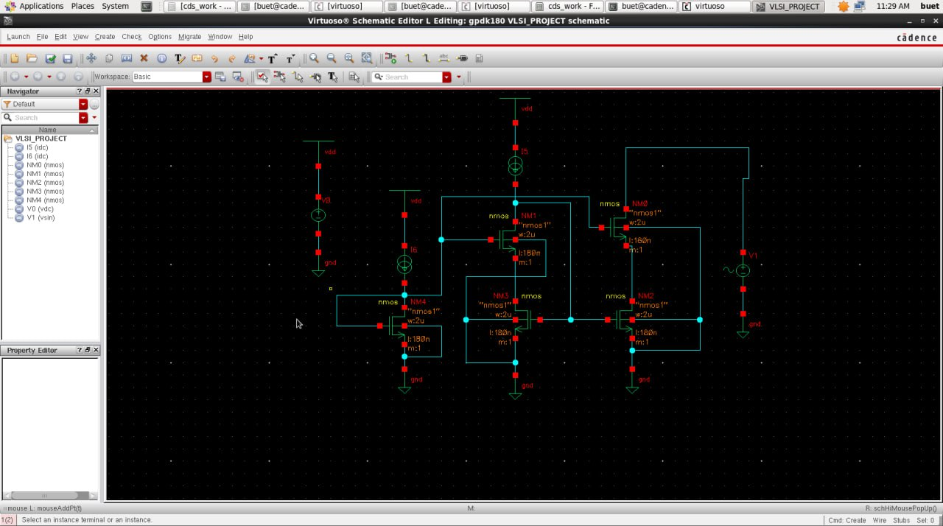

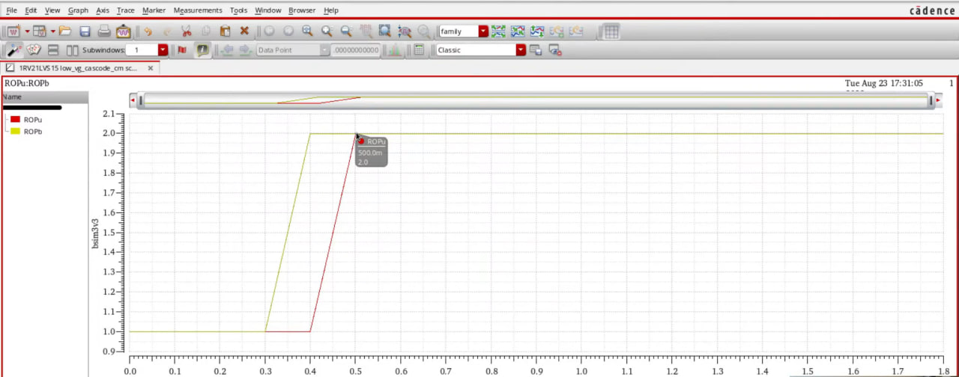

The DC analysis results clearly demonstrated the difference in output accuracy among the three current mirror topologies. The simple current mirror showed a noticeable drop in output current as the output voltage varied, highlighting its strong dependence on channel-length modulation. The Wilson mirror improved the output behavior by providing negative feedback, which reduced current deviation but did not completely eliminate it. The cascode mirror exhibited the most stable output current, maintaining nearly constant current even as the output voltage approached the lower limit of saturation.

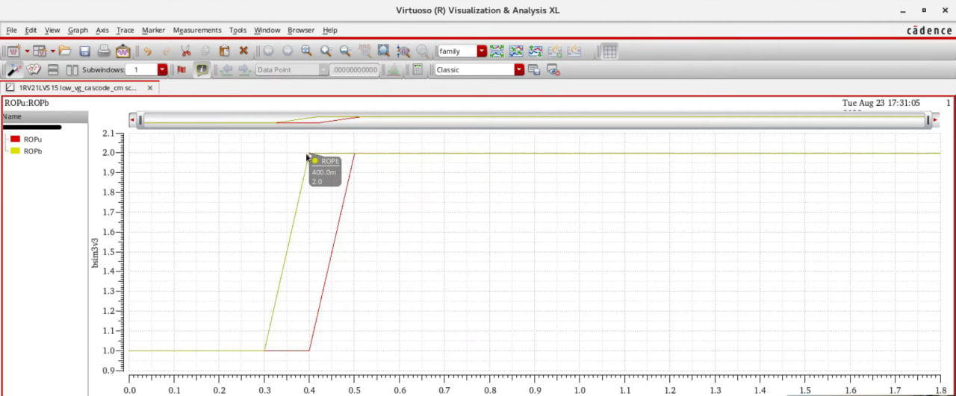

AC analysis further reinforced these findings. The simple current mirror displayed the lowest small-signal gain due to its limited output impedance. The Wilson mirror achieved a moderate improvement in gain, reflecting the additional feedback transistor that increased its effective output resistance. The cascode mirror produced the highest gain because its stacked transistors significantly raised the output impedance.

Noise simulations provided additional insight into the performance differences. At low frequencies, flicker noise was dominant in all topologies, but the simple mirror exhibited the highest levels due to larger voltage swings at the drain of the input device. The Wilson mirror offered slight noise reduction, but the cascode mirror produced the lowest flicker noise levels by keeping the input transistor’s drain voltage nearly constant.

Transient analysis and power measurements completed the evaluation. The simple mirror responded quickly to changes in reference current but suffered from poor settling accuracy and larger overshoot. The Wilson mirror showed a smoother response with improved stability. The cascode mirror achieved the most accurate and stable transient behavior, though with a slightly slower settling time due to increased node capacitances. Power consumption remained similar for all three mirrors at a given bias current, but the cascode structure required higher voltage headroom to keep all devices in saturation, indirectly increasing its minimum power requirement. Even with this limitation, the cascode mirror provided the best overall combination of accuracy, gain, noise performance, and stability.

CONCLUSION and FUTURE WORK

Conclusion:
This project successfully analyzed and compared the performance of simple, Wilson, and cascode current mirrors using Cadence Virtuoso in 180-nm CMOS technology. Through systematic simulations—including DC, AC, noise, transient, and post-layout analysis—the cascode current mirror was found to deliver the highest output resistance, most stable current replication, and significantly improved gain. Noise analysis showed that the cascode structure effectively suppressed low-frequency flicker noise, offering the cleanest output among the tested topologies. Although the cascode mirror required higher voltage headroom and exhibited slightly reduced bandwidth because of increased parasitic capacitance, its overall performance remained superior for precision analog applications.

The Wilson current mirror provided moderate improvements over the simple mirror, demonstrating better current matching and reduced dependence on output voltage, but it did not reach the performance level of the cascode structure. The simple current mirror served as a baseline and highlighted the limitations of basic current replication when used in modern analog designs. Post-layout results confirmed that parasitic effects slightly degrade performance, especially in cascode structures, but the overall trends remained consistent with pre-layout simulations. Overall, the study concludes that the cascode current mirror offers the best balance of accuracy, gain, and noise performance in the 180-nm technology node, making it highly suitable for analog and mixed-signal circuits where precision is critical.

Future Work:
There are several opportunities to extend and improve the current work. One important direction is to explore wide-swing cascode current mirrors, which preserve high output resistance while reducing voltage headroom requirements. This would make the design more suitable for low-voltage systems. Another extension could involve studying gain-boosted and regulated cascode structures, which further enhance output resistance and precision, especially in high-gain amplifier stages.

Future work could also focus on evaluating current mirror performance across different process corners, temperatures, and Monte Carlo mismatch simulations. This would give a more complete picture of reliability and expected variation in real-world scenarios. Additionally, implementing the design in advanced technologies such as 130 nm or 65 nm could provide insight into how short-channel effects impact mirror behavior in modern nodes. Finally, hardware fabrication and lab measurement of the designed mirrors would allow comparison between simulated and practical performance, providing valuable validation for analog IC design flows.

References

- B. Razavi, Design of Analog CMOS Integrated Circuits, McGraw-Hill, 2001.

- P. R. Gray, P. J. Hurst, S. H. Lewis, and R. G. Meyer, Analysis and Design of Analog Integrated Circuits, 5th Edition, Wiley, 2009.

- R. Jacob Baker, CMOS: Circuit Design, Layout, and Simulation, 3rd Edition, Wiley-IEEE Press, 2010.

- Behzad Razavi, Fundamentals of Microelectronics, 2nd Edition, Wiley, 2013.

- A. S. Sedra and K. C. Smith, Microelectronic Circuits, 7th Edition, Oxford University Press, 2015.

- Y. Tsividis and C. McAndrew, Operation and Modeling of the MOS Transistor, Oxford University Press, 2011.

- E. Sackinger and W. Guggenbuhl, “A High-Swing, High-Impedance MOS Cascode Circuit,” IEEE Journal of Solid-State Circuits, vol. 18, no. 6, pp. 630-633, 1983.

- K. Bult and G. J. G. M. Geelen, “A Fast-Settling CMOS Op-Amp for SC Circuits with 90-dB DC Gain,” IEEE Journal of Solid-State Circuits, vol. 25, no. 6, pp. 1379–1384, 1990.

- P. E. Allen and D. R. Holberg, CMOS Analog Circuit Design, 3rd Edition, Oxford University Press, 2011.

- R. Gregorian and G. C. Temes, Analog MOS Integrated Circuits for Signal Processing, Wiley, 1986.

- T. H. Lee, The Design of CMOS Radio-Frequency Integrated Circuits, Cambridge University Press, 2004.

- A. Hastings, The Art of Analog Layout, 2nd Edition, Prentice Hall, 2005.

- C. C. Enz and G. C. Temes, "Circuit Techniques for Reducing the Effects of Op-Amp Imperfections: Autozeroing, Correlated Double Sampling, and Chopper Stabilization," Proceedings of the IEEE, vol. 84, no. 11, pp. 1584–1614, 1996.

- B. Gilbert, “Precision Current Mirrors Using Bipolar Transistors,” IEEE Journal of Solid-State Circuits, vol. 3, no. 4, pp. 365–373, 1968.

- A. M. Abo and P. R. Gray, “A 1.5-V, 10-bit, 14.3-MS/s CMOS Pipeline Analog-to-Digital Converter,” IEEE Journal of Solid-State Circuits, vol. 34, no. 5, pp. 599–606, 1999.

- S. Yan and E. Sánchez-Sinencio, “Low Voltage Analog Circuit Design Techniques: A Tutorial,” IEICE Transactions on Fundamentals, vol. 83, no. 2, pp. 179–196, 2000.

- M. J. Deen and Z. Dang, “Low-Frequency Noise in Advance MOSFETs: Models and Measurement,” Microelectronics Reliability, vol. 45, no. 9–11, pp. 1443–1460, 2005.

- P. Kinget, “Device Mismatch and Tradeoffs in the Design of Analog Circuits,” IEEE Journal of Solid-State Circuits, vol. 40, no. 6, pp. 1212–1224, 2005.

- F. Maloberti, Analog Design for CMOS VLSI Systems, Kluwer Academic Publishers, 2001

- J. M. Rabaey, A. Chandrakasan, and B. Nikolic, Digital Integrated Circuits: A Design Perspective, 2nd Edition, Prentice Hall, 2003.

