FML Assign4

Sushma

2023-10-27

##Load the librabries  
  
library(factoextra)

## Loading required package: ggplot2

## Welcome! Want to learn more? See two factoextra-related books at https://goo.gl/ve3WBa

library(ggplot2)  
library(tidyverse)

## ── Attaching core tidyverse packages ──────────────────────── tidyverse 2.0.0 ──  
## ✔ dplyr 1.1.3 ✔ readr 2.1.4  
## ✔ forcats 1.0.0 ✔ stringr 1.5.0  
## ✔ lubridate 1.9.3 ✔ tibble 3.2.1  
## ✔ purrr 1.0.2 ✔ tidyr 1.3.0

## ── Conflicts ────────────────────────────────────────── tidyverse_conflicts() ──  
## ✖ dplyr::filter() masks stats::filter()  
## ✖ dplyr::lag() masks stats::lag()  
## ℹ Use the conflicted package (<http://conflicted.r-lib.org/>) to force all conflicts to become errors

library(ISLR)  
library(NbClust)  
library(cluster)

## Import the data from csv file.  
  
Pharmaceuticals <- read.csv("C:/Users/niyas/Downloads/Pharmaceuticals.csv")  
view(Pharmaceuticals)

## a. Use only the numerical variables (1 to 9) to cluster the 21 firms. Justify the various choices made in conducting the cluster analysis, such as weights for different variables, the specific clustering algorithm(s) used, the number of clusters formed, and so on.

##Create a new data frame 'A' by removing rows with missing values from 'Pharmaceuticals'  
A <- na.omit(Pharmaceuticals)  
##Generate a summary of the data in the 'A' data frame  
summary(A)

## Symbol Name Market_Cap Beta   
## Length:21 Length:21 Min. : 0.41 Min. :0.1800   
## Class :character Class :character 1st Qu.: 6.30 1st Qu.:0.3500   
## Mode :character Mode :character Median : 48.19 Median :0.4600   
## Mean : 57.65 Mean :0.5257   
## 3rd Qu.: 73.84 3rd Qu.:0.6500   
## Max. :199.47 Max. :1.1100   
## PE_Ratio ROE ROA Asset_Turnover Leverage   
## Min. : 3.60 Min. : 3.9 Min. : 1.40 Min. :0.3 Min. :0.0000   
## 1st Qu.:18.90 1st Qu.:14.9 1st Qu.: 5.70 1st Qu.:0.6 1st Qu.:0.1600   
## Median :21.50 Median :22.6 Median :11.20 Median :0.6 Median :0.3400   
## Mean :25.46 Mean :25.8 Mean :10.51 Mean :0.7 Mean :0.5857   
## 3rd Qu.:27.90 3rd Qu.:31.0 3rd Qu.:15.00 3rd Qu.:0.9 3rd Qu.:0.6000   
## Max. :82.50 Max. :62.9 Max. :20.30 Max. :1.1 Max. :3.5100   
## Rev_Growth Net_Profit_Margin Median_Recommendation Location   
## Min. :-3.17 Min. : 2.6 Length:21 Length:21   
## 1st Qu.: 6.38 1st Qu.:11.2 Class :character Class :character   
## Median : 9.37 Median :16.1 Mode :character Mode :character   
## Mean :13.37 Mean :15.7   
## 3rd Qu.:21.87 3rd Qu.:21.1   
## Max. :34.21 Max. :25.5   
## Exchange   
## Length:21   
## Class :character   
## Mode :character   
##   
##   
##

#Set row names of the data frame 'A' to the values in its first column  
row.names(A) <- A[,1]  
#Create a new data frame 'Pharma' containing columns 3 to 11 from 'A'  
Pharma <- A[,3:11]  
#Display the rows of the 'Pharma' data frame  
head(Pharma)

## Market_Cap Beta PE_Ratio ROE ROA Asset_Turnover Leverage Rev_Growth  
## ABT 68.44 0.32 24.7 26.4 11.8 0.7 0.42 7.54  
## AGN 7.58 0.41 82.5 12.9 5.5 0.9 0.60 9.16  
## AHM 6.30 0.46 20.7 14.9 7.8 0.9 0.27 7.05  
## AZN 67.63 0.52 21.5 27.4 15.4 0.9 0.00 15.00  
## AVE 47.16 0.32 20.1 21.8 7.5 0.6 0.34 26.81  
## BAY 16.90 1.11 27.9 3.9 1.4 0.6 0.00 -3.17  
## Net_Profit_Margin  
## ABT 16.1  
## AGN 5.5  
## AHM 11.2  
## AZN 18.0  
## AVE 12.9  
## BAY 2.6

# Scale the data in the 'Pharma' data frame to standardize variables  
Pharma1 <- scale (Pharma)  
# Display the rows of the scaled 'Pharma1' data frame  
head(Pharma1)

## Market_Cap Beta PE_Ratio ROE ROA Asset_Turnover  
## ABT 0.1840960 -0.80125356 -0.04671323 0.04009035 0.2416121 0.0000000  
## AGN -0.8544181 -0.45070513 3.49706911 -0.85483986 -0.9422871 0.9225312  
## AHM -0.8762600 -0.25595600 -0.29195768 -0.72225761 -0.5100700 0.9225312  
## AZN 0.1702742 -0.02225704 -0.24290879 0.10638147 0.9181259 0.9225312  
## AVE -0.1790256 -0.80125356 -0.32874435 -0.26484883 -0.5664461 -0.4612656  
## BAY -0.6953818 2.27578267 0.14948233 -1.45146000 -1.7127612 -0.4612656  
## Leverage Rev_Growth Net_Profit_Margin  
## ABT -0.2120979 -0.5277675 0.06168225  
## AGN 0.0182843 -0.3811391 -1.55366706  
## AHM -0.4040831 -0.5721181 -0.68503583  
## AZN -0.7496565 0.1474473 0.35122600  
## AVE -0.3144900 1.2163867 -0.42597037  
## BAY -0.7496565 -1.4971443 -1.99560225

# Visualize the Elbow Method for determining the optimal number of clusters (k) in k-means clustering and using the 'Pharma1' data and the "wss" (Within-Cluster Sum of Squares) method then Add a subtitle to the plot indicating it's the "Elbow Method."  
  
fviz_nbclust(Pharma1, kmeans, method = "wss") + labs(subtitle = "Elbow Method")

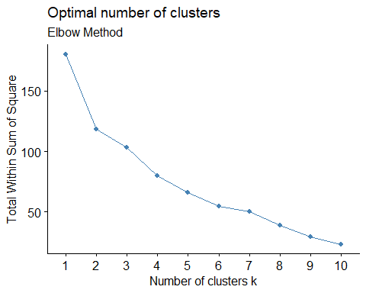

# Visualize the Silhouette Method for determining the optimal number of clusters (k) in k-means clustering and using the 'Pharma1' data and the "silhouette" method then Add a subtitle to the plot indicating it's the "Silhouette Method."  
  
fviz_nbclust(Pharma1, kmeans, method = "silhouette") + labs(subtitle = "silhouette Method")

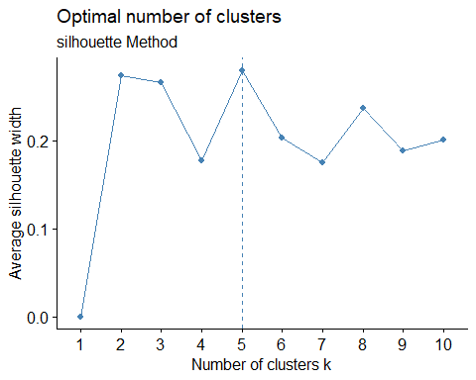

# Set the seed for reproducibility at 64060  
set.seed(64060)  
  
# Perform k-means clustering with 5 clusters and 25 different starting points  
k5 <- kmeans(Pharma1, centers = 5, nstart = 25)  
  
# Display the cluster centers for the 5 clusters  
k5$centers

## Market_Cap Beta PE_Ratio ROE ROA Asset_Turnover  
## 1 -0.87051511 1.3409869 -0.05284434 -0.6184015 -1.1928478 -0.4612656  
## 2 -0.43925134 -0.4701800 2.70002464 -0.8349525 -0.9234951 0.2306328  
## 3 -0.76022489 0.2796041 -0.47742380 -0.7438022 -0.8107428 -1.2684804  
## 4 -0.03142211 -0.4360989 -0.31724852 0.1950459 0.4083915 0.1729746  
## 5 1.69558112 -0.1780563 -0.19845823 1.2349879 1.3503431 1.1531640  
## Leverage Rev_Growth Net_Profit_Margin  
## 1 1.36644699 -0.6912914 -1.320000179  
## 2 -0.14170336 -0.1168459 -1.416514761  
## 3 0.06308085 1.5180158 -0.006893899  
## 4 -0.27449312 -0.7041516 0.556954446  
## 5 -0.46807818 0.4671788 0.591242521

# Visualize the results of k-means clustering using the 'fviz_cluster' function.  
  
fviz_cluster(k5, data = Pharma1)

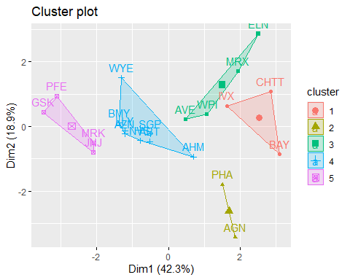

# Calculate the Euclidean distance matrix between observations in the 'Pharma1' dataset  
distance <- dist(Pharma1, method = "euclidean")  
  
# Visualizing the distance matrix using the 'fviz_dist' function  
fviz_dist(distance)

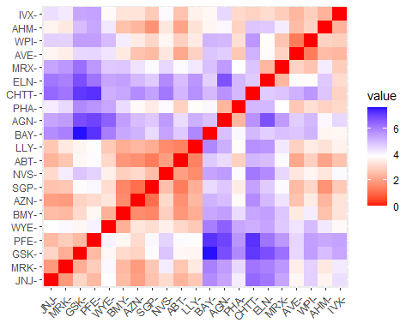

# Set the CRAN mirror to a specific location  
options(repos = c(CRAN = "https://cran.rstudio.com/"))

# Performing k-means clustering on the 'Pharma1' dataset to create 5 clusters  
fit <-kmeans(Pharma1, 5)  
  
# Calculate and aggregate the mean values of variables within each cluster  
aggregate(Pharma1, by = list(fit$cluster), FUN=mean)

## Group.1 Market_Cap Beta PE_Ratio ROE ROA  
## 1 1 1.69558112 -0.1780563 -0.1984582 1.2349879 1.3503431  
## 2 2 -0.66114002 -0.7233539 -0.3512251 -0.6736441 -0.5915022  
## 3 3 -0.96247577 1.1949250 -0.3639982 -0.5200697 -0.9610792  
## 4 4 -0.52462814 0.4451409 1.8498439 -1.0404550 -1.1865838  
## 5 5 0.08926902 -0.4618336 -0.3208615 0.3260892 0.5396003  
## Asset_Turnover Leverage Rev_Growth Net_Profit_Margin  
## 1 1.153164e+00 -0.4680782 0.4671788 0.5912425  
## 2 -1.537552e-01 -0.4040831 0.6917224 -0.4005718  
## 3 -1.153164e+00 1.4773718 0.7120120 -0.3688236  
## 4 1.480297e-16 -0.3443544 -0.5769454 -1.6095439  
## 5 6.589509e-02 -0.2559803 -0.7230135 0.7343816

# Create a new data frame 'Pharma2' by adding cluster assignments to 'Pharma1'  
Pharma2 <- data.frame(Pharma1, fit$cluster)  
Pharma2

## Market_Cap Beta PE_Ratio ROE ROA Asset_Turnover  
## ABT 0.1840960 -0.80125356 -0.04671323 0.04009035 0.2416121 0.0000000  
## AGN -0.8544181 -0.45070513 3.49706911 -0.85483986 -0.9422871 0.9225312  
## AHM -0.8762600 -0.25595600 -0.29195768 -0.72225761 -0.5100700 0.9225312  
## AZN 0.1702742 -0.02225704 -0.24290879 0.10638147 0.9181259 0.9225312  
## AVE -0.1790256 -0.80125356 -0.32874435 -0.26484883 -0.5664461 -0.4612656  
## BAY -0.6953818 2.27578267 0.14948233 -1.45146000 -1.7127612 -0.4612656  
## BMY -0.1078688 -0.10015669 -0.70887325 0.59693581 0.8617498 0.9225312  
## CHTT -0.9767669 1.26308721 0.03299122 -0.11237924 -1.1677918 -0.4612656  
## ELN -0.9704532 2.15893320 -1.34037772 -0.70899938 -1.0174553 -1.8450624  
## LLY 0.2762415 -1.34655112 0.14948233 0.34502953 0.5610770 -0.4612656  
## GSK 1.0999201 -0.68440408 -0.45749769 2.45971647 1.8389364 1.3837968  
## IVX -0.9393967 0.48409069 -0.34100657 -0.29136529 -0.6979905 -0.4612656  
## JNJ 1.9841758 -0.25595600 0.18013789 0.18593083 1.0872544 0.9225312  
## MRX -0.9632863 0.87358895 0.19240011 -0.96753478 -0.9610792 -1.8450624  
## MRK 1.2782387 -0.25595600 -0.40231769 0.98142435 0.8429577 1.8450624  
## NVS 0.6654710 -1.30760129 -0.23677768 -0.52338423 0.1288598 -0.9225312  
## PFE 2.4199899 0.48409069 -0.11415545 1.31287998 1.6322239 0.4612656  
## PHA -0.0240846 -0.48965495 1.90298017 -0.81506519 -0.9047030 -0.4612656  
## SGP -0.4018812 -0.06120687 -0.40231769 -0.21181593 0.5234929 0.4612656  
## WPI -0.9281345 -1.11285216 -0.43297324 -1.03382590 -0.6979905 -0.9225312  
## WYE -0.1614497 0.40619104 -0.75792214 1.92938746 0.5422849 -0.4612656  
## Leverage Rev_Growth Net_Profit_Margin fit.cluster  
## ABT -0.21209793 -0.52776752 0.06168225 5  
## AGN 0.01828430 -0.38113909 -1.55366706 4  
## AHM -0.40408312 -0.57211809 -0.68503583 2  
## AZN -0.74965647 0.14744734 0.35122600 5  
## AVE -0.31449003 1.21638667 -0.42597037 2  
## BAY -0.74965647 -1.49714434 -1.99560225 4  
## BMY -0.02011273 -0.96584257 0.74744375 5  
## CHTT 3.74279705 -0.63276071 -1.24888417 3  
## ELN 0.61983791 1.88617085 -0.36501379 3  
## LLY -0.07130879 -0.64814764 1.17413980 5  
## GSK -0.31449003 0.76926048 0.82363947 1  
## IVX 1.10620040 0.05603085 -0.71551412 3  
## JNJ -0.62166634 -0.36213170 0.33598685 1  
## MRX 0.44065173 1.53860717 0.85411776 3  
## MRK -0.39128411 0.36014907 -0.24310064 1  
## NVS -0.67286239 -1.45369888 1.02174835 5  
## PFE -0.54487226 1.10143723 1.44844440 1  
## PHA -0.30169102 0.14744734 -1.27936246 4  
## SGP -0.74965647 -0.43544591 0.29026942 5  
## WPI -0.49367621 1.43089863 -0.09070919 2  
## WYE 0.68383297 -1.17763919 1.49416183 5

# Create a cluster plot to visualize the clusters formed by k-means clustering  
clusplot(Pharma1, fit$cluster, color = TRUE, shade = FALSE, labels = 2, lines = 0)

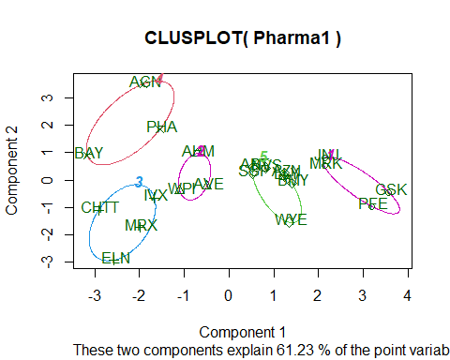

## b. Interpret the clusters with respect to the numerical variables used in forming the clusters.

#Among the companies that comprise Cluster 1 are #JNJ, MRK, PFE, and GSK; these companies have the largest market capitalizations and use financing to run their operations efficiently. (lower than 0.47 leverage).

#Due to their lowest asset turnover and beta values, the stocks of Cluster 2 companies, AHM, WPI, and AVE, have the potential to outperform the current market benchmark.

#They are the least capitalized company on the market, have the fastest revenue growth in Cluster 3, and are unable to even raise capital to support their operations. (MRX, CHTT, LVX, ELN). These business stocks’ strong returns can be attributed in part to their high beta values.

#Cluster 4: AGN, BAY, RHA Because of their highest expense to earnings ratio, they are the lowest earning. Additionally, their Return on Equity is less than 1, which suggests that it is unlikely that investing in these companies will yield the highest returns.

#The group is composed of #Cluster-5 ABT, SGP, NVS, AZN, BMY, and WYE. They have the lowest rate of sales development, the highest asset turnover, and the highest net profit margin. These businesses are prospering as a result of their growth.

## c. Is there a pattern in the clusters with respect to the numerical variables (10 to 12)? (those not used in forming the clusters)

#The stocks in Cluster-1 have a mediocre personality; they are neither strong nor have they recently produced noteworthy returns.

#The businesses in Cluster-2 are evenly distributed over the world. Despite their sound technical foundation, the media has largely embraced their concepts.

#Cluster 3-Despite having a high leverage ratio, they are only moderately advised due to the security of their finances.

#Shares in Group-4 The media claims that should be preserved because they will eventually turn into priceless assets.

#Cluster No. 5: It is advised that companies having a high net profit margin stay in the cluster for a long time.

## d. Provide an appropriate name for each cluster using any or all of the variables in the dataset.

#Cluster 1: A workable strategy (since these are reputable stocks).

#Cluster-2 is a collection of gold miners, despite their low beta, the market is very bullish on them.

#The original configuration, or #Cluster-3 (stocks with solid financial and other fundamentals).

#Cluster-4: The original setup (stocks with solid fundamentals, including financials).

#cluster 5 is the recurring cluster. Adding the stocks to the portfolio is highly recommended because a significant net profit margin indicates that the business is performing well.