A

SYNOPSIS

ON

**EVENT MANAGEMENT SYSTEM**

MCSP-060

MCA

**INDIRA GANDHI NATIONAL OPEN UNIVERSITY**

**NEW DELHI**



SUBMITTED BY

**SUSHMA KUMARI JAISWAL**

**MCA 6TH SEM**

**(173566621)**

UNDER GUIDENCE OF

KISHORE KUMAR

**INDEX**

|  |  |
| --- | --- |
|  |  |
|  |  |
|  |  |
|  |  |
|  |  |
|  |  |
|  |  |
|  |  |
|  |  |
|  |  |
|  |  |
|  |  |
|  |  |

## **INTRODUCTION OF EVENT MANAGEMENT SYSTEM**

**Event Management System** is developed as a web-based application developed in PHP. It facilitates online booking of events like birthday’s, weddings, anniversary,seminars,official functions and other small programs like kitty party. It includes all the features and functions needed to efficiently manage an event. It includes an administrator account which is used to handle/control all the system functionality. The system keeps track of event status and advance bookings. The system keeps records of event bookings along with associated event details and customer contacts in a well maintained database. The administrator can easily check the event bookings and timings in the system guide. The system also allows notifies when new event timing draws near. The system should able to handle any sort of query, get information for it and should be able to store all the related data into the database. Each user would be able to get information from the system according to their requirements and at any time. It should tell about the status of the entire Event. Through this computerized system all the activities of the proceedings can be managed efficiently by the user and in quickest possible time.

**BACKGROUND:**

**Event management** is a prime task for an organisation to achieve its goals of maintaining event properly and successfully. A web-based system of managing event, we accepted to help various facilities keep and update on the status of their event and tools. In designing such a web based system HTML, CSS, JavaScript as developing language and MYSQL as a backend database with PHP implemented for the interface.

**OBJECTIVES:**

The main objective of the **Event Management System** is to manage the detail of Booking dates, Booking auditorium hall, Customers, Payment, Catering, Decoration etc. It manages all the information about payment, inventory, auditorium. The project is totally built at administrative end and thus only the administrator is guaranteed the access. The purpose of the project is to build an application program to reduce the manual work for managing the payment, Booking, Dates, Inventory ,Booking .It tracks all the details about the Booking, Customers, and halls.

**OVERVIEW:**

**Event management** refers to the process of booking hall for a event and store the detail of customer and booking dates and payments. These includes the management of events, decorators, caterors, auditorium halls.

**EXISTING SYSTEM:**

In the existing system, there is a lot of paper work; it is very time consuming and uneconomical as most of the works include manual processing. The records are difficult to store in manual system, and it requires more manual labour work.

**PURPOSED SYSTEM:**

In the proposed event management system, everything is web-based. This will immediately reduce the manual processing, thereby increasing the speed of event management process. There are various functions and modules in the system to perform various features. This overall increases management productivity, eliminate paper works, reduce manpower, and prove to be very economical in the long run.

**SPECIFIC REQUIREMENT:-**

**SOFTWARE REQUIREMENTS**

Operating system : windows 2007/2010 or Linux

User Interface : HTML/CSS

Client-side scripting : Java Script

Programming language : PHP

Web Server : XAMPP server

Database : MY SQL

Software : XAMPP/WAMP

Web Browser : Mozilla, Google Chrome

**HARDWARE REQUIREMENTS:**

1. Computer 512 MB+ RAM, Monitor with minimum resolution of 1024*768 keyboards, and mouse.
2. Hard Drive should be in NTFS file-system formatted with minimum 10GB of free space.

**FUNCTIONAL SPECIFICATION**

**USER SPECIFICATION:**

**ADMIN:** Admin can add new auditorium hall, event manager, and manage the event package and payment and also view the feedback and enquiry.

**USER:** User can view information of available auditorium hall for event and track their own booking ,easily book and pay and give feedback and enquiry.

**MODULE SPECIFICATION:**

**ADMIN:**

It has admin login who is has the authority of the system and he is responsible for approving and disapproving the users request for event booking. Admin can add and delete notifications and updates in the system.

Name: Name of Admin.

Admin ID: It will be a unique value which will act as the primary key.

Email ID: For contacting purpose.

**USER:**

There is user registration form available where new users can create their account by providing required information to the system.

**MANAGER:**

Manager is secondary user after admin, which will interact with the system and see the detail of user and different event hall and booking of events and payments.

Name: Name of Manager.

ID: It will be unique value which will act as the primary key.

Email id: For contacting purpose

**Auditorium Booking Hall:**

User can request for the booking for a particular date. Subsequently the system will generate the total cost incurred for the expected days.

**Approving/Disapproving Request:**

The booking requests are directly sent to admin account by the system. Admin can view all the requests along with respective user details and therefore make decisions for approving or disapproving the requests.

**Email Notification:**

The system will inform the respective customers through an email about their status of booking request whether approved or disapproved. Also it mails user their respective receipts.

**DATA FLOW DIAGRAM**



# **0 LEVEL**

EVENT MANAGEMENT









**1ST LEVEL**

**2ND LEVEL**

**ENTITY RELATIONSHIP DIAGRAM**

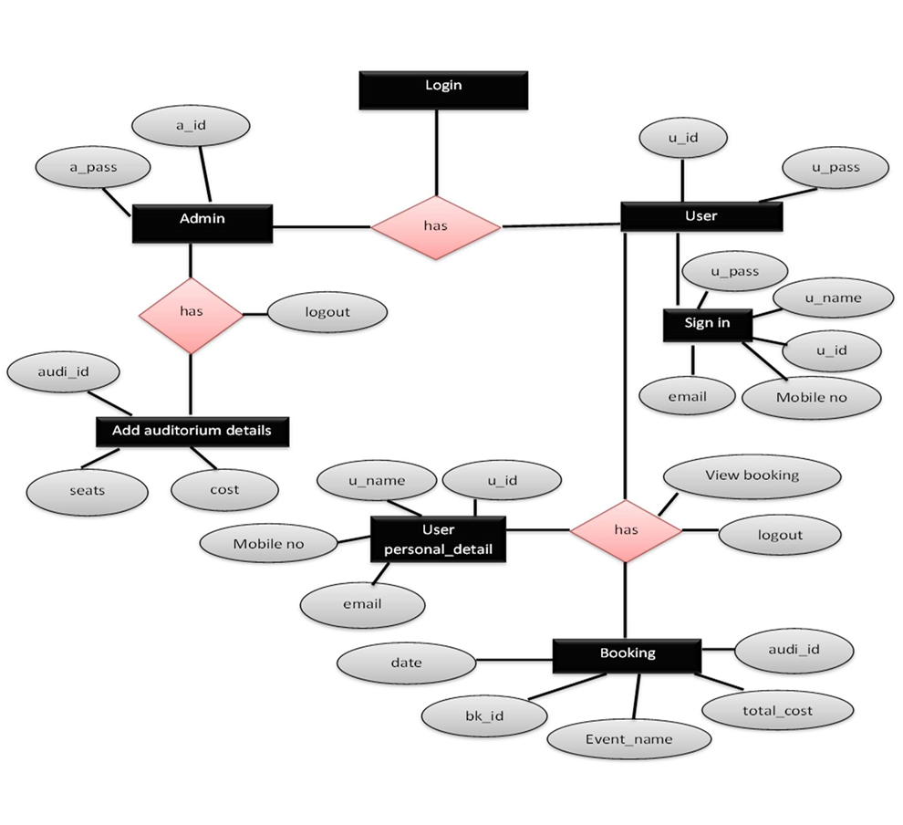

**CLASS DIAGRAM**

**GANTT CHART**

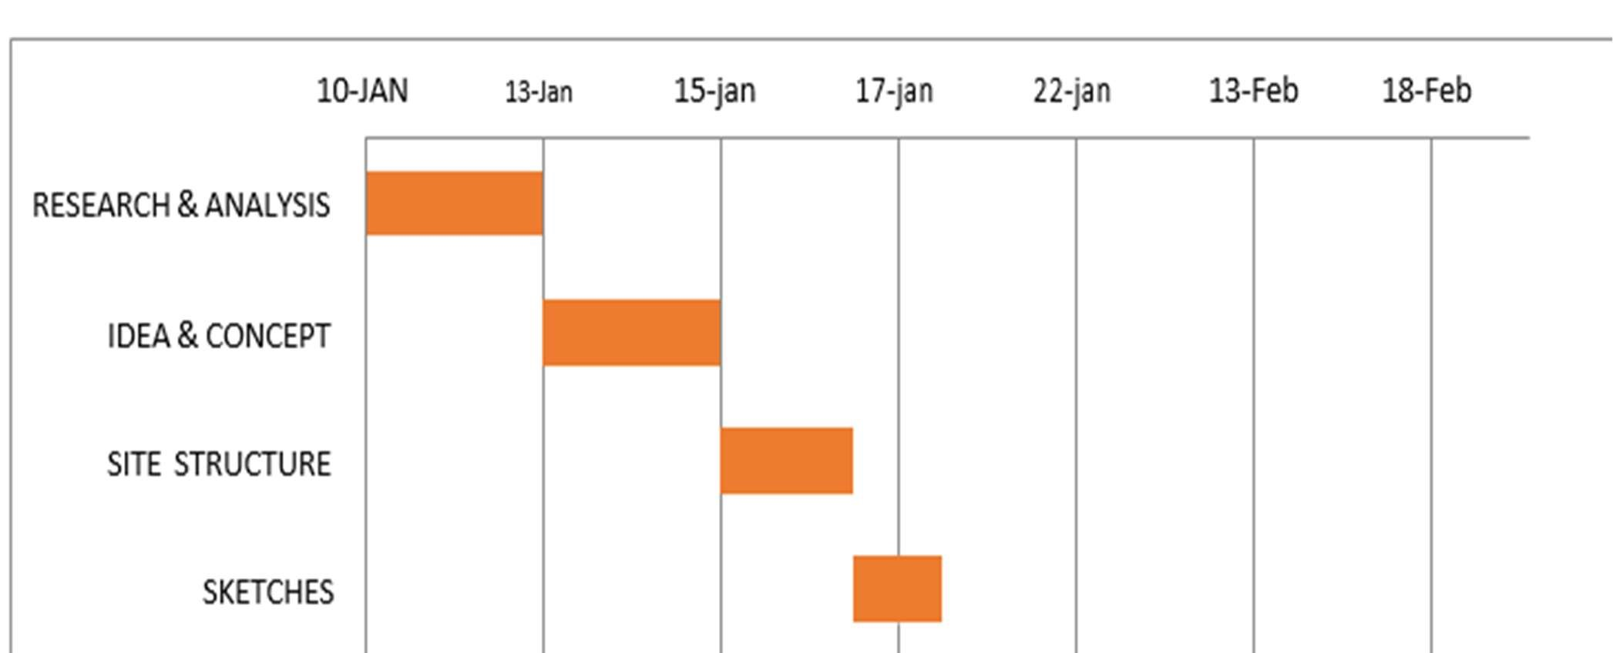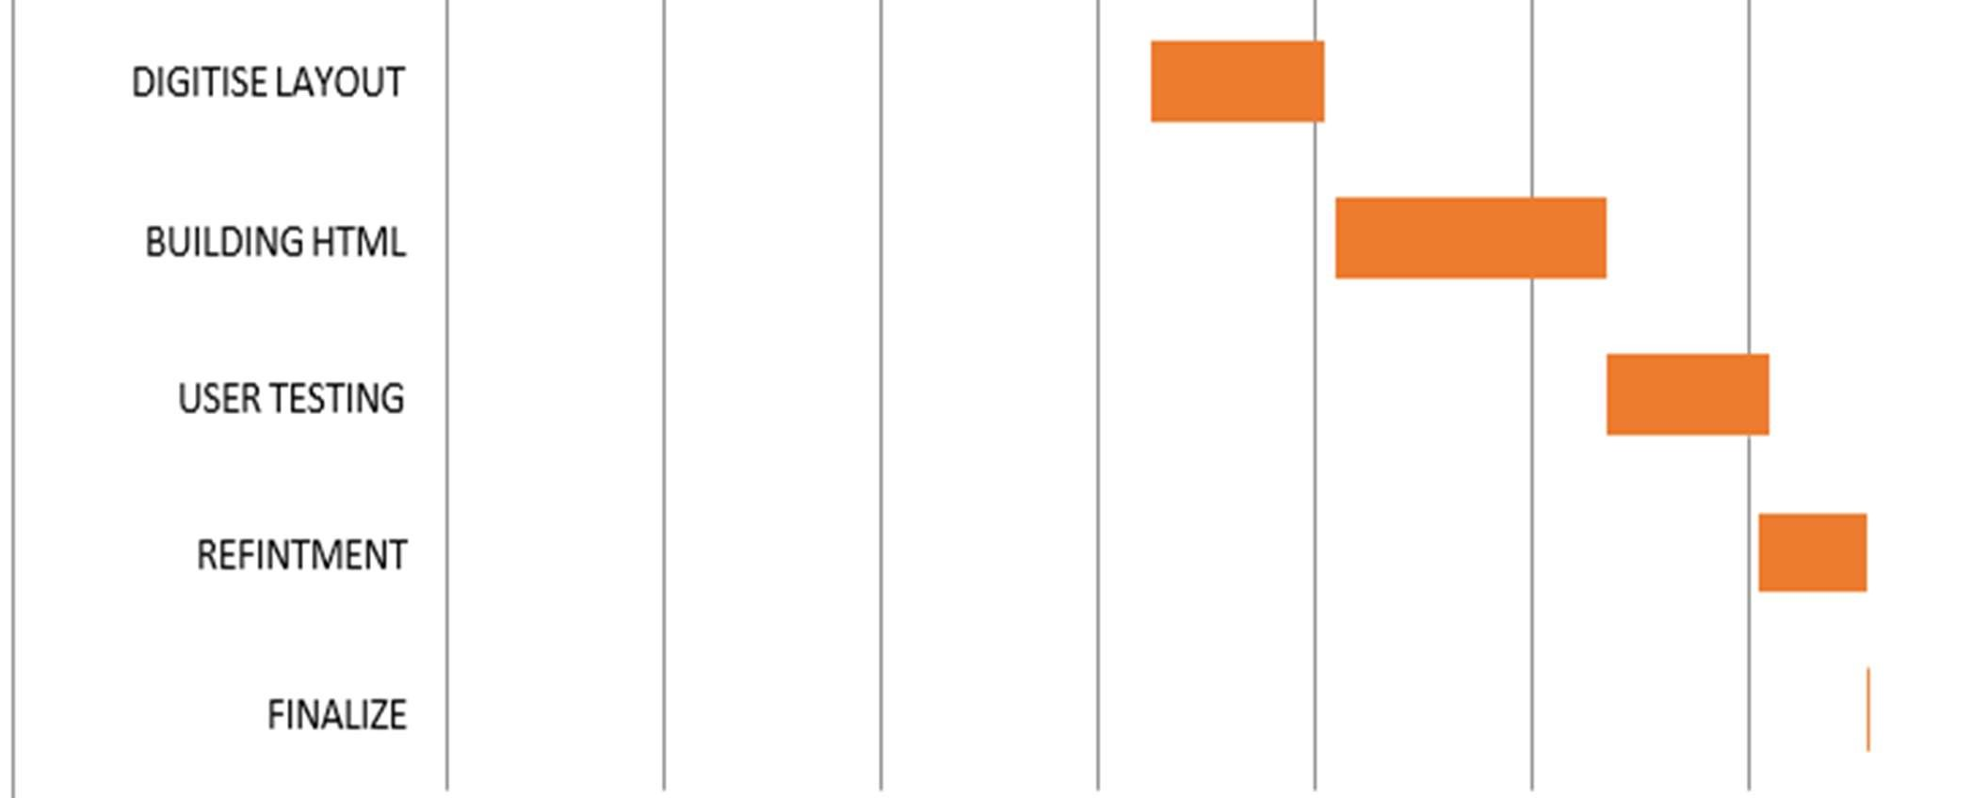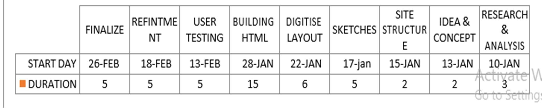

**DATA DICTIONARY**

**TABLE:ADMIN**

|  |  |  |  |
| --- | --- | --- | --- |
| **FIELD NAME** | **DATA TYPE** | **CONSTRAINTS** | **SIZE** |
| ID | INTEGER | PRIMARY KEY | 20 |
| NAME | VARCHAR |  | 25 |
| PASSWORD | VARCHAR | NOT NULL | 25 |

**TABLE:MANAGER**

|  |  |  |  |
| --- | --- | --- | --- |
| **FIELD NAME** | **DATA TYPE** | **CONSTRAINTS** | **SIZE** |
| ID | INTEGER | PRIMARY KEY | 20 |
| NAME | VARCHAR |  | 25 |
| PASSWORD | VARCHAR | NOT NULL | 25 |

**TABLE:USER LOGIN**

|  |  |  |  |
| --- | --- | --- | --- |
| **FIELD NAME** | **DATA TYPE** | **CONSTRAINTS** | **SIZE** |
| USERID | INTEGER | PRIMARY KEY | 20 |
| PASSWORD | VARCHAR | NOT NULL | 20 |
| USERTYPE | VARCHAR | NOT NULL | 20 |
| USERNAME | VARCHAR | NOT NULL | 20 |
| EMAIL | VARCHAR | NOT NULL | 20 |

**TABLE:EVENT DETAILS**

|  |  |  |  |
| --- | --- | --- | --- |
| **FIELD NAME** | **DATA TYPE** | **CONSTRAINTS** | **SIZE** |
| E_ID | INTEGER | PRIMARY KEY | 20 |
| E_TYPE | VARCHAR | NOT NULL | 25 |
| DATE | DATE | NOT NULL |  |

**TABLE:ADD AUDITORIUM DETAIL**

|  |  |  |  |
| --- | --- | --- | --- |
| **FIELD NAME** | **DATA TYPE** | **CONSTRAINTS** | **SIZE** |
| AUDI_ID | INTEGER | PRIMARY KEY | 20 |
| AUDI_NAME | VARCHAR | NOT NULL | 30 |
| SEATS | INTEGER | NOT NULL | 100 |
| PRICE | INTEGER | NOT NULL | 100 |
| ADDRESS | VARCHAR |  | 50 |

**TABLE:PAYMENT**

|  |  |  |  |
| --- | --- | --- | --- |
| **FIELD NAME** | **DATA TYPE** | **CONSTRAINTS** | **SIZE** |
| PAYMENT_ID | INTEGER | PRIMARY KEY | 50 |
| PAYMENT_DATE | DATE |  |  |
| AMOUNT | INTEGER |  | 100 |
| USERID | VARCHAR | FOREIGN KEY | 20 |

**TABLE:SEARCH**

|  |  |  |  |
| --- | --- | --- | --- |
| **FIELD NAME** | **DATA TYPE** | **CONSTRAINTS** | **SIZE** |
| SEARCHBYEVENT | VARCHAR |  | 30 |

**TABLE:BOOKING DETAILS**

|  |  |  |  |
| --- | --- | --- | --- |
| **FIELD NAME** | **DATA TYPE** | **CONSTRAINTS** | **SIZE** |
| B_ID | INTEGER | PRIMARY KEY | 50 |
| USERID | INTEGER | FOREIGN KEY | 20 |
| E_ID | INTEGER | FOREIGN KEY | 20 |
| E_TYPE | VARCHAR | FOREIGN KEY | 30 |
| NAME | VARCHAR | NOT NULL | 50 |
| EMAIL | VARCHAR | NOT NULL | 30 |
| CONTACT_NO | INTEGER | NOT NULL | 20 |
| ADDRESS | VARCHAR | NOT NULL | 50 |
| PRICE | INTEGER | NOT NULL | 50 |
| DAY | INTEGER | NOT NULL | 10 |
| DATE | DATE | NOT NULL | 10 |

**TABLE:BOOKING STATUS**

|  |  |  |  |
| --- | --- | --- | --- |
| **FIELD NAME** | **DATA TYPE** | **CONSTRAINTS** | **SIZE** |
| E_ID | INTEGER | NOT NULL | 20 |
| AUDI_ID | INTEGER | NOT NULL | 20 |
| DATE | INTEGER | NOT NULL | 20 |
| DAY | INTEGER | NOT NULL | 20 |

**TABLE:FEEDBACK**

|  |  |  |  |
| --- | --- | --- | --- |
| **FIELD NAME** | **DATA TYPE** | **CONSTRAINTS** | **SIZE** |
| FEEDBACK | VARCHAR |  | 250 |

**FUTURE SCOPE**

The software is very flexible; which can easily be modified as per future requirement. The system may include the online customer facility if needed. The prototype development may extend to similar organization, contributing their services in organizing various self-employment oriented course.

The phases of “Event Management System” application were started with a definite goal. At the end of that phase, not only does there exists a bridge for the next phase, it is also made sure that the set goal is achieved giving the next phase a concrete base.

The main goal of the “Event Management System” application is to automate the existing manual data processing system. The development of software is not an end in itself but only a means to an end. With this application, a hard copy of each Report is sent from one branch to another and it is keyed in again. So this part of the application needs automation and can be considered for future enhancements and can be carried out in either of the two suggested ways –

Sending of report can be avoided by making it web-enabled or a single server concept can be adopted. There are future enhancement am going to do in the system. And may be some other kind future changes will be possible in the system also.

**CONCLUSION**

While developing the system a conscious effort has been made to create and develop a software package making use of available tools , techniques and resources that would generate a proper System.

While making the system an eye has been kept on making it as user friendly ,as cost effective and as flexible as possible. As such one may hope that the system will be acceptable to any user and will adequately meet her/his needs.

As in case of system development processes where there are a number of shortcomings ,there have been some short coming in the development of this system also .The project is still under modification.

**BIBLIOGRAPHY**

Website http://www.goggle.com http://www.wikipedia.org http://www.codeproject.com

Books

Java Complete Reference: Herbert Shield

Database Programming with JDBC and Java:

George Reese