INDEX

|  |  |  |
| --- | --- | --- |
| SI.NO | TOPICS NAME | PAGE NO |
| 1. | Introduction | 5 |
| 2. | Features | 6 |
| 3. | Objectives | 7 |
| 4. | Language used | 8 |
| 5. | DFD | 9-10 |
| 6. | ERD | 11 |
| 7. | GNATT CHART | 12 |
| 8. | Software and Hardware Requirements | 13 |
| 9. | Table structure | 14- 15 |
| 10. | Future scope and future enhancement | 16 |
| 11. | Login | 17 |
| 12. | Homepage | 18 |
| 13. | Booking | 19 |
| 14. | Booking form | 20 |
| 15. | Profile | 21 |
| 16. | Admin panel | 22 |
| 17. | Contact | 23 |
| 18. | BIBLIOGRAPHY | 24 |

# INtroDuctIoN of thE ProjEct

This system is an auditorium management software projects. It includes all the features and functions needed to efficiently manage an auditorium. It includes an administrator account which is used to handle/control all the system functionality. The system keeps track of auditorium status and advance bookings. The system keeps records of auditorium bookings along with associated event details and customer contacts in a well maintained database. The administrator can easily check the auditorium bookings and timings in the system guide. The system also allows notifies when new event timing draws near.

The system should able to handle any sort of query, get information for it and should be able to store all the related data into the database. The user will be totally abstracted from the complexity and backend working of the screen .As they don’t need to know how and why a particular work is being carried out.

Each user would be able to get information from the system according to their requirements and at any time. It should tell about the status of the entire Auditorium. Through this computerized system all the activities of the proceedings can be managed efficiently by the user and in quickest possible time.

# fEaturEs of thE systEm

* Admin login and admin dashboard: It has admin login who is has the authority of the system and he is responsible for approving and disapproving the users request for auditorium booking. Admin can add and delete notifications and updates in the system.

* User Registration: There is user registration form available where new users can create their account by providing required information to the system.

* Booking System: User can request for the booking for a particular date. Subsequently the system will generate the total cost incurred for the expected days.
* Approving/Disapproving Request: The booking requests are directly sent to admin account by the system. Admin can view all the requests along with respective user details and therefore make decisions for approving or disapproving the requests.

# objEctIvE of thE ProjEct

The main objective of the Auditorium Management System is to manage the detail of Payment, Booking dates, Booking, customers, Auditorium. It manages all the information about payment, inventory, Auditorium. The project is totally built at administrative end and thus only the administrator is guaranteed the access. The purpose of the project is to build an application program to reduce the manual work for managing the payment, Booking, Dates, Inventory, Booking. It tracks all the details about the Booking, Customers and halls.

* The system is useful as it calculates an exact cost for requested number of days.

* It is convenient for user as he do not have to actually visit the place.

* This system is effective and saves time and cost of the users.

* Easy registration.

## LaNguagE usED:-

* HTML
* CSS
* JAVA SCRIPT
* PHP
* MY SQL

### Front End:-HTML

* HTML is the standard markup language for creating Web pages.
* HTML stands for Hyper Text Markup Language.
* HTML describes the structure of Web pages using markup.
* HTML elements are represented by tags.
* HTML tags label pieces of content such as "heading", "paragraph", "table", and so on.

### Back End:-PHP

* PHP is an acronym for "PHP: Hypertext Preprocessor".
* PHP is a widely-used, open source scripting language.
* PHP scripts are executed on the server.
* PHP is free to download and use.

PHP files can contain text, HTML, CSS, JavaScript, and PHP code.

PHP codes are executed on the server, and the result is returned to the browser as plain HTML. PHP files have extension”.php”.

## ZEro-LEvEL DfD



Auditorium

management

System



Booking

management



Login management



User

management



Admin panel



Enquiry management



Profile management

### fIrst-LEvEL DfD



User



Event

booking



Request

Cancel request if

no seat available



Calculate

the

amount



Auditorium

details

Availability info

Enquiry

Booking

status



Preparation

of booking

statement

Admin

ad



Confirm if

available

Booking

details

Cost

Booking charges

Booking approval

Package

Package

statement

Modify/Add details

1.1

1.2

1.3

## Er-DIagram

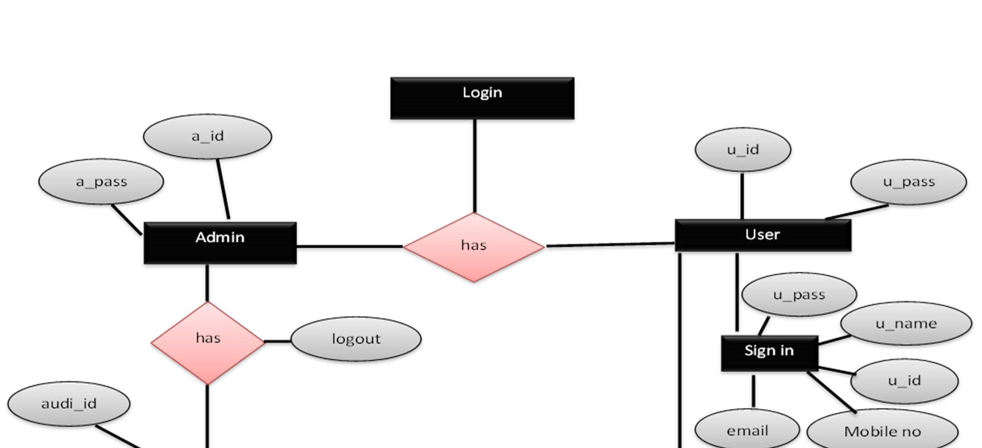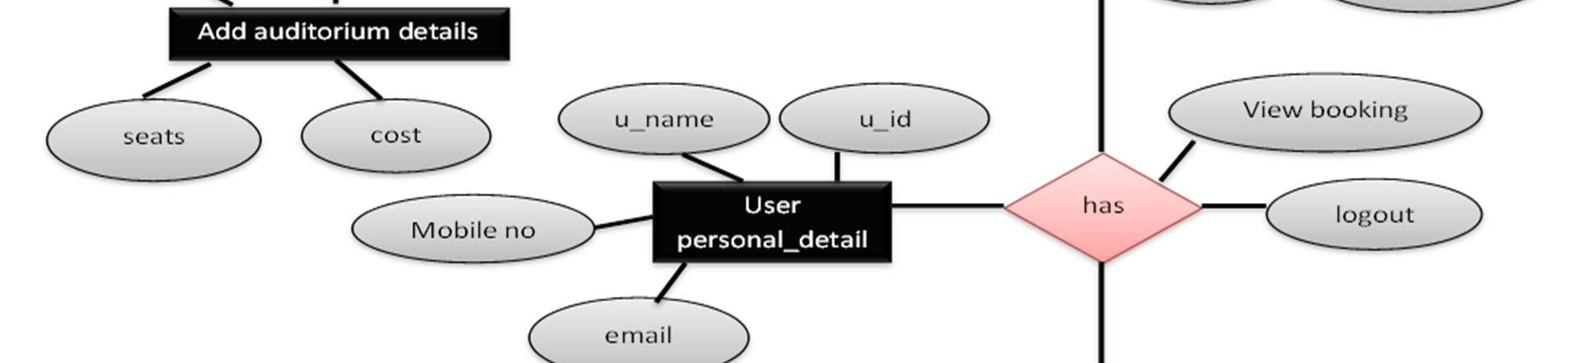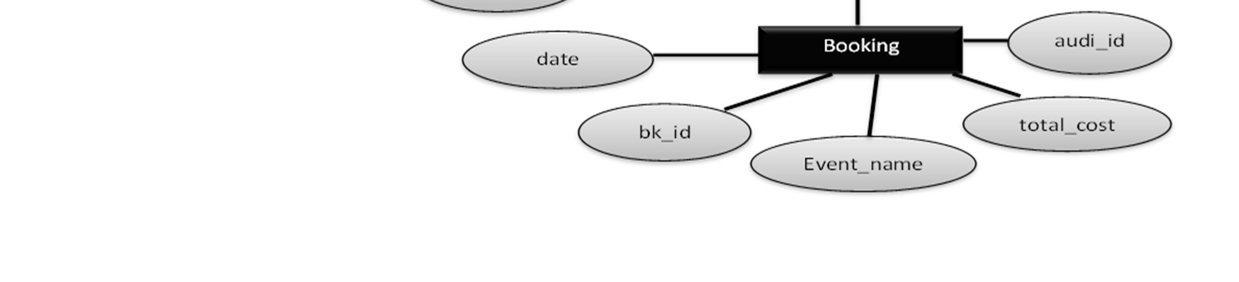

## gaNtt chart

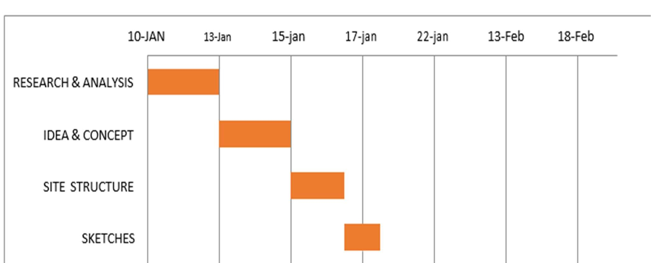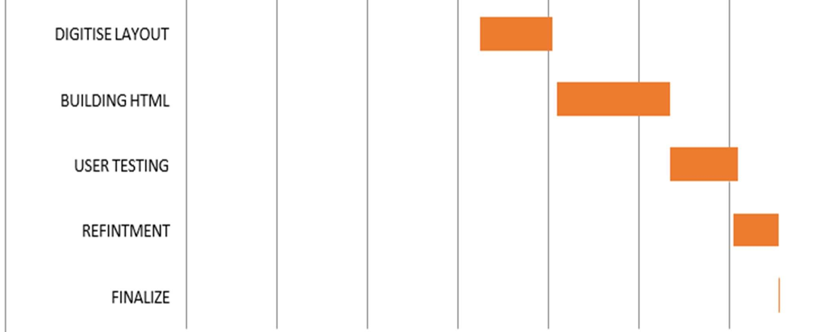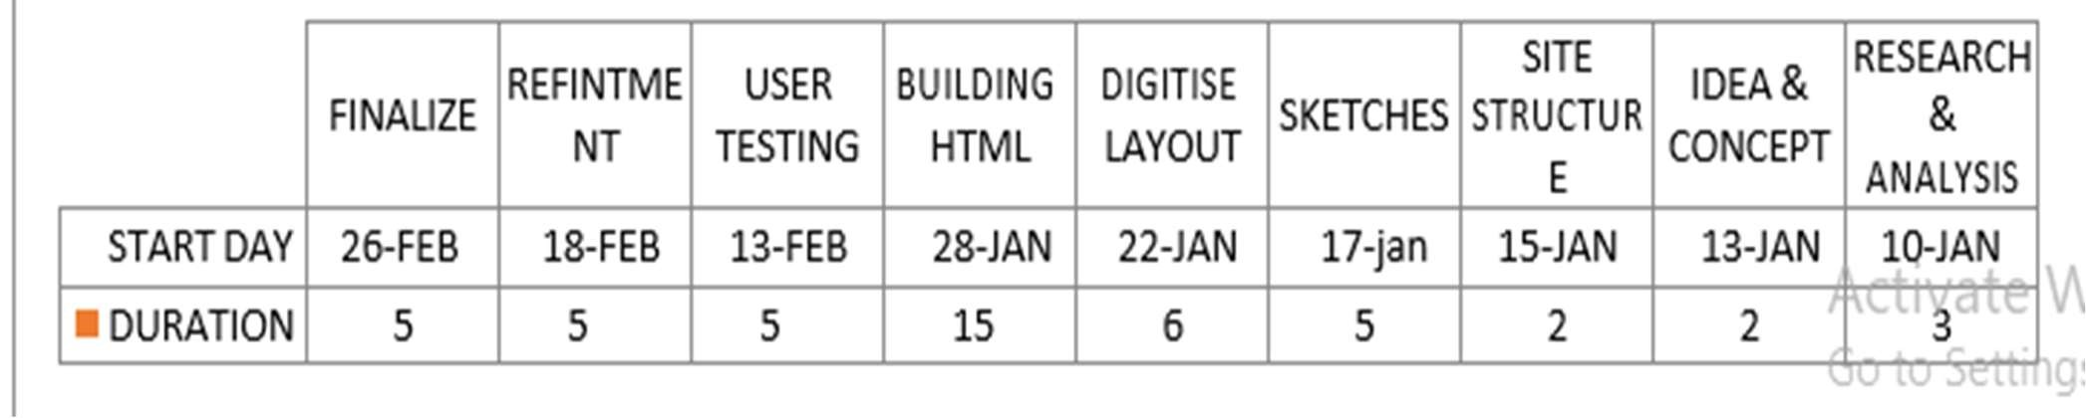

Software and Hardware Requirements: -

The following requirements relate to code installation only. The Auditorium Booking Manager products are web-based applications designed to run on a PHP/MySQL/XAMPP server. This can either be your own server or a hosted account.

### Server Requirement:-

* Operating Systems: Win98 / NT / 2000 / XP / Linux / Solaris / HP-UX.
* Server:XAMPP Server.
* Server Side: PHP (builds compatible with the standard API).
* Database: MySQL.

### Hardware Requirement:-

1. Computer 512 MB+ RAM, Monitor with minimum resolution of 1024*768 keyboards, and mouse.
2. Hard Drive should be in NTFS file-system formatted with minimum 10GB of free space.

# tabLE sructurE

## Add Auditorium Details Table

|  |  |  |  |
| --- | --- | --- | --- |
| Field name | Data type | Size | Key constraints |
| Audi_id | Varchar | 50 | Pk |
| Audi_name | varchar | 50 |  |
| Seats | Int | 100 | --- |
| Price | Int | 100 | --- |
| Address | varchar | 50 |  |

## User login Table

|  |  |  |  |
| --- | --- | --- | --- |
| Field name | Data type | Size | Key constraints |
| Userid | int | 20 | Pk |
| usertype | Varchar | 20 | -- |
| Username | varchar | 20 |  |
| email | varchar | 20 |  |
| password | varchar | 20 |  |

## Booking

|  |  |  |  |
| --- | --- | --- | --- |
| Field name | Data type | Size | Key constraints |
| bid | Varchar | 50 | Pk |
| uid | Varchar | 50 | Fk |
| name | Varchar | 100 | --- |
| address | Varchar | 500 | --- |
| A_no | varchar | 20 | -- |
| C_no | varchar | 20 | -- |
| Date | Date | 100 | --- |
| Email | Varchar | 100 | --- |
| A_id | Varchar | 50 | -- |
| seat | Varchar | 50 | -- |
| event | Varchar | 50 | -- |
| price | Varchar | 50 | -- |
| Slot1 | Varchar | 10 | -- |
| Slot2 | Varchar | 10 | -- |
| Slot3 | Varchar | 10 | -- |
| Slot4 | Varchar | 10 | -- |
| payment | Varchar | 50 | -- |
| bdate | date | -- | -- |

## Booking status

|  |  |  |  |
| --- | --- | --- | --- |
| Field name | Data type | Size | Key constraints |
| aid | Varchar | 20 | Fk |
| date | date | -- | --- |
| Slot1 | Varchar | 10 | --- |
| Slot2 | Varchar | 10 | --- |
| Slot3 | Varchar | 10 | -- |
| Slot4 | Varchar | 10 | -- |

## futurE scoPE aND furthEr ENhaNcEmENt: -

The software is very flexible; which can easily be modified as per future requirement. The system include the online customer facility . The prototype development may extend to similar organization, contributing their services in organizing various self-employment oriented course.

The phases of “Auditorium Management System” application were started with a definite goal. At the end of that phase, not only does there exists a bridge for the next phase, it is also made sure that the set goal is achieved giving the next phase a concrete base.

The main goal of the “Auditorium Management System” application is to automate the existing manual data processing system. The development of software is not an end in itself but only a means to an end. With this application, a hard copy of each Report is sent from one branch to another and it is keyed in again. So this part of the application needs automation and can be considered for future enhancements and can be carried out in either of the two suggested ways –

Sending of report can be avoided by making it web-enabled or a single server concept can be adopted. There are future enhancement am going to do in the system. And may be some other kind future changes will be possible in the system also.

### LogIN

This page is used to log in the project. There are two user type Admin & User. they can log in by using there username and password.

User just book, modify and cancel the auditorium booking

Whereas admin can add new auditorium, delete auditorium, change price and add new user.

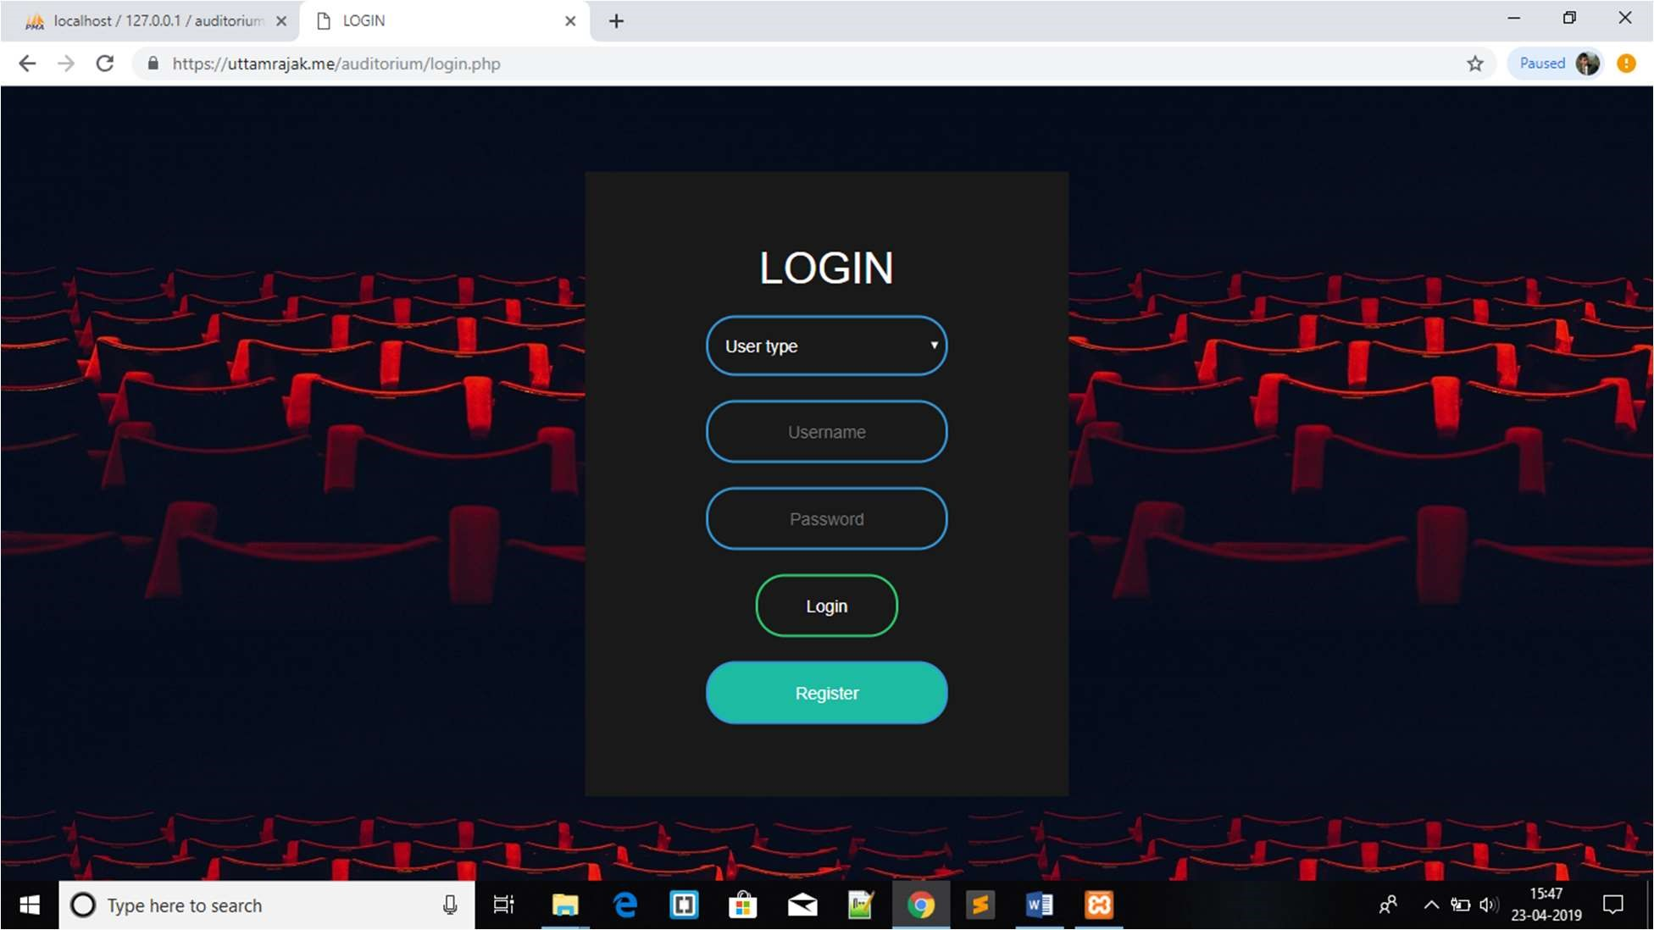

### homEPagE

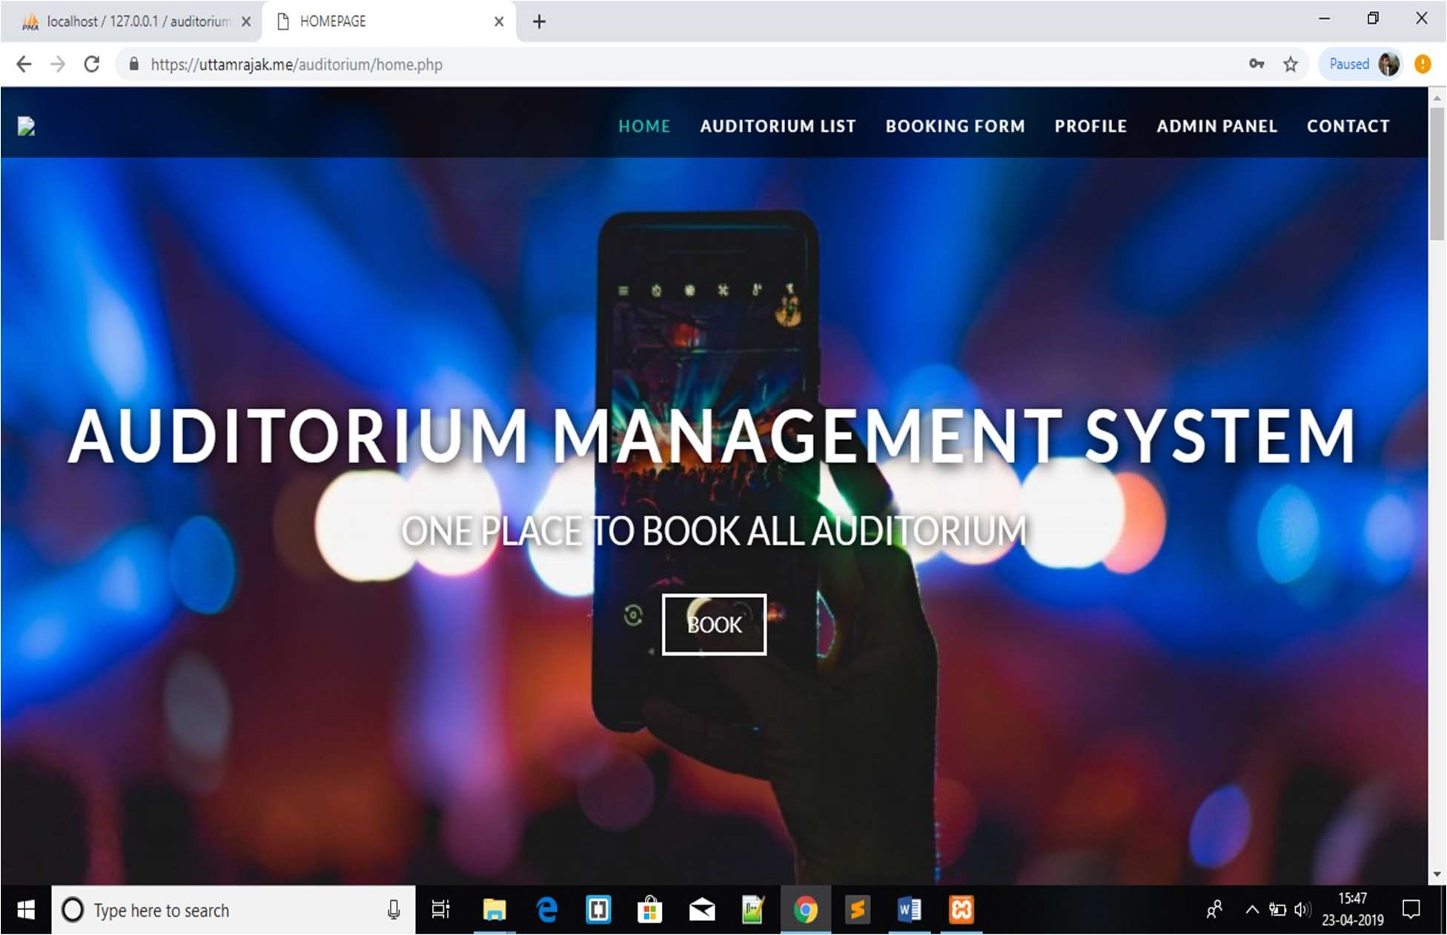

This is a single page website. If you click on the option shows in navbar it will automatically redirect you to the chosen area. or if you scroll down the page then according to area the option in navbar automatically shift.

If you click on BOOK button. It will redirect you to the booking page.

### booKINg

For booking first you have to select the auditorium from dropdown menu. Then select the date and click on go. Then the time slot appears.

You have to select time slot according to your choice if the time slot is available the it turns into green color if the time slot is not available then it turns into red. Then click on next to fill the booking form.

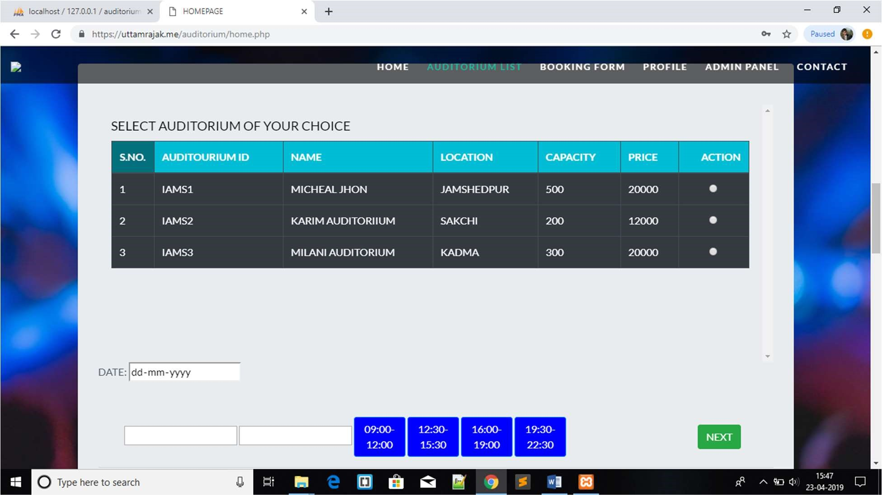

### booKINg form

After checking the available time slots we have to fill the booking form where you have to give your name, contact no, address and auditorium price and capacity will be appears automatically according to selected auditorium. At final page final amount will show which you have to pay. After click on final submit a Booking ID will be given to the customer.

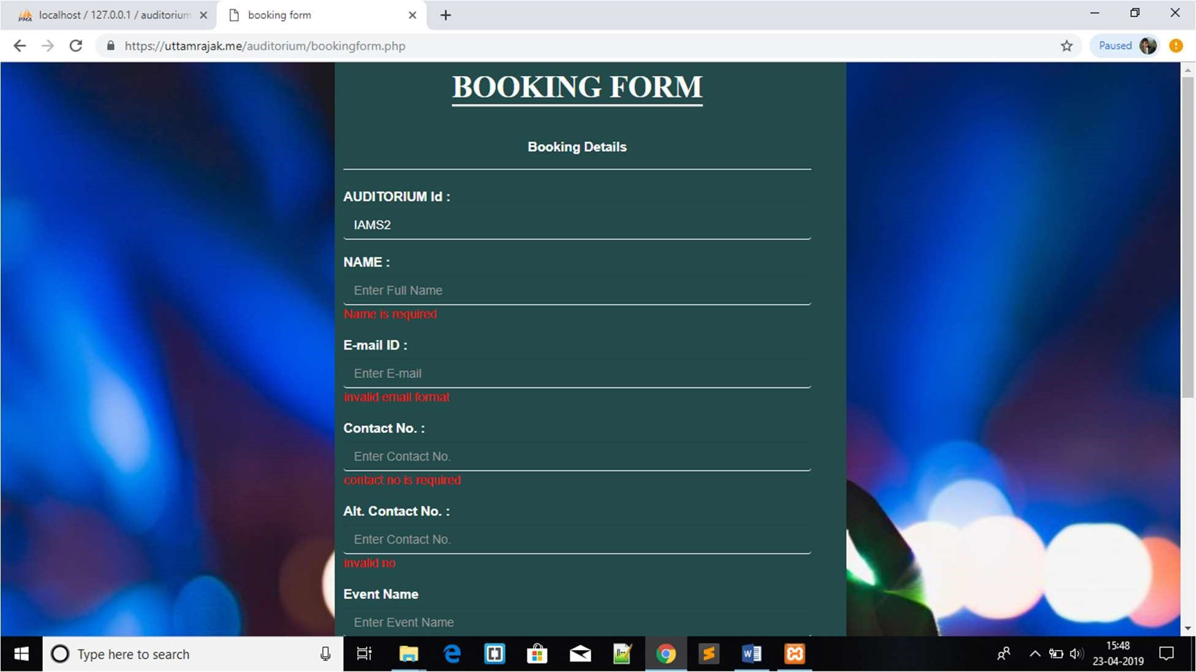

### ProfILE

From here user can view their profile. There are four option

View profile is for view the details of user.

Update profile for update the password, email id.

Booking details for view details of his booking.

LOGOUT for logout from website.

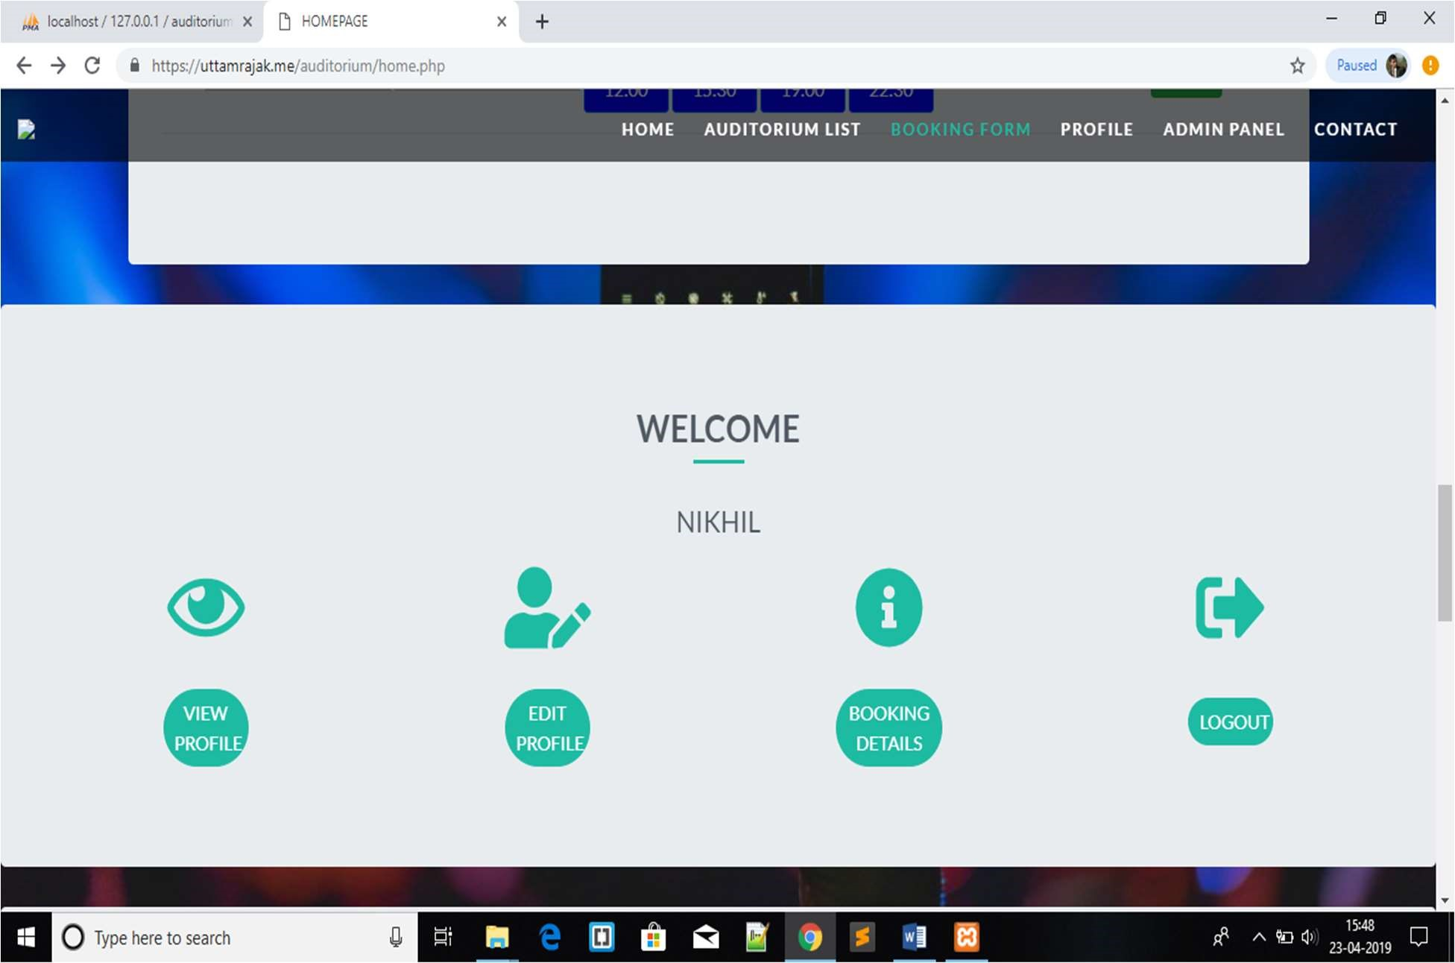

### aDmIN PaNEL

This option is only for admin. From here the admin can view user details, Add new auditorium, update the price of the auditorium, delete auditorium, booking details and admin can search booking details by booking id or booking date.

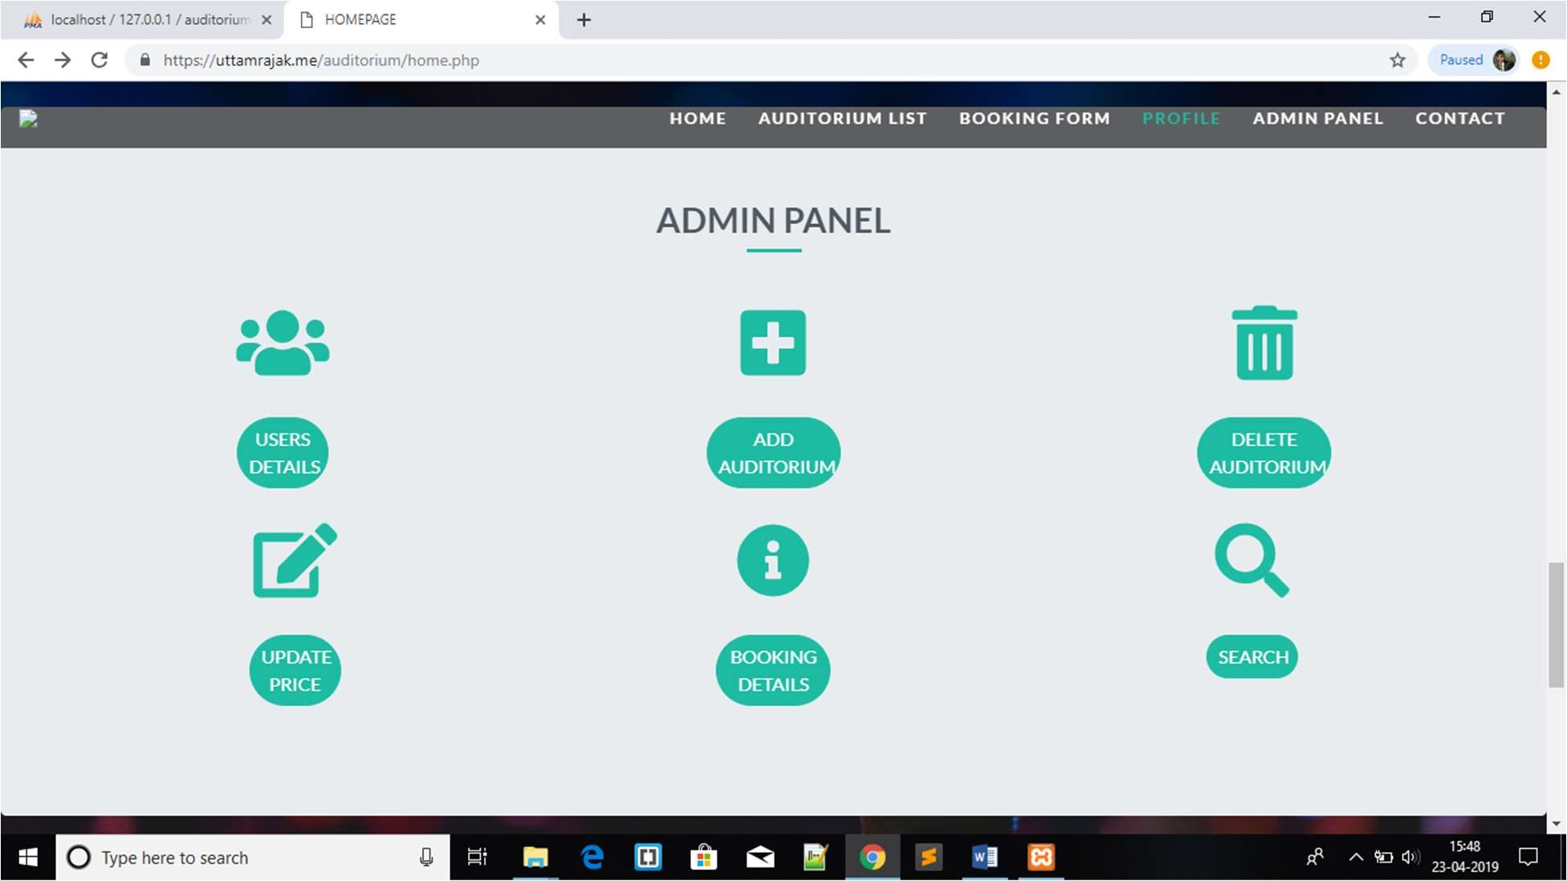

### coNtact

This page shows the contact information of admin.

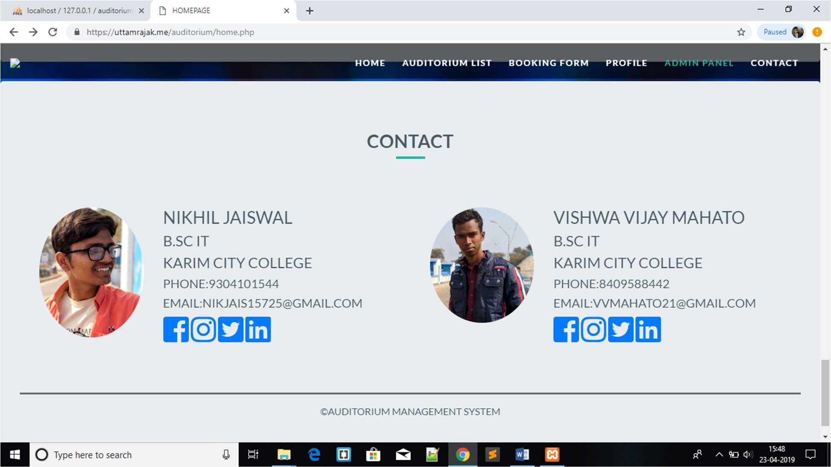

### bIbLIograPhy

Website http://www.google.com http://www.wikipedia.org http://www.codeproject.com http://www.w3school.com http://www.getbootstrap.com http://www.fontawsome.com