A

SYNOPSIS

ON

EVENT MANAGEMENT SYSTEM

MCSP-060

MCA

INDIRA GANDHI NATIONAL OPEN UNIVERSITY

NEW DELHI



SUBMITTED BY

**SUSHMA KUMARI JAISWAL**

**MCA 6TH SEM**

**(173566621)**

UNDER GUIDENCE OF

KISHORE KUMAR

# INDEX

## **INTRODUCTION OF EVENT MANAGEMENT SYSTEM**

**Event Management System** is developed as a web-based application developed in PHP. It facilitates [online registration](https://www.codewithc.com/civil-registration-system-asp-net-project/) cum feedback evaluation for different kinds of events such

as weddings, Birthdays, Anniversary, Workshops, and Seminars. The project’s main objective is to control or manage the activities and duties to be preformed by various event conductors such as attendees, organizers, event reviewers, and authors.

It includes all the features and functions needed to efficiently manage an event. It includes an administrator account which is used to handle/control all the system functionality. The system keeps track of event status and advance bookings. The system keeps records of event bookings along with associated event details and customer contacts in a well maintained database. The administrator can easily check the event bookings and timings in the system guide. The system also allows notifies when new event timing draws near.

The system should able to handle any sort of query, get information for it and should be able to store all the related data into the database. The user will be totally abstracted from the complexity and backend working of the screen .As they don’t need to know how and why a particular work is being carried out.

Each user would be able to get information from the system according to their requirements and at any time. It should tell about the status of the entire Auditorium. Through this computerized system all the activities of the proceedings can be managed efficiently by the user and in quickest possible time.

## fEaturEs of thE systEm

* Admin login and admin dashboard: It has admin login who is has the authority of the system and he is responsible for approving and disapproving the users request for auditorium booking. Admin can add and delete notifications and updates in the system.

* User Registration: There is user registration form available where new users can create their account by providing required information to the system.

* Booking System: User can request for the booking for a particular date. Subsequently the system will generate the total cost incurred for the expected days.
* Approving/Disapproving Request: The booking requests are directly sent to admin account by the system. Admin can view all the requests along with respective user details and therefore make decisions for approving or disapproving the requests.

* Email Notification: The system will inform the respective customers through an email about their status of booking request whether approved or disapproved. Also it mails user their respective receipts.

## objEctIvE of thE ProjEct

The main objective of the Auditorium Management System is to manage the detail of Payment, Booking dates, Booking, customers, Auditorium. It manages all the information about payment, inventory, Auditorium. The project is totally built at administrative end and thus only the administrator is guaranteed the access. The purpose of the project is to build an application program to reduce the manual work for managing the payment, Booking, Dates, Inventery,Booking.It tracks all the details about the Booking,Customers,and halls.

* The system is useful as it calculates an exact cost for requested number of days.

* It is convenient for user as he do not have to actually visit the place.

* This system is effective and saves time and cost of the users.

* Easy registration.

### LaNguagE usED:-

* HTML
* CSS
* BOOTSTRAP
* JAVA SCRIPT
* PHP
* MY SQL

#### Front End:-HTML

* HTML is the standard markup language for creating Web pages.
* HTML stands for Hyper Text Markup Language.
* HTML describes the structure of Web pages using markup.
* HTML elements are represented by tags.
* HTML tags label pieces of content such as "heading", "paragraph", "table", and so on.

#### Back End:-PHP

* PHP is an acronym for "PHP: Hypertext Preprocessor".
* PHP is a widely-used, open source scripting language.
* PHP scripts are executed on the server.
* PHP is free to download and use.

PHP files can contain text, HTML, CSS, JavaScript, and PHP code.

PHP codes are executed on the server, and the result is returned to the browser as plain HTML. PHP files have extension”.php”.

### ZEro-LEvEL DfD

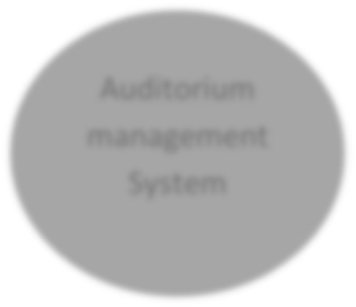

Auditorium

management

System

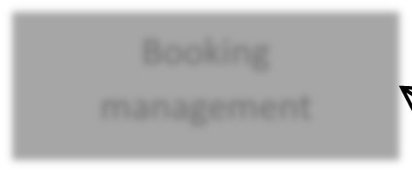

Booking

management

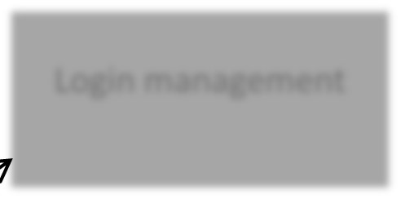

Login management

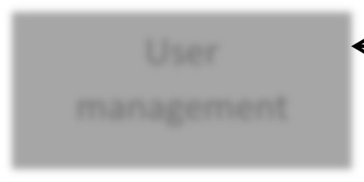

User

management

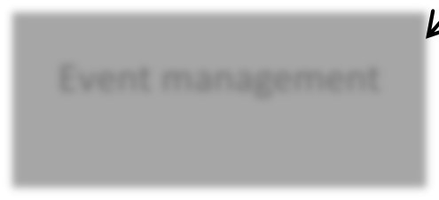

Event management

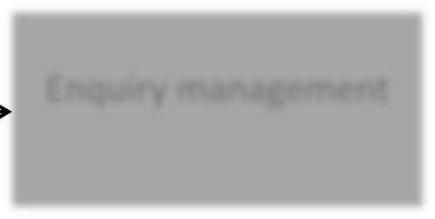

Enquiry management

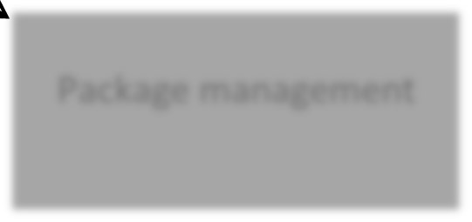

Package management

#### fIrst-LEvEL DfD



User

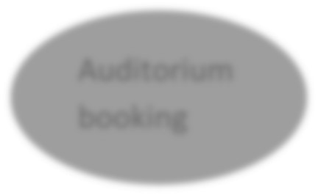

Auditorium

booking



Request

Cancel request if

no seat available

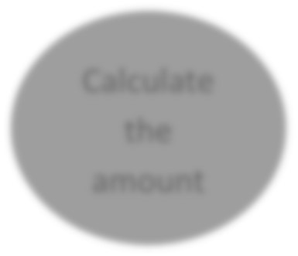

Calculate

the

amount



Auditorium

details

Availability info

Enquiry

Booking

status



Preparation

of booking

statement



Admin



Confirm if

available

Booking

details

Cost

Booking charges

Booking approval

Package

Package

statement

Modify/Add

details

1.1

1.2

1.3

### Er-DIagram

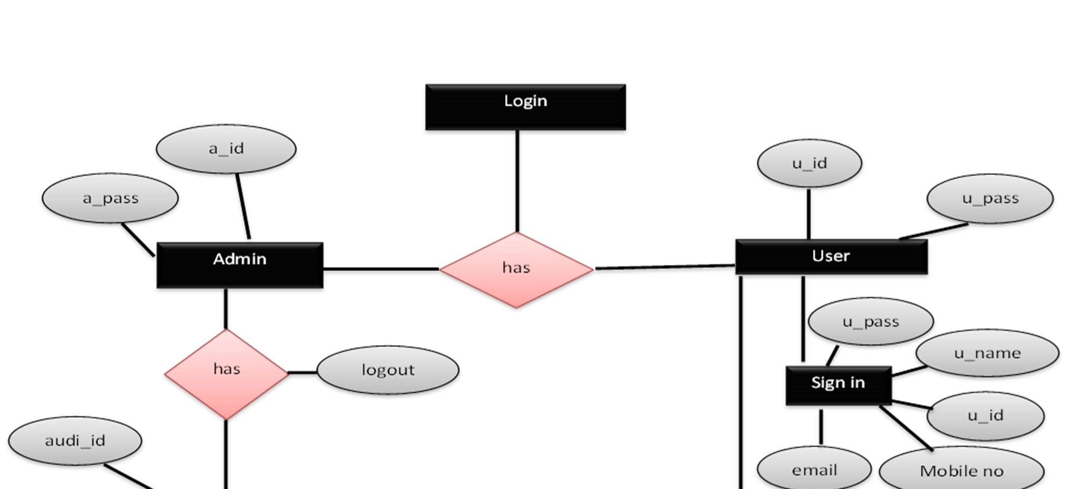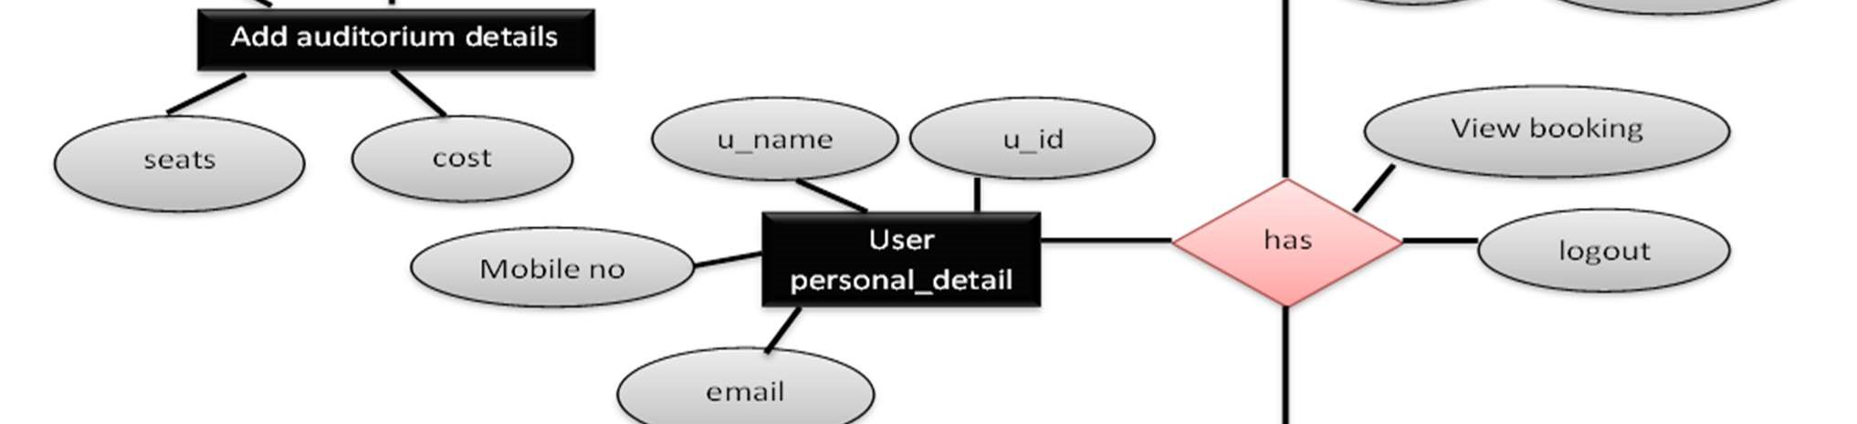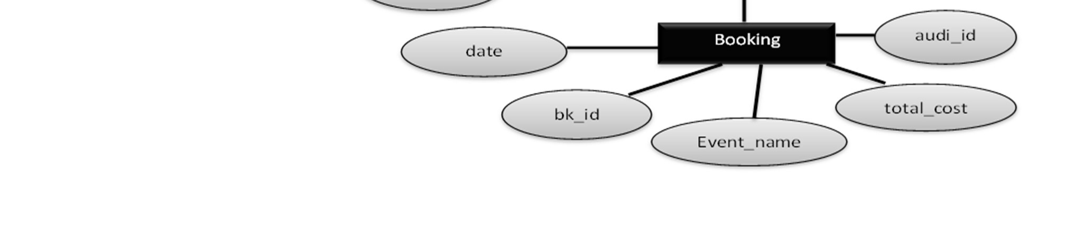

### gaNtt chart

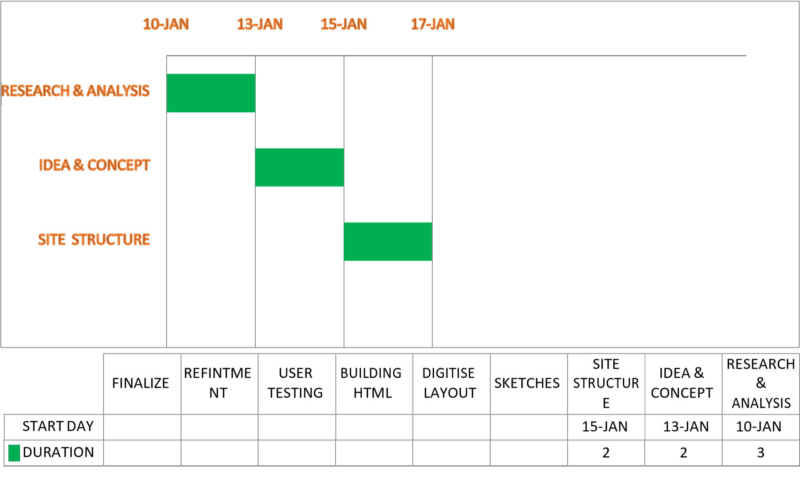







## tabLE sructurE

### Admin login table

|  |  |  |  |
| --- | --- | --- | --- |
| Field name | Data type | Size | Key constraints |
| A_id | Varchar | 200 | Pk |
| A_pass | Varchar | 200 | --- |

### Add Auditorium Details Table

|  |  |  |  |
| --- | --- | --- | --- |
| Field name | Data type | Size | Key constraints |
| Audi_id | Varchar | 200 | Pk |
| Seats | Int | 500 | --- |
| Price | Int | 500 | --- |

### User login Table

|  |  |  |  |
| --- | --- | --- | --- |
| Field name | Data type | Size | Key constraints |
| U_id | Varchar | 200 | Pk |
| U_pass | Varchar | 200 | -- |

### Add Booking

|  |  |  |  |
| --- | --- | --- | --- |
| Field name | Data type | Size | Key constraints |
| Bk_id | Varchar | 200 | Pk |
| Audi_id | Varchar | 200 | Fk |
| Total cost | Int | 500 | --- |
| Seat | Int | 500 | --- |
| Date | Date | 100 | --- |
| E_name | Varchar | 200 | --- |

### Personal Details

|  |  |  |  |
| --- | --- | --- | --- |
| Field name | Data type | Size | Key constraints |
| U_id | Varchar | 200 | Fk |
| U_name | Varchar | 200 | --- |
| U_pass | Varchar | 50 | --- |
| Mobile no | Int | 10 | --- |
| Email id | Varchar | 10 | --- |

### futurE scoPE aND furthEr ENhaNcEmENt:-

The software is very flexible; which can easily be modified as per future requirement. The system may include the online customer facility if needed. The prototype development may extend to similar organization, contributing their services in organizing various self-employment oriented course.

The phases of “Auditorium Management System” application were started with a definite goal. At the end of that phase, not only does there exists a bridge for the next phase, it is also made sure that the set goal is achieved giving the next phase a concrete base.

The main goal of the “Auditorium Management System” application is to automate the existing manual data processing system. The development of software is not an end in itself but only a means to an end. With this application, a hard copy of each Report is sent from one branch to another and it is keyed in again. So this part of the application needs automation and can be considered for future enhancements and can be carried out in either of the two suggested ways –

Sending of report can be avoided by making it web-enabled or a single server concept can be adopted. There are future enhancement am going to do in the system. And may be some other kind future changes will be possible in the system also.

#### bIbLIograPhy

Website http://www.goggle.com http://www.wikipedia.org http://www.codeproject.com

Books

Java Complete Reference: Herbert Shield

Database Programming with JDBC and Java:

George Reese