HOSPITAL EMERGENCY-ROOM TRIAGE SYSTEM
Java Project Report

1. Introduction
The Hospital Emergency-Room Triage System is a console-based Java application designed to register patient details and display patients according to simplified emergency-priority levels. It accepts a patient's name, age, temperature, and main complaint. The application provides menu options to register patients, display the priority list, generate a summary, and save or read records from a text file.

2. Abstract
This project demonstrates a basic patient-record management application developed using Java. Patients are classified as Critical, Serious, or Normal using predefined educational rules. The program applies classes and objects, methods, conditional statements, loops, collections, sorting, exception handling, streams, and file input/output. It is intended to demonstrate programming concepts and is not a clinically validated medical triage system.

3. Advantages
- Provides a simple menu-driven console interface.
- Stores patient details in a structured collection while the program runs.
- Displays patients in emergency-priority order.
- Generates a summary of patient counts and average temperature.
- Saves patient records to a text file and reads saved records.
- Demonstrates multiple Java programming concepts in one project.

4. Future Works
- Add a graphical user interface for easier interaction.
- Use a database such as MySQL for persistent and searchable records.
- Add patient IDs, registration date and time, and update/delete options.
- Improve input validation and error messages.
- Add secure login and access control for authorized users.
- Use medically approved protocols and qualified clinical oversight before any real-world use.

5. Source Code
Save this code as Main.java. It uses Java features including ArrayList, Map, streams, and file handling.
import java.util.*;
import java.io.IOException;
import java.nio.file.*;
import java.util.stream.Collectors;

public class Main {

static final int MAX = 20;

static class Patient {
String name;
int age;
double temperature;
String complaint;
String level;

Patient(String name, int age, double temperature,
String complaint) {
this.name = name;
this.age = age;
this.temperature = temperature;
this.complaint = complaint;
this.level = findLevel(complaint, age, temperature);
}

static String findLevel(String complaint, int age,
double temperature) {
if (temperature >= 104 ||
complaint.equals("Chest pain") ||
complaint.equals("Difficulty breathing") ||
complaint.equals("Severe bleeding")) {
return "Critical";
} else if (complaint.equals("Broken bone") ||
complaint.equals("High fever") ||
age < 5 || age >= 65) {
return "Serious";
} else {
return "Normal";
}
}

@Override
public String toString() {
return name + " | Age: " + age
+ " | Temp: " + temperature
+ " F | Complaint: " + complaint
+ " | Level: " + level;
}
}

static Scanner sc = new Scanner(System.in);
static ArrayList<Patient> patients = new ArrayList<>();
static final String FILE = "patients.txt";

static void registerPatient() {
System.out.print("Enter patient name: ");
String name = sc.nextLine().trim();

System.out.print("Enter age: ");
int age = Integer.parseInt(sc.nextLine());

System.out.print("Enter temperature in Fahrenheit: ");
double temp = Double.parseDouble(sc.nextLine());

String[] complaints = {
"Chest pain",
"Difficulty breathing",
"Severe bleeding",
"Broken bone",
"High fever",
"Minor injury",
"General checkup"
};

for (int i = 0; i < complaints.length; i++) {
System.out.println((i + 1) + ". " + complaints[i]);
}

System.out.print("Select complaint (1-7): ");
int choice = Integer.parseInt(sc.nextLine());

if (name.isEmpty() || age < 0 || age > 120 ||
temp < 90 || temp > 110 ||
choice < 1 || choice > 7) {
System.out.println("Invalid patient details.");
return;
}

Patient p = new Patient(name, age, temp,
complaints[choice - 1]);
patients.add(p);

System.out.println("Patient registered successfully!");
System.out.println("Emergency level: " + p.level);
}

static void displayPatients() {
if (patients.isEmpty()) {
System.out.println("No patients registered.");
return;
}

patients.stream()
.sorted(Comparator.comparingInt(p ->
p.level.equals("Critical") ? 1 :
p.level.equals("Serious") ? 2 : 3))
.forEach(System.out::println);
}

static void showSummary() {
Map<String, Long> counts = patients.stream()
.collect(Collectors.groupingBy(
p -> p.level, Collectors.counting()));

System.out.println("\\n--- Emergency Summary ---");
System.out.println("Total patients: " + patients.size());
System.out.println("Critical: " +
counts.getOrDefault("Critical", 0L));
System.out.println("Serious: " +
counts.getOrDefault("Serious", 0L));
System.out.println("Normal: " +
counts.getOrDefault("Normal", 0L));

double average = patients.stream()
.mapToDouble(p -> p.temperature)
.average().orElse(0.0);

System.out.printf("Average temperature: %.1f F%n",
average);
}

static void savePatients() {
List<String> lines = patients.stream()
.map(p -> p.name + "|" + p.age + "|"
+ p.temperature + "|" + p.complaint
+ "|" + p.level)
.collect(Collectors.toList());

try {
Files.write(Paths.get(FILE), lines);
System.out.println("Patient records saved to " + FILE);
} catch (IOException e) {
System.out.println("Unable to save patient records.");
}
}

static void readPatients() {
Path path = Paths.get(FILE);

try {
if (!Files.exists(path)) {
System.out.println("No saved patient file found.");
return;
}

List<String> lines = Files.readAllLines(path);
System.out.println("\\n--- Saved Patient Records ---");
lines.forEach(System.out::println);

} catch (IOException e) {
System.out.println("Unable to read patient file.");
}
}

public static void main(String[] args) {
int choice;

do {
System.out.println("\\n===== HOSPITAL TRIAGE SYSTEM =====");
System.out.println("1. Register Patient");
System.out.println("2. Display Patients by Priority");
System.out.println("3. Show Summary");
System.out.println("4. Save Patient Records");
System.out.println("5. Read Saved Records");
System.out.println("6. Exit");
System.out.print("Enter choice: ");

try {
choice = Integer.parseInt(sc.nextLine());

switch (choice) {
case 1:
if (patients.size() < MAX) {
registerPatient();
} else {
System.out.println("Patient limit reached.");
}
break;

case 2:
displayPatients();
break;

case 3:
showSummary();
break;

case 4:
savePatients();
break;

case 5:
readPatients();
break;

case 6:
System.out.println("Program ended.");
break;

default:
System.out.println("Choose from 1 to 6.");
}

} catch (NumberFormatException e) {
System.out.println("Please enter a valid number.");
choice = 0;
}

} while (choice != 6);

sc.close();
}
}

6. Output Screenshots

6.1 Patient Registration and Priority Display
This screenshot shows the menu, patient priority display, registration, and validation of an invalid temperature.
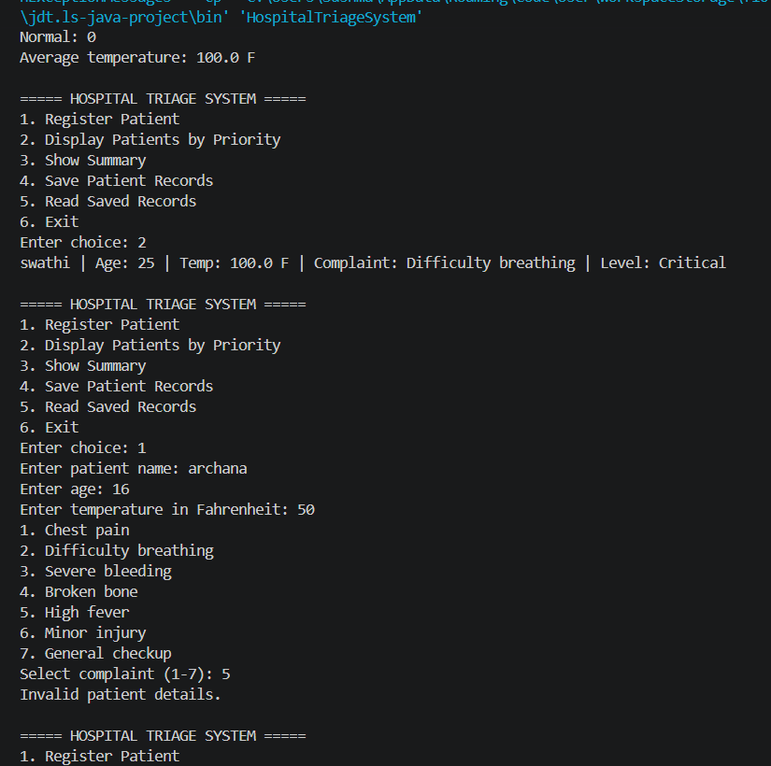
Figure 1: Patient registration and priority display.

6.2 Reading Saved Patient Records
This screenshot shows saved patient records being read and displayed in the console.
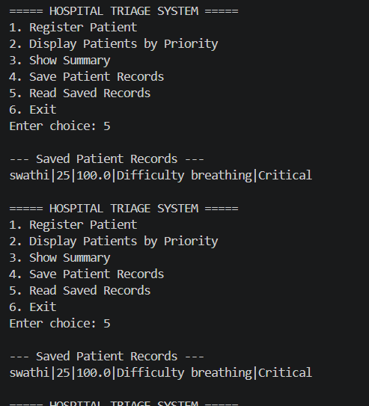
Figure 2: Saved patient records displayed in the console.

7. Conclusion
The Hospital Emergency-Room Triage System demonstrates how Java can be used to build a simple application for patient registration, priority display, summary generation, and text-file record management. The project provides practical experience with object-oriented programming, control flow, collections, sorting, streams, exception handling, and file operations. The classification rules are simplified for educational use only and must not be used for real medical decisions.

