Q1.
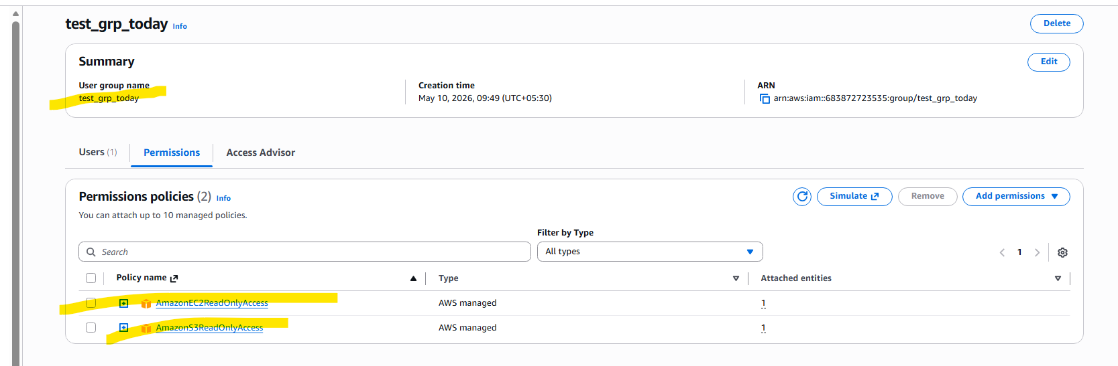

Q2.
EC2 instance created and attached volume
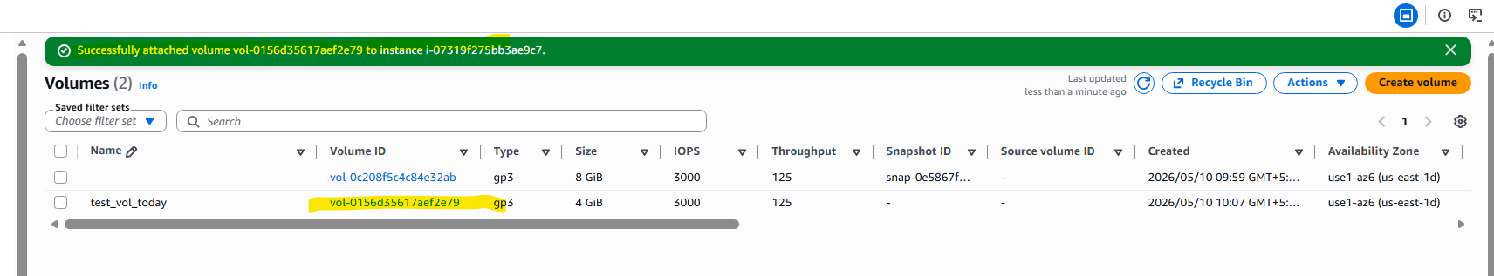

Create snapshot
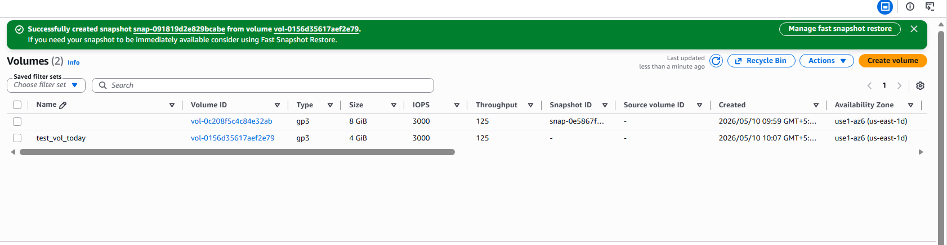
Detach Volume:
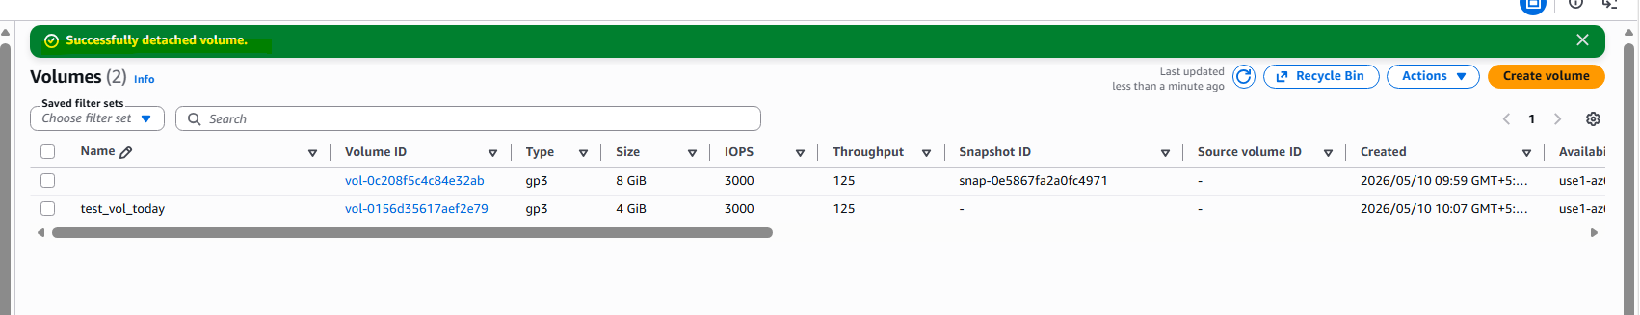

Q5.
Create Table
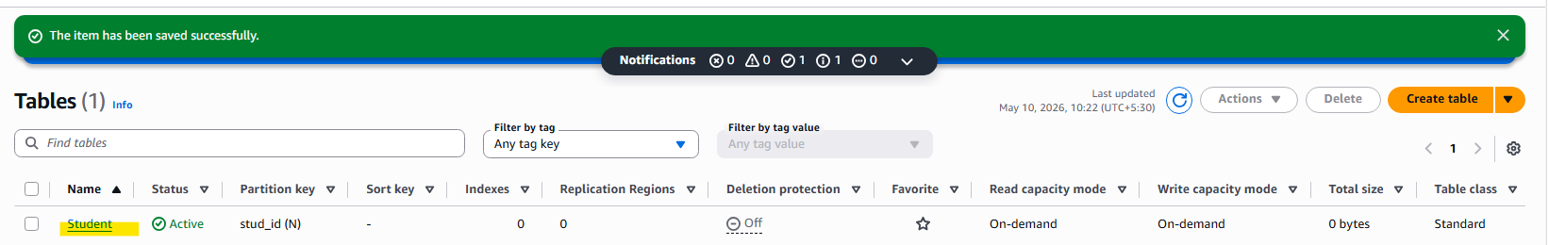

Attributes:
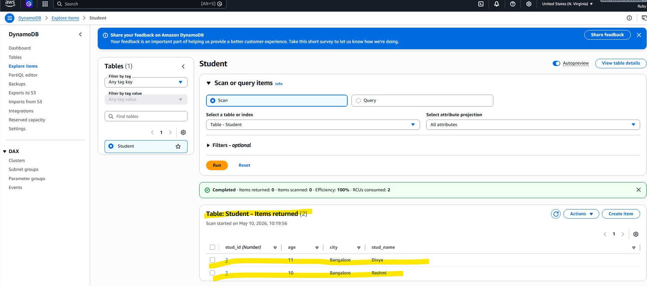

Q
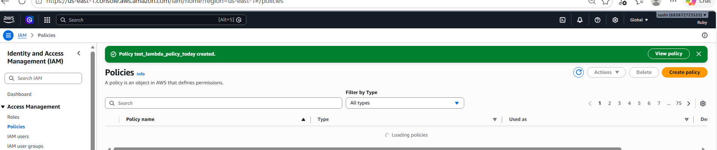

Role:
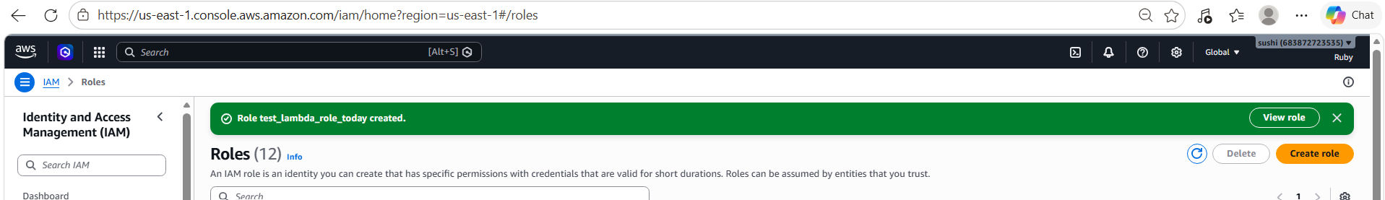

Used below code to stop the services but got unauthorized access:
importjson
import boto3

# Configuration
region = 'us-east-1'
instances = ['i-07319f275bb3ae9c7']
ec2 = boto3.client('ec2', region_name=region)

def lambda_handler(event, context):
# Stop the instances
ec2.stop_instances(InstanceIds=instances)
print(f'Stopped your instances: {str(instances)}')
return {
'statusCode': 200,
'body': f'Stopped instances: {str(instances)}'
}

# I also tried using the default policies with full access still getting errro as below:
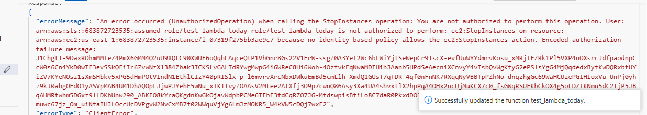

Code:
