OpsDesk
Three-Tier DevOps Project Documentation
Containerized ticket-tracking application — Git, Docker, Jenkins, CI/CD

1. Project overview
OpsDesk is a three-tier engineering ticket-tracking application built to demonstrate an end-to-end DevOps workflow: source control, containerization, automated build/test/deploy, and CI/CD pipeline execution.
The application itself is intentionally simple — an operations team can create, view, update, and close tickets — so that the assessment centers on the DevOps practices around it rather than application complexity. Every tier is a genuine, independent service; the frontend performs no business logic itself and depends entirely on the backend API for data.

2. Architecture
The system follows a standard three-tier separation of concerns. Each tier runs in its own container, communicates with its neighbor over a defined interface, and can be built, tested, and redeployed independently.
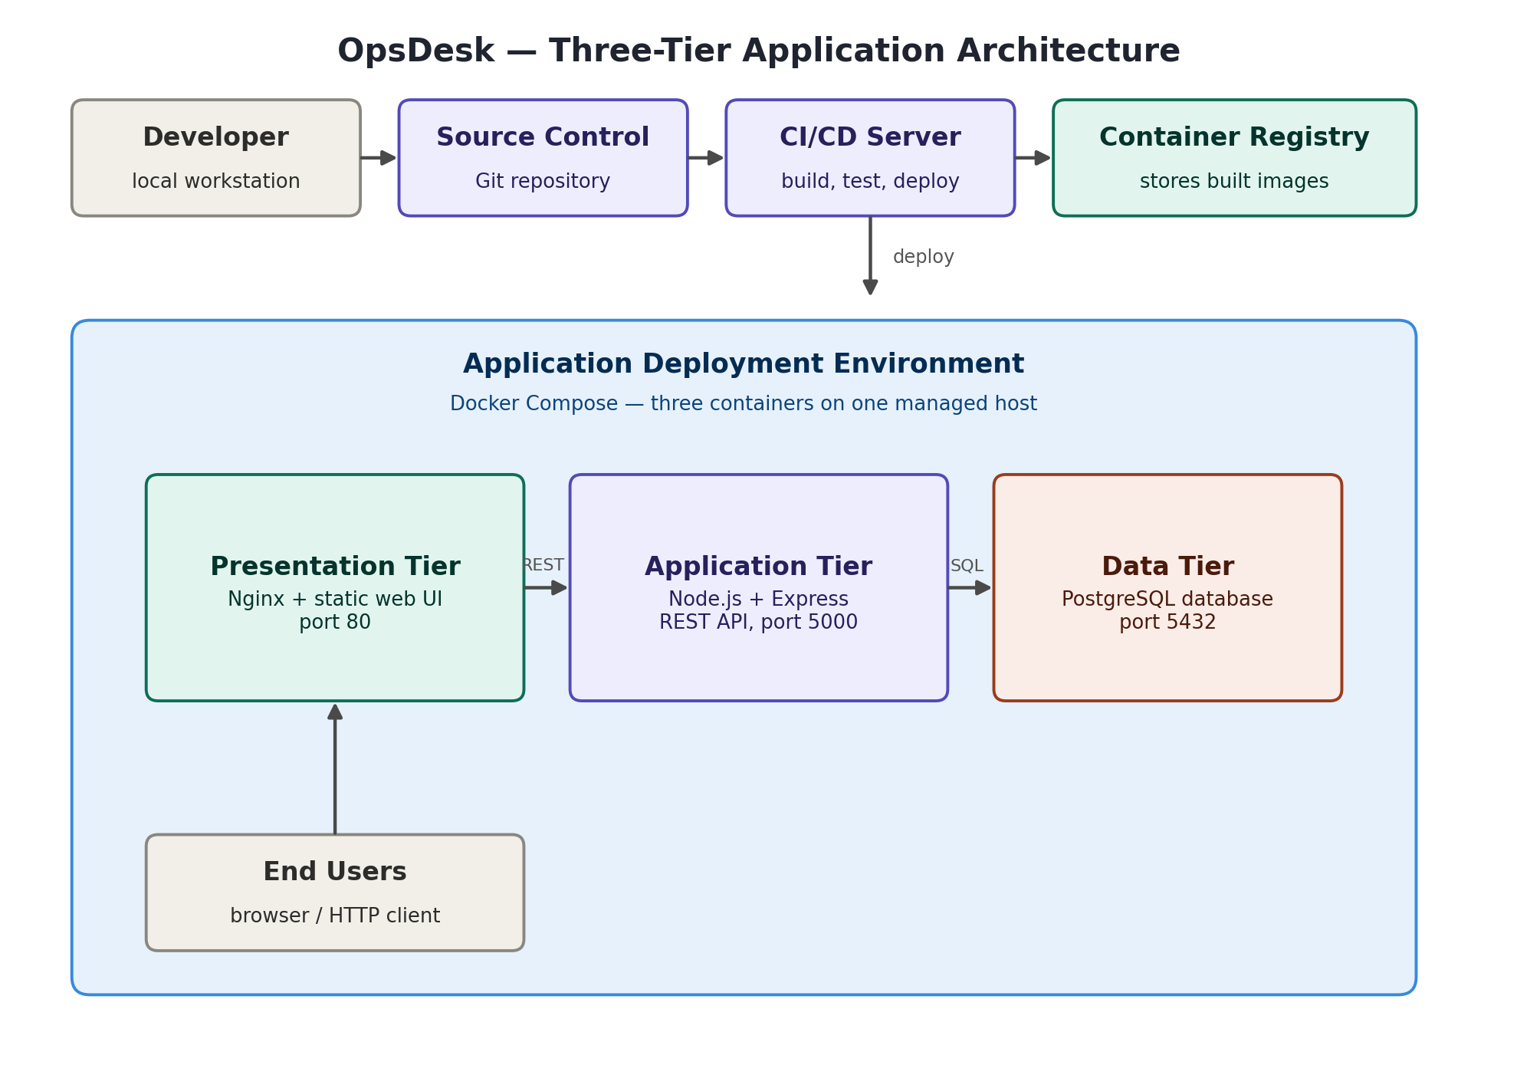
Tier | Technology | Responsibility
Presentation | Nginx + HTML/CSS/JavaScript | Serves the web UI and reverse-proxies API calls to the application tier
Application | Node.js + Express | Exposes the REST API and implements all ticket business logic
Data | PostgreSQL | Persists ticket records

3. Repository structure
The repository is organized so each tier is self-contained in its own directory, with shared orchestration and documentation at the root.
opsdesk-3tier/
|-- backend/ Application tier (Node.js + Express)
| |-- server.js REST API and route handlers
| |-- package.json Dependencies (express, pg, cors)
| \-- Dockerfile Backend container build definition
|-- frontend/ Presentation tier (Nginx + static UI)
| |-- index.html Ticket board markup
| |-- app.js Client-side logic calling the REST API
| |-- styles.css UI styling
| |-- nginx.conf Reverse proxy config (routes /api to backend)
| \-- Dockerfile Frontend container build definition
|-- db/
| \-- init.sql Schema definition and seed data
|-- docs/
| |-- architecture-diagram.png
| \-- infrastructure-diagram.txt
|-- docker-compose.yml Local multi-container orchestration
|-- Jenkinsfile CI/CD pipeline definition
\-- README.md Project summary and quick start

4. CRUD API reference
The application tier exposes a REST API over a single resource, tickets, plus a health endpoint used by the pipeline and by container orchestration to verify the service is ready.
Method | Endpoint | Description
GET | /api/health | Reports service and database connectivity status
GET | /api/tickets | Returns all tickets, most recent first
GET | /api/tickets/:id | Returns a single ticket by ID
POST | /api/tickets | Creates a new ticket
PUT | /api/tickets/:id | Updates an existing ticket
DELETE | /api/tickets/:id | Deletes a ticket

5. Running the application locally
Prerequisite: Docker Desktop, or Docker Engine with the Compose plugin.
git clone <your-repository-url>
cd opsdesk-3tier
docker compose up -d --build
This builds the frontend and backend images, pulls the official PostgreSQL image, and starts all three containers on a shared internal network. The application becomes available at http://localhost, and the API health check can be verified independently:
curl http://localhost/api/health
To stop the stack:
docker compose down

6. Source control workflow
Development follows a standard feature-branch workflow so every change is reviewable before it reaches the main branch:
- Work happens on a feature branch created from main
- Changes are committed with descriptive messages and pushed to the remote
- A Pull Request is opened, reviewed, and then merged into main
- main is always kept in a deployable state
git checkout -b feature/ticket-crud
git add .
git commit -m "feat: build OpsDesk three-tier application"
git push -u origin feature/ticket-crud

7. CI/CD pipeline
The Jenkinsfile defines an automated pipeline that validates, builds, tests, and deploys the application on every change. It runs the following stages in sequence:
Stage | Purpose
Checkout | Pulls the latest commit from source control
Validate | Confirms Docker is available and the Compose file is syntactically correct
Build Images | Builds the frontend and backend container images
Test API Container | Starts the stack and verifies the health endpoint responds successfully
Deploy | Brings the stack up in its running configuration
A pipeline run is considered successful only if the health check stage passes — this ensures a broken build is never marked as deployed.

8. Deployment model
The application deploys as a single Docker Compose stack on a provisioned cloud compute instance. The CI/CD pipeline connects to that instance, pulls the latest images, and restarts the stack — the same three containers that run locally run there, so behavior is consistent between environments.
Network access to the deployed environment is restricted to what each tier needs: the presentation tier is the only component reachable from outside the environment, and inter-tier communication happens over an internal network that is not exposed publicly.
Environment-specific configuration — hostnames, credentials, and access rules — is intentionally kept out of source control and out of this document, and is managed separately as operational configuration for the deployed environment.

9. Troubleshooting reference
Symptom | Likely cause / next step
/api/health reports database disconnected | The database container is still starting, or environment variables don't match between backend and db services
Frontend loads but shows no tickets | Check that the nginx reverse-proxy rule for /api/ is intact and the backend container is running
Pipeline fails at Build Images | A Dockerfile syntax error or missing dependency — check the stage log for the failing build step
Pipeline fails at Test API Container | The application started but /api/health did not return success in time — check backend container logs
Port 80 already in use locally | Stop any other service bound to port 80, or change the published port in docker-compose.yml

