GROUP PROJECT

CS480C

GUESS THE LOGO ..?

BY

**SINDHU GOTTUMUKKALA      (12125)**

**SUSHMA PULLELA     (12124)**

**SWATHI MUPPALLA (12419)**



Northwestern Polytechnic University

47671 Westinghouse Dr, Fremont, CA 94539  
(510) 592-9688

**INDEX**

* ABSTRACT
* INTRODUCTION
* SOFTWARE REQIURMENTS
* SOURCE CODE
* SCREEN SHOTS
* CONCLUSION

**ABSTRACT**

Guess The Logo... ? It is a puzzle game on words. We have to guess the correct word as what the game maker is guessing about that image, in detail there is a matrix of combination of word like a puzzle in which there are some words related to that image and a correct answer we have to find out. The matrix is like a clue and it’s also misleads you about the answer. To start the game we have to give your name and fallow on, if you guess the correct answer it will give you the score along with music and moves to next image. If it is wrong it will display a message that the answer is wrong with music and the correct combination of letters will be highlighted in the matrix and moves to next image. When you reach the maximum number of trails a message will be displayed that you had reached the maximum number of trails and the final score will be allocated and saved in data base. There will be a tag in the menu which is height score for that thing this height score data base will be used.

**INTRODUCTION**

OBJECTIVE:

The objective of our study to improve your IQ with some fun

The project is mainly based on java programming by using the concepts like GUI components, colors, fonts, sounds, images, Layout managers, event handlers, File I/O & other techniques.

Description:

The game begins in a simple Applet viewer display a image along with collection of letters in a matrix and a text box.

We have to trace the correct combination of letters which are in any pattern means of horizontally are vertically. If the answer is correct it will moves to next image with a simple music. If not means it display a message that it is a wrong answer with another music and at end it will display final score

**SOFTWARE & HARDWARE REQIURMENTS**

**Operating system :** Windows Family, Linux/Unix

**Platform :** Java

**Tool :** Eclipse

**Processor :** P4 / higher

**Ram :** 512Mb

**Hard disk :** 1 GB

**SOURCE CODE**

**NOTE:**

* Please do change the path of the “images” folder.
* Increase the volume of your PC.

String image = *orderedImages*.get(*imgCounter*);

ImageIcon guy = **new** ImageIcon(*PATH* + image + *IMAGE_EXTENSION*);

JPanel buttonPanel = **new** JPanel();

buttonPanel.add(**new** JLabel(guy));

guiFrame.add(buttonPanel, BorderLayout.*CENTER*);

randomNum = (**int**) (Math.*random*() * 10);

**if** (randomNum % 2 == 0) {

**for** (;;) {

randomNum = (**int**) (Math.*random*() * 100);

**if** ((randomNum / 10) < 10) {

**if** (((randomNum % 10) + image.length()) <= 10) {

**for** (**int** i = 0; i < image.length(); i++) {

position.add(randomNum + i);

}

**break**;

}

}

}

} **else** {

**for** (;;) {

randomNum = (**int**) (Math.*random*() * 100);

**if** ((randomNum / 10) + image.length() < 10) {

**for** (**int** i = 0; i < image.length(); i++) {

position.add(randomNum + 10 * i);

}

**break**;

}

}

}

**for** (;;) {

**if** (position.contains(count)) {

optionPanel.add(**new** JLabel(

image.charAt(position.indexOf(count)) + ""));

count++;

} **else** {

randomNum = (**int**) (Math.*random*() * 100);

**if** (randomNum >= 0 && randomNum <= 25) {

optionPanel.add(**new** JLabel(Alphabets.*values*()[randomNum]

.toString()));

count++;

}

}

**if** (count == 100) {

**break**;

}

}

guiFrame.add(optionPanel, BorderLayout.*WEST*);

}

**private** **void** playSound(String fileName) {

**try** {

Applet.*newAudioClip*(**new** URL("file:" + *PATH* + fileName)).play();

} **catch** (MalformedURLException e) {

}

}

**private** **void** addButtonPanel() {

JPanel buttonPanel = **new** JPanel();

**final** JTextField answer = **new** JTextField(10);

JButton nextButton = **new** JButton("Next");

JButton stopButton = **new** JButton("Stop");

nextButton.addActionListener(**new** ActionListener() {

@Override

**public** **void** actionPerformed(ActionEvent event) {

**if** (*imgCounter* != 10) {

**if** (*orderedImages*.get(*imgCounter* - 1).equalsIgnoreCase(

answer.getText())) {

playSound("Trumpet1.wav");

guiFrame.dispose();

showPage();

} **else** {

playSound("lost.wav");

String warningMsg;

**if** (answer.getText().trim().isEmpty()) {

warningMsg = "Please enter your answer into Textbox and click next button.";

} **else** {

warningMsg = "Your Answer is wrong. Please try again.";

}

JOptionPane.*showMessageDialog*(guiFrame, warningMsg);

}

} **else** **if** (*imgCounter* == 10) {

guiFrame.dispose();

guiFrame = **new** JFrame();

guiFrame.setDefaultCloseOperation(JFrame.*EXIT_ON_CLOSE*);

guiFrame.setTitle("Sample Game");

guiFrame.setSize(500, 100);

guiFrame.setResizable(**false**);

guiFrame.setLocationRelativeTo(**null**);

JPanel panel = **new** JPanel();

panel.add(**new** JLabel(

"You have successfully completed the game. click on close to close the widget."));

JButton closeBUtton = **new** JButton("Close");

closeBUtton.addActionListener(**new** ActionListener() {

@Override

**public** **void** actionPerformed(ActionEvent event) {

guiFrame.dispose();

}

});

panel.add(closeBUtton);

guiFrame.add(panel, BorderLayout.*CENTER*);

guiFrame.setVisible(**true**);

}

}

});

buttonPanel.add(answer);

buttonPanel.add(nextButton);

stopButton.addActionListener(**new** ActionListener() {

@Override

**public** **void** actionPerformed(ActionEvent event) {

guiFrame.dispose();

}

});

buttonPanel.add(stopButton);

guiFrame.add(buttonPanel, BorderLayout.*SOUTH*);

}

**private** **void** createImgArray() {

**int** randomNum;

**for** (;;) {

randomNum = (**int**) (Math.*random*() * 10);

**if** (!*orderedImages*.contains(Images.*values*()[randomNum].toString())) {

*orderedImages*.add(Images.*values*()[randomNum].toString());

**if** (*orderedImages*.size() == 10)

**break**;

}

}

}

**private** **void** showPage() {

guiFrame = **new** JFrame();

guiFrame.setDefaultCloseOperation(JFrame.*EXIT_ON_CLOSE*);

guiFrame.setTitle("Sample Game");

guiFrame.setSize(800, 400);

guiFrame.setResizable(**false**);

guiFrame.setLocationRelativeTo(**null**);

JLabel title = **new** JLabel("MY GAME PLAN");

title.setHorizontalAlignment(JTextField.*CENTER*);

guiFrame.add(title, BorderLayout.*NORTH*);

addLeftGridAndImage();

*imgCounter*++;

addButtonPanel();

guiFrame.setVisible(**true**);

}

**public** PlayGame() {

createImgArray();

showPage();

}}

**SCREEN SHOTS**

1) Run the game and click ‘PLAY GAME’

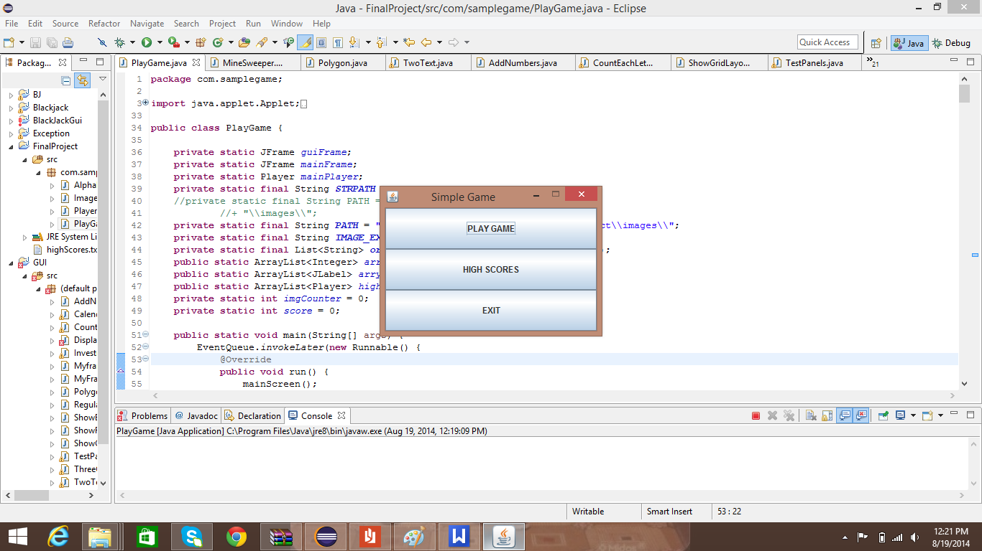

2) Enter the ‘PLAYER NAME’

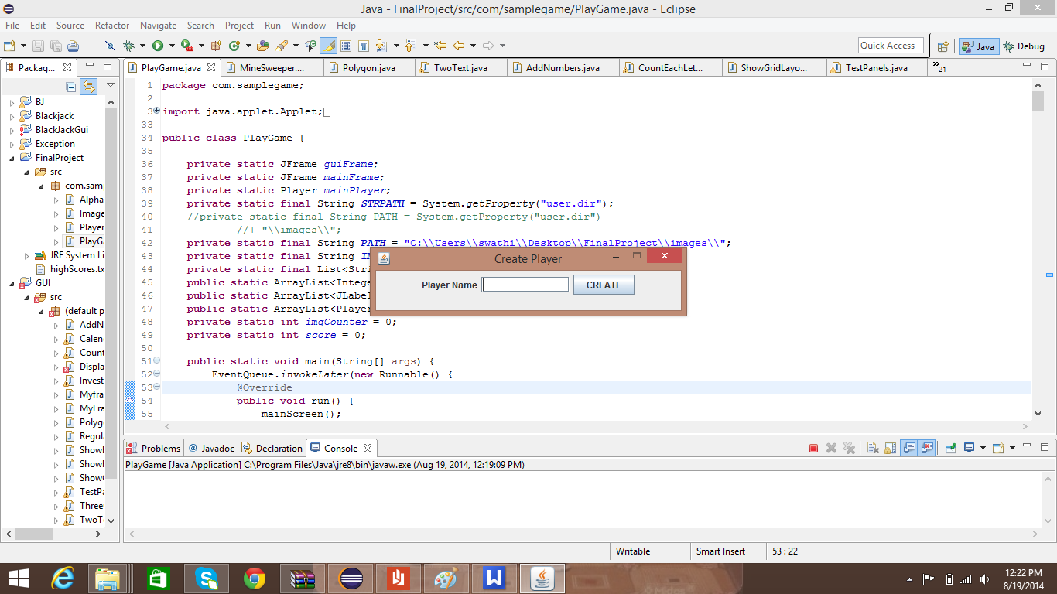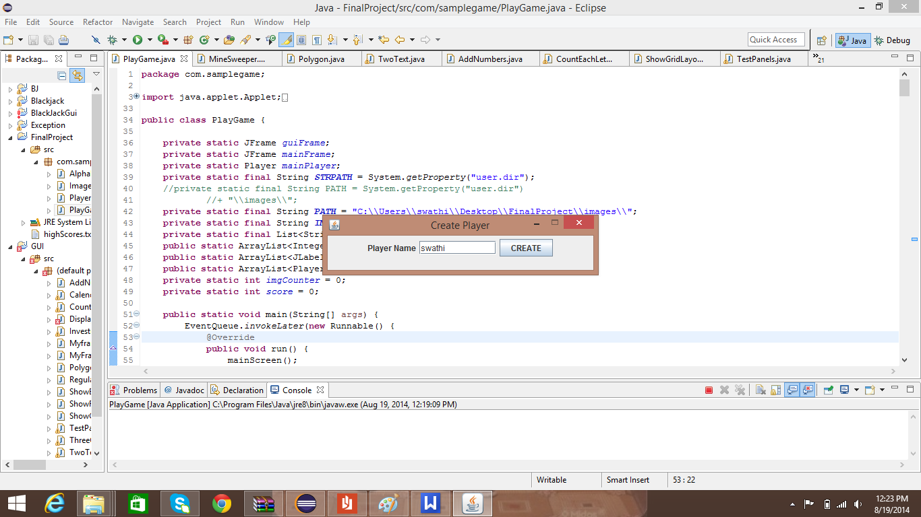

3) Guess the logo on your right and choose the word from jumbled letters on your left.

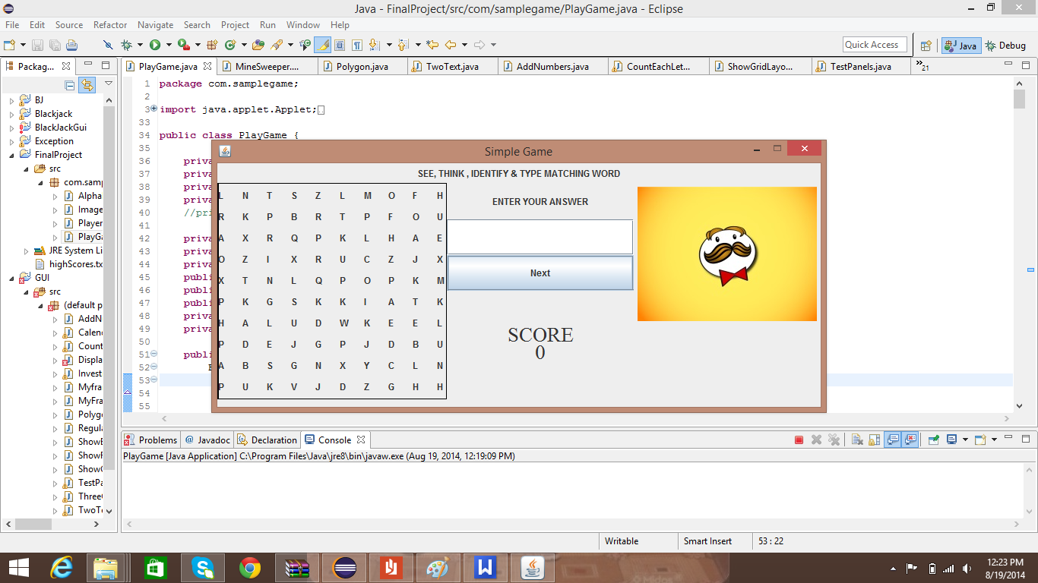

4) After you guess 10 logos you will get your Final score.

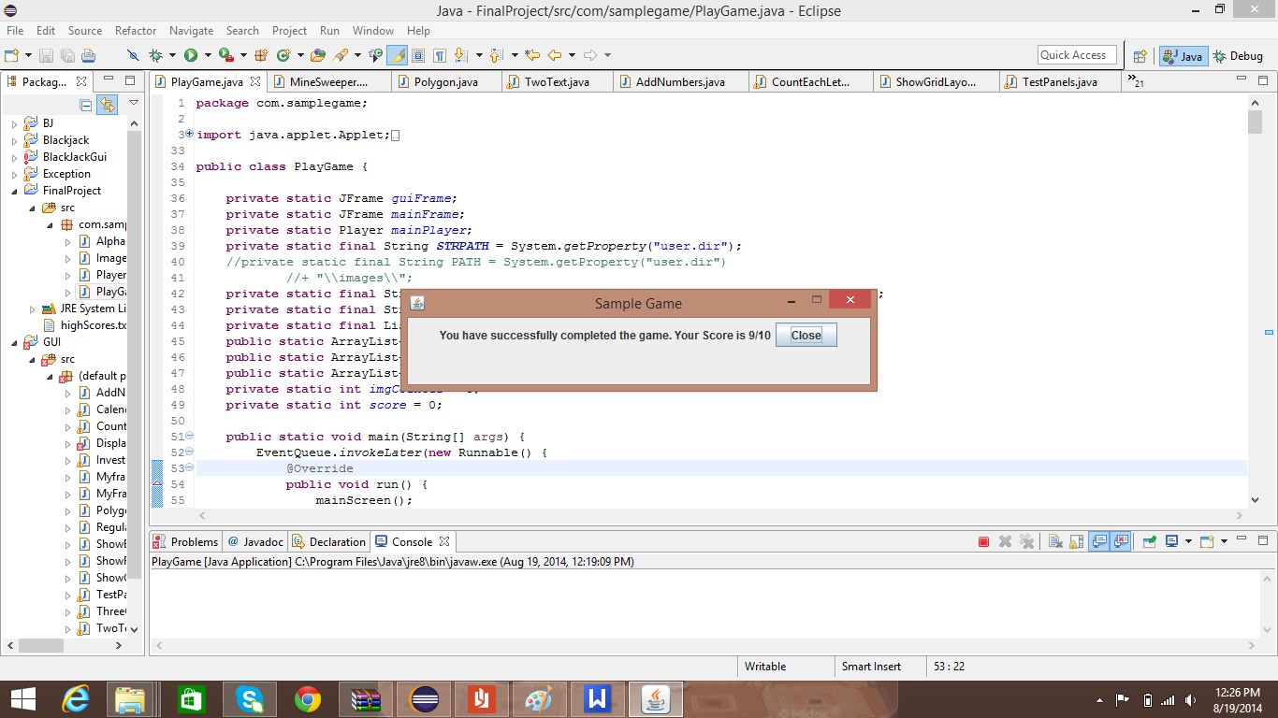

5) You can check your high scores by clicking on ‘HIGH SCORE’ option.

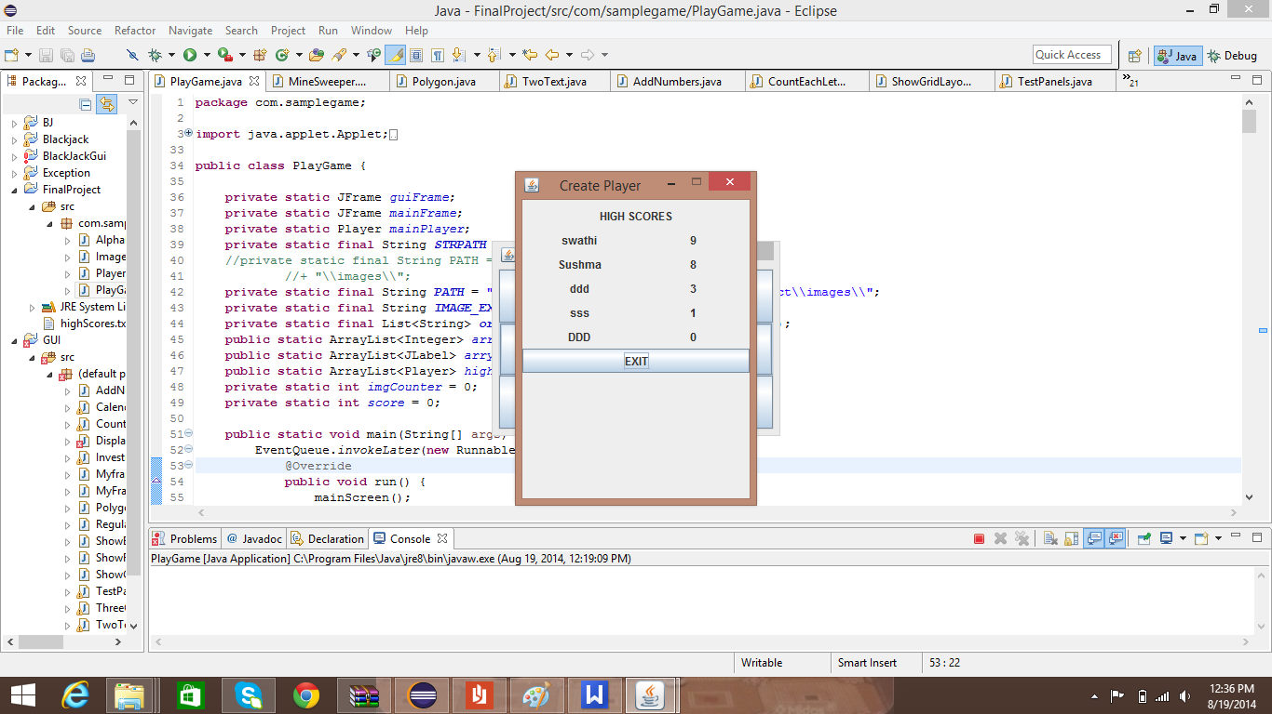

**CONCLUSION**

We would like to improve your IQ along with giving some fun & entertainment.