# INTRODUCTION

## 1.1 OVERVIEW

***“CREATE A WEBSITE USING CANVA”***

Building a website using Canva is a user-friendly and creative process that leverages Canva's design tools and templates to create a visually appealing and functional website. Canva, primarily known for its graphic design capabilities, now offers a feature called Canva Websites, which simplifies website creation for users without extensive coding or design skills. Users can choose from a variety of professionally designed templates, customize them with their own content, images, and branding elements, and publish their website with ease. Canva Websites provides a convenient drag-and-drop interface, making it accessible to beginners and small businesses looking to establish an online presence quickly and affordably.

## 1.2 PURPOSE

The purpose of the guide "Create a website and Brand Mail, in Canva" is to equip individuals and businesses with the essential knowledge and practical steps needed to establish a strong and coherent brand identity. By providing a systematic approach to creating a brand name, brand mail, and brand logo, the guide aims to enable users to develop a unique and recognizable brand presence in the market. It seeks to empower individuals to make informed decisions during the brand creation process, emphasizing the importance of coherence and consistency in conveying the brand's values and messaging. Moreover, the guide's focus on utilizing Canva's user-friendly platform highlights the accessibility and convenience of leveraging technology for effective brand development, catering to both novices and experienced users alike**.**

### 2. PROBLEM DEFINITION & DESIGN THINKING

#### 2.1 EMPATHY MAP



#### 2.2 IDEATION & BRAINSTORMING THINKING

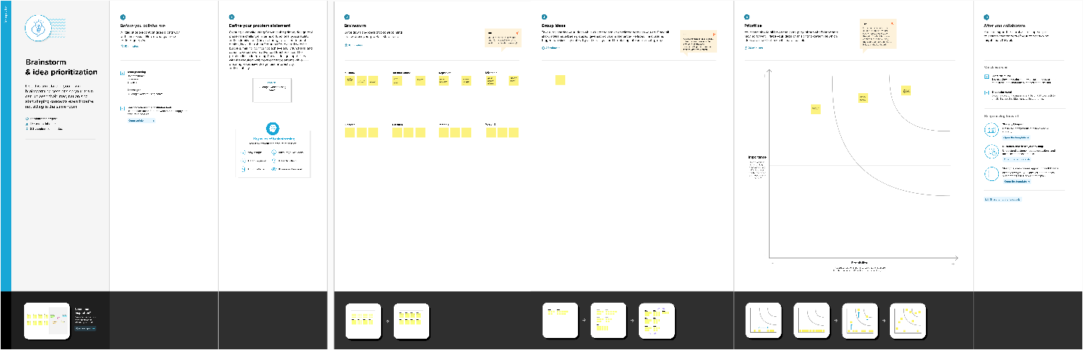

# 3. RESULT

**BRAND WEBSITE**

**BRAND NAME :** ReadUp

**BRAND MAIL ID:** readupbooks@gmail.com

# 4. ADVANTAGES & DISADVANTAGES

# ADVANTAGES

* User-friendly platform: Canva's intuitive interface makes it accessible to users with limited graphic design experience.
* Cost-effective: Canva offers a range of free and premium options, making it a budget-friendly choice for individuals and small businesses.
* Streamlined design process: The guide simplifies the branding process, providing step-by-step instructions for creating a cohesive brand identity.
* Promotes coherence: Emphasizes the importance of maintaining consistency and coherence across the brand name, brand mail, and website, fostering a professional and unified brand image.

# DISADVANTAGES

* Limitations of templates: While Canva offers a variety of templates, the preexisting options may limit the originality and uniqueness of the final brand identity.
* Potential legal issues: The guide might not fully address trademark and copyright considerations, leaving users vulnerable to legal challenges if the brand name or logo inadvertently infringes on existing trademarks.
* Creativity constraints: Relying solely on Canva's tools may restrict the creative potential of the brand identity, especially for users seeking highly customized and unique designs.

# 5. APPLICATIONS

* Entrepreneurs: Those starting a new business can utilize the guide to develop a unique brand identity that resonates with their target audience, thus enhancing brand recognition and recall.
* Small businesses: Small businesses can leverage the guide to create a professional brand identity that sets them apart from competitors and builds credibility within their industry.
* Freelancers and solopreneurs: Individuals offering freelance services or operating as solopreneurs can benefit from the guide to develop a professional brand image, enabling them to effectively market their services and establish a strong online presence.
* Content creators: Bloggers, vloggers, and social media influencers can use the guide to create a consistent and visually appealing brand identity that helps them connect with their audience and build a loyal following.
* Non-profit organizations: Non-profits seeking to enhance their visibility and credibility can follow the guide to develop a cohesive brand identity that effectively communicates their mission and values to potential supporters and donors.

# 6. CONCLUSION

In conclusion, "Create a website using Canva" serves as a valuable resource for individuals and businesses seeking to establish a strong and cohesive brand identity. By offering a systematic approach to branding using Canva's user-friendly platform, the guide empowers users to create a unique and professional brand presence that resonates with their target audience. While emphasizing the importance of coherence and consistency, the guide encourages users to think strategically about their brand's values and messaging. However, it is essential for users to be aware of the limitations of pre-existing templates and tools, as well as the potential legal implications of brand creation. Overall, the guide equips users with the necessary knowledge and practical steps to develop a compelling brand name, brand mail, and brand website that effectively communicate their brand's essence and values.