1. Install atom software from <https://atom.io/>
2. In file option from top bar , go to settings

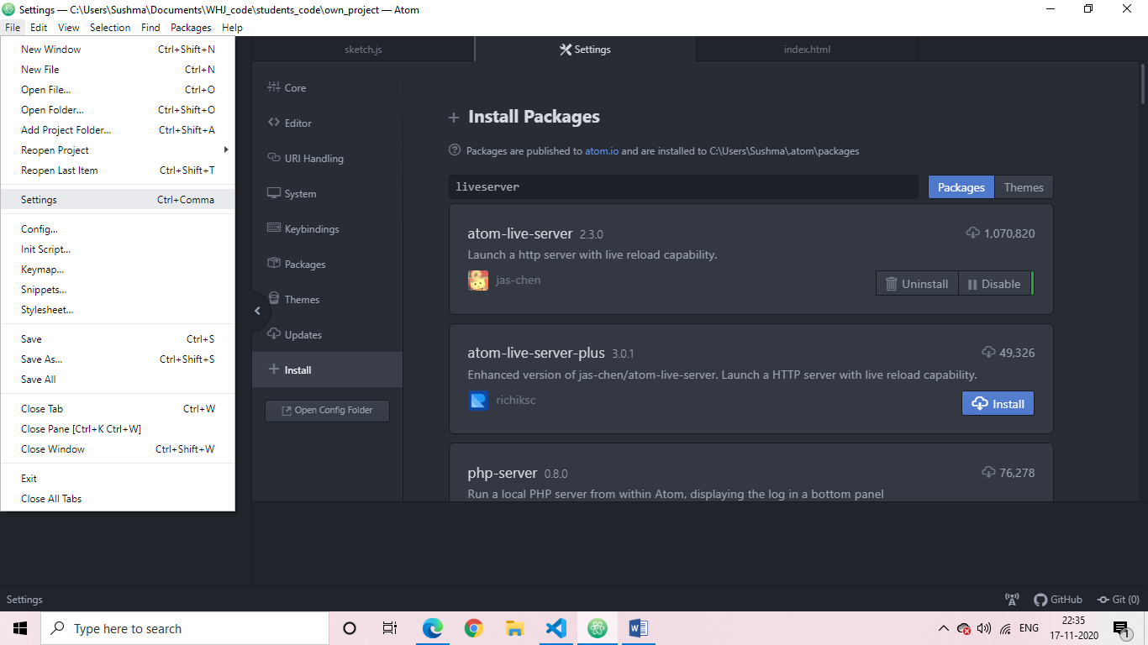

1. In settings select install options of the left side panel

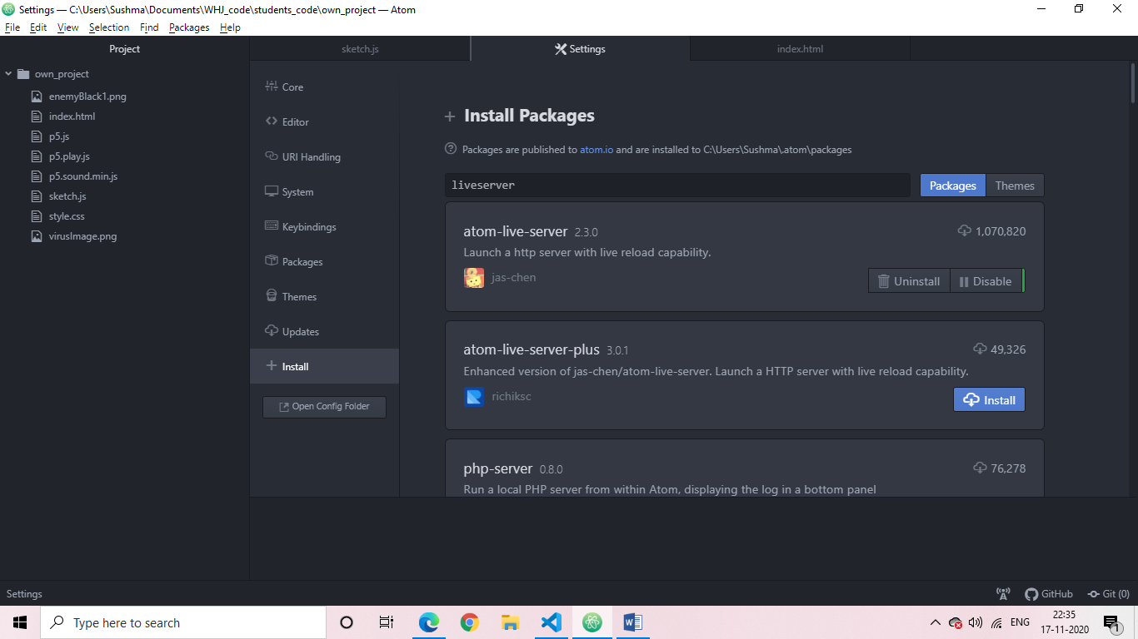

In the search bar type, atom-live-server

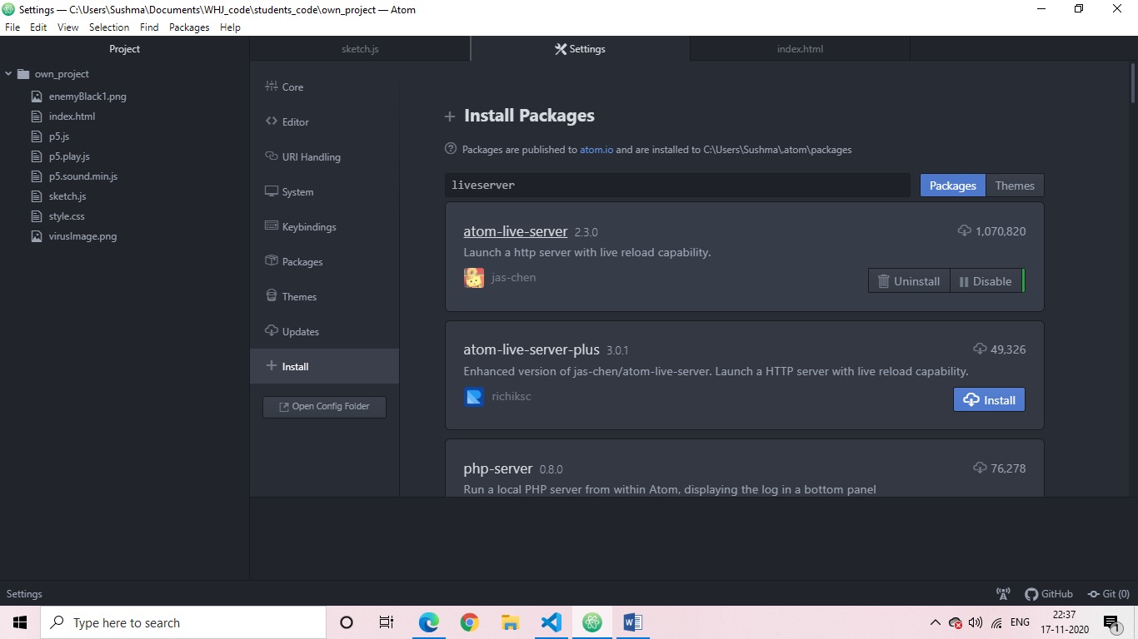

Install it.

1. Install teletype just like above.

