# Liquidity Ratios

|  |  |  |  |
| --- | --- | --- | --- |
| Ratio Name | 2017.0 | 2016.0 | 2015 |
| Current Ratio | 2.02 | 2.53 | 1.9 |
| Quick Ratio | 1.81 | 2.3 | 1.53 |
|  |  |  |  |

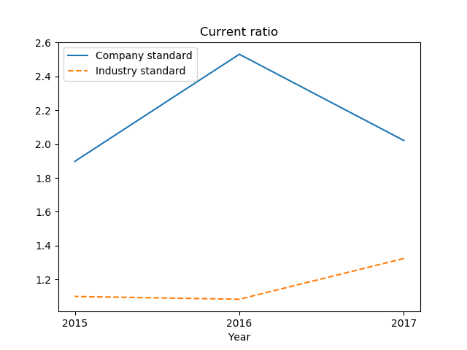

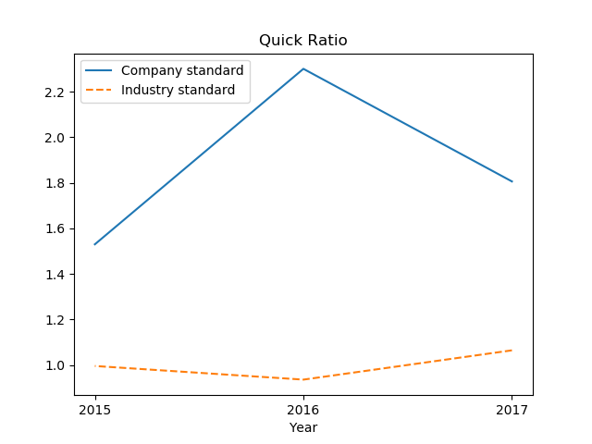

# Profitability Ratios

|  |  |  |  |
| --- | --- | --- | --- |
| Ratio Name | 2017.0 | 2016.0 | 2015 |
| Return On Assets | 14.85 | 13.94 | 14.41 |
| Return On Equity | 29.18 | 22.91 | 29.45 |
| Gross Margin | 19.26 | 18.96 | 20.11 |
| Profit Margin | 9.54 | 9.03 | 11.22 |
| Operating Margin | 9.6 | 8.63 | 10.95 |

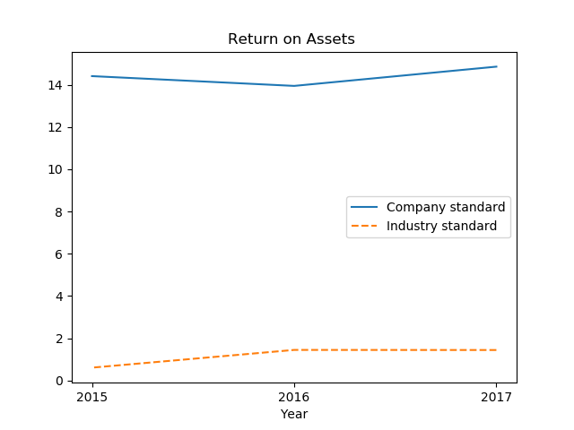

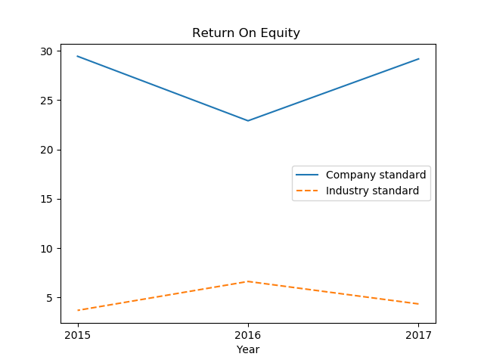

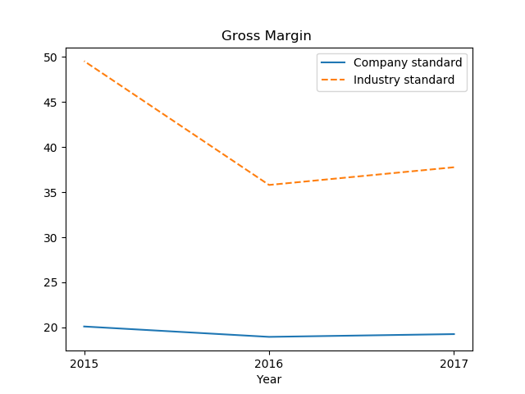

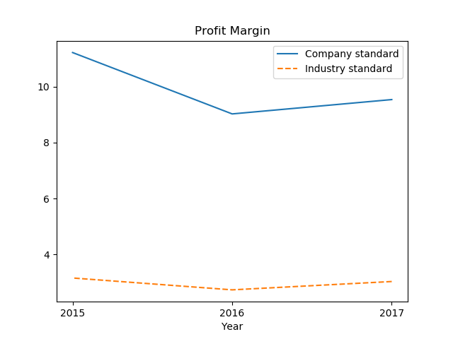

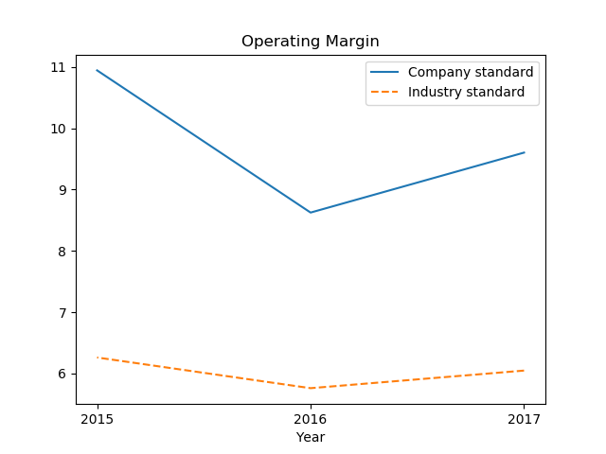

# Activity Turn over Ratios

|  |  |  |  |
| --- | --- | --- | --- |
| Ratio Name | 2017.0 | 2016.0 | 2015 |
| Asset Turn Over | 1.56 | 1.54 | 1.28 |
| Accounts Receivable Turnover | 2.45 | 2.1 | 1.91 |
| Average Days Sales | 20334.15 | 15730.13 | 14700.82 |
| Days Receivable | 166.44 | 169.38 | 191.09 |
| Days Payable | 135.41 | 104.55 | 173.22 |
| Inventory Turnover | 2.59 | 0.85 | 0.85 |
| Inventory Turnover Period | 140.87 | 427.63 | 430.12 |
| Working Capital Turnover | 3.11 | 2.59 | 2.8 |

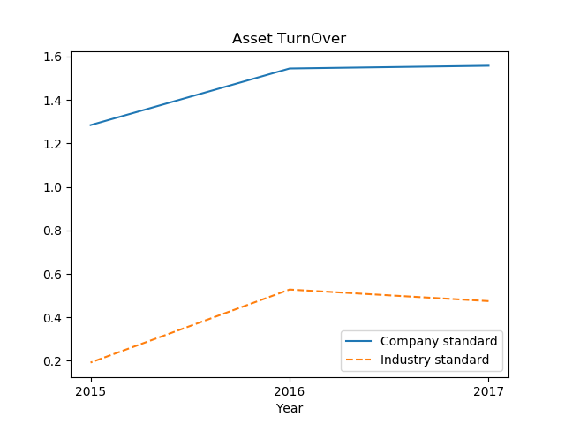

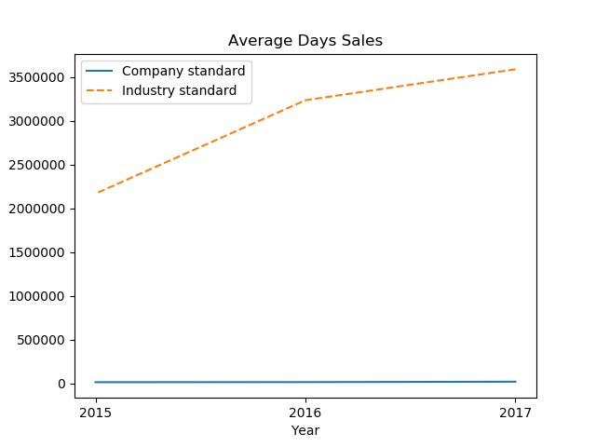

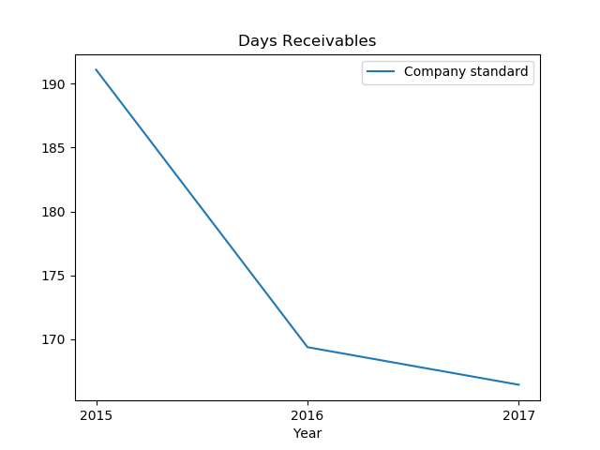

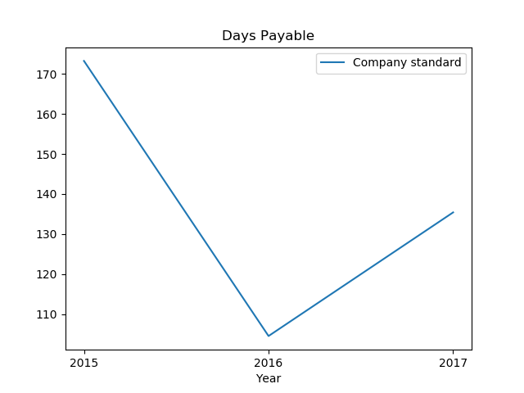

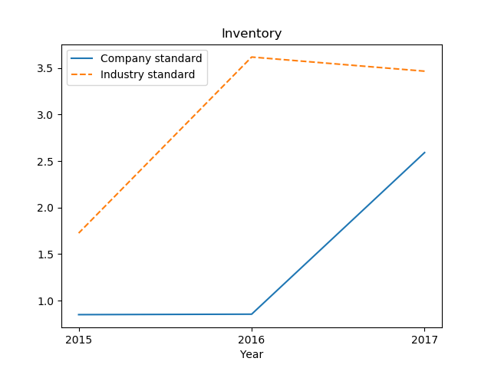

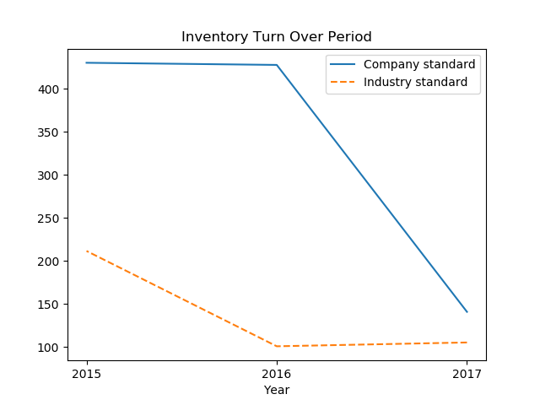

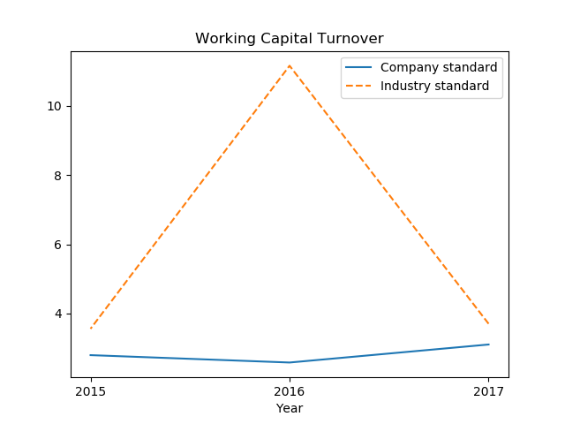

# Solvency Ratios

|  |  |  |  |
| --- | --- | --- | --- |
| Ratio Name | 2017.0 | 2016.0 | 2015 |
| Debt Ratio | 0.49 | 0.39 | 0.51 |
| Debt To Equity Ratio | 1.96 | 1.64 | 2.04 |

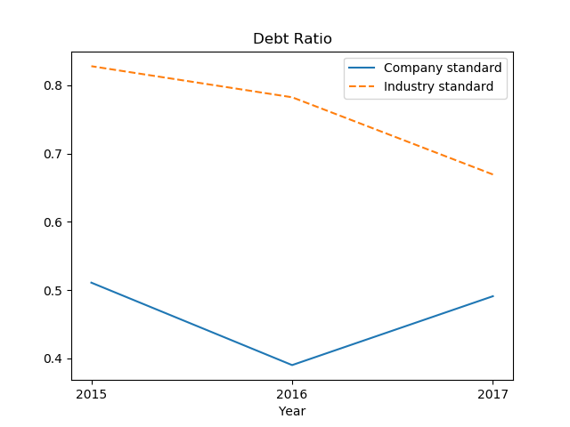

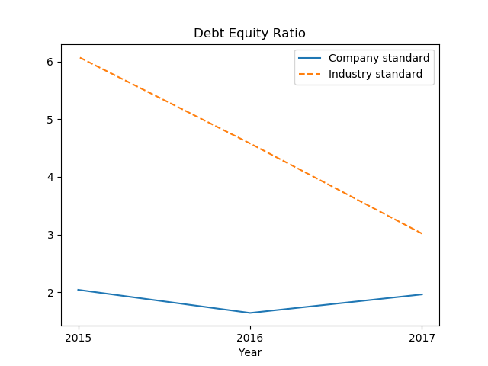

# Common Size Analysis of Income Statements ( % of Sales)

|  |  |  |  |
| --- | --- | --- | --- |
| Ratio Name | 2017.0 | 2016.0 | 2015 |
| Revenue | 7421963.0 | 5741499.0 | 5365799.0 |
| Beginning Inventory | 55.55 | 184.09 | 173.67 |
| Purchases | 48.78 | 43.88 | 47.74 |
| Freight Expenses | 0.0 | 0.0 | 0.0 |
| Ending Inventory | 6.77 | 5.81 | 14.63 |
| Bill Of Materials | 46.51 | 51.74 | 52.04 |
| Labour Expenses | 0.0 | 0.0 | 0.01 |
| Labour Charges Per Working Hour | 0.0 | 0.0 | 0.12 |
| Sub Contract Expenses | 34.23 | 29.3 | 27.85 |
| Cost Of Goods Sold | 80.74 | 81.04 | 79.89 |
| Business Development Expenses | 0.0 | 0.0 | 0.0 |
| Fuel Expenses | 0.62 | 1.09 | 1.29 |
| Conveyance Expenses | 0.04 | 0.22 | 0.16 |
| Telephone Expenses | 0.64 | 1.18 | 0.91 |
| Selling & Admin Expenses | 1.3 | 2.48 | 2.35 |
| Electricity Charges | 0.0 | 0.0 | 0.0 |
| Vehicle Maintenance | 0.0 | 0.47 | 0.22 |
| Machine Maintenance | 0.0 | 0.0 | 0.0 |
| Rent | 0.0 | 0.0 | 0.0 |
| Consumables | 0.0 | 0.0 | 0.0 |
| Bank Charges | 0.01 | 0.04 | 0.01 |
| Other Operating Expenses | 0.01 | 0.51 | 0.23 |
| EBITDA | 17.95 | 15.96 | 17.53 |
| Depreciation | 0.14 | 0.14 | 0.69 |
| Amortization | 0.0 | 0.0 | 0.0 |
| Other Expenses | 8.21 | 7.19 | 5.89 |
| Bank Interest Expense | 0.0 | 0.0 | 0.0 |
| Other Interest Expense | 0.0 | 0.0 | 0.0 |
| Total Interest Expense | 0.0 | 0.0 | 0.0 |
| Interest Expense Per Working Hour | 0.0 | 0.0 | 0.0 |
| Bank Interest Income | 0.0 | 0.0 | 0.0 |
| Other Income | 0.0 | 0.4 | 0.32 |
| Income(Bank Interest Income+Other Income) | 0.0 | 0.4 | 0.32 |
| Net Income Before Taxes | 9.6 | 9.03 | 11.26 |
| Income Tax Expense | 0.07 | 0.0 | 0.05 |

