Monitoring
Overall monitoring stack and why metrics and logs are kept as separate pipelines:
- Prometheus performs metrics collection and alerting rules; Grafana provides dashboards; Alertmanager handles notification routing.
- An OpenSearch/Fluentd pipeline (Fluentd or Fluent Bit, OpenSearch, OpenSearch Dashboards) handles centralized logs.
- Metrics and logs are two separate pipelines on purpose: metrics show that something is wrong and when; logs show why.
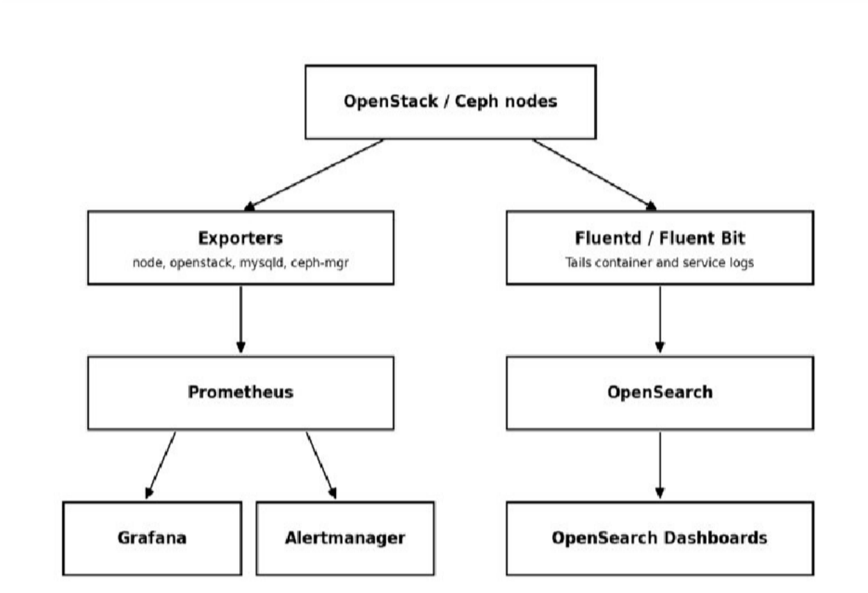
- The same exporter-based pattern is reused across every OpenStack service, so operators only need to learn one model.

Core OpenStack API Services ( Nova, Neutron, Keystone, Glance)
    - Nova, Neutron, Keystone, and Glance are monitored via openstack-exporter, which polls each API on an interval and converts the response into Prometheus metrics.
    - Nova: instance states, hypervisor stats, and resource usage, plus node_exporter for host-level CPU/RAM/disk on compute nodes.
    - Neutron: L3/DHCP/OVS agent up-down status and port/network counts, plus blackbox_exporter ICMP/TCP probes on floating IPs and VIPs to confirm real reachability.

    - Keystone: blackbox HTTP probes for API reachability and token issuance latency, since every other service depends on Keystone being up.
    - Glance: node_exporter tracks image-store disk usage (a full store blocks new builds) alongside openstack-exporter's image list/status, correlated on one Grafana panel.
    - Nagios/Zabbix-style tools were skipped here because they need manual plugin scripts for OpenStack APIs; Ceilometer/Gnocchi was skipped as heavier and largely deprecated.

Component | Primary Tool | Key Signal
Nova (Compute) | openstack-exporter + node_exporter | Instance/hypervisor state, host resources
Neutron (Networking) | openstack-exporter + blackbox_exporter | Agent status, floating IP/VIP reachability
Keystone (Identity) | blackbox_exporter (HTTP probe) | Endpoint availability, token latency
Glance (Image) | openstack-exporter + node_exporter | Image status, store disk usage

Storage Monitoring Ceph Backend
    - Storage monitoring is Ceph-first because the actual persistent data lives on Ceph, not on the Cinder API itself (see section 1.2).
    - ceph-mgr runs a Prometheus plugin exposing OSD up/down/in/out state, placement group (PG) status, pool capacity/usage, and cluster I/O throughput and latency.
    - This sits underneath the Cinder/Glance API checks: the API layer shows whether an operation succeeded; the Ceph layer shows why it might be slow or failing.
    - A degraded PG count or a downed OSD is exactly the kind of backend problem that causes slow or failed volume attach/detach without ever appearing as a Cinder-level error.
    - Monitoring only the Cinder API and skipping the Ceph layer is the single most common gap in OpenStack monitoring setups.

Layer | Tool | Key Signal
Ceph cluster | ceph-mgr Prometheus module | OSD state, PG health, pool capacity
Cinder API | openstack-exporter | Volume state counts (available/in-use/error)
Glance API | openstack-exporter | Image status, backed by Ceph RBD pool

Application & Orchestration Services (Horizon, Heat, Octavia, Zun)
    - Horizon: blackbox_exporter issues an HTTPS GET against the login page (status code, response time, cert expiry) since a process-level check can pass while the app itself is broken.
    - Heat: openstack-exporter reports stack counts by status (CREATE_COMPLETE, FAILED); Fluentd tails heat-engine logs to OpenSearch so OpenSearch Dashboards can surface the root cause.

    - Octavia: openstack-exporter polls loadbalancer/listener/pool/member status; blackbox_exporter probes the VIP:port directly, since amphora status alone can miss a misconfigured listener.
    - Zun: cAdvisor reads cgroups for true per-container CPU/memory/network, since the Zun API alone only shows reported state, not actual consumption.
    - Each of these services is watched on both a control-plane signal and a data-plane/user-facing signal, not just one.

Component | Primary Tool | Key Signal
Horizon (Dashboard) | blackbox_exporter (HTTP probe) | Page load status, TLS cert expiry
Heat (Orchestration) | openstack-exporter + Fluentd logs | Stack status, failure root cause
Octavia (Load Balancer) | openstack-exporter + blackbox_exporter | Amphora state, VIP reachability
Zun (Containers) | cAdvisor + Prometheus | Per-container CPU/memory/network

Infrastructure Layer (Database, Messaging, Load Balancing)
    - MariaDB/Galera: mysqld_exporter runs as a monitoring user and reports wsrep_* variables — node state, replication lag, and cluster quorum.
    - Generic host monitoring alone will not show replication lag or split-brain risk, which is why a MySQL-aware exporter is required.
    - RabbitMQ: the Prometheus plugin exposes queue depth, message rates, and consumer counts, since queue backlog is the earliest sign of an overloaded service (e.g. Nova conductor falling behind).
    - HAProxy: haproxy_exporter reads the stats socket for backend up/down state and request metrics, combined with a blackbox_exporter probe directly on the VIP.
    - The HAProxy + VIP combination catches cases where HAProxy's own view of a backend disagrees with reality due to a check misconfiguration.

Component | Primary Tool | Key Signal
MariaDB / Galera | mysqld_exporter + Grafana Galera dashboard | Node state, replication lag, quorum
RabbitMQ | RabbitMQ Prometheus plugin | Queue depth, unacked messages
HAProxy + Keepalived (VIP) | haproxy_exporter + blackbox_exporter | Backend health, VIP failover

Host & Container Layer
    - Every Kolla-Ansible service runs as a Docker container, so container restart counts and resource limits are a first-line signal across the deployment.
    - cAdvisor exposes per-container state and restart counts; Docker's own HEALTHCHECK directive (built into Kolla images) flags unhealthy containers.
    - node_exporter runs on every node and exposes CPU, memory, disk I/O, filesystem, and network metrics in Prometheus format.
    - Alertmanager fires a notification whenever a defined threshold — e.g. disk usage above 85% — is crossed.

    - Vendor dashboards (iDRAC/iLO) or ad hoc 'top'/'htop' checks were not used as the primary signal since they give a snapshot, not historical trend data or automated alerts.

Layer | Tool | Key Signal
Docker containers (Kolla runtime) | cAdvisor + Docker healthchecks | Restart counts, unhealthy containers
Host / OS (all nodes) | node_exporter + Alertmanager | CPU, memory, disk, network thresholds

Why This Combination Over a Single All-in-One Tool
    - Commercial all-in-one suites (Zabbix, SolarWinds, Datadog) can technically monitor everything, but need paid licensing at data-center scale.
    - Zabbix was evaluated directly for this deployment and would still need custom scripts to understand Nova, Neutron, and Ceph the way openstack-exporter and ceph-mgr already do natively.
    - Prometheus + Grafana + exporters is open source and container-native, fitting the Kolla/Docker model directly rather than fighting it.
    - A purpose-built openstack-exporter is maintained specifically for OpenStack API monitoring.
    - Alertmanager handles alert routing and deduplication without needing a separate paid alerting product.
    - The full comparison against every alternative considered, including newer 2026 tools, is presented in sections 13 and 14.

