Creating a client-username and ACL profile and changing configuration of acl-profile

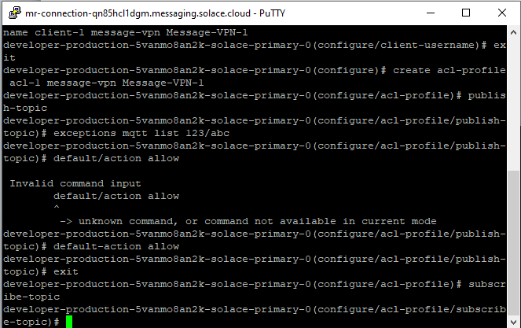

Client-username is created : -> client-1

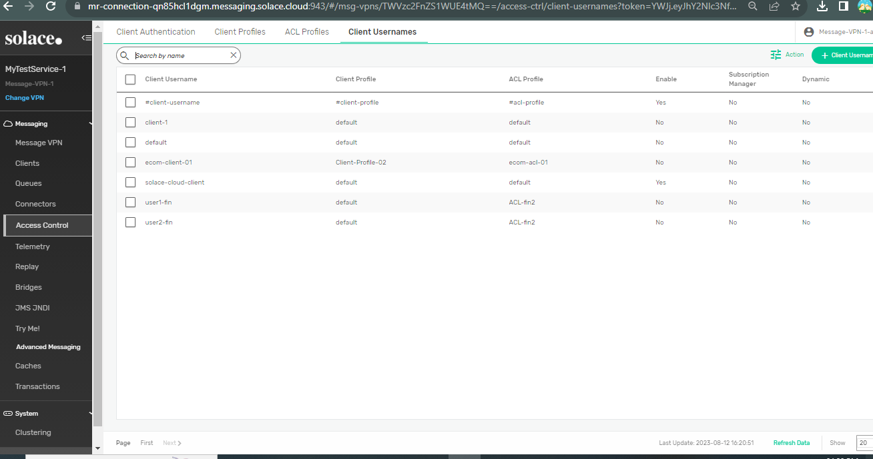

Acl-profile is created ,the commands are shown in first snap.

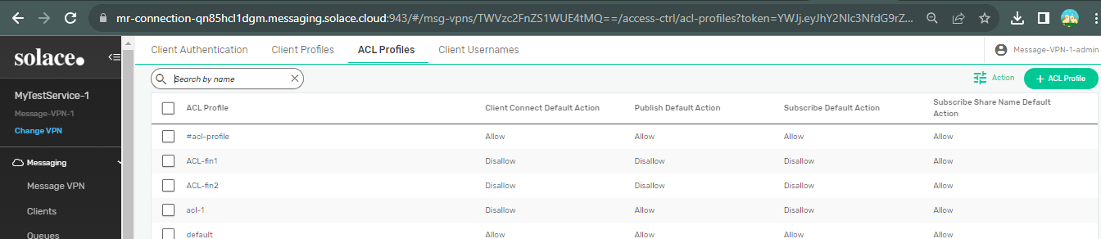

Publish default action made allow using command and exception is also added.

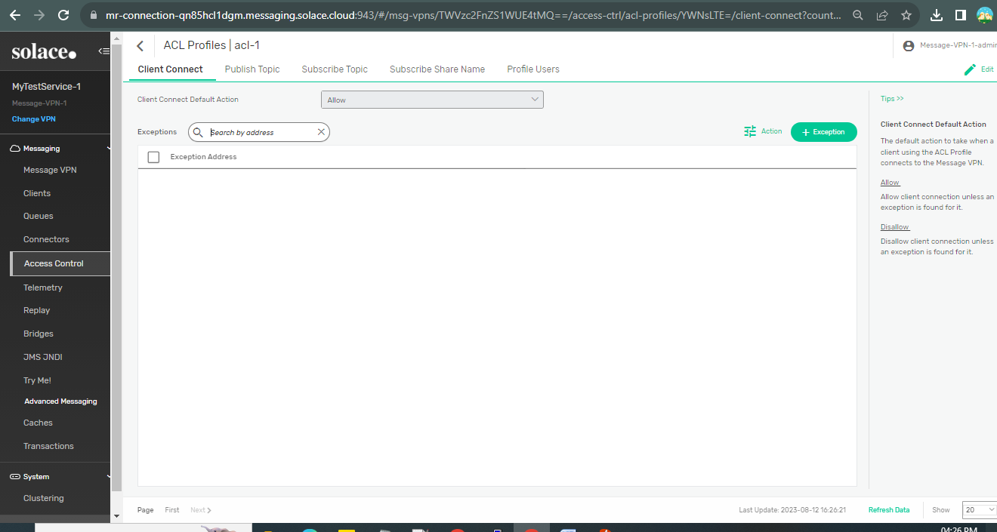

Subscribe default action made allow and exception added with MQTT Syntax

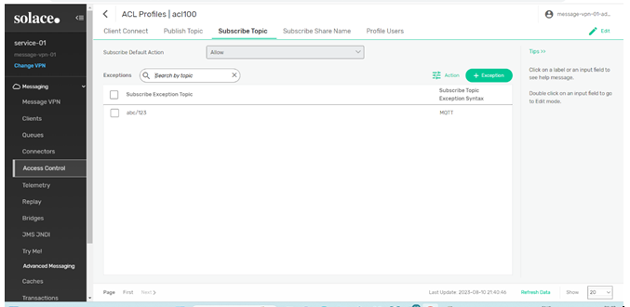

We will not be able to create Client-profile from cli ,so to create we click on client profile in

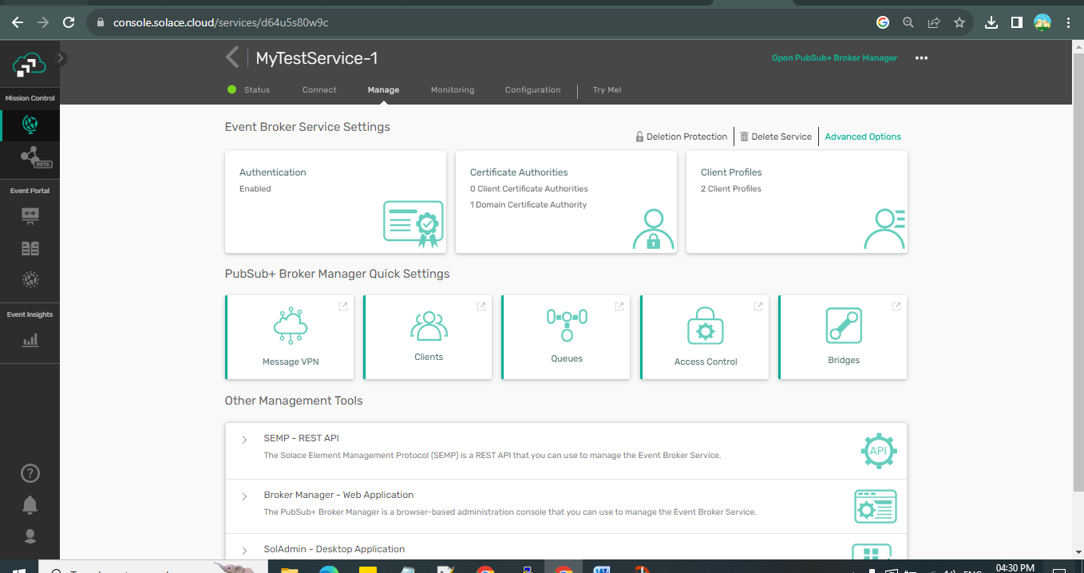

To add new client-profile click on add new

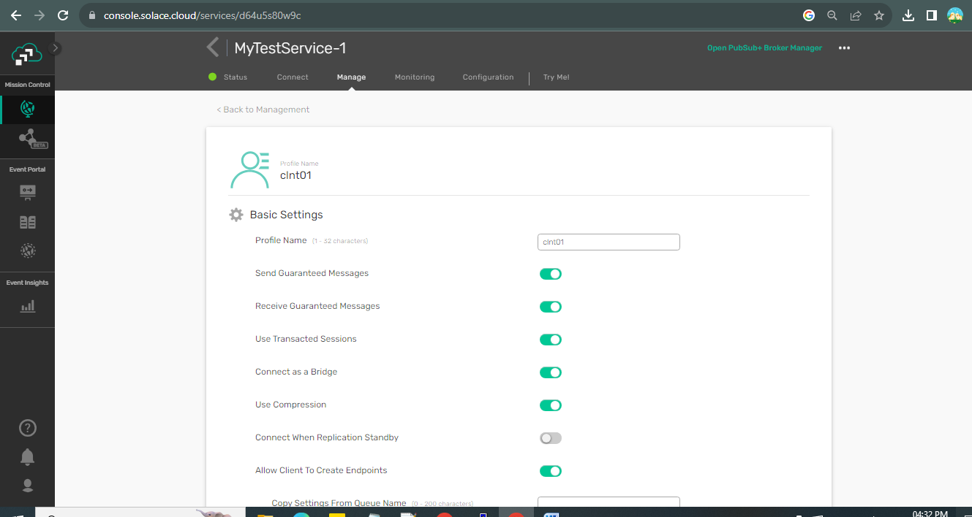

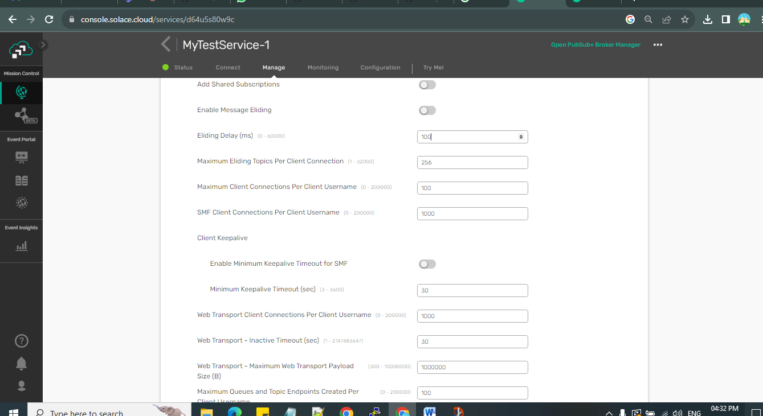

Client-profile is created:

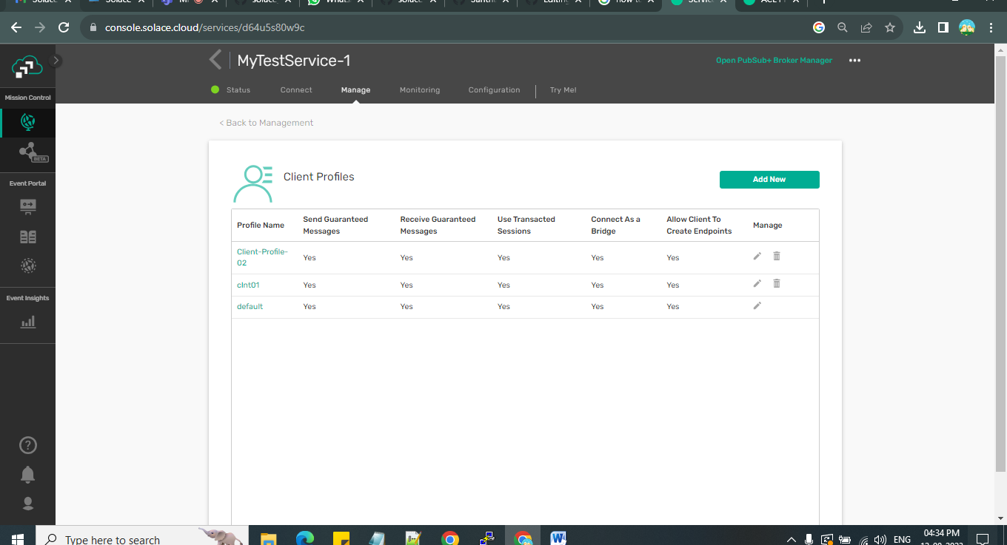

Client-username configuration can be changed

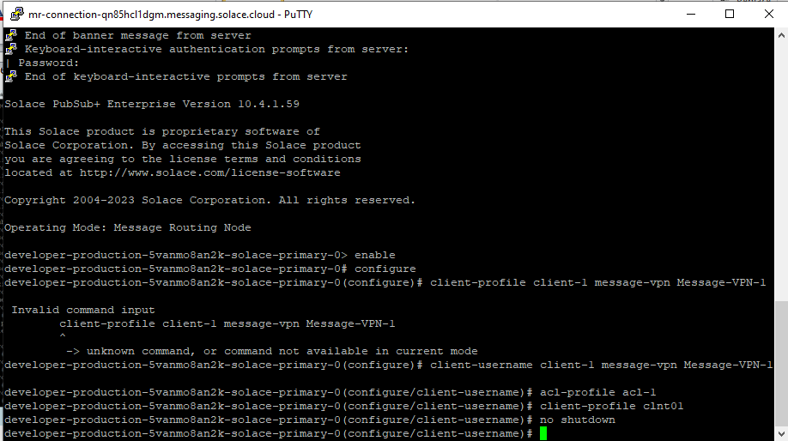

The configuration client-profile and acl-profile is changed/updated

