Software Requirement Specification (SRS)

Project Title: Rent a Car

**Requirement:**

We need to build a software for Rent a Car. The application will have following features:

1. There will be different type users like Admin, operator.
2. There will be different type of cars.
3. There will be different location.
4. Car booking advance will be at least 1000 BDT.
5. Customer give advance by cash. And also full payment takes by cash.

**Analysis and Design Part:**

1. Brain Stroma Diagram:

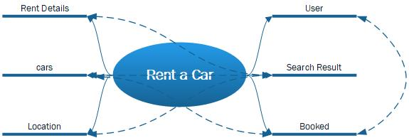

1. Use case Diagram:
2. Class Diagram:
3. Entity Relationship Diagram:
4. Front End Designs: