**STREAMLIT-SONAR CLOUD**

1. **Go to** [**https://sonarcloud.io/login**](https://sonarcloud.io/login) **-> Login with Github-> Click on the “+” symbol on the top right of the page -> Analyze New Project**

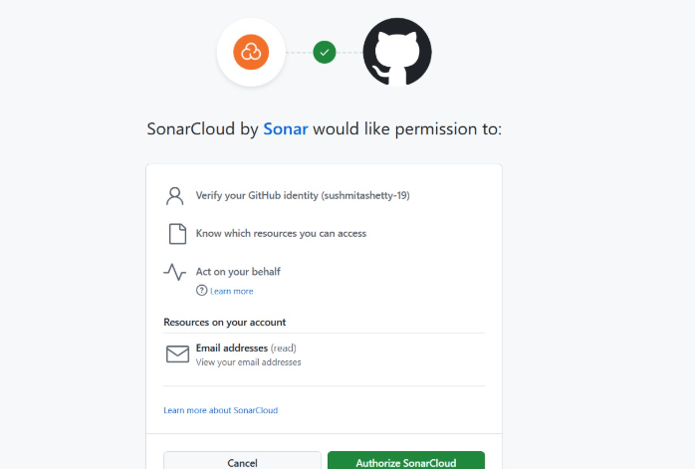

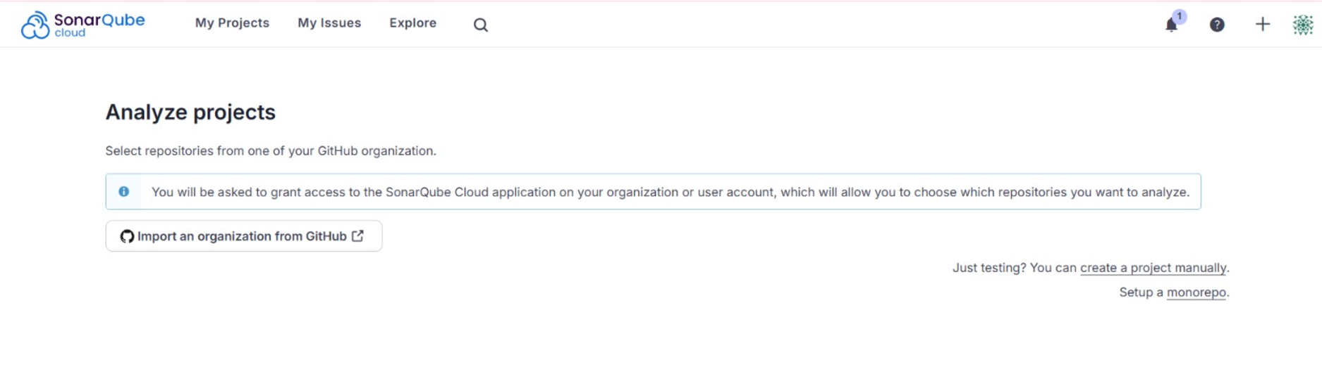

1. **Select “Set Up”**

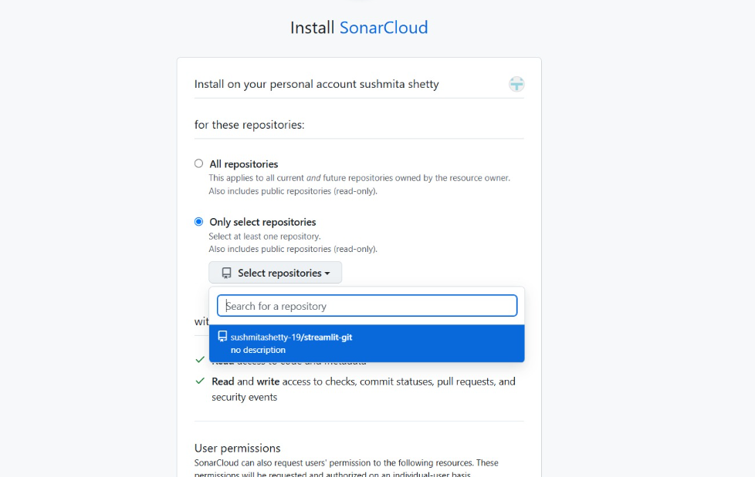

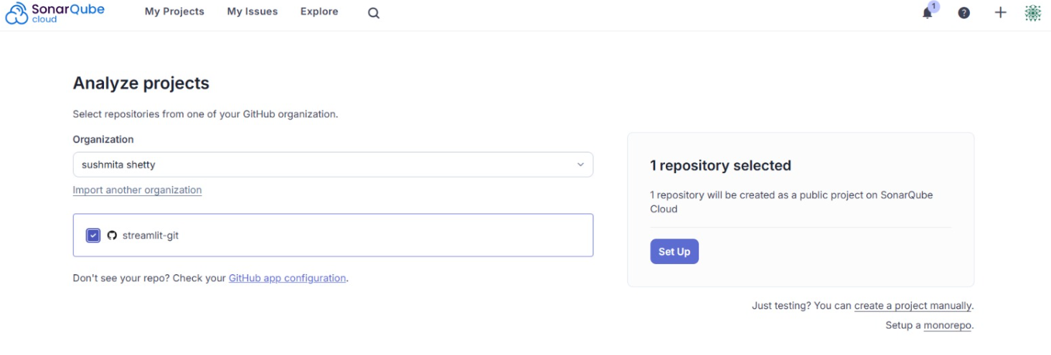

1. **Select Previous Version and Scroll down and select Create Project**

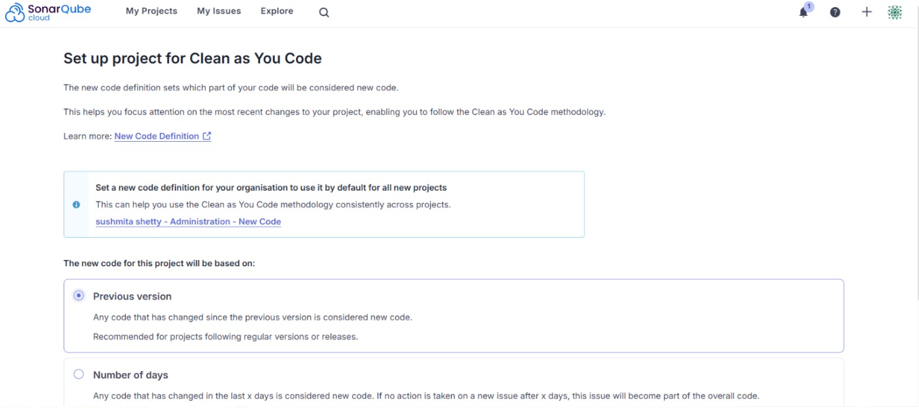

1. **Screenshots of the code:**

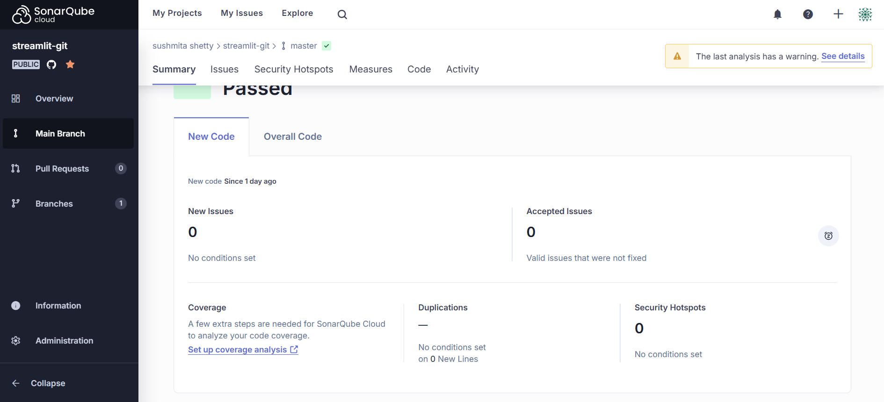

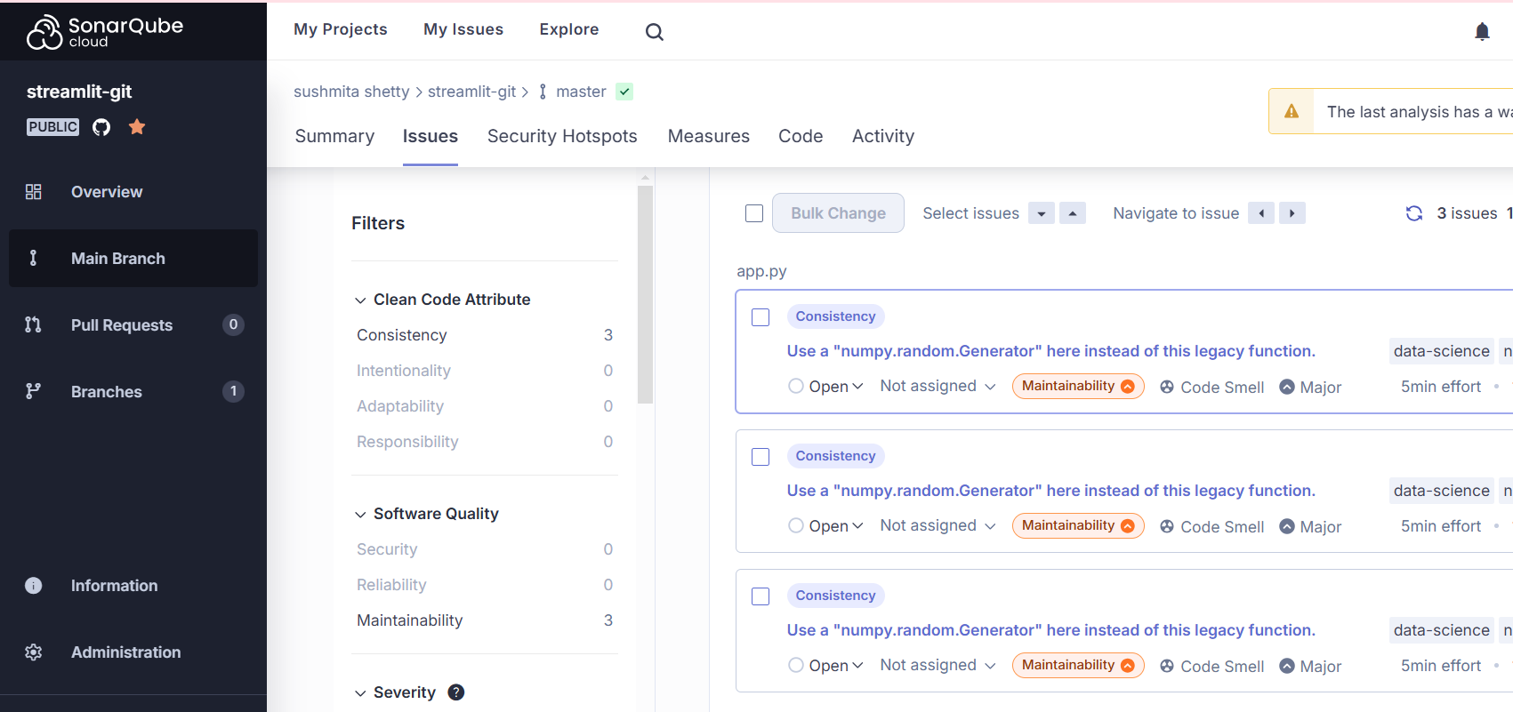

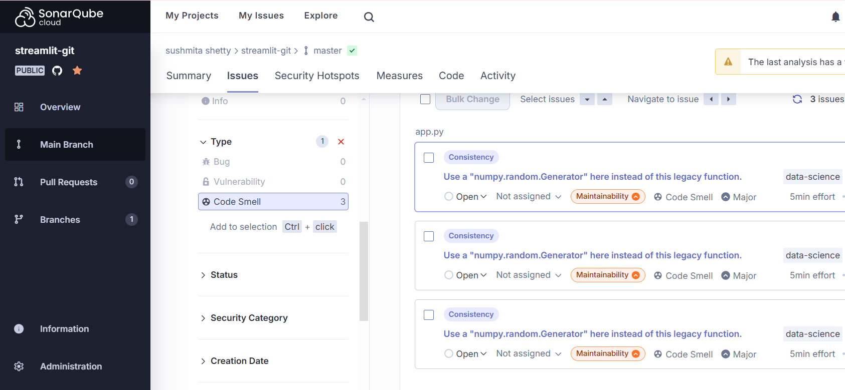

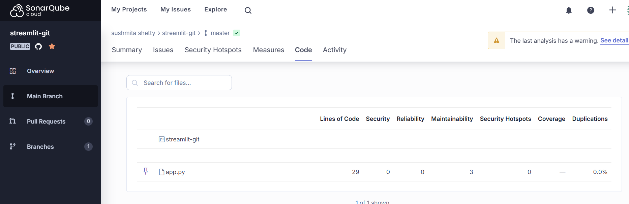

**Creating a Custom Quality Gate**

1. **Go to Administration->Quality Gate**

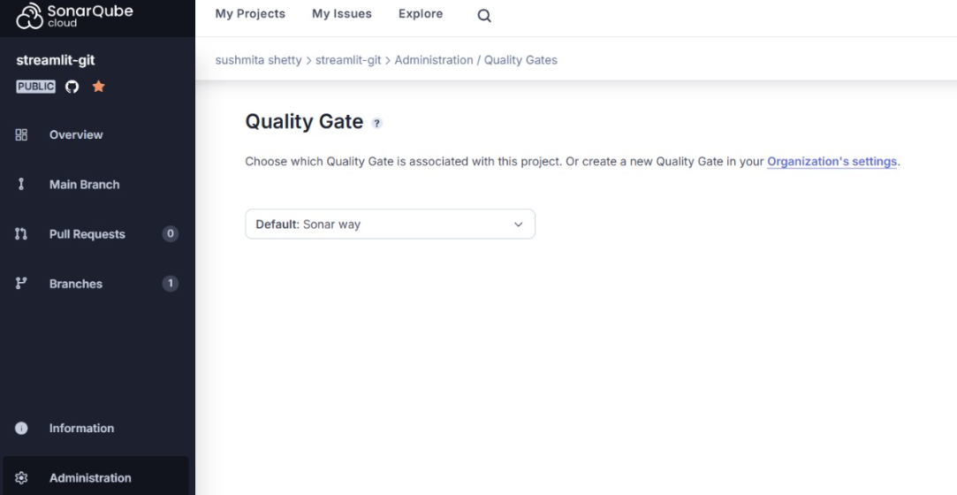

1. **Go to Quality gate page**
2. **Click on Organization Settings to create your own quality gate**

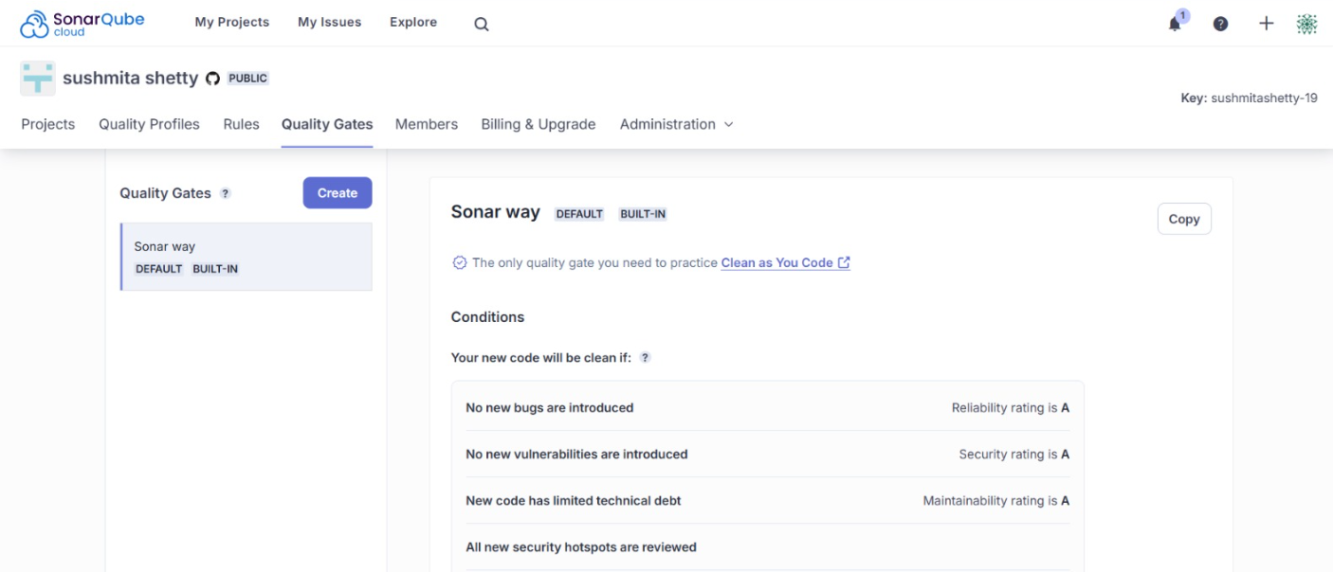

1. **Click on Create-> Give it a custom name**

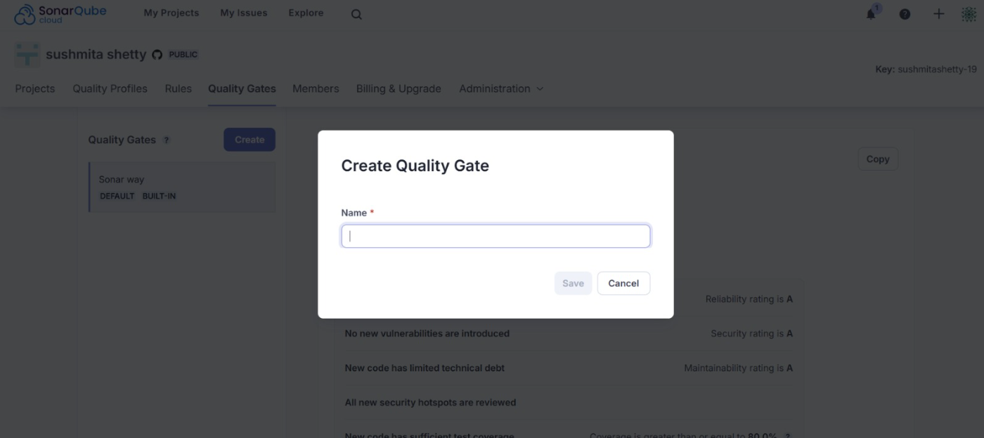

1. **Give it any custom settings**

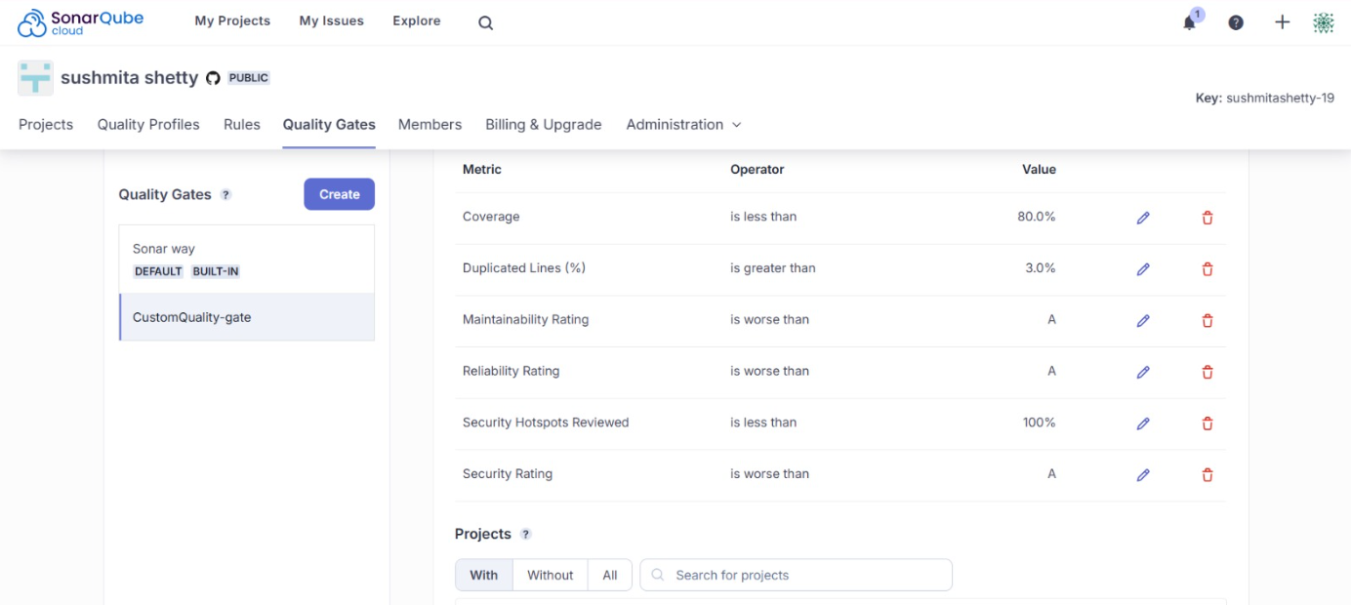

1. **Update any quality gate conditions if needed**

1. **After Updating**

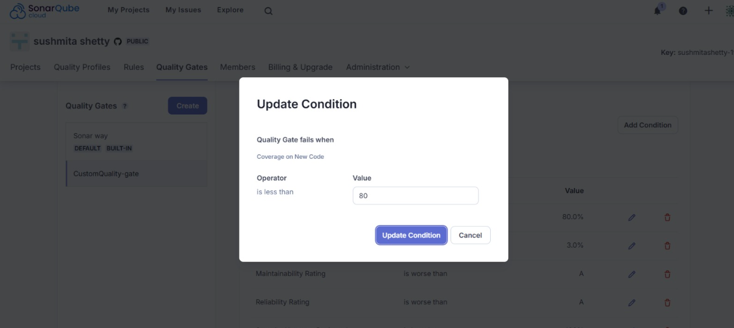

1. **Set Custom Quality Gate as default:**

* **Go to My Projects->Click on the Project**

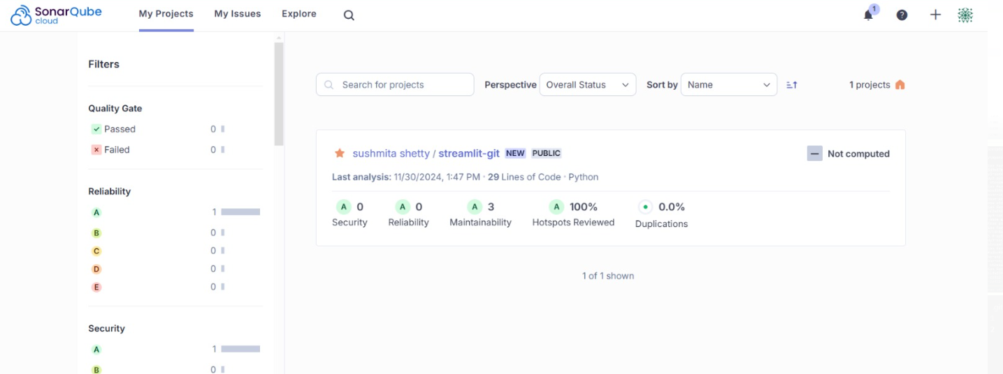

* **Click on Administration-> Quality Gate**

* **Set My Custom Quality Gate as default from the dropdown menu**

