**Q. ANSIBLE-APACHE**

**Question:** **Write an Ansible playbook that installs Apache on a remote server and ensures the service is started.**

**Creating Remote Servers Using Docker and installing SSH**

**Install docker, from docker hub pull the image**

**Step 1: Pull Docker image of ubuntu from docker hub and run**

1. **Now we’ve entered the bash (CMD) of the container. Now install SSH and Python3 on the container using this bash:**

**apt install -y openssh-server python3**

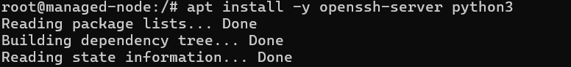

Now start ssh on the container   
using service ssh start command



1. **Now setup password for SSH on the container**



1. **Now setup password for SSH on the container**

1. **Edit this file using “I” to insert and then press esc key and save using :wq**



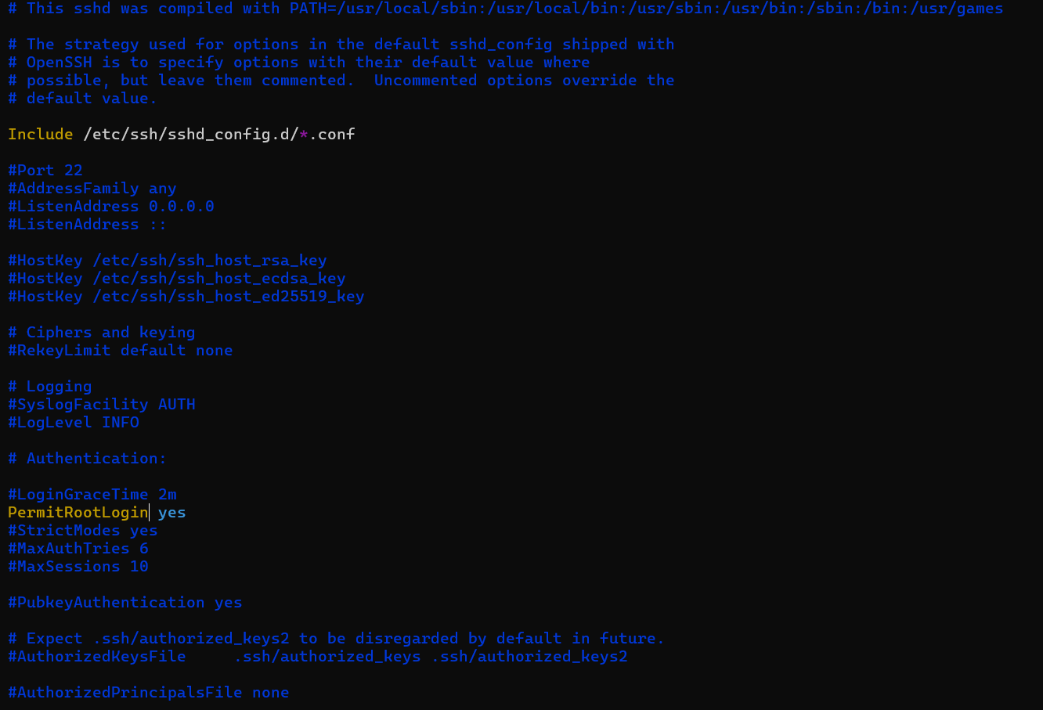

1. **Restart SSH on the container**



1. Vm **On create SSH public key on WSL Ubuntu machine**

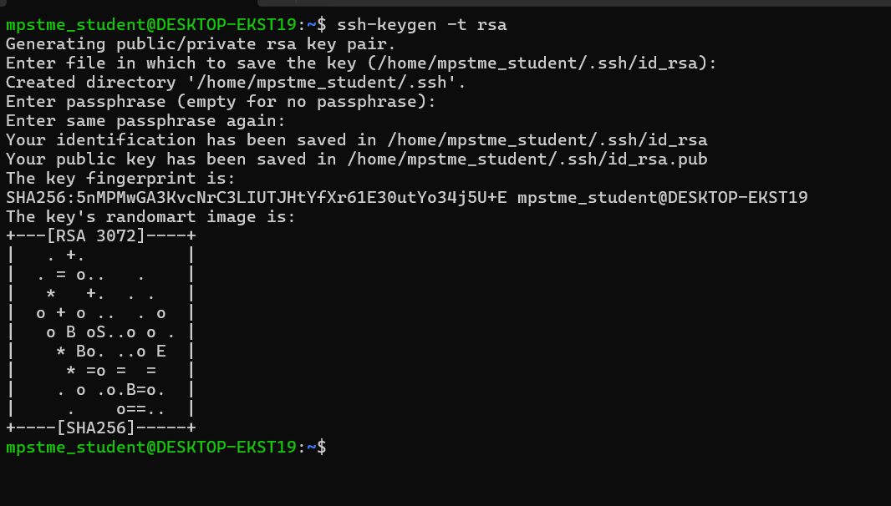

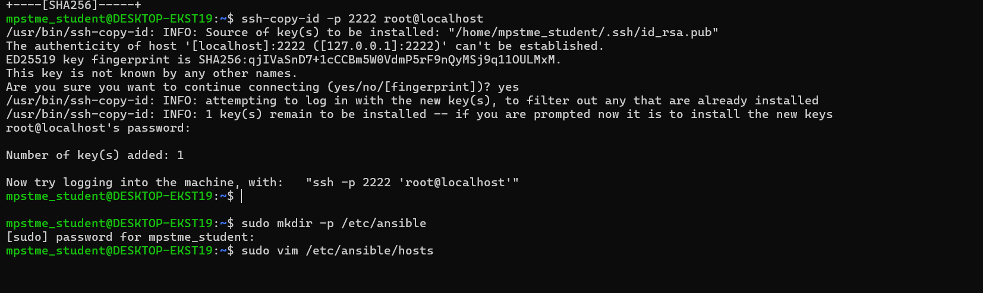

//

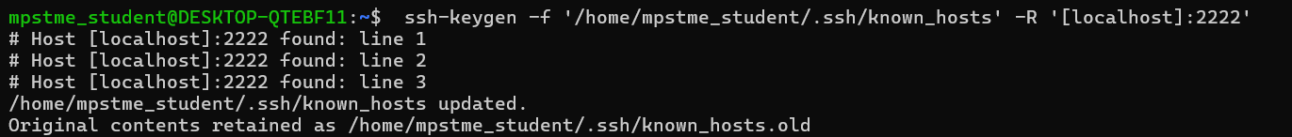

1. **Now add the manage nodes(docker codes) to the container**

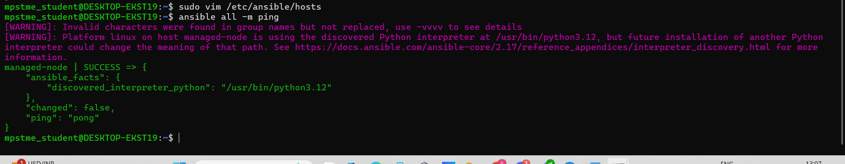

1. **Test your connections**

**Command: ansible all -m ping**

**Run mkdir playbooks, to create a new directory to store your playbooks**

**Next run ls to verify**







**Playbook:**

---

- name: Install and ensure Apache is running

hosts: localhost

become: yes # Run tasks as sudo

tasks:

- name: Update the package repository

apt:

update_cache: yes

- name: Install Apache

apt:

name: apache2

state: present

- name: Ensure Ap

ache service is started and enabled

service:

name: apache2

state: started

enabled: yes





