**GROUP NAME :** TRIO GROUP

INNOVATION CHOSEN : SOCIAL MEDIA

1. Title of innovation

Social media ( Instagram)



1. introduction

Social media refers to interactive online platforms where users can communicate, share information, and create virtual communities. These platforms include websites and apps like Facebook, Instagram, Twitter, and TikTok. Social media has become a significant part of both personal and professional lives, facilitating connections, news dissemination, entertainment, and even commerce.



3.founder

The term "social media founder" can refer to different individuals depending on the specific platform. Andrew Weinreich is credited with creating the first social media site, Six Degrees, in 1997. Later, Mark Zuckerberg co-founded Facebook in 2004 with his roommates Eduardo Saverin, Andrew McCollum, Dustin Moskovitz, and Chris Hughes. Twitter was founded in 2006 by Jack Dorsey, Biz Stone, and Evan Williams. YouTube was founded by Jawed Karim, Steve Chen, and Chad Hurley in 2005.

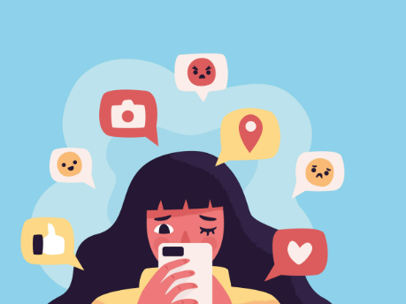4.problem statement

Social media presents numerous problems, including mental health issues like anxiety and depression, cyberbullying, the spread of misinformation, and privacy concerns. Additionally, social media can lead to addiction, reduced productivity, and feelings of inadequacy due to comparison with others.

Mental Health Impacts:

* **Anxiety and Depression:**

Social media can fuel anxiety and depression, particularly among young people. Comparison with others, unrealistic portrayals, and the fear of missing out (FOMO) can contribute to these feelings.

* **Low Self-Esteem:**

The constant exposure to curated highlight reels and the pressure to maintain a perfect online persona can lead to feelings of inadequacy and low self-esteem.

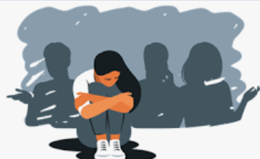**Social Isolation and Loneliness:**

While social media can connect people, it can also paradoxically lead to social isolation and feelings of loneliness. People may spend more time online than in real-life interactions, leading to a decline in face-to-face connections.

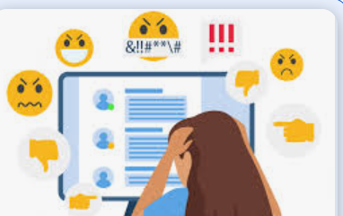

* **Cyberbullying and Harassment:**

Social media platforms can be breeding grounds for cyberbullying and harassment, which can have severe negative impacts on mental health.

5.the innovative thinking behind social media

 Social media refers to interactive internet-based communication platforms where users can create, share, and engage with content. It encompasses a wide range of applications and websites, including social networking sites, blogging platforms, photo-sharing apps, and video-sharing services. Social media facilitates communication, information sharing, and community building through various forms of digital content.

6. research and development process

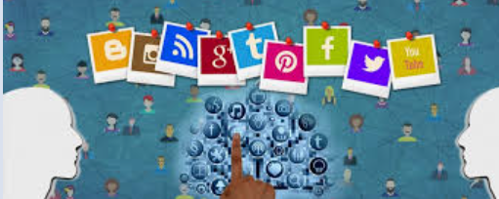Social media can be integrated into the research and development (R&D) process to enhance various stages, from ideation and product development to marketing and post-launch monitoring. This involves using social media for tasks like monitoring trends, gathering user feedback, and engaging with stakeholders.

7. Risks and challenges

Social media presents numerous risks and challenges, impacting individuals and organizations alike. These include privacy breaches, cyberbullying, misinformation, and mental health concerns.

Individual Risks and Challenges:

* **Privacy:**

Users share personal information, potentially exposing them to identity theft, cyberstalking, and unwanted attention.

* **Cyberbullying:**

Online harassment and bullying can have severe emotional and psychological consequences.

* **Mental Health:**

Social media addiction, comparison with others, and exposure to negative content can contribute to depression, anxiety, and low self-esteem.

* **Misinformation and Fake News:**

The rapid spread of false information can erode trust and have real-world consequences.

8. impact on learnings

Social media significantly impacts learning, offering both benefits and drawbacks. While it can enhance communication, collaboration, and access to information, it also poses challenges like distraction, misinformation, and potential negative impacts on mental health and social skills.

Benefits of Social Media in Learning:

* **Enhanced Communication and Collaboration:**

Social media platforms facilitate communication between students, teachers, and experts, enabling quick sharing of information, real-time discussions, and collaborative projects.

* **Access to Diverse Perspectives and Resources:**

Social media provides access to a wealth of information, diverse viewpoints, and learning materials that may not be readily available in traditional settings.

Drawbacks of Social Media in Learning:

* **Distraction and Reduced Productivity:**

The constant stream of notifications, updates, and engaging content can distract students from their studies and reduce their productivity.

* **Misinformation and Lack of Critical Thinking:**

Not all content on social media is credible, and students may encounter inaccurate information that can hinder their understanding and critical thinking skills.

**Conclusion**

Social media's conclusion is a mixed bag of profound impacts, both positive and negative, shaping how we connect, communicate, and consume information. While it offers opportunities for global connectivity and information sharing, it also presents challenges like misinformation, mental health concerns, and privacy risks. Ultimately, responsible and mindful usage is key to harnessing its benefits while mitigating its drawbacks.

**TRIO GROUP NAME :**

**SUSHMITA**

**MAHAK**

**MAHAK**