**HANA_SQL_PRACTICE_SCENRIOS**

1. **Product** table created

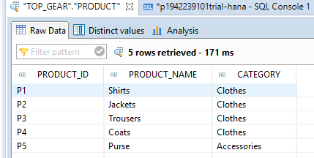

1. **SALES** table created

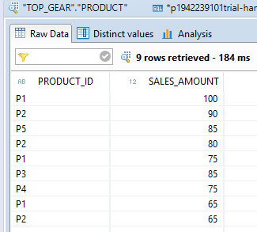

**EXERCISE#1:**

Create a procedure by using above tables to get the PRODUCT_NAME and SALES_AMOUNT.

Provide the Output using a table type.

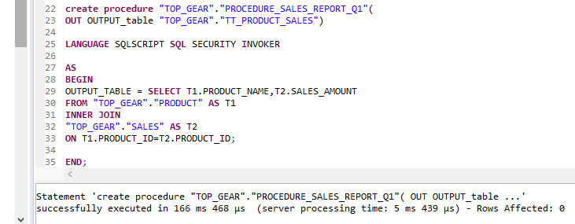

**Output:**

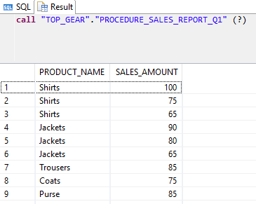

**EXERCISE#2:**

Create a procedure to Pass the Product id as Input parameter to Product id of Product table and

get PRODUCT_NAME and SALES_AMOUNT based on Input value passed by user and provide the

output using table type.

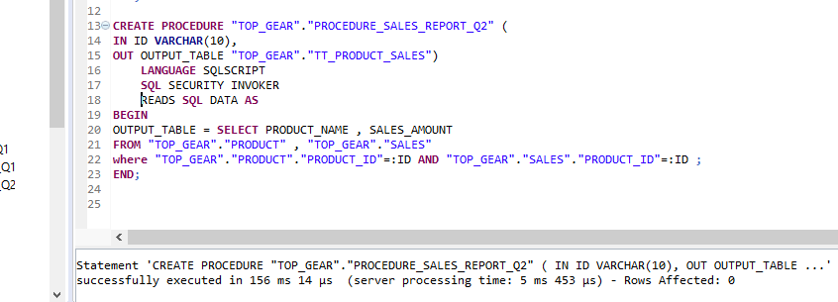

**Output:**

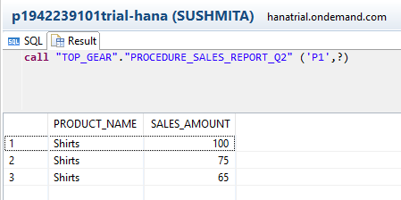

**EXERCISE#3:**

Create a procedure to pass product id, product name and category as input. If product already

exists in Product table, update the record else create a new record in the table.

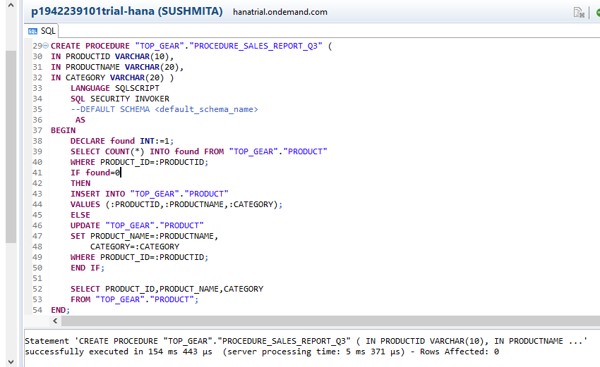

Record got updated for Product_Id ‘P1’

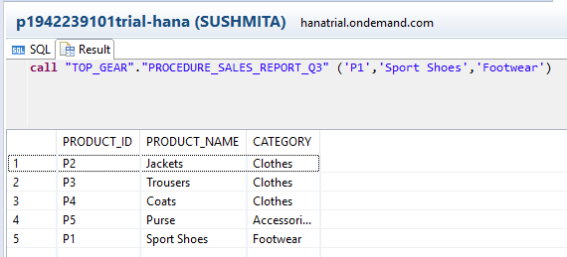

New record created for Product_Id ‘P6’

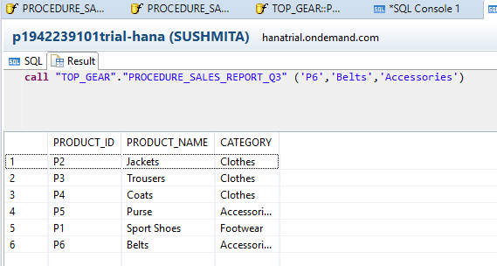

**EXERCISE#4:**

Create a procedure using PRODUCT table and pass the filter condition dynamically (dynamic

filter) while calling the procedure. Provide the Output using table type.

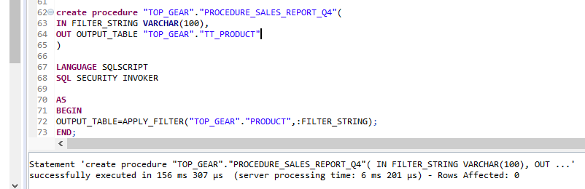

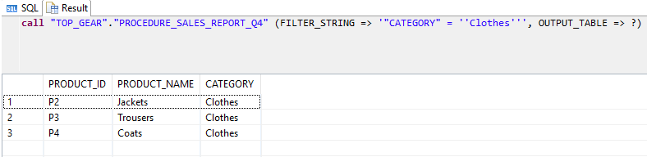

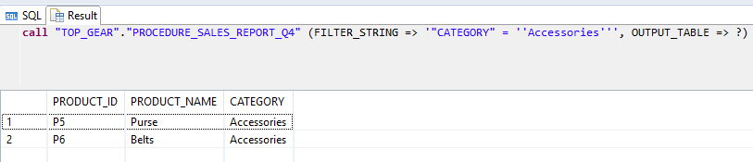

**EXERCISE#5:**

Create a procedure using Exception handling. Try to insert record into a table. If record already

exists, then it should throw an error.

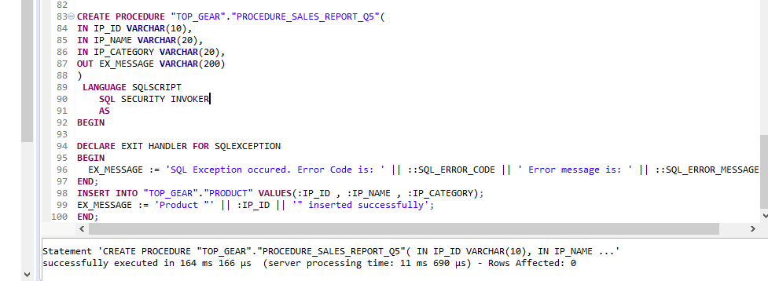

New Record inserted successfully

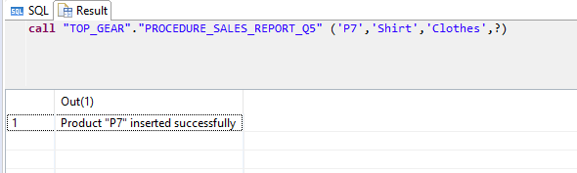

Throwing error when inserting the already existing record

