**HANA Modeling**

**Task 1: Create an Attribute View for Business Partner Master Data (Dimension Table)**

Attribute view created for Business Partner Master Data and selecting Raw Data Preview to display the output.

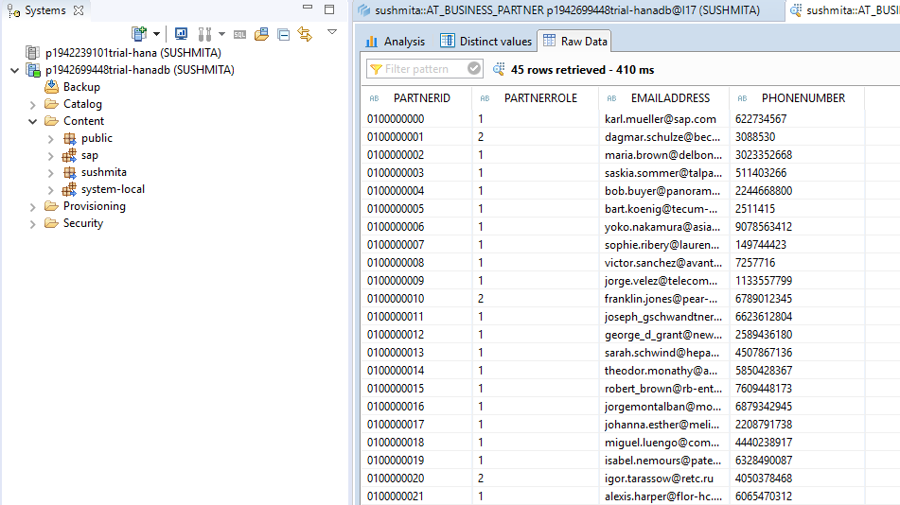

**Task 2: Create an Attribute View for Product Master Data (Dimension Table)**

Attribute view created for Product Master Data and selecting Raw Data Preview to display the output.

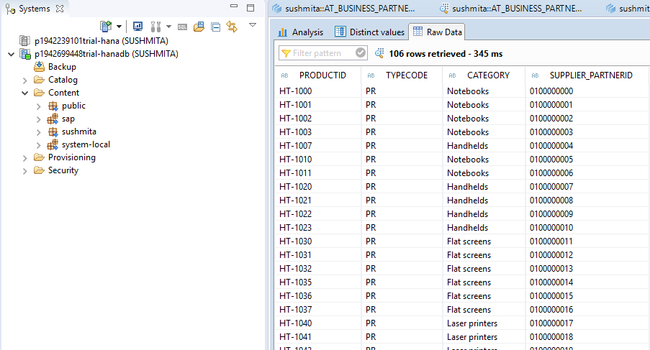

**Task 3: Create an Analytic View for Purchase Orders (Fact Table)**

The Gross amount for each of the partner id can be analyzed graphically as

shown below.

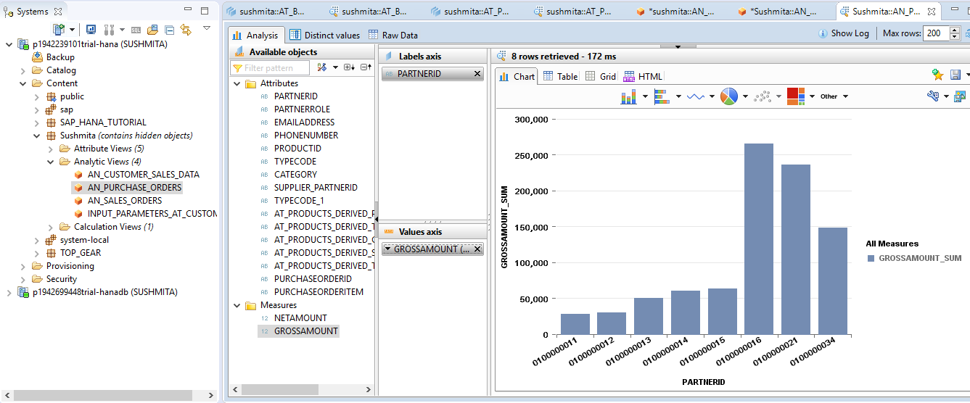

**Task 4: Create a Derived Attribute View from AT_PRODUCTS (Dimension Table)**

Created an Attribute View AT_PRODUCTS_DERIVED Derived From AT_PRODUCTS

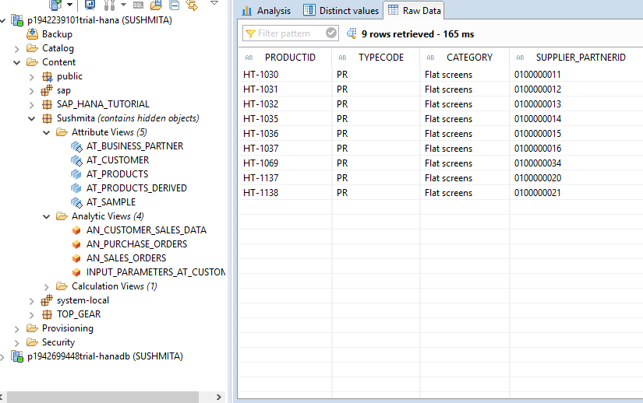

**Task 5: Create an Analytic View for Sales Orders (Fact Table)**

Analytic View for Sales Orders created:

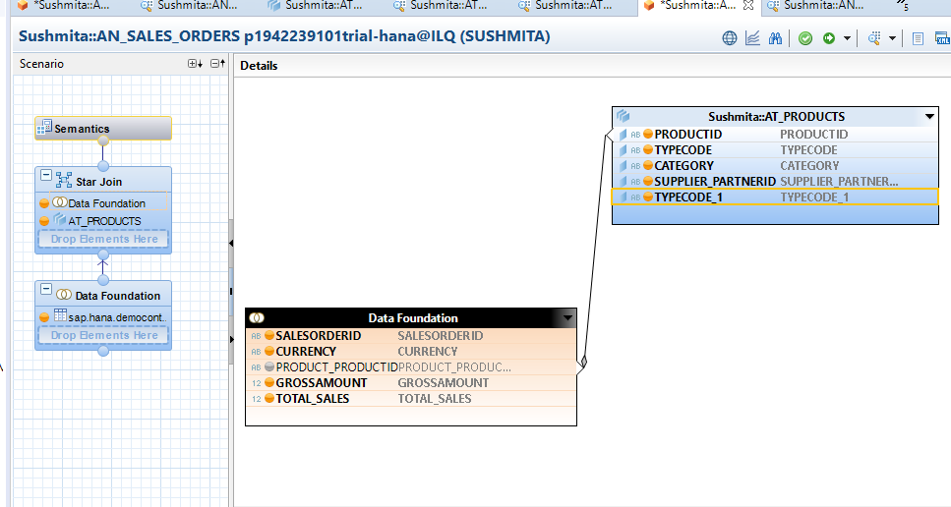

**Task 6: Restricted and Calculated columns**

Restricted column created on category column.

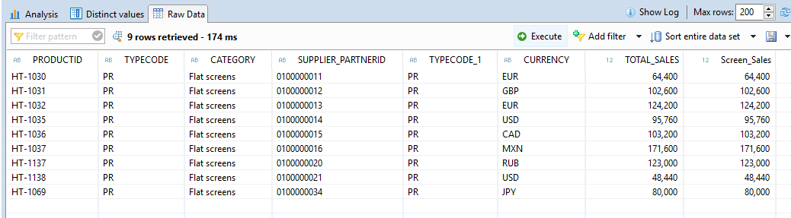

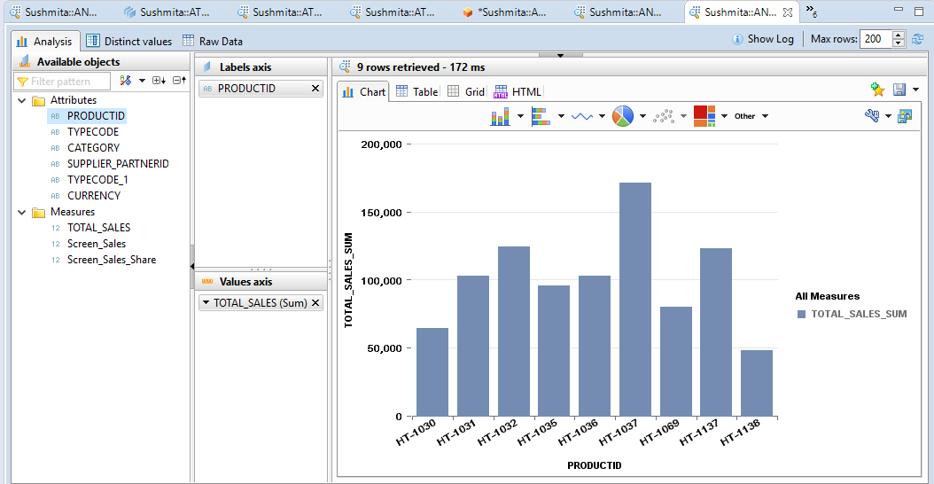

**Calculated columns**

Please find below the calculated column created

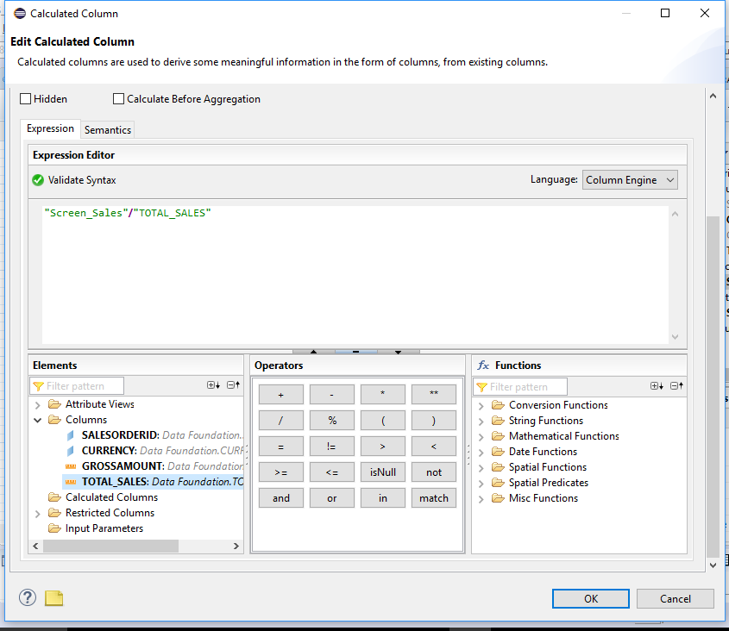



**Task 7: Filter Operations**

Client Dependent Views

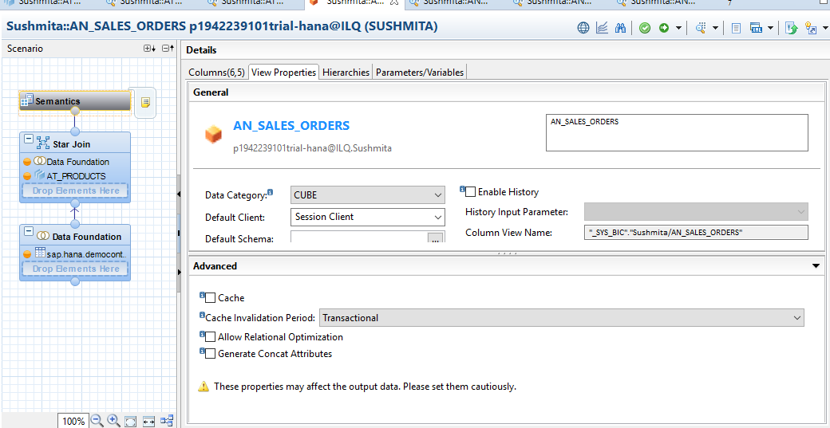

**Constraint filter**

Filter added to category column

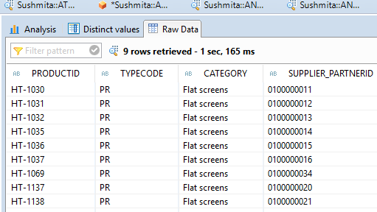

**Task 8: Variables and Input Parameters**

Created an Analytic View AN_CUSTOMER_SALES_DATA selecting partner_id as column variable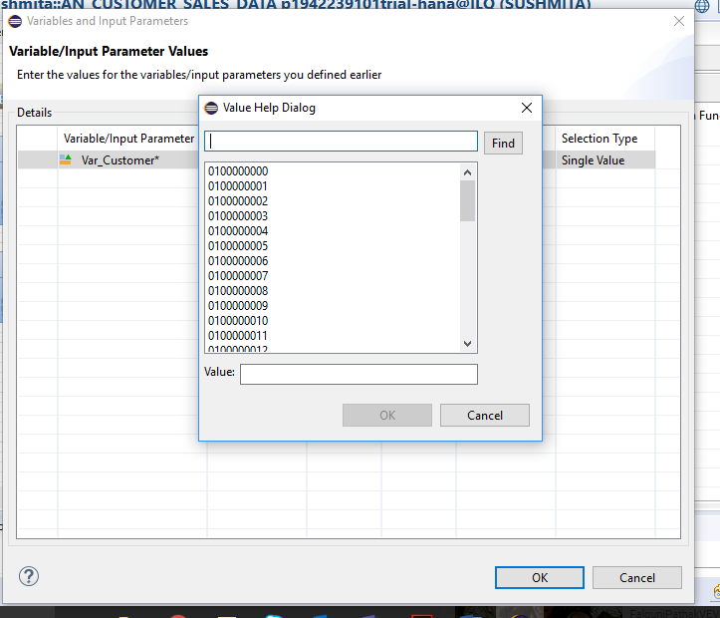

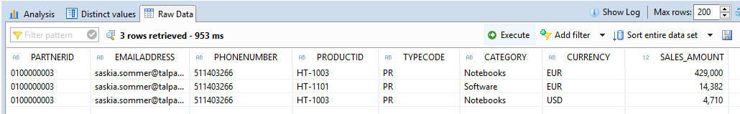

**Input Parameters**

created Calculated Column as Email_Date and previewed data by column variable as partner_id and input parameter as Email_Date

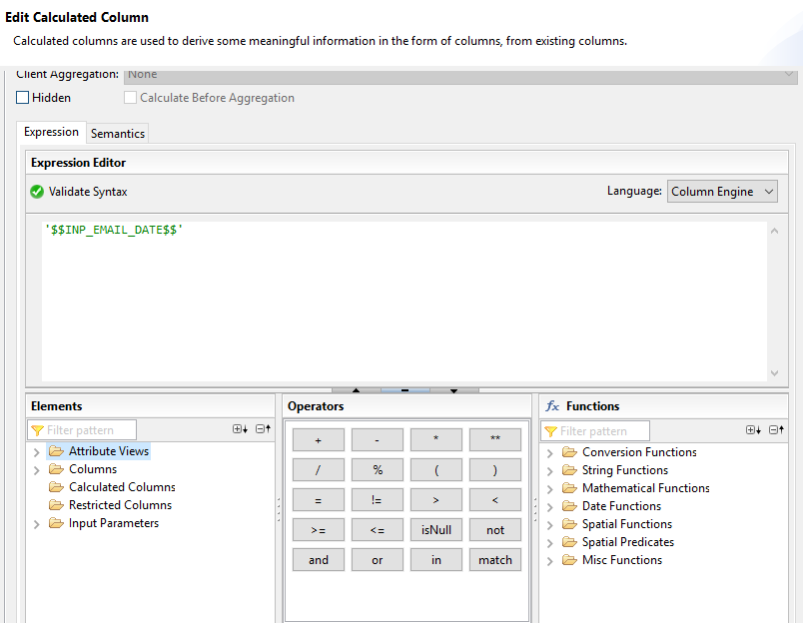

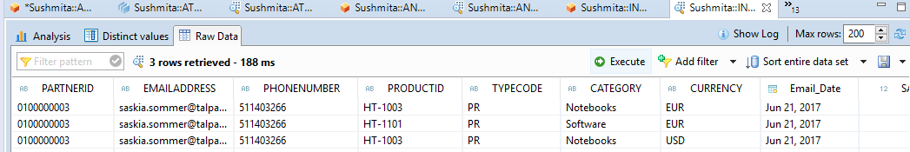

**Task 9: Create a Calculation View for Sales Orders (Cube)**

Created Calculation View CA_SALES_ORDERSs

