**Extra Credit: Putting it All Together: Data Cleaning to Model Evaluation**

Sushmita Prafull Halasawade

IFT 511: Analyzing Big Data (2022 Fall-MW)

Instructor: Asmaa Elbadrawy

4 Dec 2022

**PartI: Data Set Information:**

I am working with **Heart Disease Data Set**

Number of Instances: 303

Number of attributes: 14

Description of each attribute:

1. age in years

2. sex (1 = male; 0 = female)

3.(cp) chest pain type

1 = typical angina

2 = atypical angina

3 = non-anginal pain

4 = asymptomatic

4. (trestbps) resting blood pressure (in mm Hg on admission to the

hospital)

5. (chol) serum cholestoral in mg/dl

6. (fbs) (fasting blood sugar > 120 mg/dl) (1 = true; 0 = false)

7. (restecg) resting electrocardiographic results

0 = normal

1 = having ST-T wave abnormality (T wave inversions and/or ST

elevation or depression of > 0.05 mV)

2 = showing probable or definite left ventricular hypertrophy

by Estes' criteria

8. (thalach) maximum heart rate achieved

9. (exang) exercise induced angina (1 = yes; 0 = no)

10.(oldpeak) ST depression induced by exercise relative to rest

11.(slope) the slope of the peak exercise ST segment

1 = upsloping

2 = flat

3 = downsloping

12. (ca) number of major vessels (0-3) colored by flourosopy

13. (thal) thal:

3 = normal

6 = fixed defect

7 = reversable defect

14. (num) (the predicted attribute) diagnosis of heart disease (angiographic disease status)

0 = < 50% diameter narrowing

1 = > 50% diameter narrowing

**PartII: Loading dataset:**

Code:

import pandas as pd

df = pd.read_csv('processed.cleveland.data', header=None)

df

output:

Code:

headers = {0 : "age",

1 : "sex",

2 : "cp",

3 : "trestbps",

4 : "chol",

5 : "fbs",

6 : "restecg",

7 : "thalach",

8 : "exang",

9 : "oldpeak",

10 : "slope",

11 : "ca",

12 : "thal",

13 : "Diagnosis"}

df = df.rename(columns=headers)

df

Output:

**PartIII: Finding and removing missing data from the dataset:**

Code:

df = df[~df.isin(['?', '-9'])]

df

df2=df.dropna()

df2

Output:

**PartIV: Finding accuracy of Decision tree with gini and entropy with stratified k fold.**

Code:

from sklearn.model_selection import StratifiedKFold

from sklearn.preprocessing import StandardScaler

from sklearn import tree

from sklearn.model_selection import GridSearchCV

from sklearn.pipeline import Pipeline

skf = StratifiedKFold(n_splits=5)

target = df2.loc[:,'Diagnosis']

X=df2

y =target

cnt = 1

ss = StandardScaler()

dt = tree.DecisionTreeClassifier()

pipe = Pipeline(steps=[('std_slc', ss),

('dec_tree', dt)])

print("Creating Parameter Grid...")

criterion = ['gini', 'entropy']

max_depth = [760]

param_grid = dict(dec_tree__criterion=criterion,

dec_tree__max_depth=max_depth)

giniscore = 0

entropyscore = 0

print("Creating a grid search cross validator object...")

for train_index, test_index in skf.split(X, y):

print(f'Fold:{cnt}, Train set: {len(train_index)}, Test set:{len(test_index)}')

x_train_fold, x_test_fold = X.iloc[train_index], X.iloc[test_index]

y_train_fold, y_test_fold = y.iloc[train_index], y.iloc[test_index]

search = GridSearchCV(pipe,param_grid)

search = search.fit(x_train_fold, y_train_fold)

df3 = pd.DataFrame(search.cv_results_)

df3.to_csv("tada.csv")

giniscore=giniscore +df3.loc[df3['param_dec_tree__criterion'] == 'gini', 'mean_test_score']

entropyscore=entropyscore+df3.loc[df3['param_dec_tree__criterion'] == 'entropy', 'mean_test_score']

for index, row in df3.iterrows():

print("KFold ", cnt , ": ",row["params"], ", Mean Test Accuracy =",row["mean_test_score"],", Mean StdDev=",row["std_test_score"])

print("Best parameter (CV score=%0.3f):" % search.best_score_)

print(search.best_params_)

pipe2 = Pipeline([('scaler', StandardScaler()), ('bestmodel', search.best_estimator_)])

pipe2.fit(x_train_fold, y_train_fold)

best_accuracy = pipe2.score(x_test_fold, y_test_fold)

print("Accuracy of decision tree with heart disease dataset : %0.3f" % best_accuracy)

cnt+=1

giniscore = giniscore/5

entropyscore = entropyscore/5

print("overall gini accuracy:%0.3f" % giniscore)

print("overall entropy accuracy:%0.3f" % entropyscore)

Output:

Creating Parameter Grid...

Creating a grid search cross validator object...

Fold:1, Train set: 237, Test set:60

KFold 1 : {'dec_tree__criterion': 'gini', 'dec_tree__max_depth': 760} , Mean Test Accuracy = 1.0 , Mean StdDev= 0.0

KFold 1 : {'dec_tree__criterion': 'entropy', 'dec_tree__max_depth': 760} , Mean Test Accuracy = 1.0 , Mean StdDev= 0.0

Best parameter (CV score=1.000):

{'dec_tree__criterion': 'gini', 'dec_tree__max_depth': 760}

Accuracy of decision tree with heart disease dataset : 1.000

Fold:2, Train set: 237, Test set:60

KFold 2 : {'dec_tree__criterion': 'gini', 'dec_tree__max_depth': 760} , Mean Test Accuracy = 1.0 , Mean StdDev= 0.0

KFold 2 : {'dec_tree__criterion': 'entropy', 'dec_tree__max_depth': 760} , Mean Test Accuracy = 1.0 , Mean StdDev= 0.0

Best parameter (CV score=1.000):

{'dec_tree__criterion': 'gini', 'dec_tree__max_depth': 760}

Accuracy of decision tree with heart disease dataset : 1.000

Fold:3, Train set: 238, Test set:59

KFold 3 : {'dec_tree__criterion': 'gini', 'dec_tree__max_depth': 760} , Mean Test Accuracy = 1.0 , Mean StdDev= 0.0

KFold 3 : {'dec_tree__criterion': 'entropy', 'dec_tree__max_depth': 760} , Mean Test Accuracy = 1.0 , Mean StdDev= 0.0

Best parameter (CV score=1.000):

{'dec_tree__criterion': 'gini', 'dec_tree__max_depth': 760}

Accuracy of decision tree with heart disease dataset : 1.000

Fold:4, Train set: 238, Test set:59

KFold 4 : {'dec_tree__criterion': 'gini', 'dec_tree__max_depth': 760} , Mean Test Accuracy = 1.0 , Mean StdDev= 0.0

KFold 4 : {'dec_tree__criterion': 'entropy', 'dec_tree__max_depth': 760} , Mean Test Accuracy = 1.0 , Mean StdDev= 0.0

Best parameter (CV score=1.000):

{'dec_tree__criterion': 'gini', 'dec_tree__max_depth': 760}

Accuracy of decision tree with heart disease dataset : 1.000

Fold:5, Train set: 238, Test set:59

KFold 5 : {'dec_tree__criterion': 'gini', 'dec_tree__max_depth': 760} , Mean Test Accuracy = 1.0 , Mean StdDev= 0.0

KFold 5 : {'dec_tree__criterion': 'entropy', 'dec_tree__max_depth': 760} , Mean Test Accuracy = 1.0 , Mean StdDev= 0.0

Best parameter (CV score=1.000):

{'dec_tree__criterion': 'gini', 'dec_tree__max_depth': 760}

Accuracy of decision tree with heart disease dataset : 1.000

overall gini accuracy:1.000

overall entropy accuracy:1.000

From above we can see that both gini and entropy criteria gives highest accuracy of 1. but gini is fastest so best criteria returned with GridSearchCV is gini.

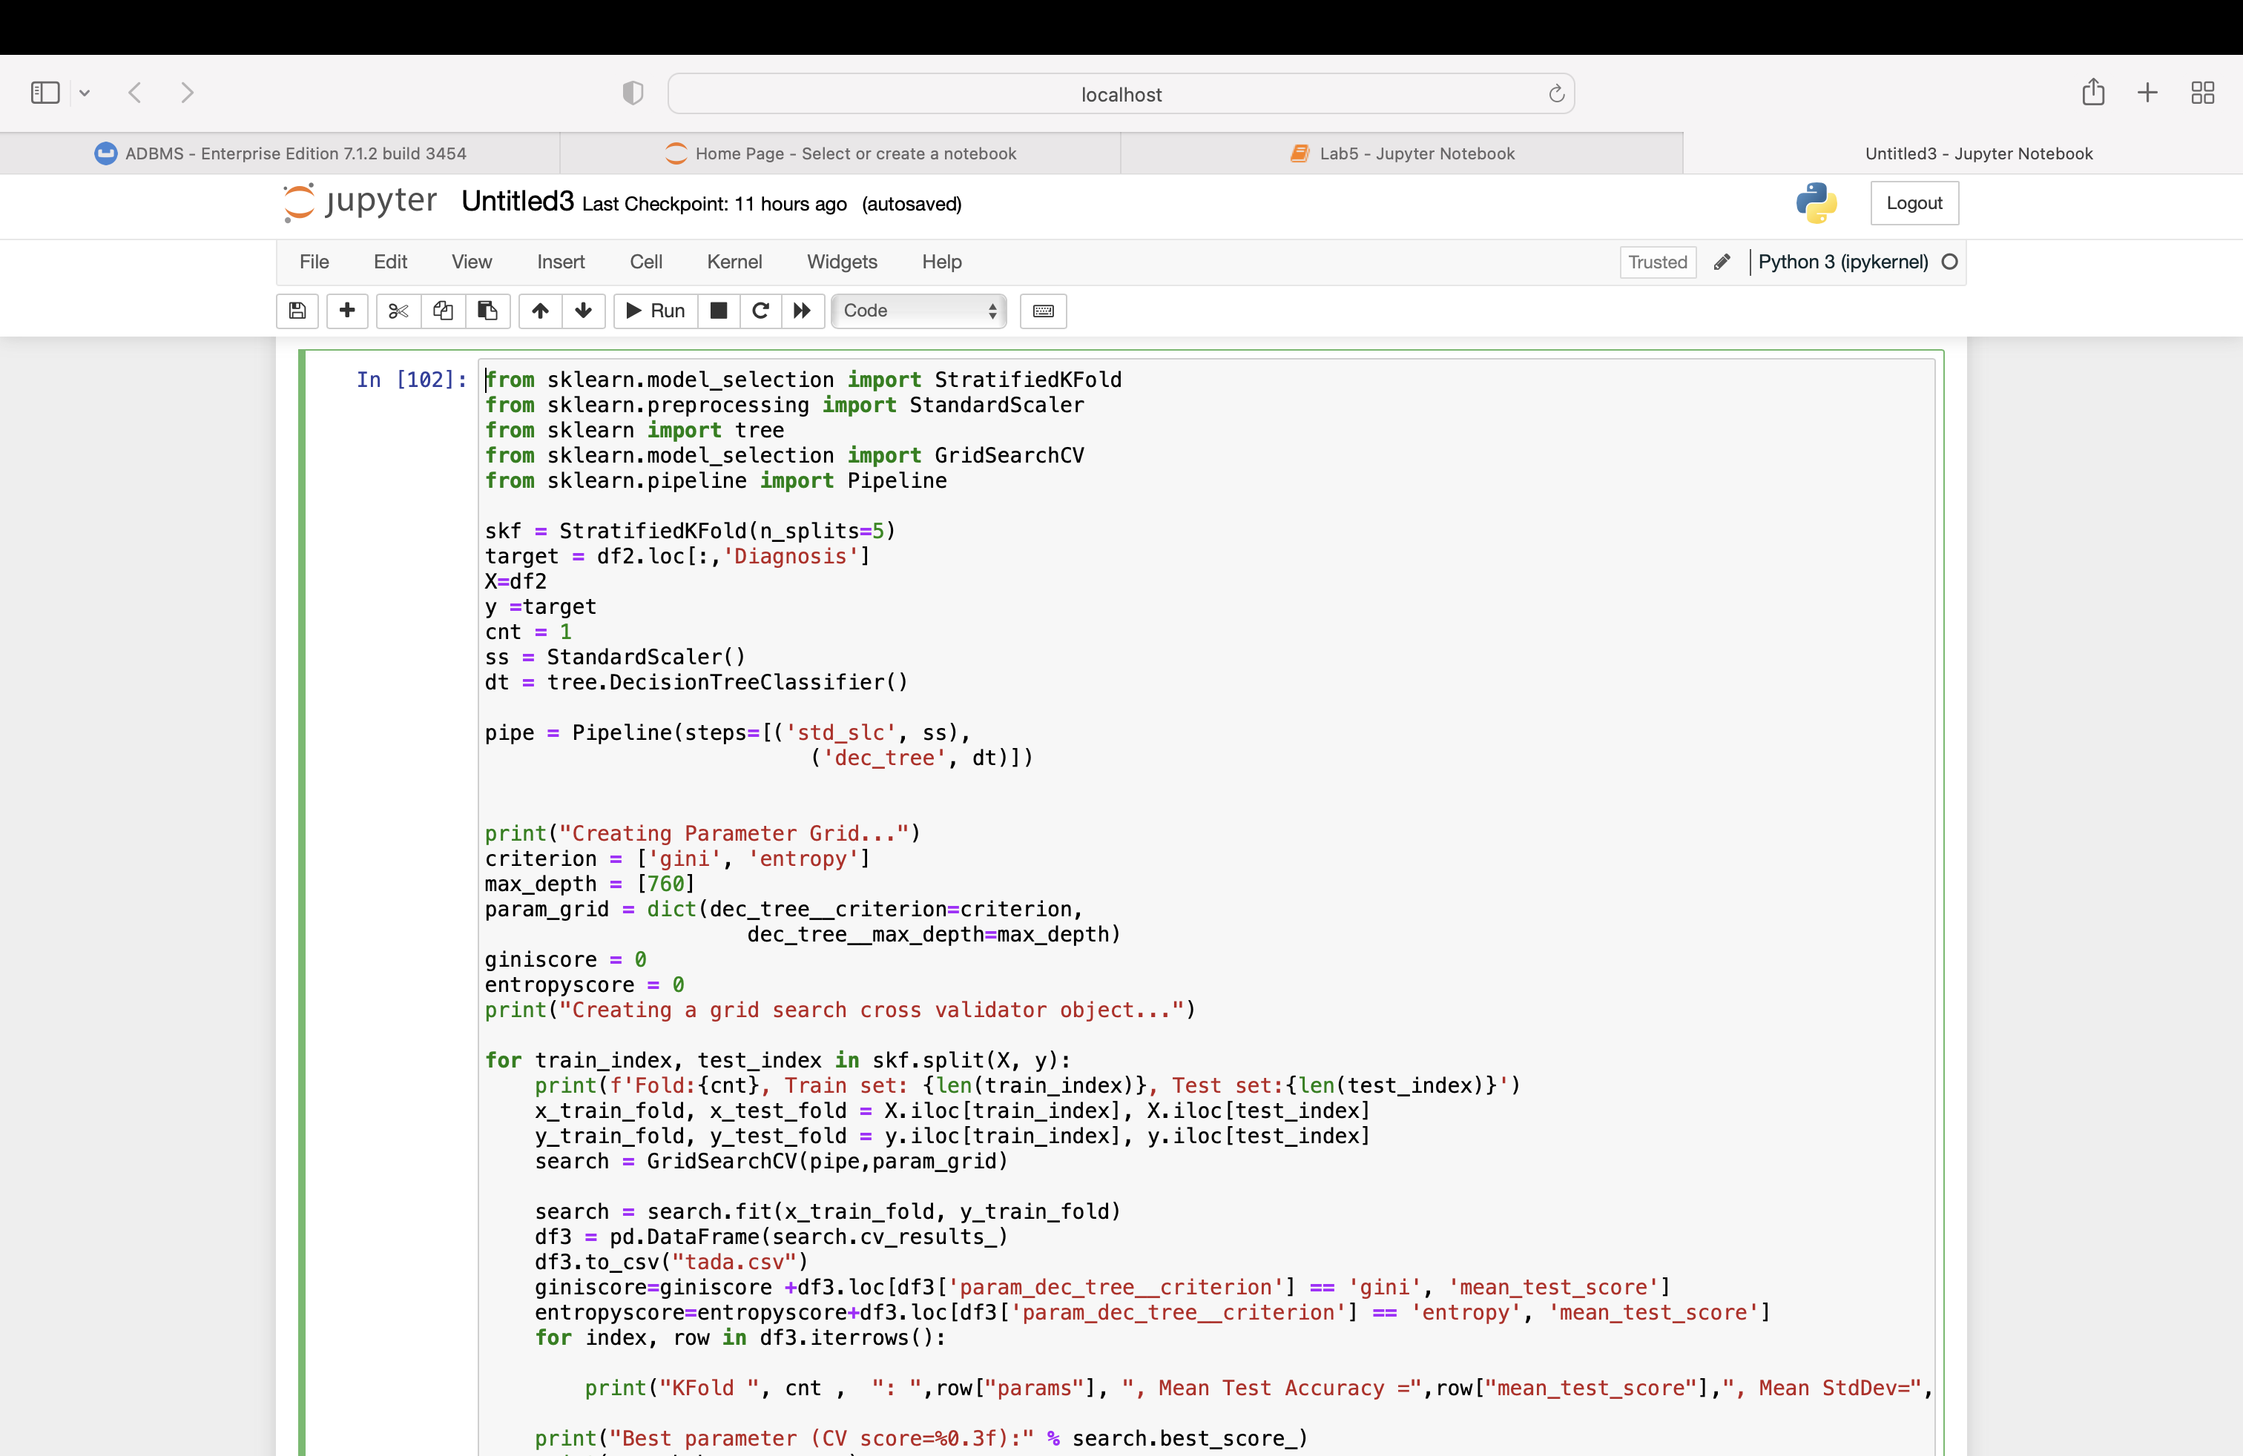

**Reference:**

UCI Machine Learning Repository: Heart Disease Data Set. (n.d.). Archive.ics.uci.edu. http://archive.ics.uci.edu/ml/datasets/Heart+Disease