DATA SCIENCE TOOL MASTERY PROJECT
Name: Kotapati Sushmitha Reddy
Course: B.Tech – CSE-AIML, 2nd Year
Institution: Malla Reddy Deemed to be University, Hyderabad
Internship Task: Task 4 – Data Science Tool Mastery Project
GitHub Repository: sushmitakotapati/data-science-fundaamentals
1. Introduction
Data Science combines programming, statistical analysis, and visualization to extract useful information from datasets. This project demonstrates the practical use of Python and commonly used Data Science libraries for data inspection, numerical calculations, visualization, and introductory machine learning.
2. Objectives
- Understand industry-standard Data Science tools.
- Analyze a dataset using Python.
- Perform numerical calculations using NumPy.
- Create visualizations using Matplotlib and Seaborn.
- Build and evaluate a machine learning model using Scikit-learn.
- Organize and document project files for a portfolio.
3. Tools and Technologies
- Python: Programming and analysis.
- Pandas: Data manipulation and summary statistics.
- NumPy: Numerical calculations.
- Matplotlib: Creating charts.
- Seaborn: Statistical visualization.
- Scikit-learn: Machine learning and model evaluation.
- Visual Studio Code: Writing and executing code.
- GitHub: Project version control and sharing.
4. Dataset Description
This project uses the Iris dataset provided by Scikit-learn. It contains measurements of iris flowers, including sepal length, sepal width, petal length, and petal width. The dataset represents three classes: Setosa, Versicolor, and Virginica.

5. Methodology
The workflow includes importing libraries, loading the dataset, inspecting records, checking missing values and duplicates, calculating numerical summaries, generating visualizations, splitting the dataset into training and testing sets, training a Random Forest classifier, and evaluating its predictions.
6. Data Analysis and Visualization
Pandas is used to inspect the dataset and calculate descriptive statistics. NumPy calculates the mean and median of sepal length. Matplotlib and Seaborn generate charts to show the distribution of sepal length and the relationship between sepal length and petal length.
Figure 1: Distribution of Sepal Length
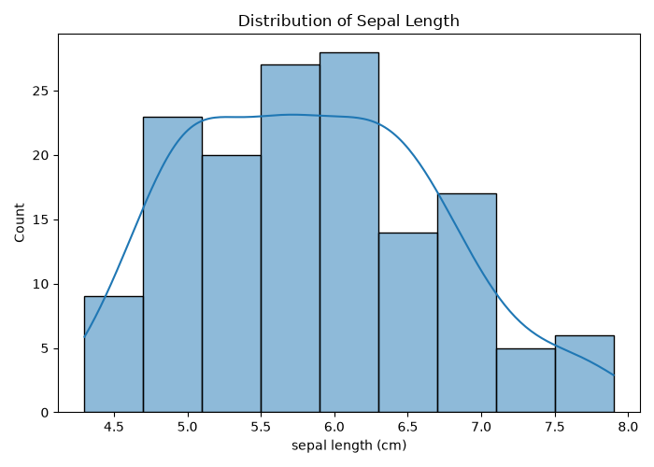
Figure 2: Sepal Length versus Petal Length
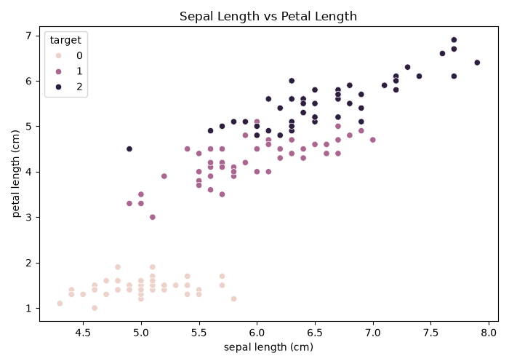

7. Machine Learning Model
A Random Forest Classifier is trained using the four flower measurements to predict the flower species. The data is divided into training and testing sets using an 80:20 ratio. The model is evaluated using accuracy, precision, recall, and F1-score.
The evaluation results should be taken from the actual output of the Python program after execution.
8. Results and Discussion
The project demonstrates how multiple Data Science libraries can work together in a single workflow. Pandas and NumPy support data inspection and numerical analysis, while Matplotlib and Seaborn help communicate patterns visually. Scikit-learn supports model training and evaluation. The results should be interpreted in the context of the dataset and the selected train-test split.
9. Conclusion
This project provided practical experience with essential Data Science tools and libraries. It demonstrated data inspection, numerical calculations, visualization, and introductory machine learning using Python. It also highlighted the importance of organizing code, verifying results, and documenting the analysis. These skills provide a foundation for more advanced Data Science and Artificial Intelligence projects.
10. References
- Scikit-learn: https://scikit-learn.org/
- Pandas: https://pandas.pydata.org/docs/
- NumPy: https://numpy.org/doc/
- Matplotlib: https://matplotlib.org/stable/
- Seaborn: https://seaborn.pydata.org/

