ANALYTICS REPORT & INSIGHTS DOCUMENTATION
Retail Sales Data Analysis
Student Name: Kotapati Sushmitha Reddy
Course: B.Tech – CSE-AIML, 2nd Year
Institution: Malla Reddy Deemed to be University, Hyderabad
Internship Task: Task 5 – Analytics Report & Insights Documentation
GitHub Repository: sushmitakotapati/data-science-fundaamentals
1. Executive Summary
This project analyzes a sample retail sales dataset using Python and Pandas. The objective is to understand monthly revenue trends, compare product category performance, and develop actionable business recommendations. The dataset contains 12 sample records covering six months and two product categories: Electronics and Clothing.
The total revenue across the sample records is 179,000. Electronics contributes 108,000, while Clothing contributes 71,000. June records the highest monthly revenue at 41,000, whereas January records the lowest at 20,000. These results demonstrate how data analysis can help identify performance patterns and support business decisions.
2. Business Objectives
- Analyze monthly revenue and identify high- and low-performing months.
- Compare revenue generated by different product categories.
- Create charts to communicate the findings clearly.
- Identify potential business opportunities.
- Recommend practical actions based on the observed data.
3. Dataset Description
The project uses a sample dataset created in Python. It contains three columns: Month, Category, and Revenue. The dataset covers January through June and includes Electronics and Clothing records for each month.
This is an illustrative dataset created for learning purposes. It does not represent actual sales from a real company.
4. Tools and Technologies
- Python: Programming and analysis.
- Pandas: Dataset creation, grouping, and revenue calculations.
- Matplotlib: Generating bar charts.
- Visual Studio Code: Writing and running the program.
- GitHub: Storing and sharing the project files.
5. Methodology
The dataset was created as a Pandas DataFrame and saved as sales_data.csv. The records were grouped by month to calculate monthly revenue and by category to compare product performance. The total revenue and average revenue per record were also calculated. Finally, two bar charts were generated to communicate the results visually.
6. Key Findings
Overall revenue: 179,000
Average revenue per record: 14,916.67
Metric | Result
Highest monthly revenue | June — 41,000
Lowest monthly revenue | January — 20,000
Electronics revenue | 108,000
Clothing revenue | 71,000
Total revenue | 179,000
Electronics contributes approximately 60.3% of the total revenue, while Clothing contributes approximately 39.7%. June has the strongest sales performance in the sample, and January has the lowest.
7. Visualizations
Figure 1: Monthly Retail Sales
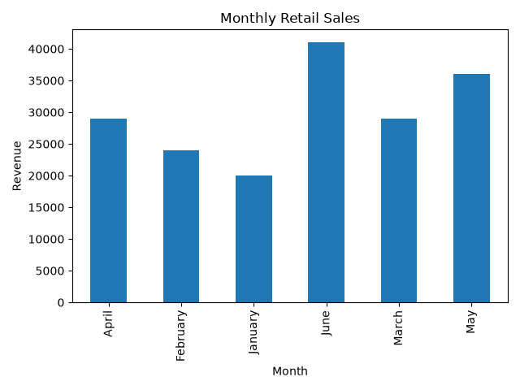
The chart compares total revenue across the six months. June has the highest revenue, while January has the lowest. This highlights the difference in monthly performance within the sample dataset.
Figure 2: Sales by Product Category
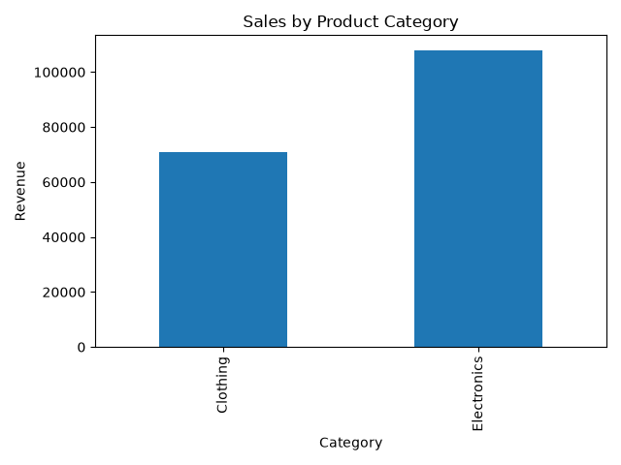
The chart compares revenue from Electronics and Clothing. Electronics generates more revenue than Clothing in the sample records.
8. Business Insights
The sample results indicate that Electronics is the larger revenue contributor and June is the strongest month. January may deserve closer examination to understand whether the lower revenue reflects seasonal demand, fewer purchases, or other factors.
However, the dataset is small and illustrative. These results cannot establish real-world seasonal trends or explain why revenue differs. Additional information, such as order counts, costs, profit margins, customer segments, and multiple years of sales, would be needed for stronger business conclusions.
9. Actionable Recommendations
- Review product performance: Examine Electronics sales and profit margins before deciding whether to expand inventory.
- Investigate low-performing months: Review January sales and compare them with additional periods to identify possible causes.
- Plan inventory carefully: Use verified demand patterns to guide stock levels and reduce excess inventory.
- Track performance regularly: Prepare monthly reports showing revenue, order volume, costs, and profit.
- Improve future analysis: Collect real sales records over a longer period before making major marketing or purchasing decisions.
10. Conclusion
This project demonstrates how Python, Pandas, and Matplotlib can be used to summarize sales data, compare product categories, visualize monthly performance, and develop business recommendations. The analysis found total sample revenue of 179,000, with Electronics contributing the larger share and June showing the highest monthly revenue. The project also highlights the importance of using reliable data and considering limitations before making business decisions.
11. References
- Pandas documentation: https://pandas.pydata.org/docs/
- Matplotlib documentation: https://matplotlib.org/stable/
- Python documentation: https://docs.python.org/3/

