FINAL DATA SCIENCE CAPSTONE PROJECT
Retail Sales Analysis and Sales Prediction Using Python
Name: Kotapati Sushmitha Reddy
Course: B.Tech (CSE-AIML), 2nd Year
Institution: Malla Reddy Deemed to be University, Hyderabad
Internship Task: Task 6 – Final Data Science Capstone Project
GitHub Repository: sushmitakotapati/data-science-fundaamentals
1. Executive Summary
This capstone project demonstrates a complete introductory Data Science workflow using an illustrative retail sales dataset. Python, Pandas, NumPy, Matplotlib, and Scikit-learn are used to prepare data, perform exploratory analysis, visualize sales patterns, and build a basic linear regression model. The dataset contains monthly Electronics and Clothing sales for 12 months. Total sales increase from 20,000 in Month 1 to 63,000 in Month 12. A linear regression model is trained on the first ten months and evaluated on Months 11 and 12. The Mean Absolute Error is 4,563.64, while the R-squared value is -0.994. These results indicate that the simple model does not predict the two held-out months well. The project illustrates the importance of evaluating models critically rather than relying only on visual trends.
2. Problem Statement and Objectives
The objective is to analyze retail sales trends, compare product category performance, and explore whether a simple linear regression model can estimate future monthly sales. The project aims to organize data, calculate descriptive statistics, create meaningful visualizations, evaluate model performance, and communicate limitations and recommendations.
3. Dataset Description
The dataset is an illustrative sample created in Python. It contains 12 monthly records with Month_Number, Electronics sales, Clothing sales, and Total_Sales. Total_Sales is calculated by adding the two category values for each month. This dataset is intended for learning and does not represent verified real-world business transactions.
4. Tools and Technologies
- Python for programming.
- Pandas for data preparation and analysis.
- NumPy for numerical operations.
- Matplotlib for visualizations.
- Scikit-learn for linear regression and evaluation metrics.
- CSV for storing the dataset.
- Visual Studio Code for coding and execution.
- GitHub for sharing project files.
5. Methodology
First, the monthly category sales data is created and saved as a CSV file. Pandas is used to inspect the dataset and calculate summary statistics. Missing values are checked, and the current dataset contains no missing values. Total monthly sales are calculated from Electronics and Clothing revenue.
A line chart shows monthly sales, and a bar chart compares total sales by category. For the prediction experiment, Month_Number is used as the input feature and Total_Sales as the target. A Linear Regression model is trained on the first ten months. The final two months are held out for evaluation. Mean Absolute Error and R-squared are calculated to assess prediction performance.
6. Exploratory Data Analysis
The dataset contains 12 monthly records. The mean total sales per month are approximately 39,666.67, and the maximum monthly sales value is 63,000. The minimum is 20,000. No missing values were found in the dataset.
The sample indicates an overall increase in monthly sales, although the increase is not identical every month. The dataset is small, so these observations should not be generalized to an actual business without additional data.
7. Visualizations
Figure 1: Monthly Retail Sales
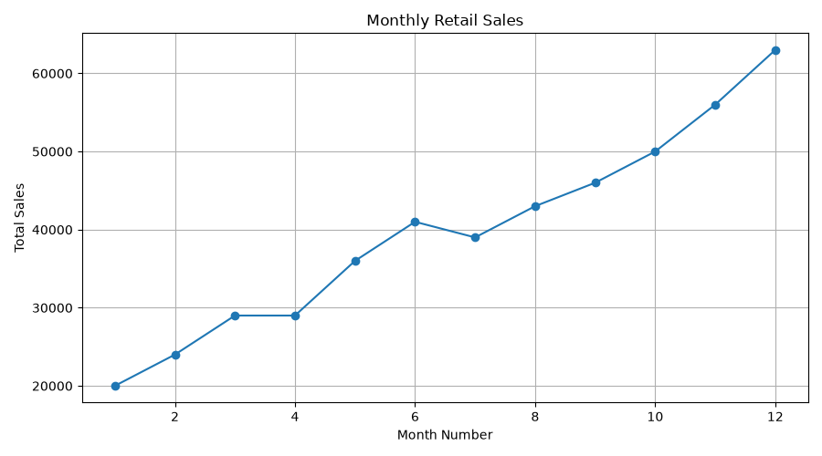
This line chart displays total sales across the 12 months and shows the overall upward pattern in the illustrative dataset.
Figure 2: Sales by Product Category
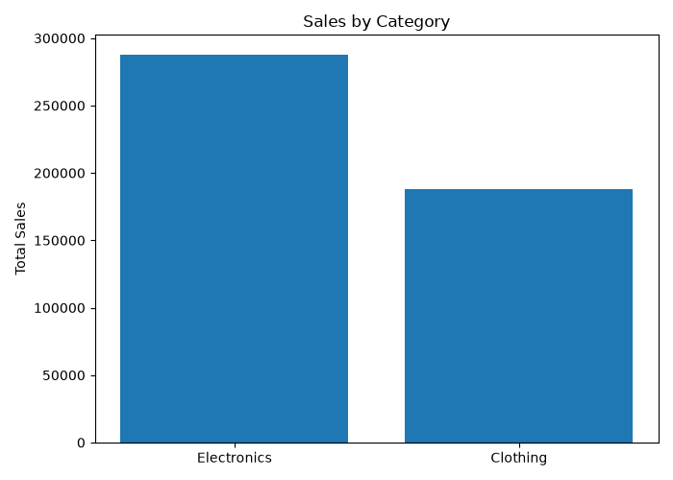
This bar chart compares cumulative Electronics and Clothing sales across the 12 months.
Figure 3: Actual vs Predicted Sales
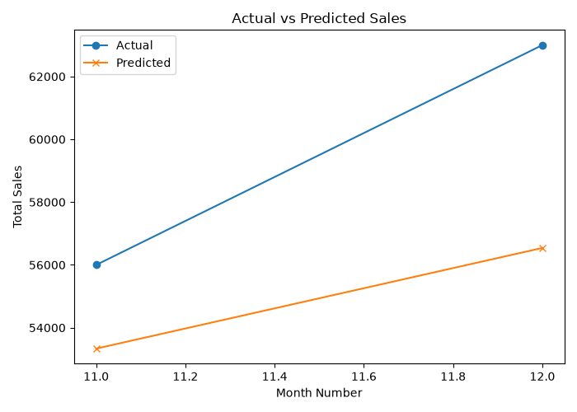
This chart compares actual sales for Months 11 and 12 with the predictions generated by the Linear Regression model.

8. Model Evaluation and Results
The model was trained using the first ten months and evaluated on the final two months.
Metric | Result
Actual sales, Month 11 | 56,000
Actual sales, Month 12 | 63,000
Predicted sales, Month 11 | 53,333.33
Predicted sales, Month 12 | 56,539.39
Mean Absolute Error | 4,563.64
R-squared | -0.994
The Mean Absolute Error indicates an average absolute prediction error of approximately 4,563.64 sales units across the two test months. The negative R-squared value indicates that the model performed worse than a baseline that predicts the mean of the test targets under the standard R-squared definition. Because the test set contains only two observations, these evaluation metrics are highly sensitive and do not establish how well the model would perform on future real-world data.
9. Business Insights and Recommendations
The illustrative data shows higher total sales toward the end of the year. Businesses could investigate whether seasonal demand, promotions, product availability, or other factors explain such changes. Electronics and Clothing should be examined separately to identify category-specific patterns.
For a real business, it is recommended to collect a larger dataset containing transaction dates, product identifiers, prices, discounts, costs, stock levels, and order quantities. More observations and relevant features could support a more reliable forecasting model. Models should be compared against simple baselines and evaluated using an appropriate time-based validation strategy before they are used for decisions.
10. Limitations
The dataset is artificially created and contains only 12 monthly observations. It does not include real customer transactions, operating costs, profit margins, promotions, or external factors. The model uses only month number as a feature and is evaluated on just two months. Consequently, the results are educational and should not be treated as a reliable commercial forecast.

11. Future Scope
Future improvements could include collecting verified real-world sales data, adding seasonal and product-related features, comparing multiple forecasting algorithms, using a larger time-based test period, and building an interactive dashboard for stakeholders.
12. Conclusion
This capstone project combines data preparation, exploratory data analysis, visualization, basic machine learning, and model evaluation in one workflow. It demonstrates how Python tools can help summarize business data and communicate findings. The evaluation also shows why model limitations and test results must be reported transparently. The project provides a foundation for more advanced analytics and forecasting work.
13. References
- Pandas documentation: https://pandas.pydata.org/docs/
- NumPy documentation: https://numpy.org/doc/
- Matplotlib documentation: https://matplotlib.org/stable/
- Scikit-learn documentation: https://scikit-learn.org/stable/
- Python documentation: https://docs.python.org/3/

