REAL-WORLD DATASET ANALYSIS PROJECT
Palmer Penguins Dataset
Internship Task: Task 3 – Real-World Dataset Analysis Project
Name: Kotapati Sushmitha Reddy
Technology Used: Python, Pandas, Matplotlib, Seaborn
1. Introduction
Data analysis is the process of examining data to identify patterns, summarize information, and support decisions. This project uses the Palmer Penguins dataset to explore physical measurements of penguins belonging to different species. Python libraries are used to inspect the dataset, check data quality, calculate statistics, and create visualizations.
2. Objective
The objectives of this project are:
- To load and inspect a real-world dataset.
- To identify missing values and duplicate records.
- To calculate descriptive statistics and compare penguin species.
- To visualize relationships between physical measurements.
- To summarize the findings using tables and graphs.
3. Dataset Description
The Palmer Penguins dataset contains information about penguin species, island, bill length, bill depth, flipper length, body mass, sex, and year.
The analysis identified 344 records, three penguin species, and three islands. The dataset contains some missing values, which were checked during data-quality inspection.
4. Tools and Technologies
- Python: Programming language used for the analysis.
- Pandas: Dataset loading, cleaning, grouping, and statistical summaries.
- Matplotlib: Graph creation.
- Seaborn: Statistical data visualization.
- Visual Studio Code: Code editing and execution.
5. Methodology
The project followed these steps:
- Loaded the dataset from its online CSV source.
- Inspected the first rows, column names, data types, and dataset dimensions.
- Checked missing values and duplicate records.
- Removed duplicate rows before calculating the final summaries.
- Calculated descriptive statistics and species-wise average measurements.
- Created graphs to compare species and explore relationships.
- Saved the cleaned dataset, summary table, and visualizations in the output folder.
For the cleaned analysis copy, missing numerical values were filled using the respective column median. Missing categorical values were filled using the most frequent value where available. These cleaning choices were applied to the analysis copy rather than changing the original source dataset.
6. Results and Findings
The executed Python program reported 344 records after duplicate removal, three species, and three islands.
Penguin species | Average body mass (g) | Average flipper length (mm)
Adelie | 3700.66 | 189.95
Chinstrap | 3733.09 | 195.82
Gentoo | 5076.02 | 217.19
The results show that Gentoo penguins had the highest average body mass and average flipper length among the three species in this dataset. Adelie penguins had the lowest average flipper length. These values describe the analyzed dataset and should not be treated as universal measurements for every penguin.
7. Data Visualizations
The project generated the following visualizations:
- Species Count: Shows the number of records for each penguin species.
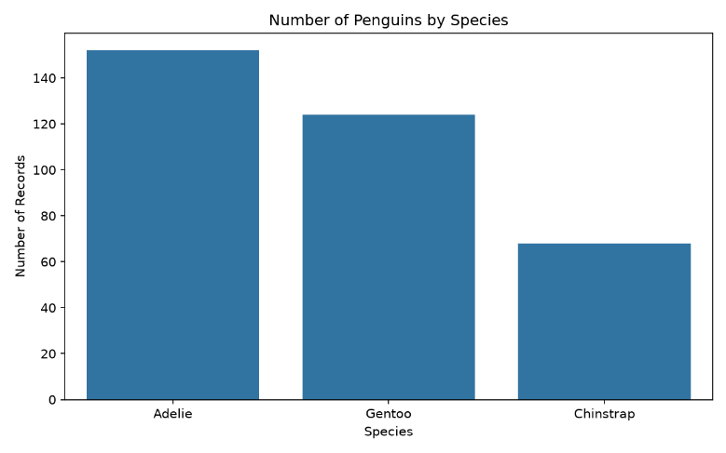
- Flipper Length by Species: Compares flipper-length distributions across species.
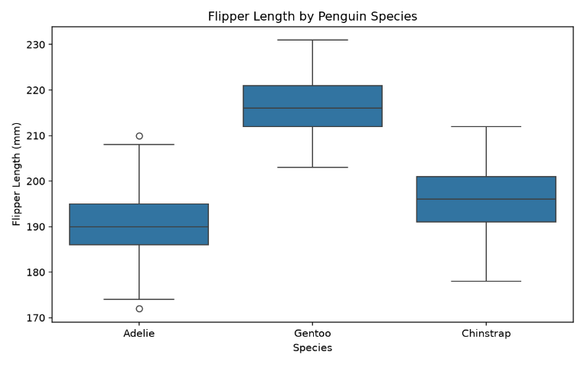
- Body Mass vs Flipper Length: Explores the relationship between body mass and flipper length.
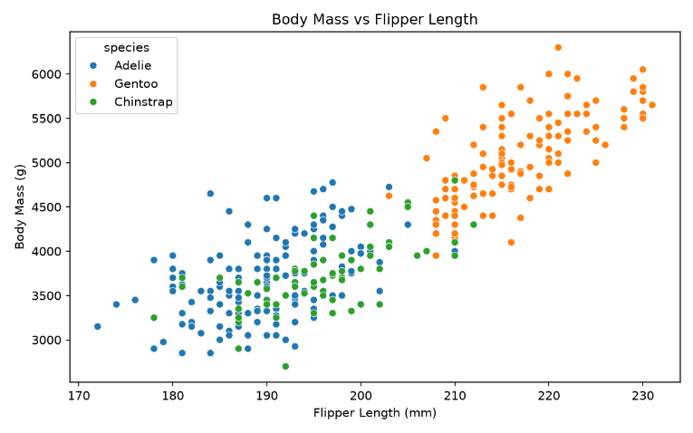
- Correlation Heatmap: Displays correlations between numerical variables.
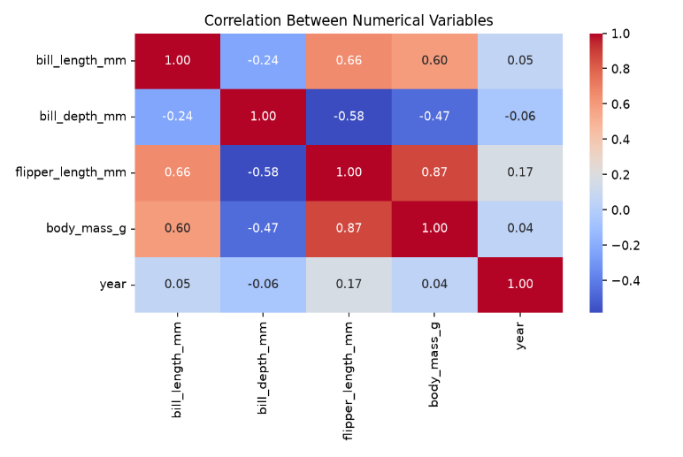
8. Output Files
The project generated the following outputs:
- species_summary.csv – species-wise average measurements.
- penguins_cleaned.csv – cleaned analysis dataset.
- species_count.png – species-count visualization.
- flipper_length.png – flipper-length comparison.
- body_mass_vs_flipper.png – body-mass and flipper-length scatter plot.
- correlation_heatmap.png – numerical correlation heatmap.
The Python script task3_analysis.py and project outputs are stored in the GitHub repository.
9. Conclusion
This project provided practical experience in analyzing a real-world dataset using Python. The workflow included data inspection, missing-value checks, duplicate handling, descriptive statistics, species-wise comparisons, and visualization. The results showed differences in average body mass and flipper length among Adelie, Chinstrap, and Gentoo penguins. Gentoo penguins had the highest averages for both measurements in the analyzed dataset.
The project helped develop foundational skills in data cleaning, exploratory data analysis, statistical summarization, visualization, and reporting. Future improvements could include additional statistical tests, more detailed analysis of relationships, and comparisons by island and sex.
10. GitHub Repository
Project Repository URL: sushmitakotapati/data-science-fundaamentals
The repository contains the Python analysis code and the generated project files.
11. References
Palmer Penguins dataset: https://github.com/allisonhorst/palmerpenguins
Python Pandas documentation: https://pandas.pydata.org/docs/
Matplotlib documentation: https://matplotlib.org/stable/
Seaborn documentation: https://seaborn.pydata.org/

