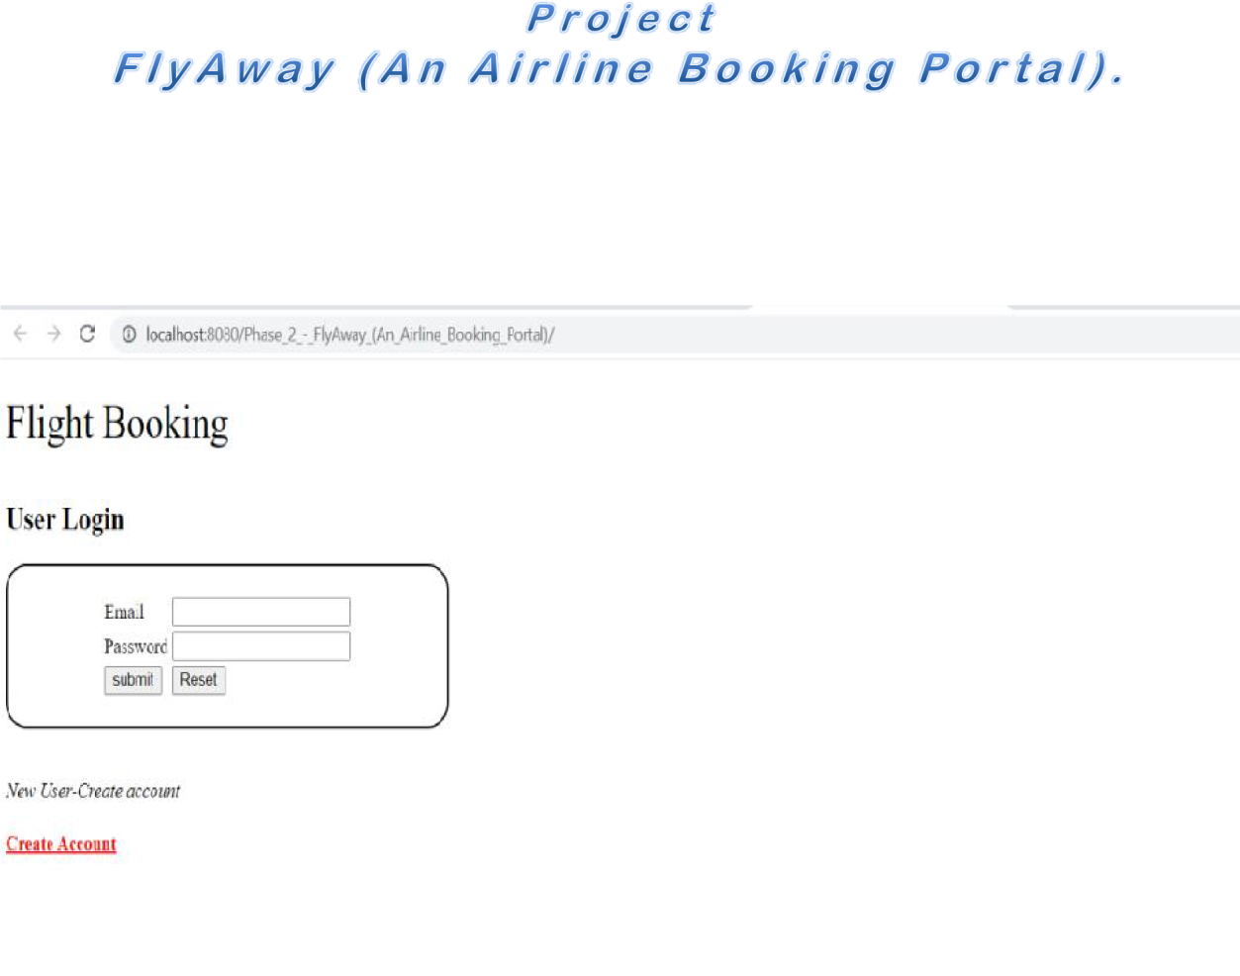

*The below output shows User Registration. Here New User can create their account and login with the credentials.*

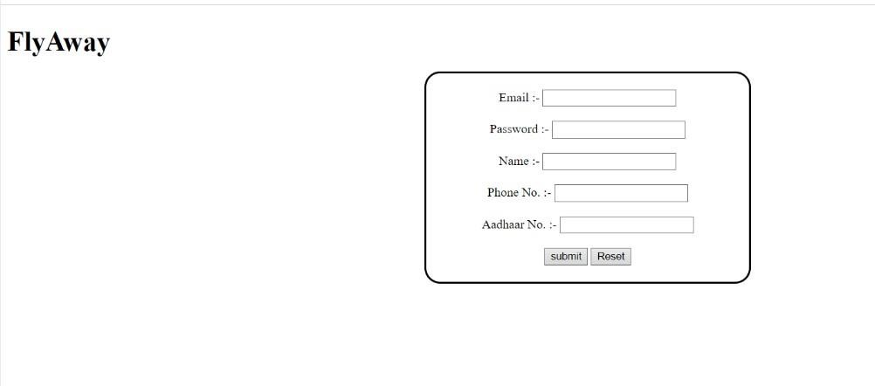

The below output shows the Home Page of Fly Away. Here users can search Flights.

*The below output shows Admin Login page.*

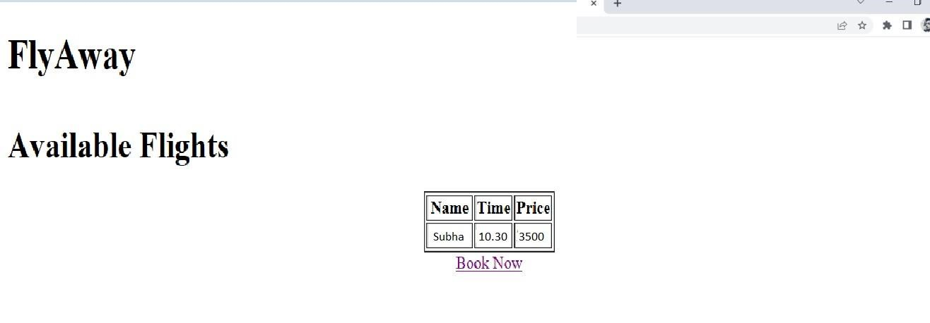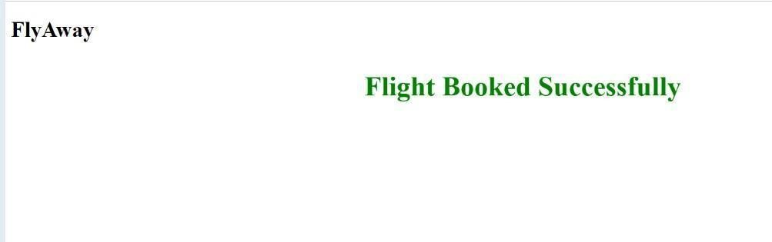

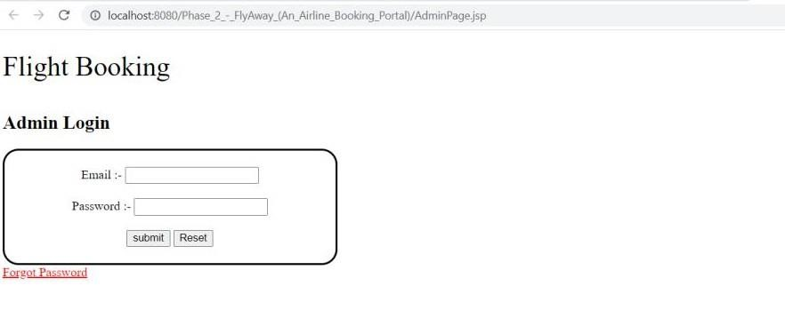

*The below output shows Insert New Flight Details.*

