.NET TECHNOLOGIES (01CE1523)
Lab Manual

Name: Sushmita Nandani Enrolment No: 92400103339
Class: 5EC2 Batch:A

INDEX

Lab | Program | CO | Date | Marks |  |  |  | Total | Signature
 |  |  |  | R1(4  ) | R2(2  ) | R3(2  ) | R4(2  ) | (10) | Signature
1. | Develop Student Admission Management Module using OOP Concepts (Class, Object, Constructor, Access Modifiers). | CO1
2. | Design Employee Payroll System using Inheritance, Interface & Polymorphism | CO1
3. | Develop Expense Tracking Module with Exception  Handling | CO1
4. | Build Online Event Registration Portal using ASP.NET Controls & Validation | CO2
5. | Develop Academic Calendar & Leave Management System using Rich Controls, Session & Cookies | CO2
6. | Create Product Catalog Application using ASP.NET MVC Architecture. (Controllers, Models, Views, Routing) | CO3

7. | Develop Feedback Management Module using MVC Layout, Partial View & Validation. (HTML Helpers, Validation, Layouts) | CO3
8. | Develop Inventory Management Module using ADO.NET & CRUD  Operations | CO4
Sushmita_3339

9. | Create Placement Dashboard using Data  Controls & Crystal Reports | CO4
10. | Build Student Management REST API using ASP.NET  Core  (Middleware, API, Project Structure) | CO5
11. | Develop Smart Campus Service Portal – Feature Extension  (Integrate MVC + Database  + API) | CO1  , CO2  , CO3  , CO4  , CO5

R1 | Practical Performance
R2 | Timely Submission
R3 | Neatness & Documentation
R4 | Uploaded on Git

Experiment 2

AIM: Design employee payroll system using Inheritence, Interface, and Polymorphism.

Source: payroll.cs
Code:
using System;
interface IPayroll
{
void CalculateSalary();
}
class Employee
{
public string Name;
public Employee(string name)
{
Name = name;
}
}
class FullTimeEmployee : Employee, IPayroll
{
int Salary;
public FullTimeEmployee(string name, int salary) : base(name)
{
Salary = salary;
}
public void CalculateSalary()
{
Console.WriteLine(Name + " Salary: " + Salary);
}
}
class PartTimeEmployee : Employee, IPayroll
{
int Hours;
int Rate;
public PartTimeEmployee(string name, int hours, int rate) : base(name)
{
Hours = hours;
Rate = rate;
}
public void CalculateSalary()
{
Console.WriteLine(Name + " Salary: " + (Hours * Rate));
}
}
class Program
{
static void Main()
{
Console.WriteLine("--- Displaying Payroll Information ---");
IPayroll e1 = new FullTimeEmployee("Sushmita", 50000);
IPayroll e2 = new PartTimeEmployee("Avinash", 20, 150000);
e1.CalculateSalary();
e2.CalculateSalary();
}
}

Output: Screenshot:
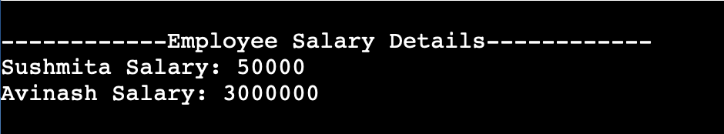

GitHub URL: sushmitanandani127686/.NET_Prac1

