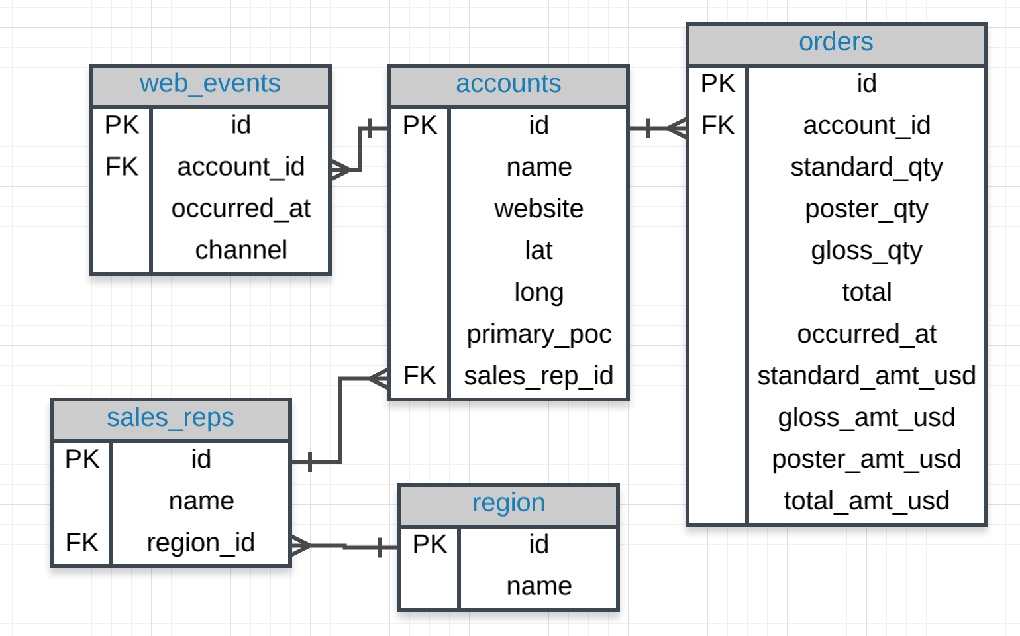

**Questions**

1. Provide a table that provides the region for each sales_rep along with their associated accounts. This time only for the Midwest region

SELECT r.name region, s.name rep, a.name account

FROM sales_reps s

JOIN region r

ON s.region_id = r.id

JOIN accounts a

ON a.sales_rep_id = s.id

WHERE r.name = 'Midwest'

ORDER BY a.name;

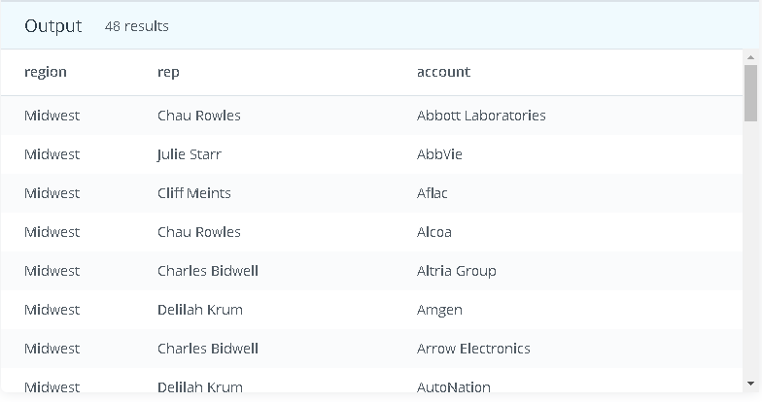

1. Provide a table that provides the **region** for each **sales_rep** along with their associated **accounts**. This time only for accounts where the sales rep has a first name starting with S and in the Midwestregion.

SELECT r.name region, s.name rep, a.name accounts

FROM sales_reps s

JOIN region r

ON r.id=s.region_id

JOIN accounts a

ON s.id=a.sales_rep_id

WHERE s.name like 'S%' AND r.name='Midwest'

ORDER by a.name

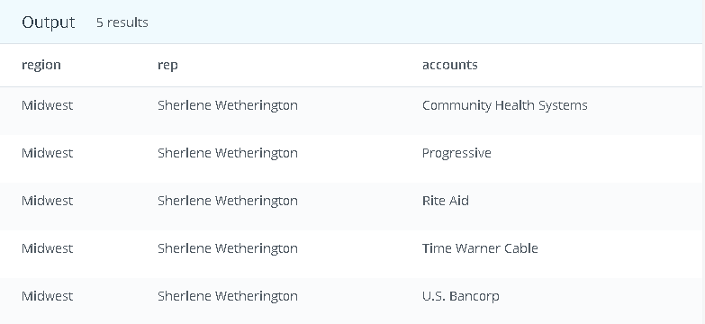

1. Provide the **name** for each region for every **order**, as well as the account **name** and the **unit price** they paid for the order. However, you should only provide the results if the **standard order quantity** exceeds 100 and the **poster order quantity** exceeds 50.

SELECT r.name region_name, a.name account, o.total_amt_usd/(o.total+0.01) AS unit_price, o.standard_qty

FROM region r

JOIN sales_reps s

ON r.id=s.region_id

JOIN accounts a

ON s.id=a.sales_rep_id

JOIN orders o

ON a.id=o.account_id

WHERE o.standard_qty>100 and o.poster_qty>50

ORDER by unit_price

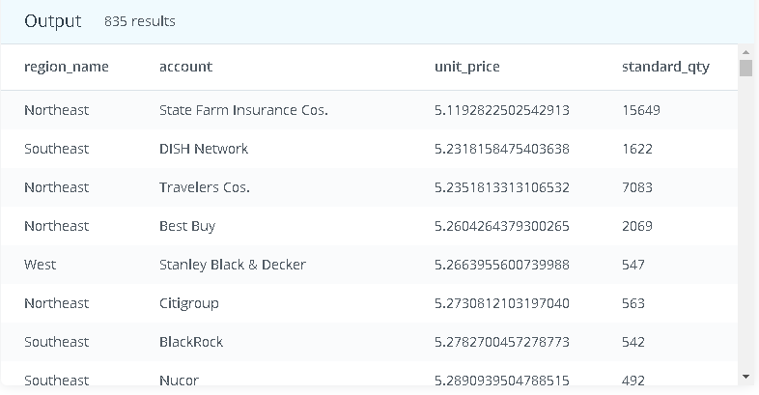

1. What are the different **channel**s used by **account id** 1001?

SELECT DISTINCT a.name, w.channel

FROM accounts a

JOIN web_events w

ON w.account_id=a.id

WHERE a.id=1001

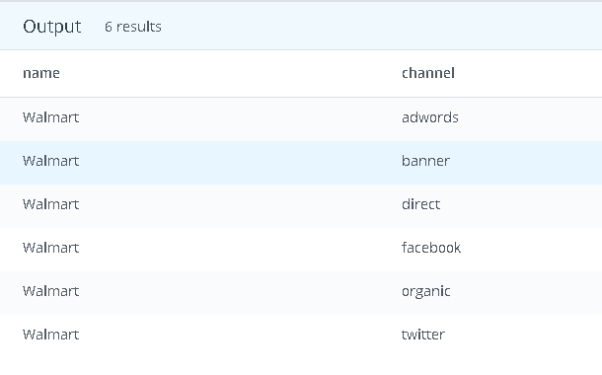

1. Find all the orders that occurred in 2015.

SELECT o.occurred_at, a.name, o.total, o.total_amt_usd

FROM accounts a

JOIN orders o

ON o.account_id = a.id

WHERE o.occurred_at BETWEEN '01-01-2015' AND '01-01-2016'

ORDER BY o.occurred_at DESC;

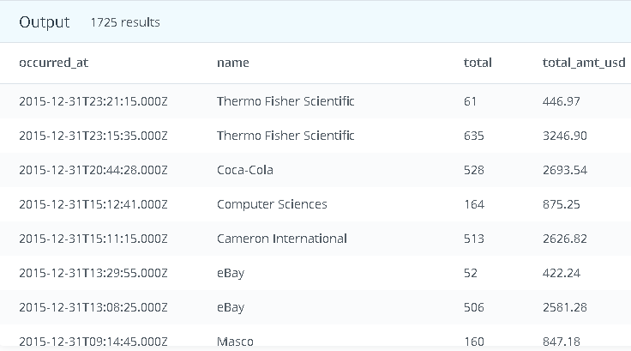

1. Find the **standard_amt_usd** per unit of **standard_qty** paper.

select sum(standard_amt_usd)/sum(standard_qty) as standard from orders

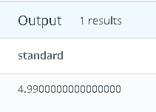

1. Find the mean (**AVERAGE**) amount spent per order on each paper type, as well as the mean amount of each paper type purchased per order.

SELECT AVG(standard_qty) mean_standard, AVG(gloss_qty) mean_gloss,

AVG(poster_qty) mean_poster, AVG(standard_amt_usd) mean_standard_usd,

AVG(gloss_amt_usd) mean_gloss_usd, AVG(poster_amt_usd) mean_poster_usd

FROM orders;

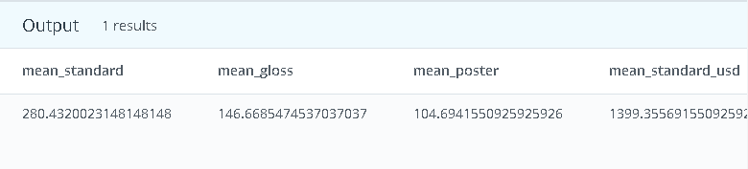 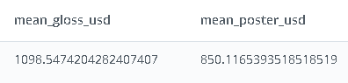

1. Which **account** (by name) placed the earliest order?

SELECT a.name, o.occurred_at

FROM accounts a

JOIN orders o

ON a.id = o.account_id

ORDER BY occurred_at

LIMIT 1;

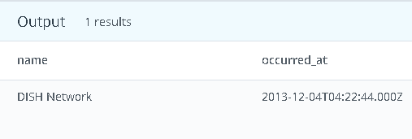

1. Find the total sales in **usd** for each account.

SELECT a.name,SUM(o.total_amt_usd) AS total_amount FROM orders o

JOIN accounts a

ON o.account_id=a.id

GROUP by a.name

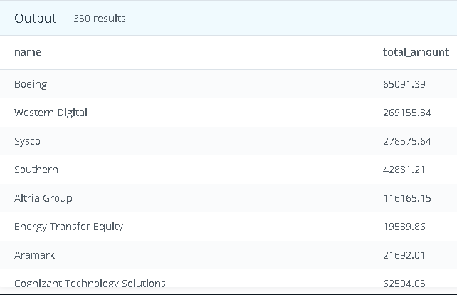

1. Via what **channel** did the most recent (latest) **web_event** occur, which **account** was associated with this **web_event**?

SELECT w.occurred_at, w.channel, a.name from accounts a

join web_events w

on w.account_id=a.id

order by occurred_at desc

limit 1;

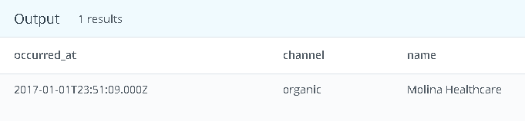

1. Find the total number of times each type of **channel** from the **web_events** was used.

SELECT w.channel, count(w.channel) as number_of_times_used

from web_events w

group by w.channel

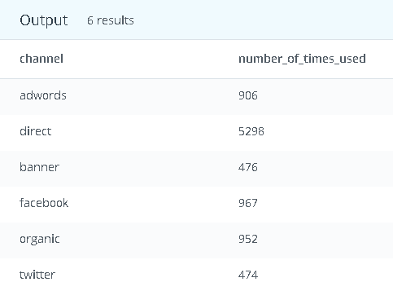

1. Who was the **primary contact** associated with the earliest **web_event**?

**SELECT** a.primary_poc

**FROM** web_events w

**JOIN** accounts a

**ON** a.**id** = w.account_id

**ORDER** **BY** w.occurred_at

**LIMIT** 1;

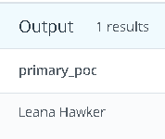

1. What was the smallest order placed by each **account** in terms of **total usd**.

SELECT a.name, min(o.total_amt_usd) as smallest_order

from accounts a

join orders o

on a.id=o.account_id

group by a.name

order by smallest_order

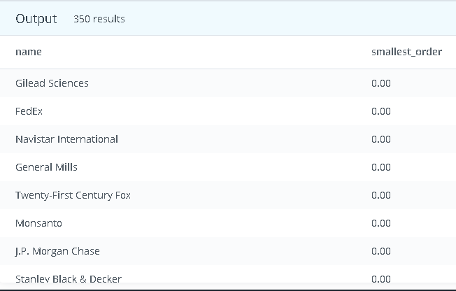

1. Find the number of **sales reps** in each region.

select r.name, count(*) as number_of_sales_rep

from sales_reps s

join region r

on s.region_id=r.id

group by r.name

order by number_of_sales_rep

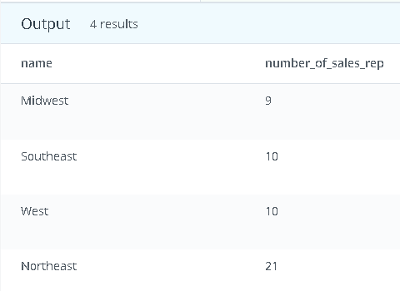

1. For each account, determine the average amount of each type of paper they purchased across their orders.

select a.name, avg(o.standard_qty) as standard_qty, avg(o.poster_qty) as poster_qty, avg(o.gloss_qty) as gloss_qty from accounts a join orders o on a.id= o.account_id group by a.name

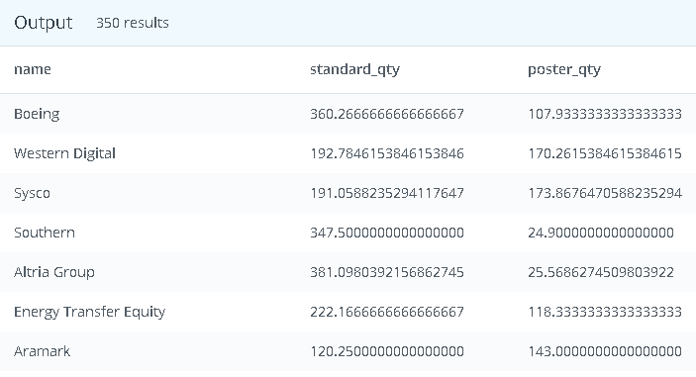 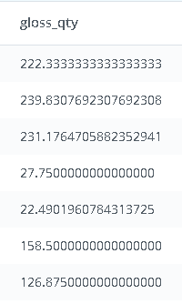

1. For each account, determine the average amount spent per order on each paper type.

select a.name, avg(o.standard_amt_usd) as avg_amt_spend_standard, avg(o.poster_qty) as avg_amt_spent_poster, avg(o.gloss_qty) as avg_amt_spent_gloss

from accounts a

join orders o

on a.id= o.account_id

group by a.name

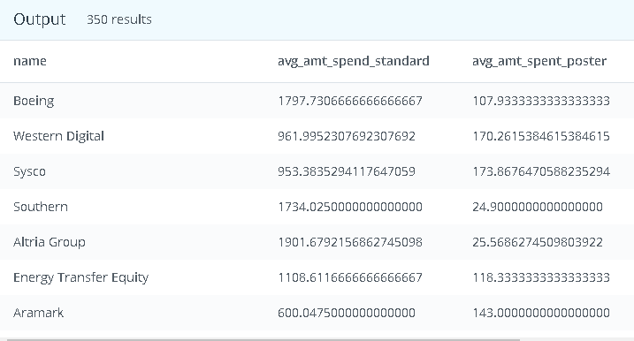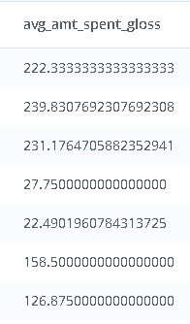

1. Determine the number of times a particular **channel** was used in the **web_events** table for each **sales rep**.

select s.name, w.channel, count(w.channel) as count_channel_used

from sales_reps s

join accounts a

on s.id=a.sales_rep_id

join web_events w

on a.id=w.account_id

group by s.name, w.channel

order by count_channel_used desc

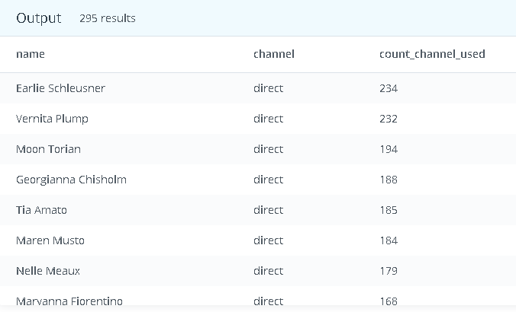

1. Determine the number of times a particular **channel** was used in the **web_events** table for each **region**.

select r.name as region, w.channel, count(w.channel) as times_channel_used from

region r join sales_reps s on r.id=s.region_id join accounts a on s.id=a.sales_rep_id join web_events w on a.id=w.account_id group by r.name, w.channel order by times_channel_used desc

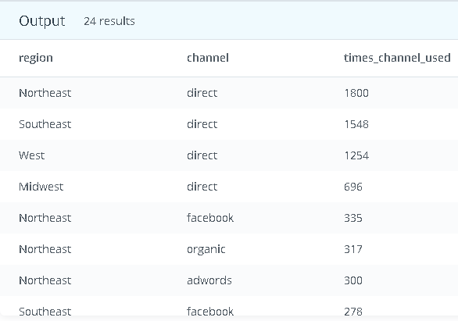

1. Have any **sales reps** worked on more than one account?

**SELECT** s.**id**, s.**name**, **COUNT**(*) num_accounts

**FROM** accounts a

**JOIN** sales_reps s

**ON** s.**id** = a.sales_rep_id

**GROUP** **BY** s.**id**, s.**name**

**ORDER** **BY** num_accounts;

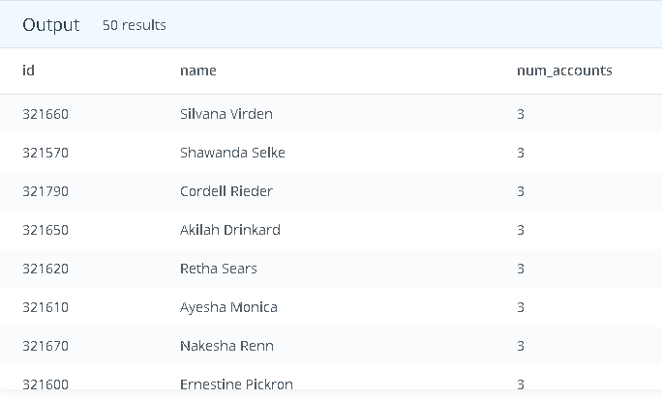

1. How many of the **sales reps** have more than 5 accounts that they manage?

select s.id as id, s.name as name, count(a.id) as count_of_accounts from sales_reps s join accounts a on s.id=a.sales_rep_id group by s.name,s.id having count(a.id)>5

order by count(a.id) 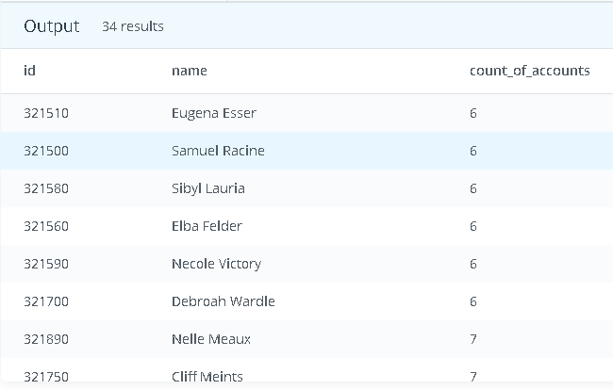

1. How many **accounts** have more than 20 orders?

select a.name,count(o.id) from accounts a join orders o on a.id=o.account_id group by a.name having count(o.id)>20 order by count(o.id)

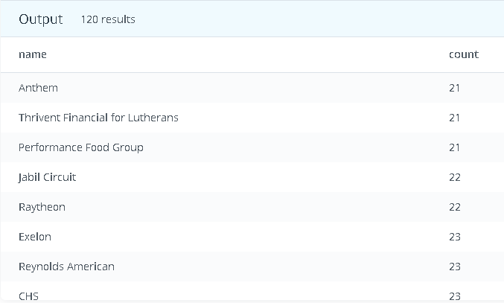

1. Which account has the most orders?

select a.name,count(o.id) from accounts a join orders o on a.id=o.account_id group by a.name order by count(o.id) desc limit 1; 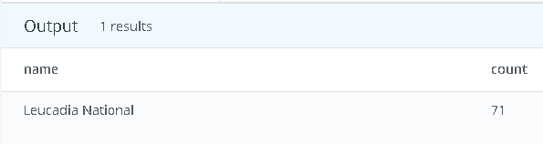

1. How many accounts spent more than 30,000 usd total across all orders?

SELECT a.id, a.name, SUM(o.total_amt_usd) total_spent

FROM accounts a

JOIN orders o

ON a.id = o.account_id

GROUP BY a.id, a.name

HAVING SUM(o.total_amt_usd) > 30000

ORDER BY total_spent;

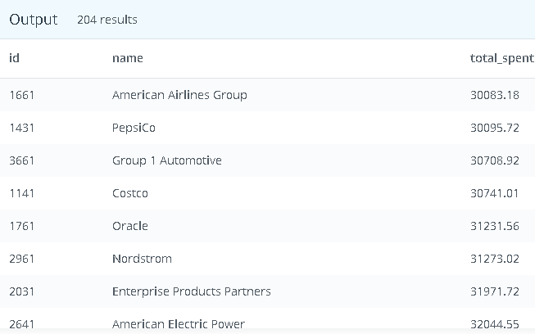

1. Which accounts used facebook as a **channel** to contact customers more than 6 times?

SELECT a.id, a.name, count(*)

FROM accounts a

JOIN web_events w

ON a.id = w.account_id

GROUP BY a.id, a.name ,w.channel

having w.channel='facebook' and count(*) > 6

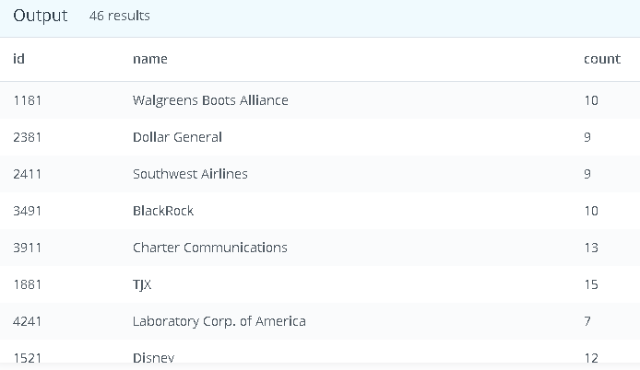

1. Which channel was most frequently used by most accounts?

SELECT a.id, a.name,w.channel,count(*)

FROM accounts a

JOIN web_events w

ON a.id = w.account_id

GROUP BY a.id, a.name ,w.channel

order by count(*) desc limit 10;

