
Mini Project Report
On
Blood Donor Management & Emergency Matching System
SUBMITTED BY:  SUSHMITA RAWAT  UID: 26MCA20019  CLASS: MCA  SECTION: MCA-1/A | SUBMITTED TO:  [Faculty Name]  [Designation]

Table of Content
S. No. | Name | Page no.
1 | Acknowledgement | 3
2 | Introduction / Background | 4
3 | Objectives | 4
4 | Technologies Used | 4
5 | Requirements and System Design | 5-7
6 | Source Code & Output | 8-19
7 | Functionalities | 20
8 | Conclusion / Future Work / Learning Outcomes | 21
9 | GitHub Link & Bibliography | 21

Acknowledgement
I would like to express my heartfelt gratitude to all those who contributed to the successful development of the Blood Donor Management & Emergency Matching System, a console-based application that helps hospitals and communities find suitable blood donors quickly.
First and foremost, I am thankful to my mentors and instructors for their continuous guidance and encouragement throughout this project. Their insights into programming in C and system design have been invaluable in shaping the technical direction of this work.
I would also like to acknowledge my peers and friends for their constructive feedback and support during the testing and debugging phases. Their suggestions helped improve the usability and reliability of the program.
Lastly, I am grateful to the open-source community and the developers behind the tools used in this project. Tools like the GCC compiler and Visual Studio Code have made it possible to bring this idea to life with both functionality and simplicity.
This project stands as a testament to learning by doing, and I am proud to present it as a small step towards using technology to support life-saving services.

1. Introduction
This report outlines the development of the “Blood Donor Management & Emergency Matching System,” a console-based application written in C that helps people find suitable blood donors during medical emergencies. The system stores donor records, accepts blood requests from patients or hospitals, and automatically suggests donors who are blood-group compatible, medically eligible and living close to the patient. Requests are handled by urgency, every donation is recorded in a history log, and simple reports can be generated. A browser-based user interface with the same logic is also provided for easier use.

2. Background
In a medical emergency, the time taken to find a matching donor can decide a patient’s outcome. In many small hospitals, colleges and community groups, donor details are still kept in notebooks or phone contacts, so relatives call people one by one, and many of them turn out to have the wrong blood group, to have donated recently, or to live far away. This project grew from the idea of replacing that manual search with a small, dependable program.
The system applies the ABO and Rh blood group rules, a minimum gap of 90 days between two donations (a configurable constant in the code), and area-based priority. All data is kept in plain text files, so no database or internet connection is needed. This makes it suitable for small hospitals, NSS units, college blood donation clubs and community groups.

3. Objectives
- Store and manage donor details in a persistent file.
- Accept and track blood requests with an urgency level (High, Medium, Low).
- Check blood group compatibility using the standard ABO and Rh rules.
- Enforce a minimum gap of 90 days between two donations.
- Rank matching donors, giving priority to donors from the same area as the patient.
- Maintain a donation history and generate basic statistical reports.
- Keep the program small, simple and easy to run on any computer with a C compiler.

4. Technologies Used
- Programming Language: C (C99) for the complete application logic.
- Compiler: GCC (MinGW on Windows) to compile and run the program.
- Editor and Terminal: Visual Studio Code with the PowerShell terminal.
- Data Storage: Plain text files (donors.txt, requests.txt, history.txt) with fields separated by the | character, handled using fopen, fscanf and fprintf.
- Standard Libraries: stdio.h, stdlib.h, string.h, ctype.h and time.h.
- Sorting: qsort with custom comparison functions for ranking donors and ordering requests.
- User Interface: HTML5, CSS3 and JavaScript (browser-based front end, data kept in browser local storage).

5. Requirements
- A computer with a modern processor and at least 512 MB RAM, running Windows, Linux or macOS.
- GCC compiler (MinGW on Windows) installed and added to the system PATH.
- A code editor (e.g., VS Code) and a terminal for project management.
- A modern web browser (e.g., Chrome, Firefox) to use the web interface.
Compile and run: gcc Blood_donor.c -o Blood_donor then ./Blood_donor

6. System Design
Architecture Overview
The system is a single, modular, menu-driven C program. The console menu calls the logic modules (donor, request, matching, donation and report modules), and these modules read and write plain text files through a small storage layer. When the program starts, all records are loaded into arrays in memory; after every change the files are saved again, so no data is lost when the program is closed.
Component Overview
Module | Main functions | Purpose
Input helpers | ask, askInt, askBG, askDate | Safe input reading and validation
Utilities | compat, eligible, same, fmt | Compatibility, eligibility, comparison and date display
Storage | load, save | Read and write the data files
Donor module | addDonor, viewDonors, searchDonors | Donor management
Request module | addRequest, showRequests | Request management and priority list
Matching module | findMatches, cmpDonor | Finds and ranks suitable donors
Donation module | recordDonation | Updates records and history log
Reports | reports, history | Statistics and donation history
Data and File Design
Donor record: id, name, age, sex, blood group (bg), phone, area, date of last donation (last, 0 if never donated) and donation count.
Request record: id, patient, blood group (bg), units still needed, area, urgency (1 = High, 2 = Medium, 3 = Low), done flag (0 = pending, 1 = fulfilled) and date raised.
File | Purpose | Format
donors.txt | Stores all donors | One donor per line, fields separated by |
requests.txt | Stores all requests | One request per line, fields separated by |
history.txt | Log of completed donations | One line appended per donation
Blood Group Compatibility
A row shows the donor group and a column shows the recipient group. “Yes” means the donor can give blood to that recipient.
Donor \ Recipient | O- | O+ | A- | A+ | B- | B+ | AB- | AB+
O- | Yes | Yes | Yes | Yes | Yes | Yes | Yes | Yes
O+ | - | Yes | - | Yes | - | Yes | - | Yes
A- | - | - | Yes | Yes | - | - | Yes | Yes
A+ | - | - | - | Yes | - | - | - | Yes
B- | - | - | - | - | Yes | Yes | Yes | Yes
B+ | - | - | - | - | - | Yes | - | Yes
AB- | - | - | - | - | - | - | Yes | Yes
AB+ | - | - | - | - | - | - | - | Yes
Instead of storing this table, the function compat() applies three short rules: (1) an Rh-positive donor can never give to an Rh-negative patient; (2) group O donors can give to every ABO group, and group AB patients can receive from every ABO group; (3) otherwise the donor and patient must have the same ABO group. The function was checked against all 64 combinations above with no mismatch.
Algorithms
Eligibility rule: a donor is eligible if they have never donated, or if at least 90 days have passed since the last donation date.
Matching: for a chosen request, keep only donors who are blood-group compatible and eligible; then sort them so that donors from the same area come first and, within each group, the donor who has waited longest since the last donation comes first (a donor who has never donated counts as the longest wait).
Priority queue of requests: pending requests are sorted by urgency (High, Medium, Low) and, within the same urgency, by request number so that the oldest request is served first.
Recording a donation: the program re-checks compatibility and eligibility, sets the donor’s last donation date to today, increases the donation count, reduces the units needed (marking the request Fulfilled at zero), appends a line to history.txt and saves all files.
Data Flow
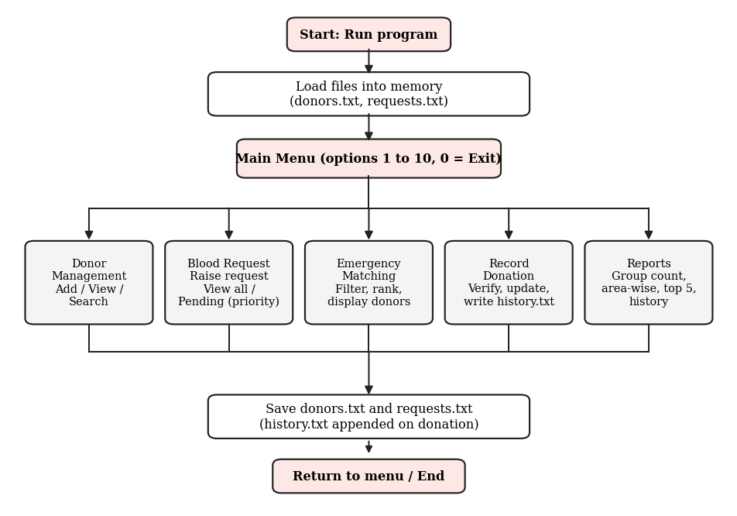

7. Source Code & Output
C Program (Blood_donor.c):-
/* BLOOD DONOR MANAGEMENT & EMERGENCY MATCHING SYSTEM (compact version)
- Donor database: add / view / search by blood group or area
- Blood requests with urgency (pending list works as a priority queue)
- Matching: blood compatibility + 90-day rule + same-area first
- Donation history log and reports
Files used: donors.txt, requests.txt, history.txt */
#include <stdio.h>
#include <stdlib.h>
#include <string.h>
#include <ctype.h>
#include <time.h>

#define MAX 200
#define GAP 90 /* minimum days between two donations */
#define DAY 86400L

typedef struct { int id, age, count; char name[30], sex[4], bg[5], phone[15], area[20]; long last; } Donor;
typedef struct { int id, units, urgency, done; char patient[30], bg[5], area[20]; long date; } Request;

Donor D[MAX]; int nd = 0;
Request R[MAX]; int nr = 0;
const char *BG[8] = {"O-", "O+", "A-", "A+", "B-", "B+", "AB-", "AB+"};
const char *URG[4] = {"", "HIGH", "MEDIUM", "LOW"};
char *mArea; /* area used by the match sorter */

/* ---------- input helpers ---------- */
void ask(const char *p, char *buf, int n) {
char t[100];
printf("%s", p);
if (!fgets(t, 100, stdin)) exit(0);
t[strcspn(t, "\n")] = 0;
if (!t[0]) strcpy(t, "-"); /* keeps file format safe */
strncpy(buf, t, n - 1); buf[n - 1] = 0;
}
int askInt(const char *p) { char b[20]; ask(p, b, 20); return atoi(b); }

void askBG(char *bg) {
while (1) {
ask("Blood group (O-,O+,A-,A+,B-,B+,AB-,AB+): ", bg, 5);
for (char *c = bg; *c; c++) *c = toupper(*c);
for (int i = 0; i < 8; i++) if (!strcmp(bg, BG[i])) return;
printf("Invalid blood group.\n");
}
}

long askDate() {
struct tm t = {0};
char b[30];
ask("Last donation date (dd mm yyyy): ", b, 30);
if (sscanf(b, "%d %d %d", &t.tm_mday, &t.tm_mon, &t.tm_year) != 3) {
printf("Invalid date, using today.\n");
return (long)time(NULL);
}
t.tm_mon--; t.tm_year -= 1900; t.tm_hour = 12;
return (long)mktime(&t);
}

/* ---------- small utilities ---------- */
int same(const char *a, const char *b) { /* case-insensitive compare */
for (; *a && tolower(*a) == tolower(*b); a++, b++);
return tolower(*a) == tolower(*b);
}

char *fmt(long t) { /* date as dd-mm-yyyy */
static char s[12];
time_t x = t;
if (!t) return "Never";
strftime(s, 12, "%d-%m-%Y", localtime(&x));
return s;
}

/* can donor blood d be given to recipient r? */
int compat(const char *d, const char *r) {
int dl = strlen(d), rl = strlen(r);
if (d[dl - 1] == '+' && r[rl - 1] == '-') return 0; /* Rh+ -> Rh- not allowed */
if (d[0] == 'O' || !strncmp(r, "AB", 2)) return 1; /* O gives all, AB takes all */
return dl == rl && !strncmp(d, r, dl - 1); /* otherwise same ABO group */
}

int eligible(Donor *d) { return d->last == 0 || difftime(time(NULL), d->last) >= GAP * DAY; }

int findReq(int id) { for (int i = 0; i < nr; i++) if (R[i].id == id) return i; return -1; }
int findDonor(int id) { for (int i = 0; i < nd; i++) if (D[i].id == id) return i; return -1; }

/* ---------- file storage ---------- */
void save() {
FILE *f = fopen("donors.txt", "w");
if (f) {
for (int i = 0; i < nd; i++)
fprintf(f, "%d|%s|%d|%s|%s|%s|%s|%ld|%d\n", D[i].id, D[i].name, D[i].age,
D[i].sex, D[i].bg, D[i].phone, D[i].area, D[i].last, D[i].count);
fclose(f);
}
f = fopen("requests.txt", "w");
if (f) {
for (int i = 0; i < nr; i++)
fprintf(f, "%d|%s|%s|%d|%s|%d|%d|%ld\n", R[i].id, R[i].patient, R[i].bg,
R[i].units, R[i].area, R[i].urgency, R[i].done, R[i].date);
fclose(f);
}
}

void load() {
FILE *f = fopen("donors.txt", "r");
if (f) {
while (nd < MAX && fscanf(f, "%d|%29[^|]|%d|%3[^|]|%4[^|]|%14[^|]|%19[^|]|%ld|%d\n",
&D[nd].id, D[nd].name, &D[nd].age, D[nd].sex, D[nd].bg, D[nd].phone,
D[nd].area, &D[nd].last, &D[nd].count) == 9) nd++;
fclose(f);
}
f = fopen("requests.txt", "r");
if (f) {
while (nr < MAX && fscanf(f, "%d|%29[^|]|%4[^|]|%d|%19[^|]|%d|%d|%ld\n",
&R[nr].id, R[nr].patient, R[nr].bg, &R[nr].units, R[nr].area,
&R[nr].urgency, &R[nr].done, &R[nr].date) == 8) nr++;
fclose(f);
}
}

/* ---------- donors ---------- */
void donorHead() {
printf("\n%-4s %-16s %-4s %-4s %-5s %-13s %-12s %-11s %-4s %s\n",
"ID", "Name", "Age", "Sex", "BGrp", "Contact", "Area", "LastDonated", "Elig", "Count");
}

void donorRow(Donor *d) {
printf("%-4d %-16s %-4d %-4s %-5s %-13s %-12s %-11s %-4s %d\n", d->id, d->name, d->age,
d->sex, d->bg, d->phone, d->area, fmt(d->last), eligible(d) ? "Yes" : "No", d->count);
}

void addDonor() {
if (nd >= MAX) { printf("Donor list is full.\n"); return; }
Donor *d = &D[nd];
d->id = nd ? D[nd - 1].id + 1 : 1;
ask("Name: ", d->name, 30);
d->age = askInt("Age: ");
ask("Gender (M/F/O): ", d->sex, 4);
askBG(d->bg);
ask("Contact: ", d->phone, 15);
ask("Area: ", d->area, 20);
d->last = 0; d->count = 0;
if (askInt("Donated before? (1=Yes, 0=No): ")) { d->last = askDate(); d->count = 1; }
nd++; save();
printf("Donor added with ID %d\n", d->id);
}

void viewDonors() {
if (!nd) { printf("No donors yet.\n"); return; }
donorHead();
for (int i = 0; i < nd; i++) donorRow(&D[i]);
}

void searchDonors(int byArea) {
char key[20];
int found = 0;
ask(byArea ? "Area: " : "Blood group: ", key, 20);
donorHead();
for (int i = 0; i < nd; i++)
if (same(byArea ? D[i].area : D[i].bg, key)) { donorRow(&D[i]); found = 1; }
if (!found) printf("No donors found.\n");
}

/* ---------- requests ---------- */
void addRequest() {
if (nr >= MAX) { printf("Request list is full.\n"); return; }
Request *r = &R[nr];
r->id = nr ? R[nr - 1].id + 1 : 1;
ask("Patient name: ", r->patient, 30);
askBG(r->bg);
while ((r->units = askInt("Units needed: ")) < 1);
ask("Area/Hospital locality: ", r->area, 20);
while ((r->urgency = askInt("Urgency (1=High, 2=Medium, 3=Low): ")) < 1 || r->urgency > 3);
r->done = 0; r->date = (long)time(NULL);
nr++; save();
printf("Request added with ID %d\n", r->id);
}

int cmpReq(const void *a, const void *b) { /* urgency first, then oldest first */
Request *x = &R[*(int *)a], *y = &R[*(int *)b];
return x->urgency != y->urgency ? x->urgency - y->urgency : x->id - y->id;
}

void showRequests(int pendingOnly) {
int idx[MAX], n = 0;
for (int i = 0; i < nr; i++) if (!pendingOnly || !R[i].done) idx[n++] = i;
if (!n) { printf("No requests.\n"); return; }
if (pendingOnly) qsort(idx, n, sizeof(int), cmpReq);
printf("\n%-4s %-16s %-5s %-6s %-12s %-8s %-10s %s\n",
"ID", "Patient", "BGrp", "Units", "Area", "Urgency", "Status", "Date");
for (int i = 0; i < n; i++) {
Request *r = &R[idx[i]];
printf("%-4d %-16s %-5s %-6d %-12s %-8s %-10s %s\n", r->id, r->patient, r->bg,
r->units, r->area, URG[r->urgency], r->done ? "Fulfilled" : "Pending", fmt(r->date));
}
}

/* ---------- matching ---------- */
int cmpDonor(const void *a, const void *b) { /* same area first, then longest wait */
Donor *x = &D[*(int *)a], *y = &D[*(int *)b];
int sx = same(x->area, mArea), sy = same(y->area, mArea);
if (sx != sy) return sy - sx;
return (x->last > y->last) - (x->last < y->last);
}

void findMatches() {
int idx[MAX], n = 0;
showRequests(1);
int ri = findReq(askInt("\nRequest ID: "));
if (ri < 0) { printf("Request not found.\n"); return; }
Request *r = &R[ri];
mArea = r->area;
for (int i = 0; i < nd; i++)
if (compat(D[i].bg, r->bg) && eligible(&D[i])) idx[n++] = i;
printf("\nMatches for request #%d (%s needs %s, area: %s)\n", r->id, r->patient, r->bg, r->area);
if (!n) { printf("No eligible & compatible donors found.\n"); return; }
qsort(idx, n, sizeof(int), cmpDonor);
printf("%-4s %-16s %-5s %-13s %-12s %-9s %s\n",
"ID", "Name", "BGrp", "Contact", "Area", "SameArea", "LastDonated");
for (int i = 0; i < n; i++) {
Donor *d = &D[idx[i]];
printf("%-4d %-16s %-5s %-13s %-12s %-9s %s\n", d->id, d->name, d->bg, d->phone,
d->area, same(d->area, r->area) ? "Yes" : "No", fmt(d->last));
}
}

void recordDonation() {
int ri = findReq(askInt("Request ID: "));
if (ri < 0 || R[ri].done) { printf("Request not found or not pending.\n"); return; }
int di = findDonor(askInt("Donor ID: "));
if (di < 0) { printf("Donor not found.\n"); return; }
Donor *d = &D[di];
Request *r = &R[ri];
if (!compat(d->bg, r->bg)) { printf("Mismatch: %s cannot donate to %s.\n", d->bg, r->bg); return; }
if (!eligible(d)) { printf("Donor not eligible yet (wait %d days).\n", GAP); return; }

d->last = (long)time(NULL); d->count++;
if (--r->units <= 0) r->done = 1;
FILE *f = fopen("history.txt", "a");
if (f) { fprintf(f, "%d|%s|%s|%s|%s\n", r->id, d->name, r->patient, d->bg, fmt(d->last)); fclose(f); }
save();
printf("Donation recorded. Units still needed: %d\n", r->units);
}

/* ---------- reports ---------- */
int cmpCount(const void *a, const void *b) { return D[*(int *)b].count - D[*(int *)a].count; }

void history() {
int id;
char dn[30], pn[30], bg[5], dt[12];
FILE *f = fopen("history.txt", "r");
if (!f) { printf("No donations recorded yet.\n"); return; }
printf("\n%-6s %-16s %-16s %-5s %s\n", "ReqID", "Donor", "Patient", "BGrp", "Date");
while (fscanf(f, "%d|%29[^|]|%29[^|]|%4[^|]|%11[^\n]\n", &id, dn, pn, bg, dt) == 5)
printf("%-6d %-16s %-16s %-5s %s\n", id, dn, pn, bg, dt);
fclose(f);
}

void reports() {
int c = askInt("1.Blood group count 2.Area-wise 3.Top 5 donors 4.History\nChoice: ");
if (c == 1) {
for (int i = 0; i < 8; i++) {
int k = 0;
for (int j = 0; j < nd; j++) if (!strcmp(D[j].bg, BG[i])) k++;
printf("%-4s : %d donor(s)\n", BG[i], k);
}
} else if (c == 2) {
for (int i = 0; i < nd; i++) {
int first = 1, k = 0;
for (int j = 0; j < nd; j++)
if (same(D[j].area, D[i].area)) { k++; if (j < i) first = 0; }
if (first) printf("%-15s : %d donor(s)\n", D[i].area, k);
}
} else if (c == 3) {
int idx[MAX];
for (int i = 0; i < nd; i++) idx[i] = i;
qsort(idx, nd, sizeof(int), cmpCount);
for (int i = 0; i < nd && i < 5; i++)
printf("%d. %-16s %-5s %d donation(s)\n", i + 1, D[idx[i]].name, D[idx[i]].bg, D[idx[i]].count);
} else if (c == 4) history();
else printf("Invalid choice.\n");
}

/* ---------- main ---------- */
int main() {
int c;
load();
printf("Loaded %d donor(s) and %d request(s).\n", nd, nr);
do {
printf("\n===== BLOOD DONOR MANAGEMENT & EMERGENCY MATCHING =====\n");
printf(" 1. Add donor 6. View all requests\n");
printf(" 2. View all donors 7. View pending (priority order)\n");
printf(" 3. Search by blood group 8. Find matching donors\n");
printf(" 4. Search by area 9. Record a donation\n");
printf(" 5. Raise blood request 10. Reports\n");
printf(" 0. Exit\n");
c = askInt("Choice: ");
switch (c) {
case 1: addDonor(); break;
case 2: viewDonors(); break;
case 3: searchDonors(0); break;
case 4: searchDonors(1); break;
case 5: addRequest(); break;
case 6: showRequests(0); break;
case 7: showRequests(1); break;
case 8: findMatches(); break;
case 9: recordDonation(); break;
case 10: reports(); break;
case 0: printf("All data saved. Goodbye!\n"); break;
default: printf("Invalid choice.\n");
}
} while (c != 0);
return 0;
}
Web Interface Code (Blood_donor_UI.html) – HTML structure:-
<body>
<div class="wrap">
<h1>Blood Donor Management &amp; Emergency Matching</h1>
<p class="mut">Register donors, raise blood requests and find eligible, compatible donors instantly.</p>
<nav>
<button data-a="tab" data-v="donors" class="on">Donors</button>
<button data-a="tab" data-v="requests">Requests &amp; Matching</button>
<button data-a="tab" data-v="reports">Reports</button>
<button data-a="sample">Load sample data</button>
<button data-a="reset" id="rst">Reset all data</button>
</nav>
<div id="msg" role="status"></div>

<section id="donors" class="on">
<div class="card"><h2>Add donor</h2>
<div class="grid">
<div><label>Name</label><input id="dn"></div>
<div><label>Age</label><input id="da" type="number" min="18" max="65"></div>
<div><label>Gender</label><select id="dg"><option>M</option><option>F</option><option>O</option></select></div>
<div><label>Blood group</label><select id="db"></select></div>
<div><label>Contact</label><input id="dp"></div>
<div><label>Area</label><input id="dr"></div>
<div><label><input type="checkbox" id="dd"> Donated before</label><input id="dl" type="date"></div>
<div><button class="pri" id="addD">Add donor</button></div>
</div></div>
<div class="card"><h2>All donors</h2>
<input id="q" placeholder="Search by name, blood group or area" style="margin-bottom:10px">
<div class="scroll" id="dt"></div></div>
</section>

Web Interface Code – compatibility and eligibility logic (JavaScript):-
function compat(d,r){
if(d.endsWith("+")&&r.endsWith("-"))return false;
if(d[0]==="O"||r.startsWith("AB"))return true;
return d.length===r.length&&d.slice(0,-1)===r.slice(0,-1);
}
const elig=d=>!d.last||Date.now()-d.last>=GAP*DAY;
Output (Console Program)
Output 1: Add donor (option 1)
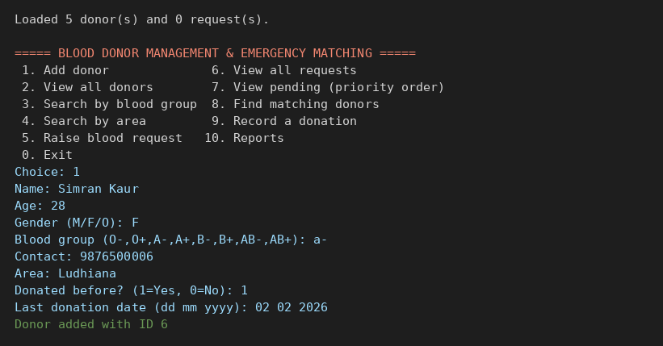
Output 2: View all donors (option 2)
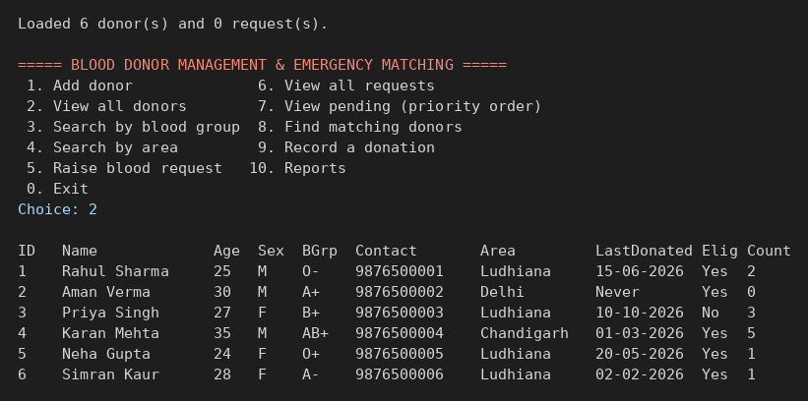
Output 3: Raise a blood request (option 5)
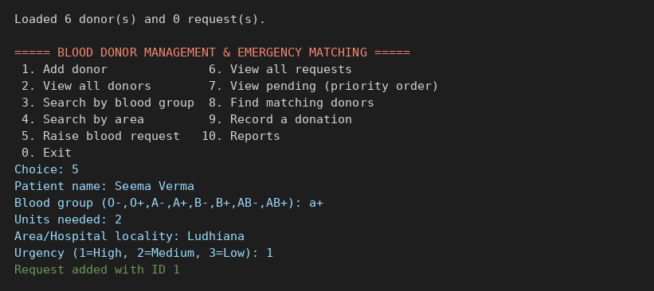
Output 4: Pending requests in priority order (option 7)
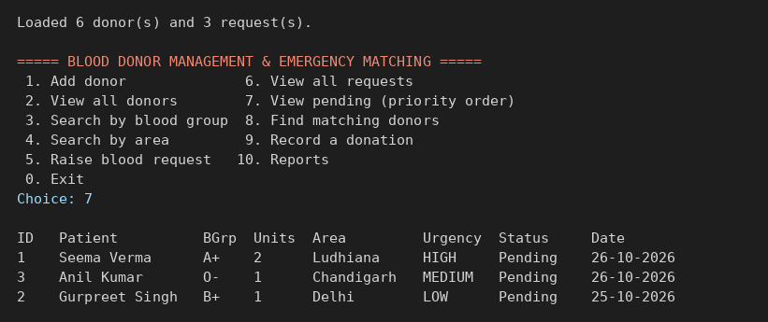
Output 5: Matching donors for request 1 – same area first, longest wait first (option 8)
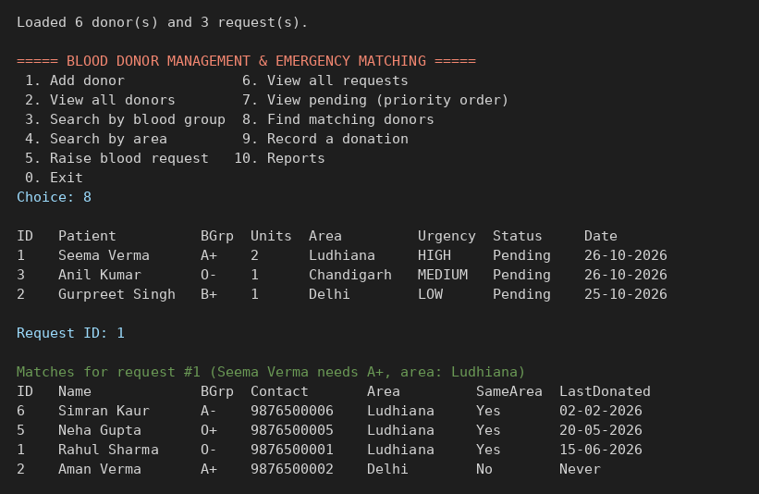
Output 6: Record a donation (option 9)
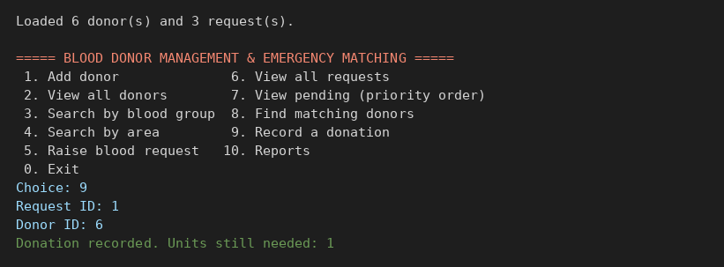
Output 7: Donation history (option 10, then 4)
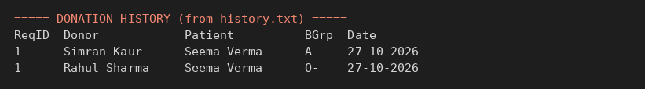
Output 8: Blood group wise donor count (option 10, then 1)
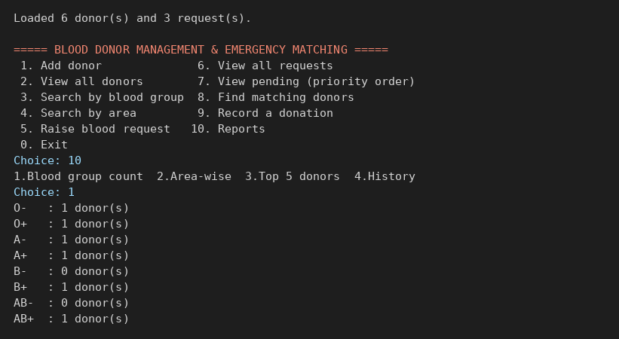
Output (Web Interface)
Output 9: Donors screen – add donor form and donor list with Eligible / Wait status
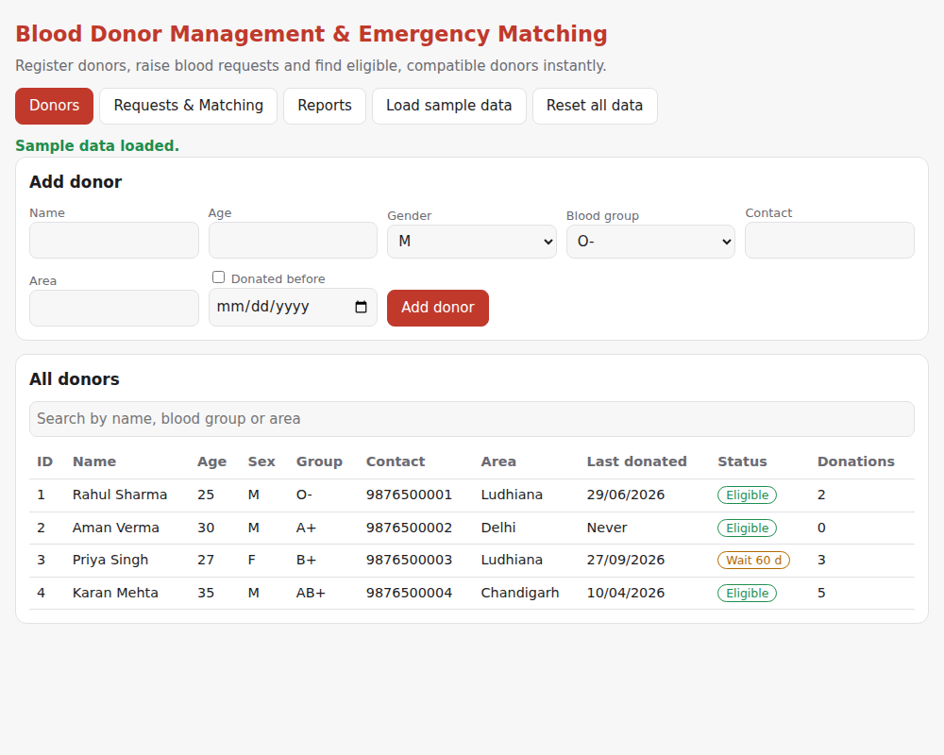
Output 10: Requests & Matching screen – ranked matching donors with Record donation button
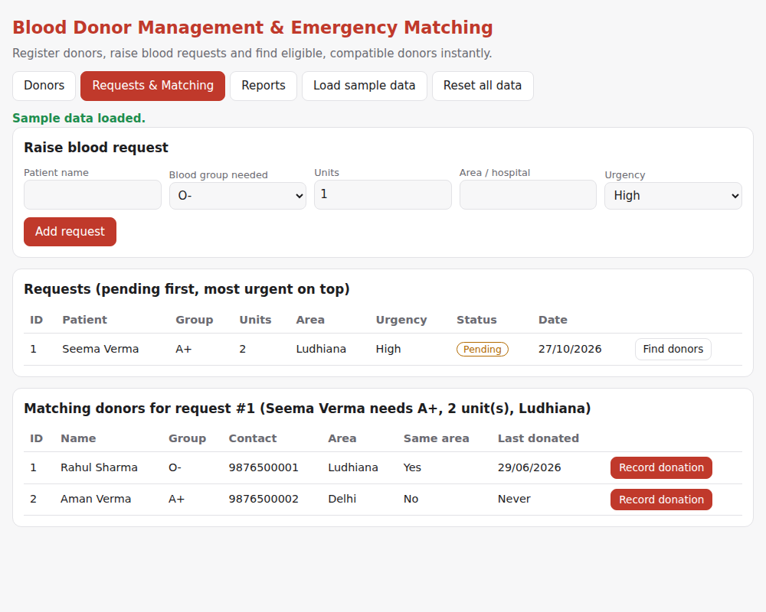
Output 11: Reports screen – statistics, donors by group and area, donation history
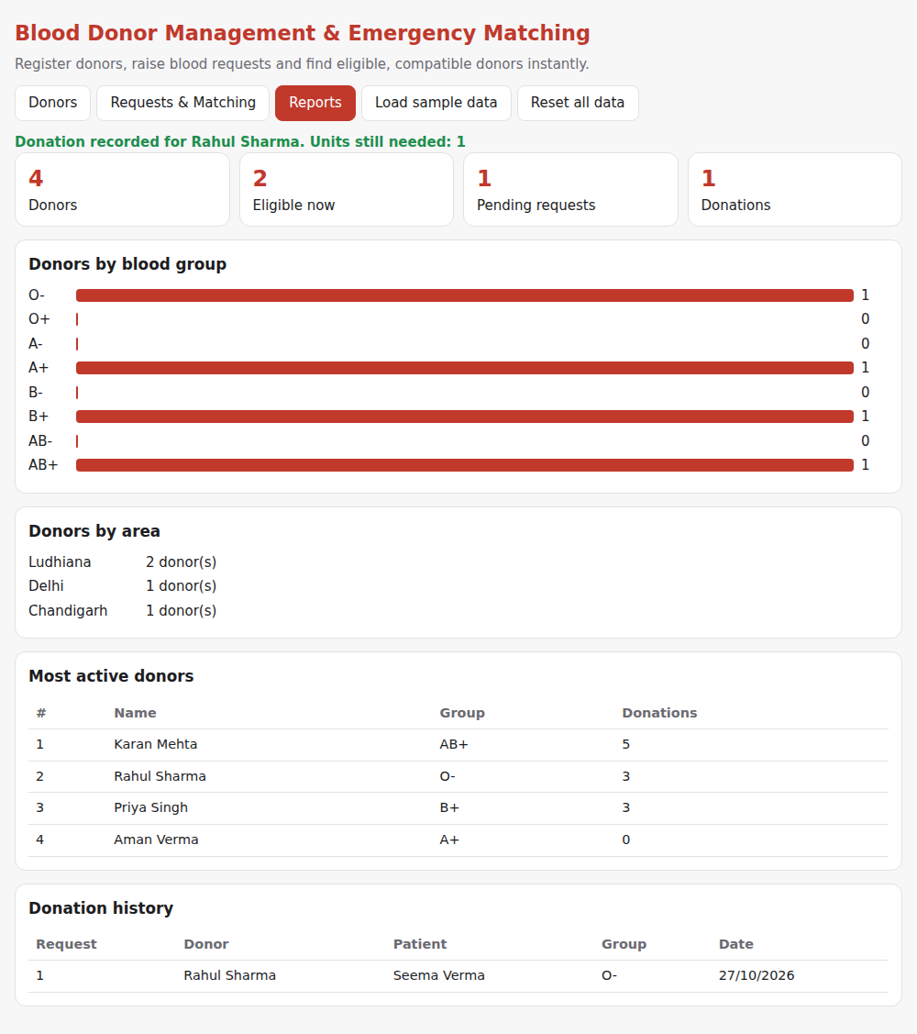

8. Functionalities
Donor Management
- Add a donor with name, age, gender, blood group, contact, area and last donation date.
- View all donors with their eligibility status (Yes / No) and donation count.
- Search donors by blood group or by area (not case sensitive).
Blood Request Management
- Raise a request with patient name, blood group, units needed, area and urgency.
- View all requests, or only pending requests ordered by urgency (High to Low).
Emergency Matching
- Select a request to list only donors who are blood-group compatible and eligible.
- Donors from the same area are shown first; then the donor who has waited longest since the last donation.
- Contact numbers are shown so that the donor can be called immediately.
Record Donation
- Updates the donor’s last donation date and count, so the donor becomes ineligible for 90 days.
- Reduces the units needed and marks the request Fulfilled when no units remain.
- Writes every donation to history.txt.
Reports
- Blood group wise donor count, area wise donor availability, top 5 most active donors and full donation history.
Data Storage
- Donors and requests are saved to text files after every change and loaded when the program starts.
Web User Interface
- A browser page with the same rules: forms to add donors and requests, one-click “Find donors”, “Record donation” and a Reports screen.

9. Conclusion
The Blood Donor Management & Emergency Matching System successfully meets its objectives. It stores donor and request data permanently, applies blood compatibility and donation-gap rules automatically, ranks donors by area and waiting time, serves requests by urgency and records every donation. Built with only the C standard library, it demonstrates how structures, file handling and sorting can be combined to solve a real social problem, and the browser interface makes it easier to use for people who are not comfortable with a console.

10. Future Work
- Location Matching: use distance or GPS instead of typed area names.
- Alerts: send SMS or e-mail notifications to matched donors.
- Database: move to SQLite or MySQL for large amounts of data and multiple users.
- Security: add login for administrators and hospitals.
- Medical Rules: separate gap rules for male and female donors and for blood components such as plasma and platelets.
- Mobile and Online Version: a shared online system for many hospitals, and blood stock management for blood banks.

11. Learning Outcomes:
- Proficiency in using structures, arrays and modular functions in C to build a complete application.
- Skill in file handling (reading, writing and appending text files) for persistent data storage.
- Understanding of sorting with qsort and custom comparison functions to rank data by multiple rules.
- Ability to turn real-world rules (blood compatibility, 90-day gap, urgency) into clear program logic.
- Experience in input validation, date handling, testing and debugging of a console application.
- Basic skill in building a browser-based interface (HTML, CSS, JavaScript) for the same logic.

12. GitHub link:
[Add your GitHub repository link here]

13. Bibliography:
- GNU Project. (n.d.). GCC, the GNU Compiler Collection. Retrieved from https://gcc.gnu.org/
- Microsoft. (n.d.). Visual Studio Code. Retrieved from https://code.visualstudio.com/
- cppreference.com. (n.d.). C reference. Retrieved from https://en.cppreference.com/w/c
- Kernighan, B. W., & Ritchie, D. M. (1988). The C Programming Language (2nd ed.). Prentice Hall.

