ASSIGNMENT

ASS03

DATA PREPARATION – STA6714

DONE BY:

SUSHMITHA MANI

**ASSIGNMENT –ASS03**

**DATA PREPARATION**

**NAME: SUSHMITHA MANI**

**UCF ID: 5016977**

***Problem 1***

*Write a simple program to create table that is similar of “Table 1” of the following categorical variables:*

1. *AppVersion*
2. *Census_ActivationChannel*
3. *Census_ChassisTypeName*
4. *Census_DeviceFamily*
5. *Census_FirmwareManufacturerIdentifier*

**SOLUTION:**

PROC Sql;

CREATE TABLE CARDINALITY_TABLE AS

Select Variable_Name, Variable_Type, Cardinality

FROM work.import

Where Variable_Name IN ('AppVersion', 'Census_ActivationChannel', 'Census_ChassisTypeName', 'Census_DeviceFamily','Census_FirmwareManufacturerID');

select *

From CARDINALITY_TABLE;

Proc Printto;

quit;

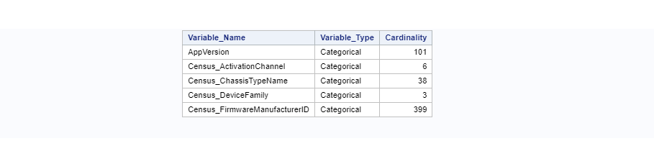

***Question 2***

*Produce a detail cardinality table of the following five variables:*

1. *AppVersion*
2. *Census_ActivationChannel*
3. *Census_ChassisTypeName*
4. *Census_DeviceFamily*
5. *Census_FirmwareManufacturerIdentifier*

**SOLUTION:**

proc freq data= WORK.IMPORT noprint;

tables AppVersion/out=FreqCount nocum;

Title 'Distribution of AppVersion Variables'

run;

proc print data=FreqCount noobs;

sum count percent;

run;

proc freq data= WORK.IMPORT noprint;

tables Census_ActivationChannel/out=FreqCount nocum;

Title 'Distribution of Census_ActivationChannel Variables'

run;

proc print data=FreqCount noobs;

sum count percent;

run;

proc freq data= WORK.IMPORT noprint;

tables Census_ChassisTypeName/out=FreqCount nocum;

Title 'Distribution of Census_ChassisTypeName Variables'

run;

proc print data=FreqCount noobs;

sum count percent;

run;

proc freq data= WORK.IMPORT noprint;

tables Census_DeviceFamily/out=FreqCount nocum;

Title 'Distribution of Census_DeviceFamily Variables'

run;

proc print data=FreqCount noobs;

sum count percent;

run;

proc freq data= WORK.IMPORT noprint;

tables Census_FirmwareManufacturerID/out=FreqCount nocum;

Title 'Distribution of Census_FirmwareManufacturerID Variables'

run;

proc print data=FreqCount noobs;

sum count percent;

run;

