ASSIGNMENT

ASS04

DATA PREPARATION – STA6714

DONE BY:

SUSHMITHA MANI

**QUESTION:**

Write a simple program to perform smoothing of a given categorical variable when the target variable is “HasDetections”. The input of the function has the following fields: (1) Data Set Name; (2) the target variable; (3) the threshold for the minimum number of observations for any given category; (4) Categorical Variable to be smoothed. The output of the function is the smoothed variables added to the original input data set.

Use the following five variables to test your function.

1. AppVersion
2. Census_ActivationChannel
3. Census_ChassisTypeName
4. Census_DeviceFamily
5. Census_FirmwareManufacturerIdentifier

Data set used for this assignment is “Malware_train_s.csv”.

**SOLUTION:**

1. For the variable AppVersion

CODE:

proc freq data= work.import;

tables AppVersion / out=freq nocum nopercent;

run;

proc freq data=work.import noprint;

where HasDetections=0;

tables AppVersion / out=no_freq nocum nopercent;

run;

proc freq data=work.import noprint;

where HasDetections=1;

tables AppVersion / out=yes_freq nocum nopercent;

run;

proc sort data= freq(rename=(count = freq) drop=PERCENT);

by AppVersion;

proc sort data=yes_freq(rename=(count = yes_freq) drop=PERCENT);

by AppVersion;

proc sort data=no_freq(rename=(count = no_freq) drop=PERCENT);

by AppVersion;

run;

data merge_out;

merge freq no_freq yes_freq;

by AppVersion;

run;

data prop;

set merge_out;

yes_prop = yes_freq / freq;

no_prop = no_freq / freq;

run;

proc print data= prop;

var Appversion freq yes_freq no_freq yes_prop no_prop;

run;

proc print data= prop;

var Appversion freq yes_freq no_freq yes_prop no_prop;

where freq<100;

sum freq yes_freq no_freq yes_prop no_prop;

run;

proc sql;

insert into prop values ( 'Other', 1070, 530, 540, 20.7800, 24.2200);

Alter table prop

Add smoothinglogit DECIMAL(10,6);

update prop

%let smoothfactor=10;

set smoothinglogit= log((yes_freq+(yes_prop*&smoothfactor))/(yes_freq+(no_prop*&smoothfactor)));

run;

quit;

proc print data=prop;

var Appversion freq yes_freq no_freq yes_prop no_prop smoothinglogit;

run;

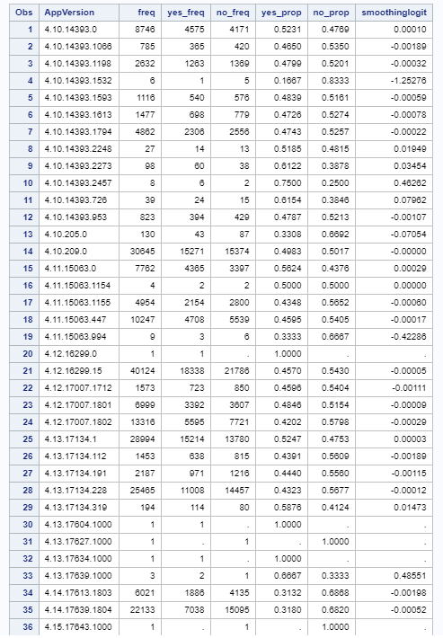

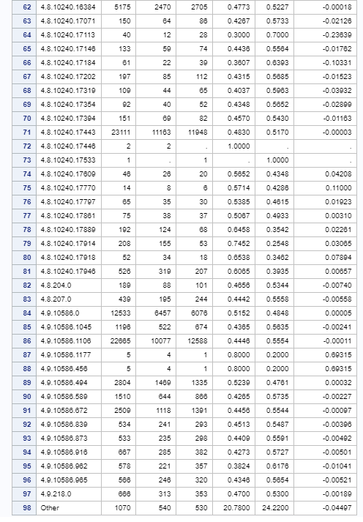

1. For the Variable: Census_ActivationChannel

CODE:

proc freq data= work.import;

tables Census_ActivationChannel / out=freq nocum nopercent;

run;

proc freq data=work.import noprint;

where HasDetections=0;

tables Census_ActivationChannel / out=no_freq nocum nopercent;

run;

proc freq data=work.import noprint;

where HasDetections=1;

tables Census_ActivationChannel / out=yes_freq nocum nopercent;

run;

proc sort data= freq(rename=(count = freq) drop=PERCENT);

by Census_ActivationChannel;

proc sort data=yes_freq(rename=(count = yes_freq) drop=PERCENT);

by Census_ActivationChannel;

proc sort data=no_freq(rename=(count = no_freq) drop=PERCENT);

by Census_ActivationChannel;

run;

data merge_out;

merge freq no_freq yes_freq;

by Census_ActivationChannel;

run;

data prop;

set merge_out;

yes_prop = yes_freq / freq;

no_prop = no_freq / freq;

run;

proc print data= prop;

var Census_ActivationChannel freq yes_freq no_freq yes_prop no_prop;

run;

proc sql;

Alter table prop

Add smoothinglogit DECIMAL(10,6);

update prop

%let smoothfactor=10;

Set smoothinglogit= log((yes_freq+(yes_prop*&smoothfactor))/(yes_freq+(no_prop*&smoothfactor)));

run;

quit;

proc print data=prop;

var Census_ActivationChannel freq yes_freq no_freq yes_prop no_prop smoothinglogit;

run;

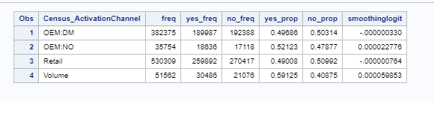

1. For the Variable : Census_ChasisTypeName

CODE:

proc freq data= work.import;

tables Census_ChassisTypeName / out=freq nocum nopercent;

run;

proc freq data=work.import noprint;

where HasDetections=0;

tables Census_ChassisTypeName/ out=no_freq nocum nopercent;

run;

proc freq data=work.import noprint;

where HasDetections=1;

tables Census_ChassisTypeName / out=yes_freq nocum nopercent;

run;

proc sort data= freq(rename=(count = freq) drop=PERCENT);

by Census_ChassisTypeName;

proc sort data=yes_freq(rename=(count = yes_freq) drop=PERCENT);

by Census_ChassisTypeName;

proc sort data=no_freq(rename=(count = no_freq) drop=PERCENT);

by Census_ChassisTypeName;

run;

data merge_out;

merge freq no_freq yes_freq;

by Census_ChassisTypeName;

run;

data prop;

set merge_out;

yes_prop = yes_freq / freq;

no_prop = no_freq / freq;

run;

proc print data= prop;

var Census_ChassisTypeName freq yes_freq no_freq yes_prop no_prop;

run;

proc print data= prop;

var Census_ChassisTypeName freq yes_freq no_freq yes_prop no_prop;

where freq<100;

sum freq yes_freq no_freq yes_prop no_prop;

run;

proc sql;

insert into prop values ( 'Other',263, 113, 150, 7.80249, 9.19751);

Alter table prop

Add smoothinglogit DECIMAL(10,6);

update prop

%let smoothfactor=10;

set smoothinglogit= log((yes_freq+(yes_prop*&smoothfactor))/(yes_freq+(no_prop*&smoothfactor)));

run;

quit;

proc print data=prop;

var Census_ChassisTypeName freq yes_freq no_freq yes_prop no_prop smoothinglogit;

run;

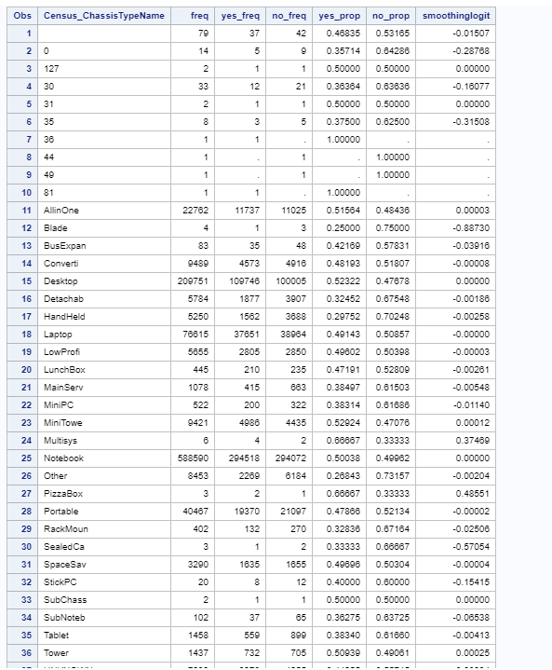

1. For the variable Census_DeviceFamily

proc freq data= work.import;

tables Census_DeviceFamily / out=freq nocum nopercent;

run;

proc freq data=work.import noprint;

where HasDetections=0;

tables Census_DeviceFamily/ out=no_freq nocum nopercent;

run;

proc freq data=work.import noprint;

where HasDetections=1;

tables Census_DeviceFamily / out=yes_freq nocum nopercent;

run;

proc sort data= freq(rename=(count = freq) drop=PERCENT);

by Census_DeviceFamily;

proc sort data=yes_freq(rename=(count = yes_freq) drop=PERCENT);

by Census_DeviceFamily;

proc sort data=no_freq(rename=(count = no_freq) drop=PERCENT);

by Census_DeviceFamily;

run;

data merge_out;

merge freq no_freq yes_freq;

by Census_DeviceFamily;

run;

data prop;

set merge_out;

yes_prop = yes_freq / freq;

no_prop = no_freq / freq;

run;

proc print data= prop;

var Census_DeviceFamily freq yes_freq no_freq yes_prop no_prop;

run;

proc print data= prop;  
var Census_DeviceFamily freq yes_freq no_freq yes_prop no_prop;  
where freq<100;   
sum freq yes_freq no_freq yes_prop no_prop;  
run;

proc sql;

insert into prop values ( 'Other',3, 2,1, 0.66667, 0.33333);

Alter table prop

Add smoothinglogit DECIMAL(10,6);

update prop

%let smoothfactor=10;

set smoothinglogit= log((yes_freq+(yes_prop*&smoothfactor))/(yes_freq+(no_prop*&smoothfactor)));

run;

quit;

proc print data=prop;

var Census_DeviceFamily freq yes_freq no_freq yes_prop no_prop smoothinglogit;

run;

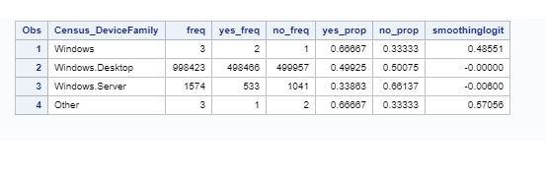

1. For The Variable: Census_FirmwareManufacturerIdent

proc freq data= work.import;

tables Census_FirmwareManufacturerIdent / out=freq nocum nopercent;

run;

proc freq data=work.import noprint;

where HasDetections=0;

tables Census_FirmwareManufacturerIdent/ out=no_freq nocum nopercent;

run;

proc freq data=work.import noprint;

where HasDetections=1;

tables Census_FirmwareManufacturerIdent / out=yes_freq nocum nopercent;

run;

proc sort data= freq(rename=(count = freq) drop=PERCENT);

by Census_FirmwareManufacturerIdent;

proc sort data=yes_freq(rename=(count = yes_freq) drop=PERCENT);

by Census_FirmwareManufacturerIdent;

proc sort data=no_freq(rename=(count = no_freq) drop=PERCENT);

by Census_FirmwareManufacturerIdent;

run;

data merge_out;

merge freq no_freq yes_freq;

by Census_FirmwareManufacturerIdent;

run;

data prop;

set merge_out;

yes_prop = yes_freq / freq;

no_prop = no_freq / freq;

run;

proc print data= prop;

var Census_FirmwareManufacturerIdent freq yes_freq no_freq yes_prop no_prop;

run;

proc print data= prop;

var Census_FirmwareManufacturerIdent freq yes_freq no_freq yes_prop no_prop;

where freq<100;

sum freq yes_freq no_freq yes_prop no_prop;

run;

proc sql;

insert into prop values (0, 3235, 1301, 1934, 133.008, 213.992);

Alter table prop

Add smoothinglogit DECIMAL(10,6);

update prop

%let smoothfactor=10;

set smoothinglogit= log((yes_freq+(yes_prop*&smoothfactor))/(yes_freq+(no_prop*&smoothfactor)));

run;

quit;

proc print data=prop;

var Census_FirmwareManufacturerIdent freq yes_freq no_freq yes_prop no_prop smoothinglogit;

run;

