ASSIGNMENT

ASS06

DATA PREPARATION – STA6714

DONE BY:

SUSHMITHA MANI

**QUESTION 1**

*Use the data to produce a ROC Curve based on decile.*

**CODE:**

proc sql noprint;

select count(*) from work.import where Posterior_Probability>0.1 and True_Target=1;

quit;

proc sql noprint;

select count(*) from work.import where Posterior_Probability>0.1 and True_Target=0;

quit;

proc sql noprint;

select count(*) from work.import where Posterior_Probability<0.1 and True_Target=1;

quit;

proc sql noprint;

select count(*) from work.import where Posterior_Probability<0.1 and True_Target=0;

quit;

proc sql noprint;

select count(*) from work.import where Posterior_Probability>0.2 and True_Target=1;

quit;

proc sql noprint;

select count(*) from work.import where Posterior_Probability>0.2 and True_Target=0;

quit;

proc sql noprint;

select count(*) from work.import where Posterior_Probability<0.2 and True_Target=1;

quit;

proc sql noprint;

select count(*) from work.import where Posterior_Probability<0.2 and True_Target=0;

quit;

proc sql noprint;

select count(*) from work.import where Posterior_Probability>0.3 and True_Target=1;

quit;

proc sql noprint;

select count(*) from work.import where Posterior_Probability>0.3 and True_Target=0;

quit;

proc sql noprint;

select count(*) from work.import where Posterior_Probability<0.3 and True_Target=1;

quit;

proc sql noprint;

select count(*) from work.import where Posterior_Probability<0.3 and True_Target=0;

quit;

proc sql noprint;

select count(*) from work.import where Posterior_Probability>0.4 and True_Target=1;

quit;

proc sql noprint;

select count(*) from work.import where Posterior_Probability>0.4 and True_Target=0;

quit;

proc sql noprint;

select count(*) from work.import where Posterior_Probability<0.4 and True_Target=1;

quit;

proc sql noprint;

select count(*) from work.import where Posterior_Probability<0.4 and True_Target=0;

quit;

proc sql noprint;

select count(*) from work.import where Posterior_Probability>0.5 and True_Target=1;

quit;

proc sql noprint;

select count(*) from work.import where Posterior_Probability>0.5 and True_Target=0;

quit;

proc sql noprint;

select count(*) from work.import where Posterior_Probability<0.5 and True_Target=1;

quit;

proc sql noprint;

select count(*) from work.import where Posterior_Probability<0.5 and True_Target=0;

quit;

proc sql noprint;

select count(*) from work.import where Posterior_Probability>0.6 and True_Target=1;

quit;

proc sql noprint;

select count(*) from work.import where Posterior_Probability>0.6 and True_Target=0;

quit;

proc sql noprint;

select count(*) from work.import where Posterior_Probability<0.6 and True_Target=1;

quit;

proc sql noprint;

select count(*) from work.import where Posterior_Probability<0.6 and True_Target=0;

quit;

proc sql noprint;

select count(*) from work.import where Posterior_Probability>0.7 and True_Target=1;

quit;

proc sql noprint;

select count(*) from work.import where Posterior_Probability>0.7 and True_Target=0;

quit;

proc sql noprint;

select count(*) from work.import where Posterior_Probability<0.7 and True_Target=1;

quit;

proc sql noprint;

select count(*) from work.import where Posterior_Probability<0.7 and True_Target=0;

quit;

proc sql noprint;

select count(*) from work.import where Posterior_Probability>0.8 and True_Target=1;

quit;

proc sql noprint;

select count(*) from work.import where Posterior_Probability>0.8 and True_Target=0;

quit;

proc sql noprint;

select count(*) from work.import where Posterior_Probability<0.8 and True_Target=1;

quit;

proc sql noprint;

select count(*) from work.import where Posterior_Probability<0.8 and True_Target=0;

quit;

title 'ROC curve based on deciles';

proc sql noprint;

select count(*) from work.import where Posterior_Probability>0.9 and True_Target=1;

quit;

proc sql noprint;

select count(*) from work.import where Posterior_Probability>0.9 and True_Target=0;

quit;

proc sql noprint;

select count(*) from work.import where Posterior_Probability<0.9 and True_Target=1;

quit;

proc sql noprint;

select count(*) from work.import where Posterior_Probability<0.9 and True_Target=0;

quit;

/*creating and inserting in decile table*/

proc sql;

create table decile (Decile_Level numeric, Cum_TPC numeric, Cum_FPC numeric,

Cum_FNC numeric, Cum_TNC numeric);

insert into decile values (1, 49929, 49816, 16, 239);

insert into decile values (2, 49345, 47386, 600, 2669);

insert into decile values (3, 47071, 40677, 2874, 9378);

insert into decile values (4, 41958, 30607, 7987, 19448);

insert into decile values (5, 31951, 18725, 17994, 31330);

insert into decile values (6, 17816, 7201, 32129, 42854);

insert into decile values (7, 9737, 2263, 40208, 47792);

insert into decile values (8, 6565, 1040, 43380, 49015);

insert into decile values (9, 670, 57, 49275, 49998);

select * from decile;

quit;

/*additing sensitivity and 1-specificity columns*/

proc sql;

alter table decile add Sensitivity numeric, False_Alarm_Rate numeric;

quit;

data decilesesp;

set decile;

Sensitivity = Cum_TPC/(Cum_TPC + Cum_FNC);

False_Alarm_Rate = 1-(Cum_TNC/(Cum_TNC + Cum_FPC));

run;

proc print data=decilesesp;

run;

proc logistic data=work.import noprint;

model True_Target(event='1') = Posterior_Probability;

output out=LogiOut predicted=PredProb;

run;

proc rank data=LogiOut out=LogiDecile groups=10;

var PredProb;

ranks Decile;

run;

proc means data=LogiDecile noprint;

class Decile;

types Decile;

var True_Target PredProb;

output out=LogiDecileOut mean=True_TargetMean PredProbMean

lclm=True_TargetLower uclm=True_TargetUpper;

run;

proc logistic data=LogiDecile;

model True_Target(event='1')=PredProb/nofit;

roc 'Predictions' pred=PredProb;

ods select ROCcurve;

run;

proc logistic data=work.import noprint;

model True_Target(event='0') = Posterior_Probability;

output out=LogiOut predicted=PredProb;

run;

proc rank data=LogiOut out=LogiDecile0 groups=10;

var PredProb;

ranks Decile;

run;

proc means data=LogiDecile0 noprint;

class Decile;

types Decile;

var True_Target PredProb;

output out=LogiDecileOut mean=True_TargetMean PredProbMean

lclm=True_TargetLower uclm=True_TargetUpper;

run;

proc logistic data=LogiDecile0;

model True_Target(event='0')=PredProb/nofit;

roc 'Predictions' pred=PredProb;

ods select ROCcurve;

run;

**OUTPUT:**

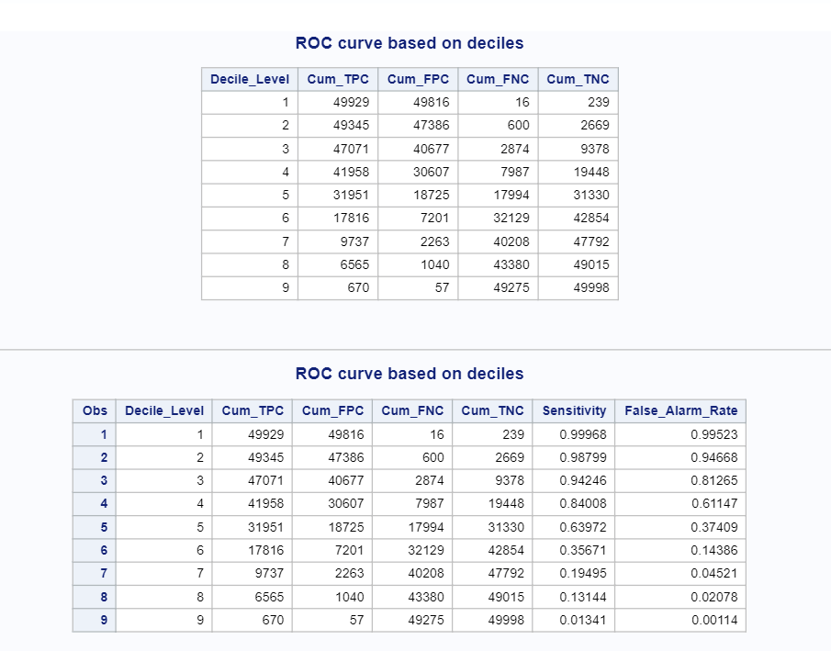

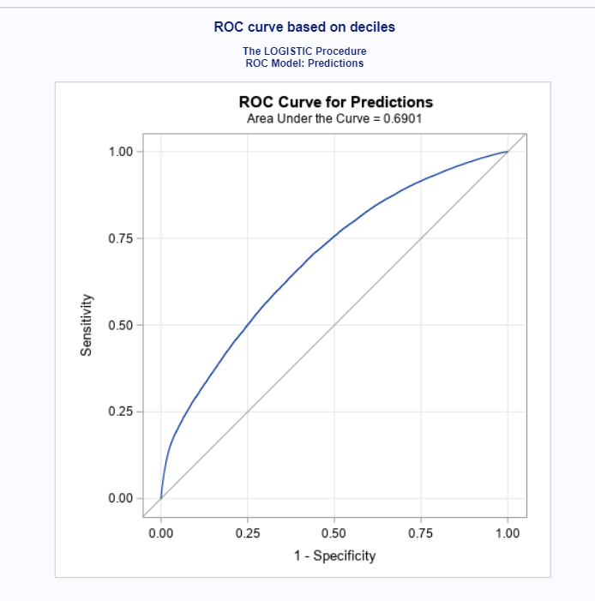

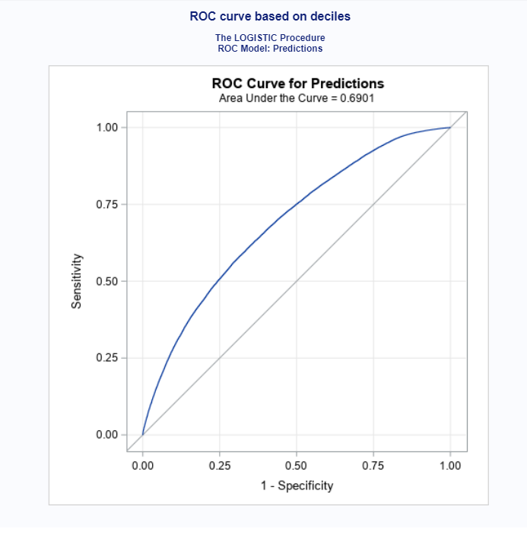

**QUESTION 2:**

*Use the same data to produce a lift chart at percentile level.*

**CODE:**

procrankdata=work.assign_dataout=percentiles ties=low

descendinggroups=100;

varPosterior_Probability;

ranks percentile;

run;

procsql;

select sum(True_Target) into: total_hits

fromwork.assign_data;

createtable lift as

select

sum(True_Target)/&total_hitsastrue_positive_rate

,percentile + 1as percentile

from percentiles

groupby percentile

orderby percentile

;

quit;

datacum_lift;

set lift;

cum_positive_rate + true_positive_rate;

cum_lift=cum_positive_rate/(percentile/100);

run;

procgplotdata=cum_lift;

title'Cummulative Lift Chart';

symboli=spline;

plotcum_lift*percentile /grid;

run;

quit;

procsgplotdata=cum_lift;

scatterx=percentile y=cum_lift;

run;

procgplotdata=cum_lift;

title ‘Cumulative Lift Chart’;

symboli=spline;

plotcum_lift*percentile /grid;

run;

quit;

**OUTPUT:**

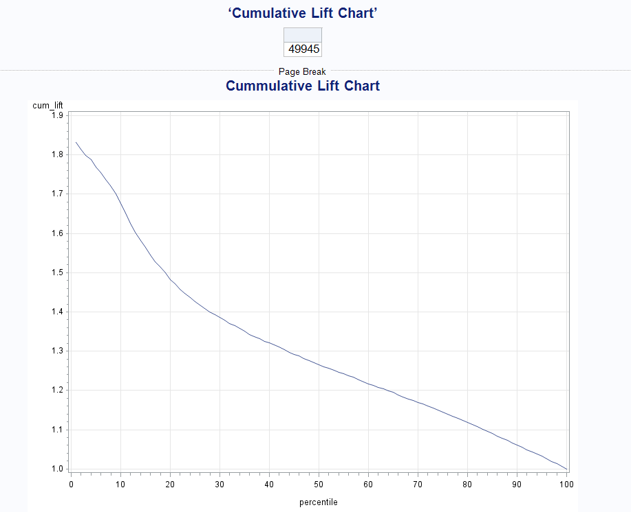

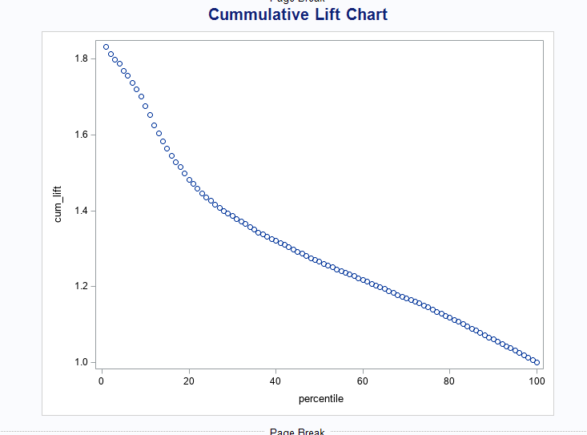

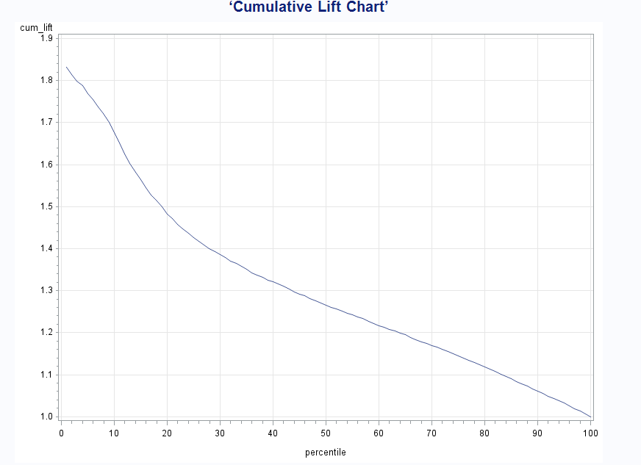

**QUESTION 3:**

*Produce one confusion matrix for each of the following cut-off probability 0.1, 0.2, and 0.3 using the same data.*

**CODE:**

proc sql noprint;

select count(*) from work.import where Posterior_Probability>0.1 and True_Target=1;

quit;

proc sql noprint;

select count(*) from work.import where Posterior_Probability>0.1 and True_Target=0;

quit;

proc sql noprint;

select count(*) from work.import where Posterior_Probability<0.1 and True_Target=1;

quit;

proc sql noprint;

select count(*) from work.import where Posterior_Probability<0.1 and True_Target=0;

quit;

proc sql noprint;

select count(*) from work.import where Posterior_Probability>0.2 and True_Target=1;

quit;

proc sql noprint;

select count(*) from work.import where Posterior_Probability>0.2 and True_Target=0;

quit;

proc sql noprint;

select count(*) from work.import where Posterior_Probability<0.2 and True_Target=1;

quit;

proc sql noprint;

select count(*) from work.import where Posterior_Probability<0.2 and True_Target=0;

quit;

proc sql noprint;

select count(*) from work.import where Posterior_Probability>0.3 and True_Target=1;

quit;

proc sql noprint;

select count(*) from work.import where Posterior_Probability>0.3 and True_Target=0;

quit;

proc sql noprint;

select count(*) from work.import where Posterior_Probability<0.3 and True_Target=1;

quit;

proc sql noprint;

select count(*) from work.import where Posterior_Probability<0.3 and True_Target=0;

quit;

proc sql;

create table Matrix (Decile_Level numeric, Cum_TPC numeric, Cum_FPC numeric,

Cum_FNC numeric, Cum_TNC numeric);

insert into matrix values (1, 49929, 16, 239, 49816);

insert into matrix values (2, 49345, 600, 2669, 47386);

insert into matrix values (3, 47071, 2874, 9378, 40677);

select * from matrix;

quit;

proc sql;

title 'Confusion Matrix with cut-off Probability 0.1';

create table confusion1 (TrueState char(10), Positive num, Negative num);

insert into confusion1 values('True', 49929, 16);

insert into confusion1 values('False', 49816, 239);

select*

from confusion1;

quit;

proc sql;

title 'Confusion Matrix with cut-off Probability 0.2';

create table confusion2 (TrueState char(10), Positive num, Negative num);

insert into confusion2 values('True', 49345, 600);

insert into confusion2 values('False',47386, 2669);

select*

from confusion3;

quit;

proc sql;

title 'Confusion Matrix with cut-off Probability 0.3';

create table confusion3 (TrueState char(10), Positive num, Negative num);

insert into confusion3 values('True', 47071, 2874);

insert into confusion3 values('False', 40677, 9378);

select*

from confusion3;

quit;

**OUTPUT:**

