**DATA PREPARATION**

**ASSIGNMENT ASS05**

**DONE BY:**

**SUSHMITHA MANI**

**DATA PREPARATION ASSIGNMENT ASS05**

**QUESTION 1:** *Use Median imputation on the following variables: CL_Limit, PD_Limit, MP_LIMIT, CREDITSCORENUM, INSURANCEEXPERIENCEDAYSNUM, PRECREDITTIERNUM, PRIORSWITCHESCOUNT, RATEMANUALNUM, and UWTIERNUM*

**ANSWER:**

**BEFORE TRANSFORMATION:**

proc means data=ASSG.FINALRAW chartype mean median vardef=df skewness qmethod=os;

var CL_Limit PD_Limit MP_Limit CreditScoreNum InsuranceExperienceDaysNum PreCreditTierNum PriorSwitchesCount RateManualNum uwtiergroup;

run;

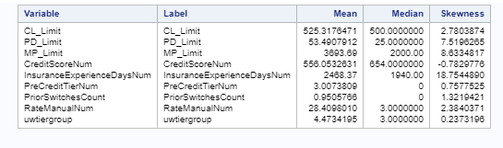

**(Table before Transformation)**

**AFTER TRANSFORMATION:**

ods noproctitle;

proc hpimpute data=work.finalraw out=work.import10;

input CL_Limit PD_Limit MP_Limit CreditScoreNum InsuranceExperienceDaysNum

PreCreditTierNum PriorSwitchesCount UWTierNum RateManualNum;

impute CL_Limit PD_Limit MP_Limit CreditScoreNum InsuranceExperienceDaysNum

PreCreditTierNum PriorSwitchesCount UWTierNum RateManualNum / method= pmedian;

run;

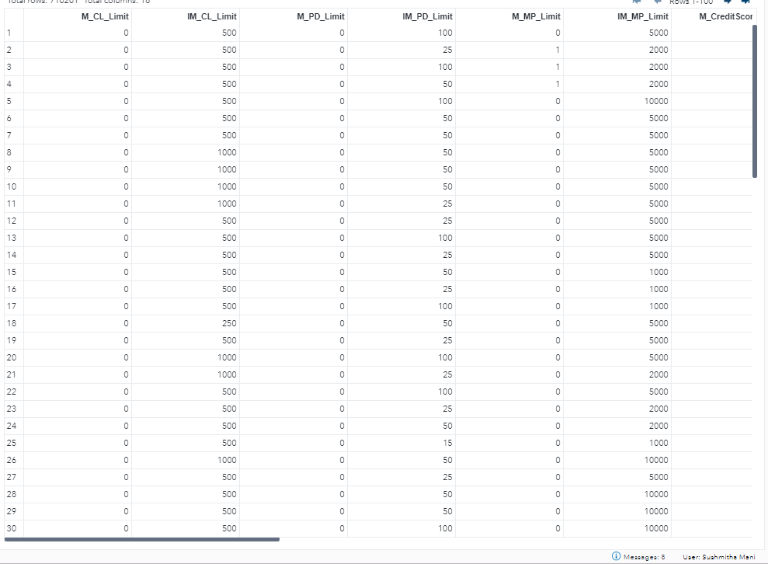

**(Output Data After Transformation)**

proc means data=ASSG.FINALRAW chartype mean median vardef=df skewness qmethod=os;

var CL_Limit PD_Limit MP_Limit CreditScoreNum InsuranceExperienceDaysNum PreCreditTierNum PriorSwitchesCount RateManualNum uwtiergroup;

run;

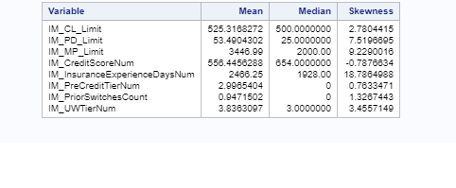

**(Table after Transformation)**

**Question 2:** *Restrict the variable PNIAGE in the interval [16, 100].*

**ANSWER:**

LIBNAME libref 'C:\Users\97150\Documents\Assignmentss SAS';

proc sql;

CREATE TABLE tab as

Select *

From finalraw

where PNIAge>16 and PNIAge<100;

quit;

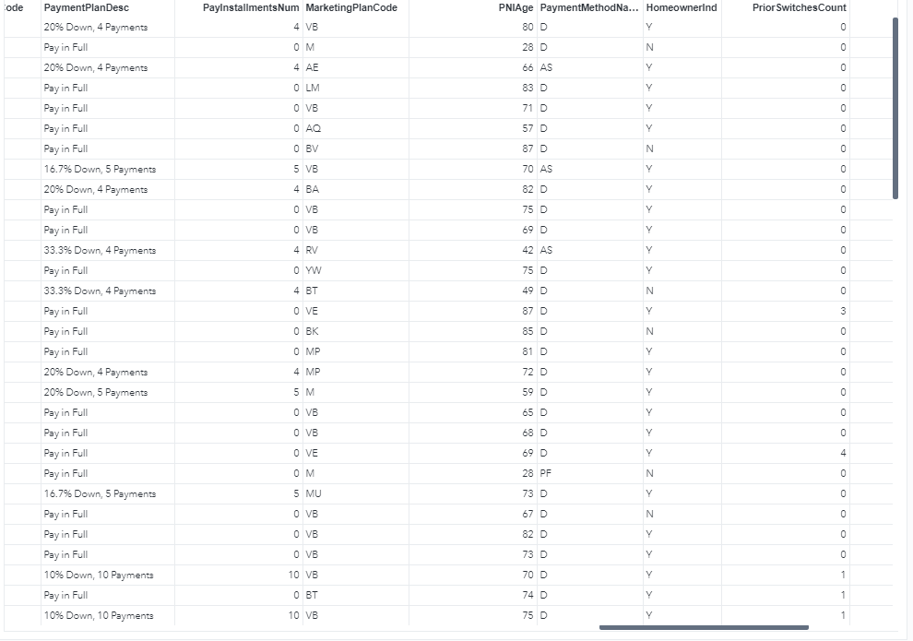

**(Output Data of PNIAge between interval 16 to 100)**

**Question 3:** *Perform rank transformation on the following variables RATEMANUALNUM N_MOD_BI_LIMIT FIRMCODE AGEGE75_LT30_LT21_POINTED PD_LIMIT MP_LIMIT MAXVEHVALUE PIP_LIMIT NEXTPREMCH*

**ANSWER:**

**BEFORE TRANSFORMATION:**

proc rank data=WORK.FINALRAW out=work.Rank;

var RateManualNum agege75_lt30_lt21_pointed PD_Limit MP_Limit maxvehvalue PIP_Limit nextpremch FirmCode;

ranks rank_RateManualNum rank_agege75_lt30_lt21_pointed rank_PD_Limit rank_MP_Limit rank_maxvehvalue rank_PIP_Limit rank_nextpremch rank_FirmCode;

run;

proc print data=work.Rank(obs=10);

title "Subset of work.Rank";

run;

title;

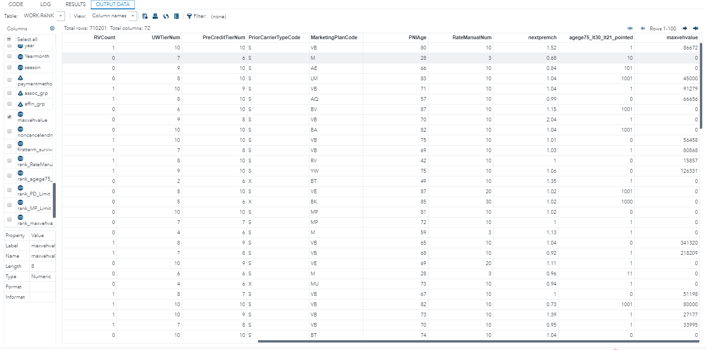

**(Output Data of the variables Before Transformation)**

ods noproctitle;

ods graphics / imagemap=on;

proc means data=WORK.FINALRAW chartype mean median vardef=df skewness qmethod=os;

var RateManualNum FirmCode agege75_lt30_lt21_pointed PD_Limit MP_Limit maxvehvalue PIP_Limit nextpremch InsuranceExperienceDaysNum;

run;

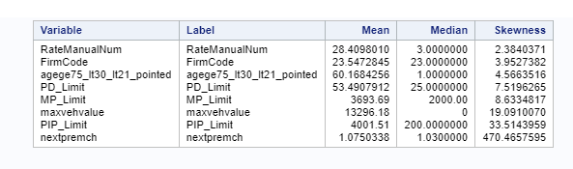

**(Table Before Transformation)**

**AFTER RANK TRANSFORMATION:**

proc rank data=WORK.FINALRAW out=work.Rank;

var RateManualNum agege75_lt30_lt21_pointed PD_Limit MP_Limit maxvehvalue PIP_Limit nextpremch FirmCode;

ranks rank_RateManualNum rank_agege75_lt30_lt21_pointed rank_PD_Limit

rank_MP_Limit rank_maxvehvalue rank_PIP_Limit rank_nextpremch rank_FirmCode;

run;

proc print data=work.Rank(obs=10);

title "Subset of work.Rank";

run;

title;

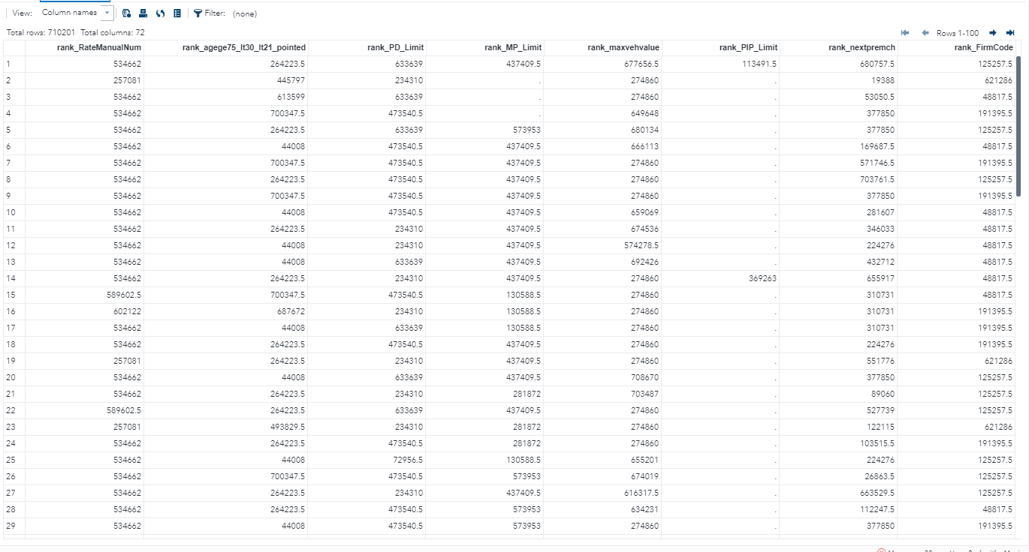

**(Output Data after Transformation)**

ods noproctitle;

ods graphics / imagemap=on;

proc means data=WORK.RANK chartype mean std min max n vardef=df;

var rank_RateManualNum rank_agege75_lt30_lt21_pointed rank_PD_Limit rank_MP_Limit rank_maxvehvalue rank_PIP_Limit rank_nextpremch rank_FirmCode;

run;

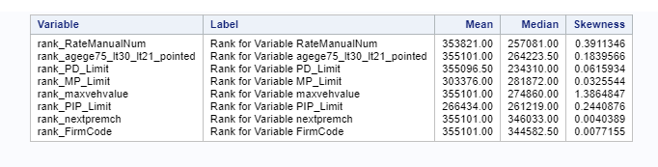

**(Table After Transformation)**

**Question 4:** *Perform log transformation on the following variables: UWTIERNUM NONCANCELENDMTS INCURRED_LOSS.*

**ANSWER:**

**BEFORE TRANSFORMATION:**

ods noproctitle;

ods graphics / imagemap=on;

proc means data=WORK.FINALRAW chartype mean median vardef=df skewness qmethod=os;

var UWTierNum noncancelendmts incurred_loss;

run;

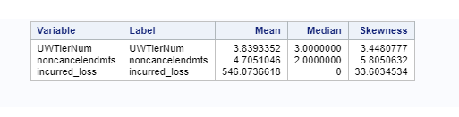  
**(Table Before Transformation)**

**AFTER TRANSFORMATION:**

LIBNAME libref 'C:\Users\97150\Documents\Assignmentss SAS';

proc stdize data=_temp0.finalraw missing=median out=work.rank1;

var UWTierNum noncancelendmts incurred_loss;

run;

data WORK.Rank1;

set _temp0.finalraw ;

log_UWTierNum = log10 (UWTierNum);

log_noncancelendmts = log10 (noncancelendmts);

log_incurred_loss= log10 (incurred_loss);

run;

proc print data= work.rank1 (obs=100);

run;

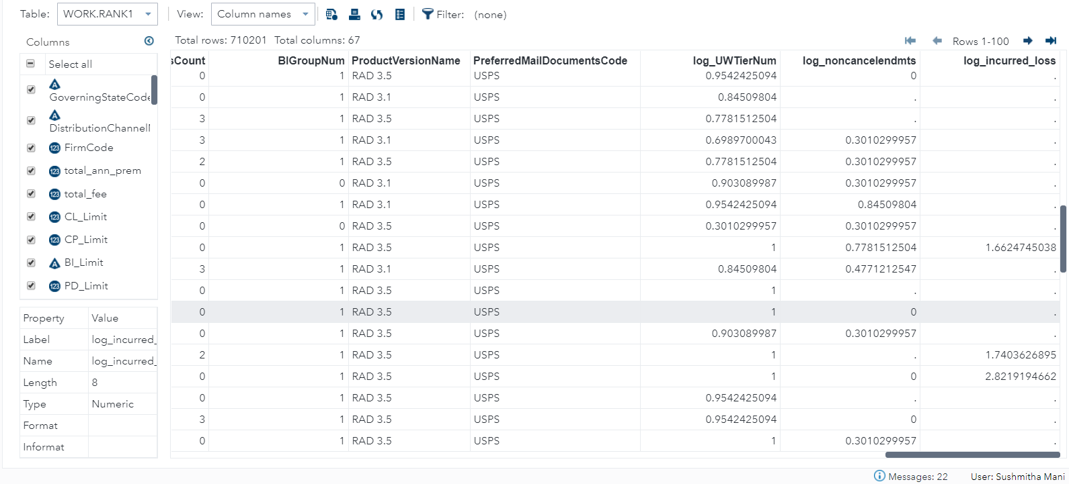

**(Output Data After Transformation)**

ods noproctitle;

ods graphics / imagemap=on;

proc means data=WORK.RANK1 chartype mean median vardef=df skewness qmethod=os;

var log_UWTierNum log_noncancelendmts log_incurred_loss;

run;

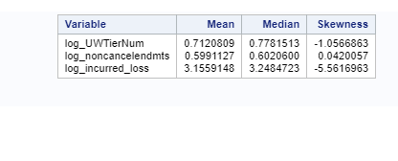

**(Table After Transformation)**

**QUESTION 5:***Perform power transformation of the following variables: TOTAL_FEE TOTAL_ANN_PREM CL_LIMIT NPCHCAT INSURANCEEXPERIENCEDAYSNUM CP_LIMIT*

* *TOTAL_FEE: Power 0.5*
* *TOTAL_ANN_PREM: Power 0.3125*
* *CL_LIMIT: Power 0.25*
* *NPCHCAT: Power 0.125*
* *INSURANCEEXPERIENCEDAYSNUM: Power 0.375*
* *CP_LIMIT: Power 0.4325*

**ANSWER:**

**BEFORE TRANSFORMATION:**

ods noproctitle;

ods graphics / imagemap=on;

proc means data=WORK.RANK1 chartype mean std min max n vardef=df;

var total_fee CL_Limit CP_Limit InsuranceExperienceDaysNum npchcat TOTAL_ANN NPCHAT;

run;

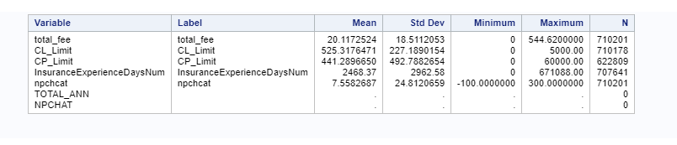

**(Table Before Transformation)**

**AFTER TRANSFORMATION:**

LIBNAME libref 'C:\Users\97150\Documents\Assignmentss SAS';

proc stdize data=_temp0.finalraw missing=median out=work.rank1;

var UWTierNum noncancelendmts incurred_loss;

run;

data WORK.Rank1;

set _temp0.finalraw ;

power_TOTAL_FEE = TOTAL_FEE**0.5 ;

power_TOTAL_ANN= (TOTAL_ANN)**0.3125;

power_CL_LIMIT= (CL_LIMIT)**0.25;

power_NPCHAT= (NPCHAT)**0.125;

power_INSURANCEEXPERIENCEDAYSNUM= (INSURANCEEXPERIENCEDAYSNUM)**0.375;

power_CP_LIMIT= (CP_LIMIT)**0.4325;

run;

proc print data= work.rank1 (obs=100);

run;

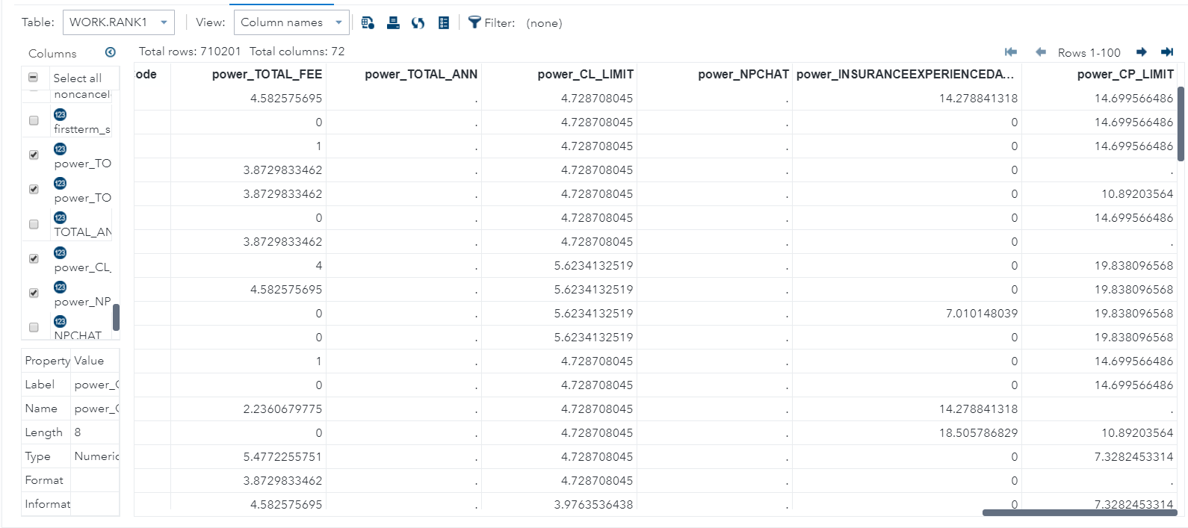

**(Output Data After Transformation)**

ods noproctitle;

ods graphics / imagemap=on;

proc means data=WORK.RANK1 chartype mean median vardef=df skewness qmethod=os;

var power_TOTAL_FEE power_TOTAL_ANN power_CL_LIMIT power_NPCHAT power_INSURANCEEXPERIENCEDAYSNUM power_CP_LIMIT;

run;

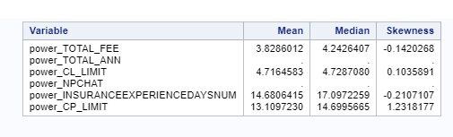

**(Table After Transformation)**