Instructions for the Editing Activity

In this editing activity, we’d like to evaluate your grammar and linguistics skills as well your ability to validate documentation.

1. Use the Style Guide below to help edit and correct the errors in the How to Clear Cache document.
2. If you are using Microsoft Word, please navigate to the **Review** tab and click on the **Track Changes** > **Track Changes** option.   
   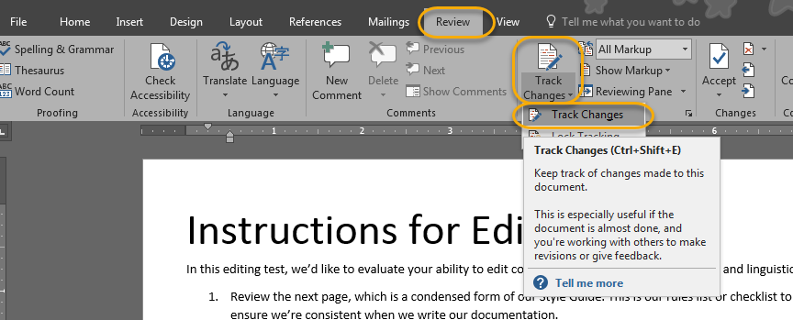
3. If you are using another form of editing software (e.g. Google Docs), please enable the tracking function or highlight your edits so we can see any changes you make to the document.

Style Guide

Tables

Tables do not include any styling or content traits. This includes bolding, italics, or underlining.

Common Words

|  |  |
| --- | --- |
| Word | Rule |
| drop-down | Must include a hyphen |
| setup / set up | Noun: Setup Adjective: Setup Verb: Set up |
| email | Do not include a hyphen |
| is not, cannot, do not, should not, could not | Do not use negative contractions (e.g., don’t, couldn’t, shouldn’t), spell out the words entirely. |

Trademarks

Most companies have strict regulations on trademarking. You can find this information on the product’s website.

* First mention of a product:
  + Apply trademark symbol(s), if applicable
  + Include the company name in front of the product name (e.g., Cisco Spark™)
* Do not include trademarks within the header or title of a section or document.

Content Traits

**Note:** Content traits do not get applied in opening paragraphs (overviews) or tables.

|  |  |  |
| --- | --- | --- |
| Text | Style | Example |
| Actions and Menu Destinations | Bold | Select **Dashboard** > **Management** > **Auditing** |
| Fields, Sections, and Menu Options | Bold | **Client Name** field, **Agent** section |
| Screens and Windows | Bold | **Tickets** screen, **Template** window |
| Product Names | Bold | **Cisco Spark** |

Table of Contents

Overview 1

Clear Cache in Microsoft Edge 1

Clear Cache in Google Chrome 2

Clear Cache in Mozilla Firefox 3

Clear Cache in Apple Safari 3

How to Clear Cache

# Overview

The browser cache is a temporary storage location on your computer for files downloaded by your browser to display websites. The browser cache can get large and take up a lot of space on your hard drive, filled with data from websites you may never visit again. While you can limit how large it can get, it is useful to occasionally clear it to fix problems and speed things up.

# Clear Cache in Microsoft Edge

To clear cache in **Microsoft Edge®**:

1. Open **Microsoft Edge**.
2. Click on  menu icon in the top right corner of the browser.
3. Navigate to **Settings** > **Privacy, search, and services** > **Clear browsing data** as shown below.

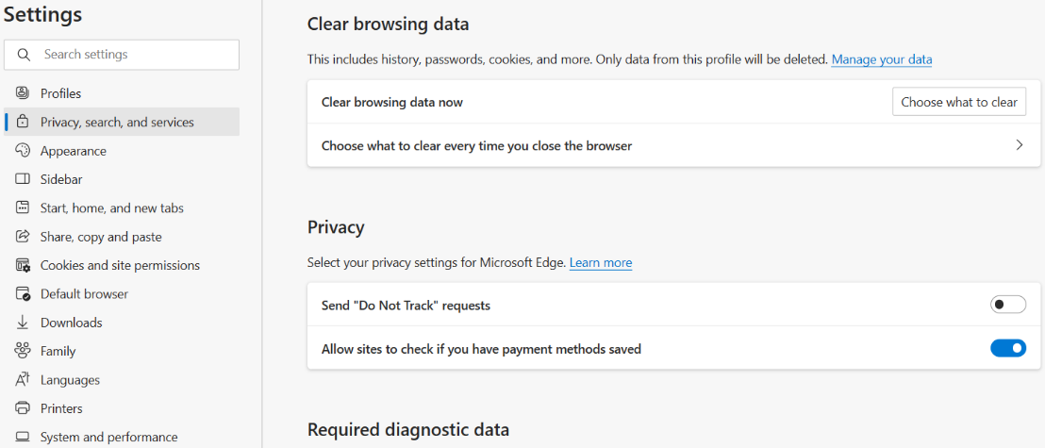

1. From **Clear browsing data now,** select **Choose what to clear**.
2. From the **Time range** drop-down menu, selectone of the following options:

1. Verify that the following checkboxes are selected:

1. Click the **Clear now** button.
2. Restart the browser to apply changes.

# Clear Cache in Google Chrome

To clear cache in **Google Chrome™** 100.0.4896:

1. Open **Google** **Chrome**.
2. Click on  menu icon in the top right corner of the browser.
3. Navigate to **Settings** > **Privacy and security** as shown below.

1. Click **Clear browsing data**.
2. From the **Time range** drop-down menu, selectone of the following options:

1. Verify that the following checkboxes are selected:

1. Click the **Clear data** button.
2. Restart the browser to apply changes.

# Clear Cache in Mozilla Firefox

To clear cache in **Mozilla Firefox®** 99.0.1:

1. Open **Mozilla Firefox**.
2. Click on  menu icon in the top right corner of the browser.
3. Navigate to **Settings** > **Privacy & Security** > **History** as shown below.

1. Click the **Clear History…** button.
2. From the **Time range to clear:** drop-down menu, select one of the following options:

1. Verify that the following checkboxes are selected:

1. Click the **Clear Now** button.
2. Restart the browser to apply changes.

# Clear Cache in Apple Safari

To clear cache in **Apple Safari**® 15:

1. Open **Apple Safari**.
2. In the menu bar, select **History** > **Clear History...** option as shown below.

1. From the **Clear** drop-down menu, select one of the following options:

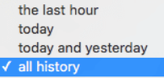

1. Click the **Clear History** button.
2. Restart the browser to apply changes.