Website Live Visitor Tracking System
Fall-2022 Cloud Computing Group Project
CS53610 - CRN: 13427

Group Title: CloudCrew
Group Members:
Student Name | Student id
Venkata Gopala Krishna Swamy Namburi | 700719027
Ashok Manavarthi | 700735871
Haritha Nallamothu | 700741311
Sushmitha Virri | 700742289

ARCHITECTURE DIAGRAM:
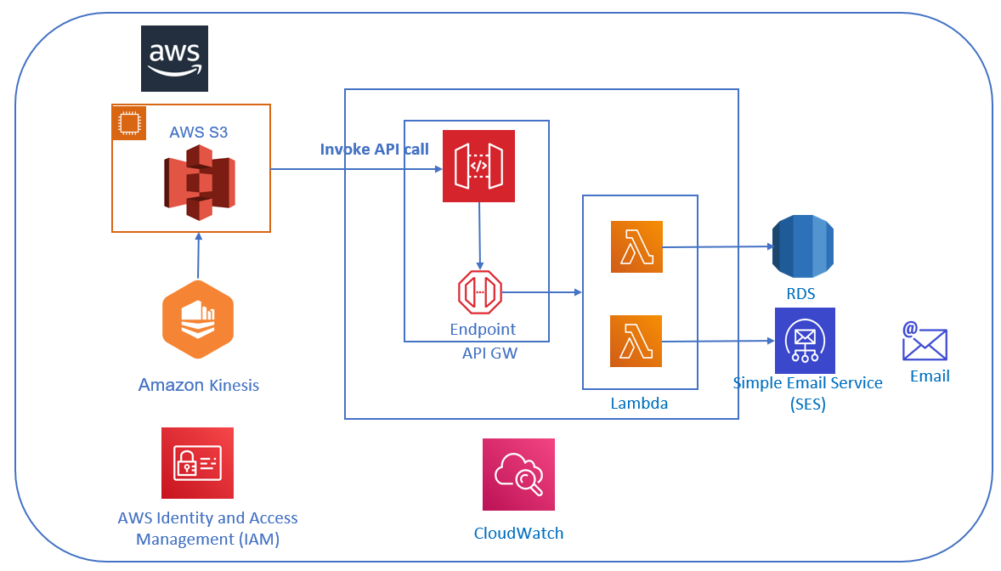

Project Description:
Website visitor tracking can help us build a cohesive, revenue-generating engine that accelerates the growth of sales for businesses. We can use the data collected to analyze which content is attracting prospects, how our website is being found, and which among our marketing campaigns is getting the most attention.
Through this project, we will try to understand user behavior by checking how many customers are actually visiting the webpage and of them how many are interested to browse the product information and are willing to share their contact details for additional information.
The application is developed over HTML and is hosted in S3. The application will integrate into the backend system via API. The API will be created & published using API GW. The S3 bucket is integrated with the API gateway (GW). API GW will further forward requests toward lambda. AWS Lambda is serverless, event-driven compute service that will allow us to run code to virtually communicate with the database, log monitoring & SES for notification. The codes for contactus page and trackingpixel page are written on Lambda with the help of the lambda function. Lambda has an IAM role and Lambda will write all login to Cloudwatch and also send the email notification. The AWS Kinesis Firehouse is used to dump the user data to S3.

Services Used:
API GW: It is the entry gate through which applications access data, business logic, or functionality from the backend services is the AWS API GW.
AWS Lambda - AWS Lambda is a serverless, event-driven computing solution that enables us to run code for almost any kind of backend service or application without creating or managing servers.
AWS CloudWatch - CloudWatch gathers operational and monitoring data in the form of metrics, events, and logs.
AWS SES - We can send email from within any application thanks to AWS SES, or Amazon Simple Email Service (SES), which is affordable, adaptable, and scalable.
AWS IAM - is a web service for securely regulating access to AWS resources. It stands for AWS Identity and Access Management.
AWS RDS - known as the Amazon Relational Database Service, is a group of managed services that make it simple to set up, run, and scale databases in the cloud.

AWS SES – provides us with the facility to send email from any application using AWS SES, which is a scalable, cost-effective, and versatile email service.

AWS S3:
A prominent provider of scalability, data availability, security, and performance, Amazon Simple Storage Service (Amazon S3) is an object storage service. Any amount of data can be optimized, organized, stored, and protected using Amazon S3 for a variety of use cases, including data lakes, websites, mobile applications, backup and restore, archives, and enterprise applications. Industries and most types of customers are capable to use S3.
We have used an open-source website for the project. The website is for a company that is providing logistics solutions. On each function such as Home, Contact and Message Send we are injecting a JavaScript code so that whenever the user clicks it an API request is triggered to the backend platform.
Whenever a user lands on the home page of the website an API is called. On that API we are passing the page title and location. If the user wants to get more information
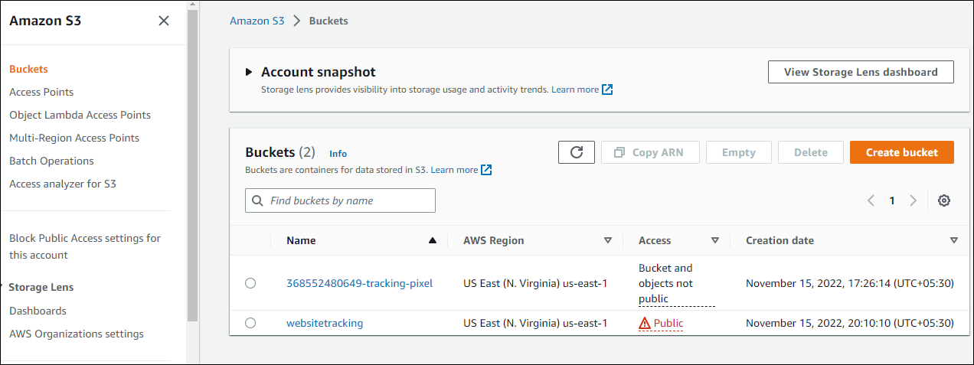

AWS API GW:
With the help of Amazon API Gateway, developers can construct, publish, maintain, monitor, and protect APIs of any size. It is a completely managed service. The primary purpose of API is to act as a "front door" through which applications can enter data, business logic, or functionality from our backend services. RESTful APIs and WebSocket APIs are also developed with the aid of API Gateway for real-time two-way communication. In addition, API Gateway supports serverless workloads, containerized workloads, and web applications.
The administration of traffic, CORS support, authorization, access control, throttling, monitoring, and API versioning is all handled by the API Gateway, which can accept and process up to hundreds of thousands of API calls concurrently. API Gateway has no setup fees or minimum fees. We pay for the amount of data carried in and out, and thanks to the API Gateway's tiered pricing mechanism, you may lower your cost as your API usage increases.
S3 Bucket is integrated with the API gateway and the API gateway will communicate with lambda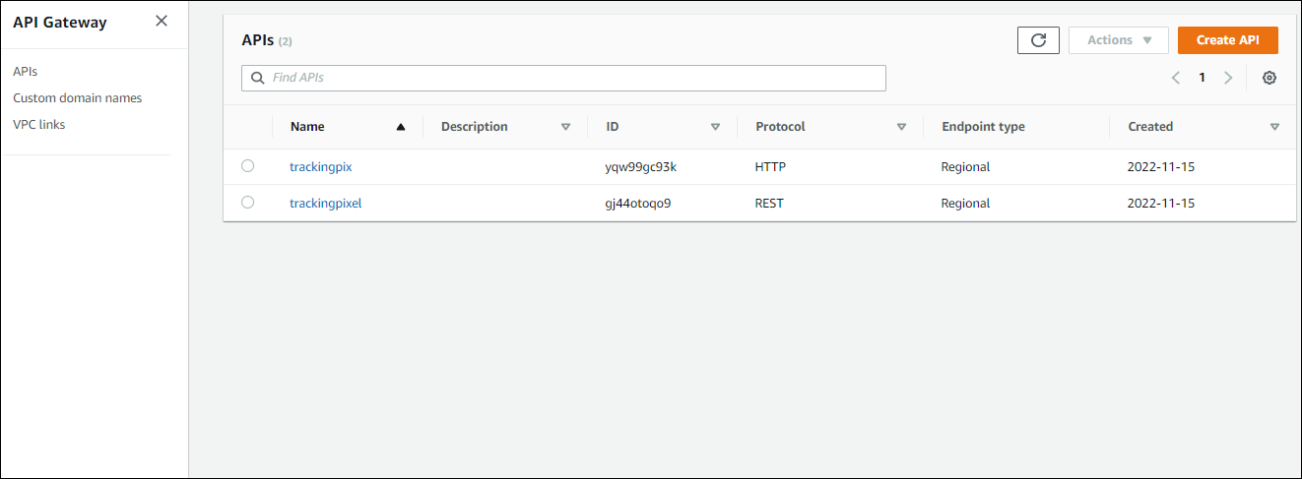
- We are creating two API gateways one is for tracking people landing on the home page other one is for user submission details on the contact us page. In tracking pixel API, it will pass the traffic information which is page title and location
- In tracking pixel API from the contact form it will send the request to the API gateway—HTTP endpoint request—Lambda function contactus
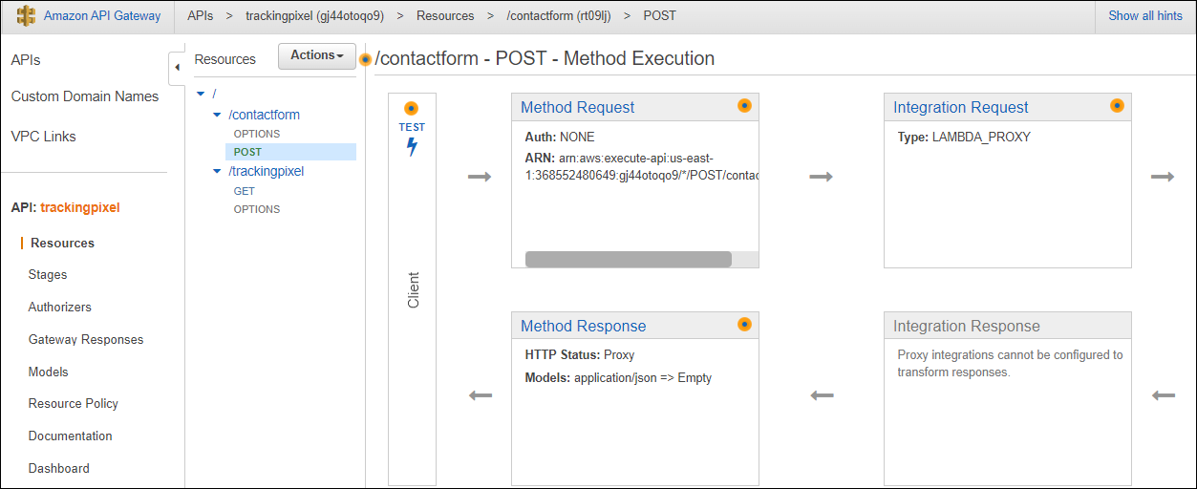
AWS LAMBDA:
With the help of Lambda, we can run code for nearly any kind of application or backend service. Lambda uses the proper function memory size to speed up code execution and improve performance. The advantage with Lambda is, instead of provisioning equipment in advance for peak capacity, cut expenses by only paying for the compute time you really use—by the millisecond.
AWS Lambda is a serverless, event-driven compute service on which we are writing code to communicate with backend platforms which are RDS and SES.
The lambda functions overview is provided below:
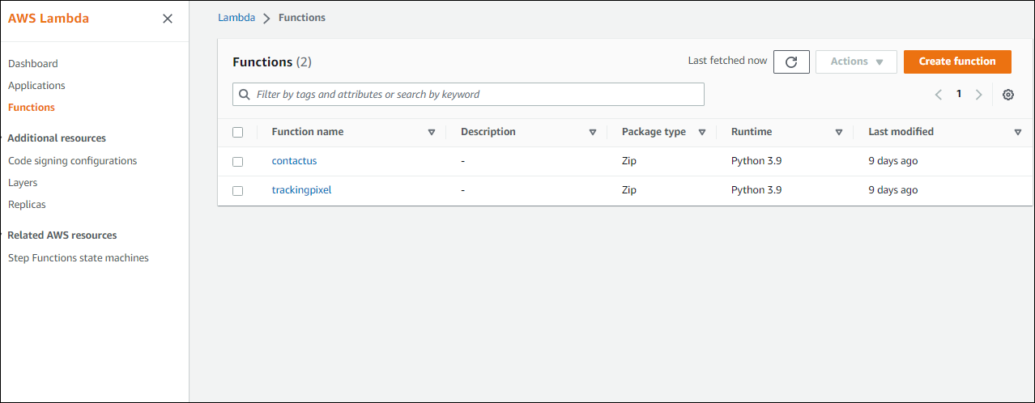
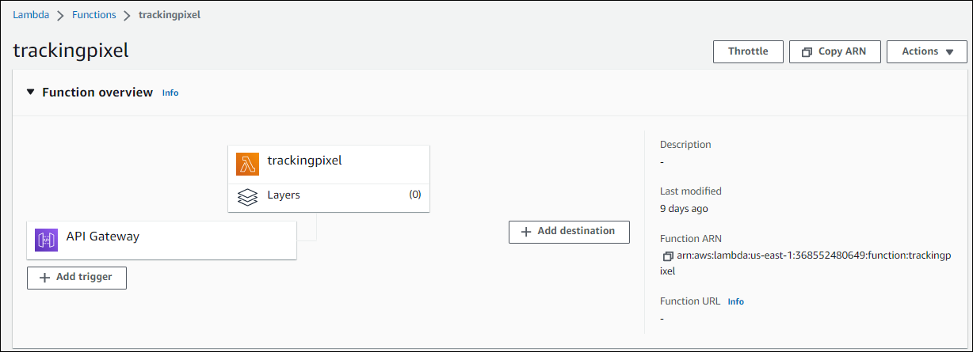
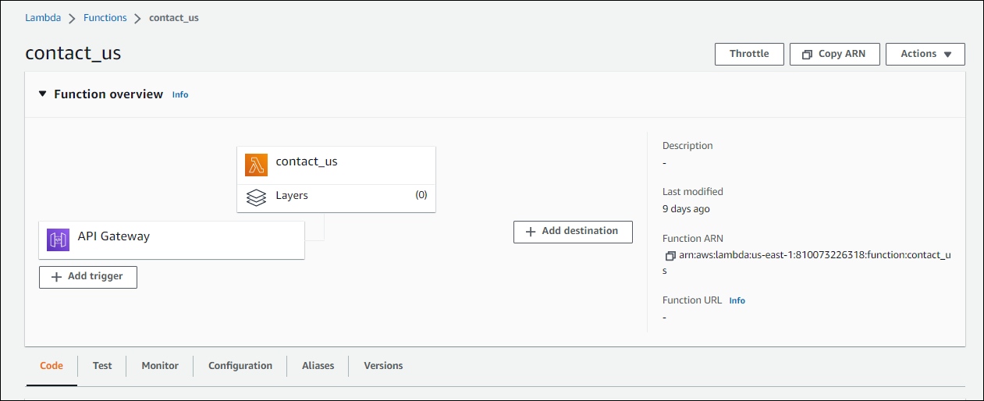

The tracking pixel API gateway will direct us trackingpixel lambda function where the header information is dumped into the firehouse.
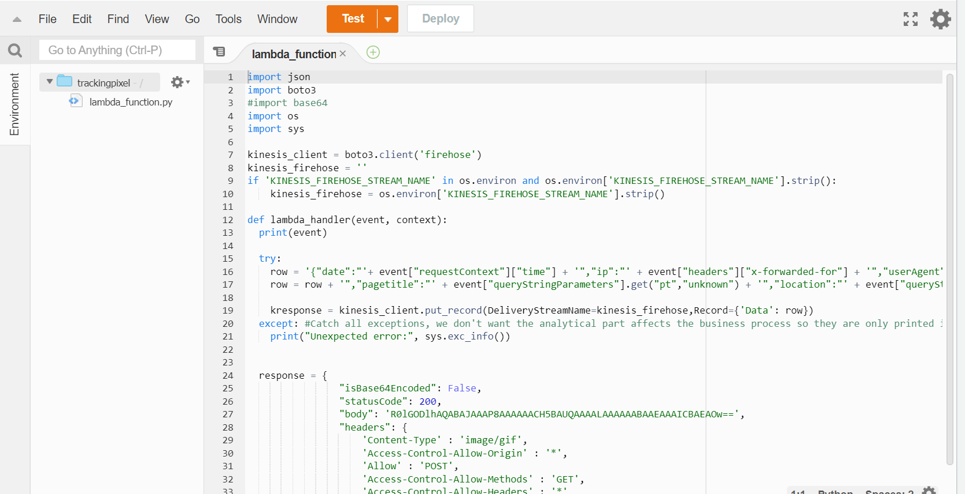

The contact us lambda function will connect to the database and will insert all websitetracking.contactus values from the user.

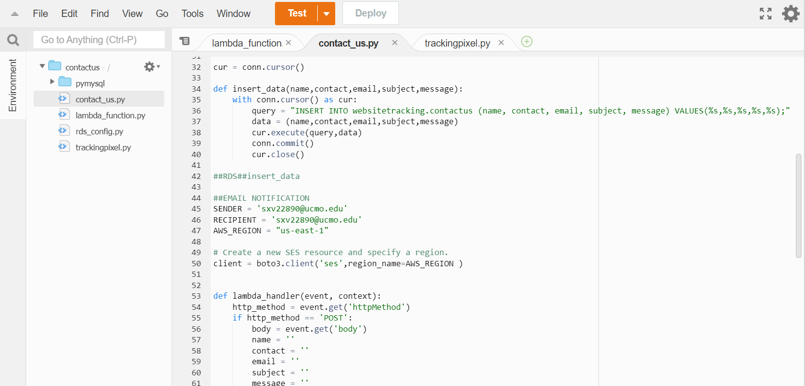

AWS Cloudwatch:
We can monitor your applications, react to changes in system performance, and maximize resource use with the help of Amazon CloudWatch, a monitoring and observability service.
In the form of logs, metrics, and events, CloudWatch gathers monitoring and operational data. Your AWS resources, apps, and services that are running on AWS and on-premises are completely visible to you, and you receive a single view of operational health.
Amazon CloudWatch monitors whatever request landing on API calls are forwarded to the Lambda function.

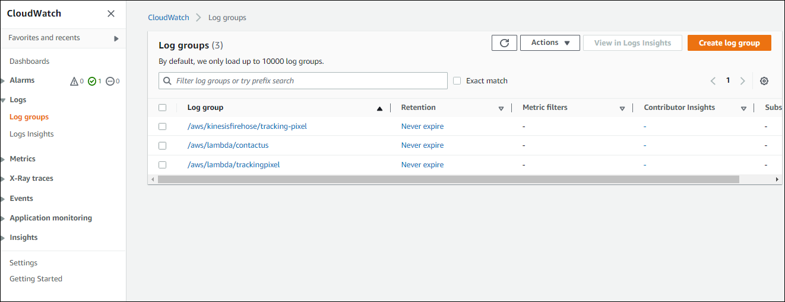
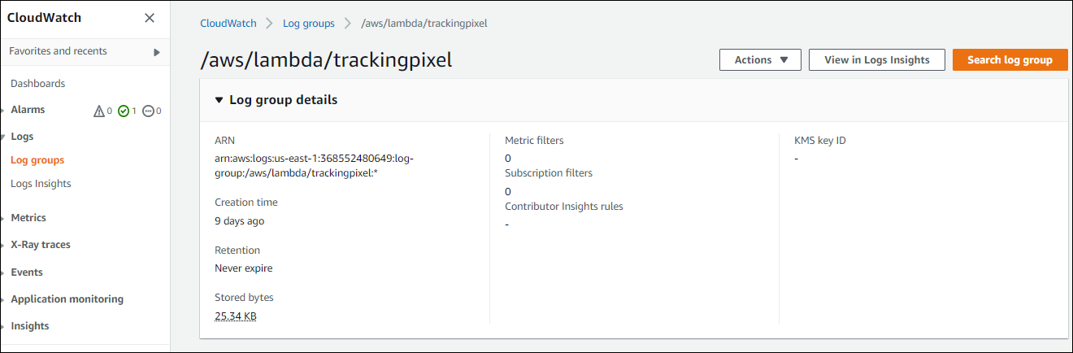

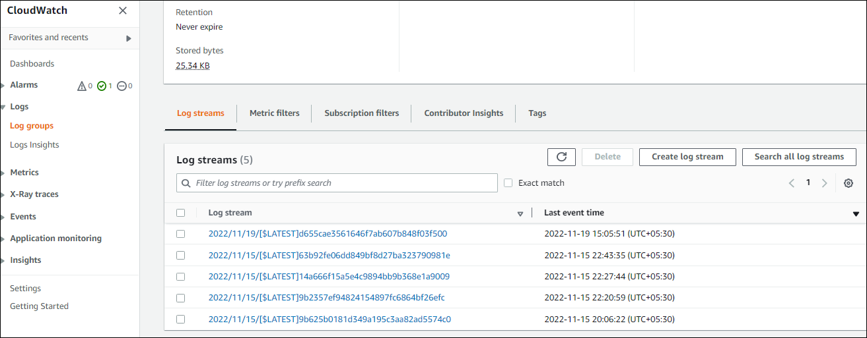
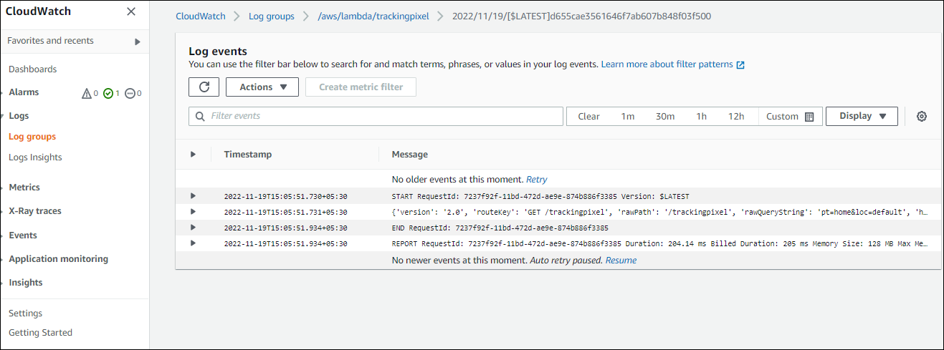
AWS IAM:
AWS Identity and Access Management (IAM) is used to securely manage access to AWS resources.
The following components are part of the IAM workflow:
A principle is a thing that has access to an AWS resource and can act on it. A principal might be a user, a position, or an application.
The process of authenticating the identity of the principal attempting to access an AWS product is known as authentication. For authentication, the principal must present its credentials or necessary keys.
Request: A principal contacts AWS with a request that details the action to be taken and the resources that should carry it out.
Authorization: All resources are automatically barred. IAM only approves a request if all of its components are permitted by matching policies.
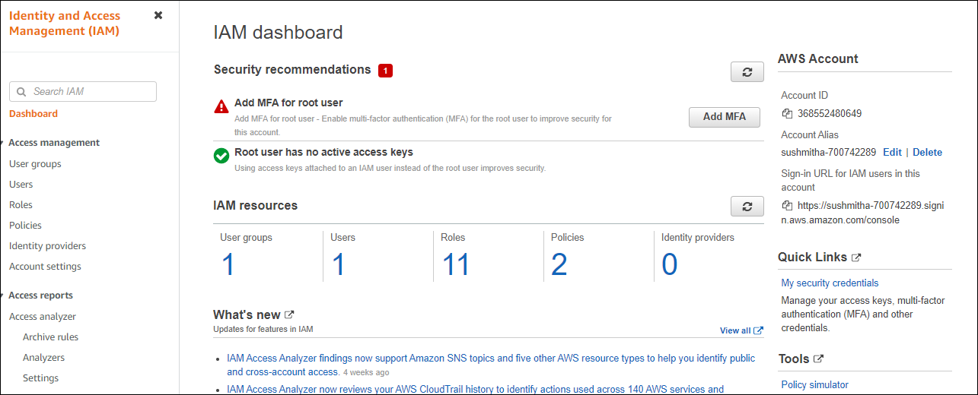
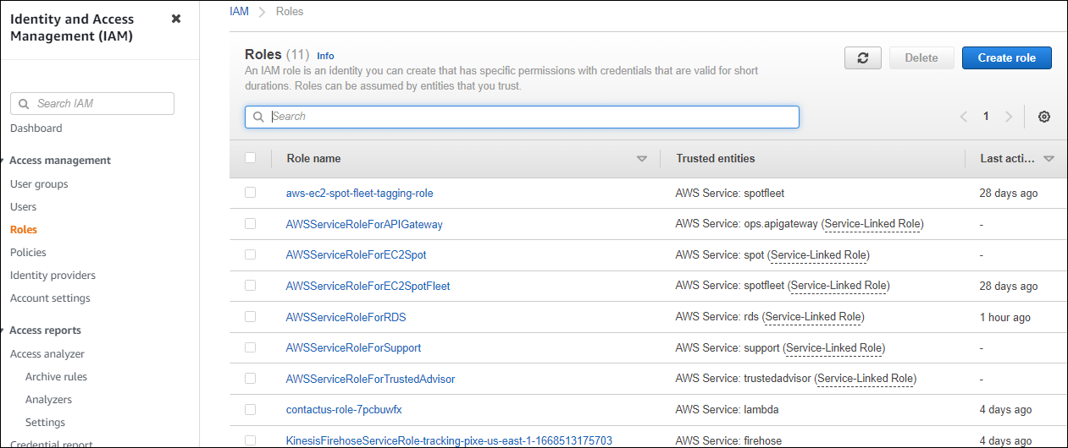

We are using three IAM roles for :
- AWSLambdaExecution Role – to write cloudwatch logs
- AWS SES FullAccess Role – for sending notifications
Amazon Kinesis Firehouse FullAccess – for dumping data into the firehouse
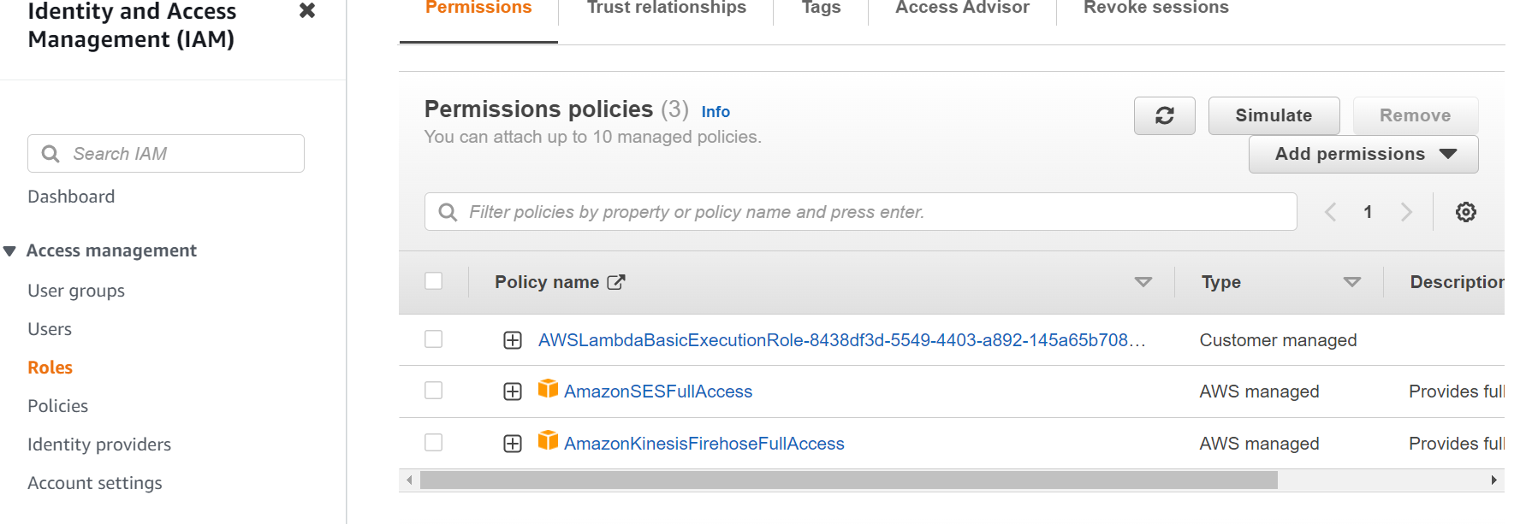

AWS RDS:
A relational database in the cloud may be set up, run, and scaled more easily with the help of Amazon Relational Database Service (Amazon RDS), a web service.
Relational database management is reduced through automation in Amazon RDS.
For high availability and failovers, Amazon RDS creates additional instances.
Oracle, SQL Server, Maria DB, PostgreSQL, MySQL, and Amazon Aurora are all supported by Amazon RDS. Transactional and analytical data are frequently stored in relational databases and benefit from the consistency and dependability that relational databases offer.

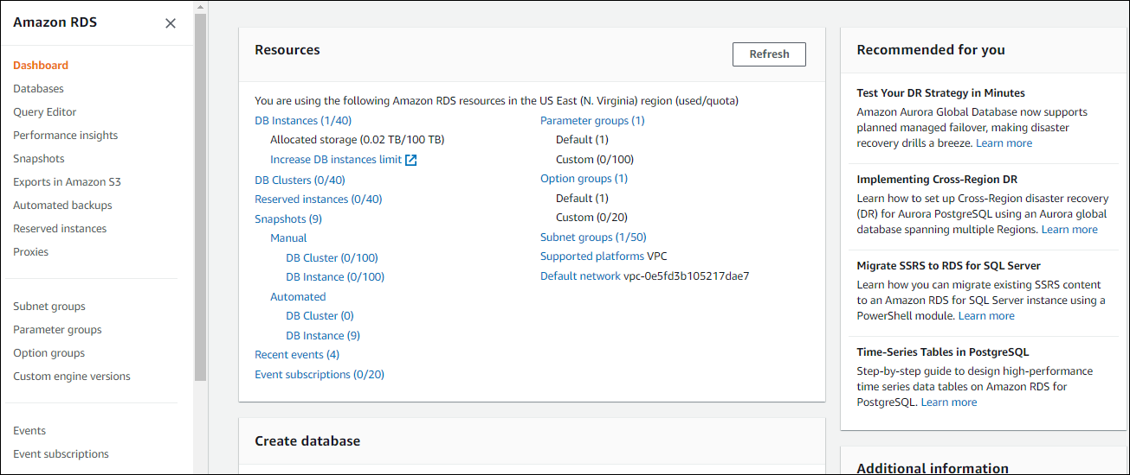

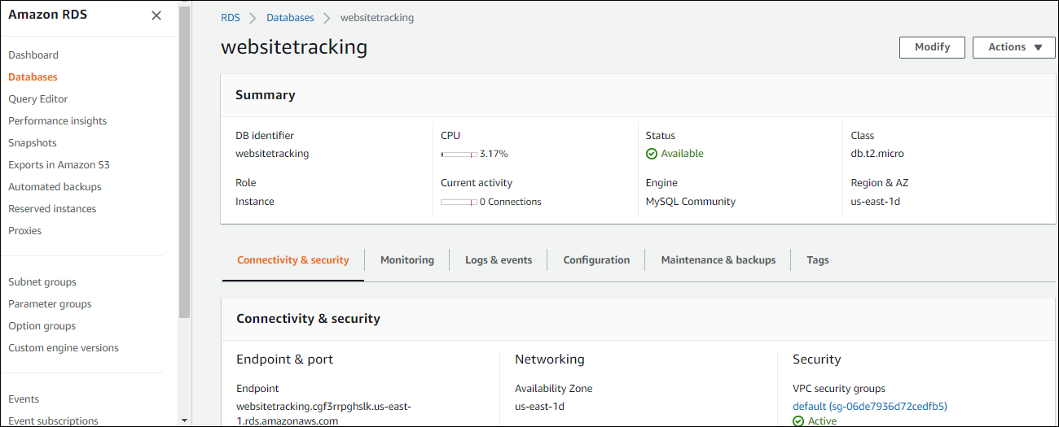

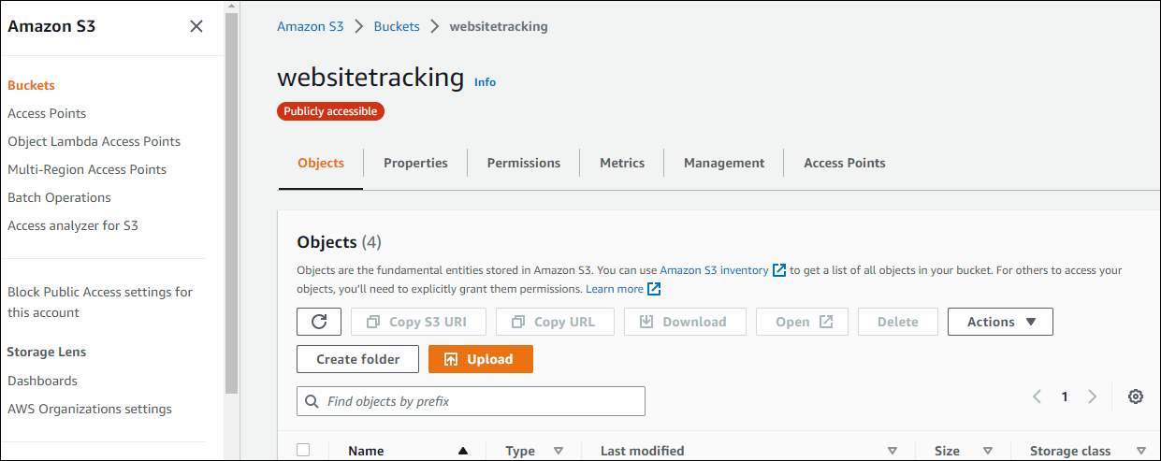

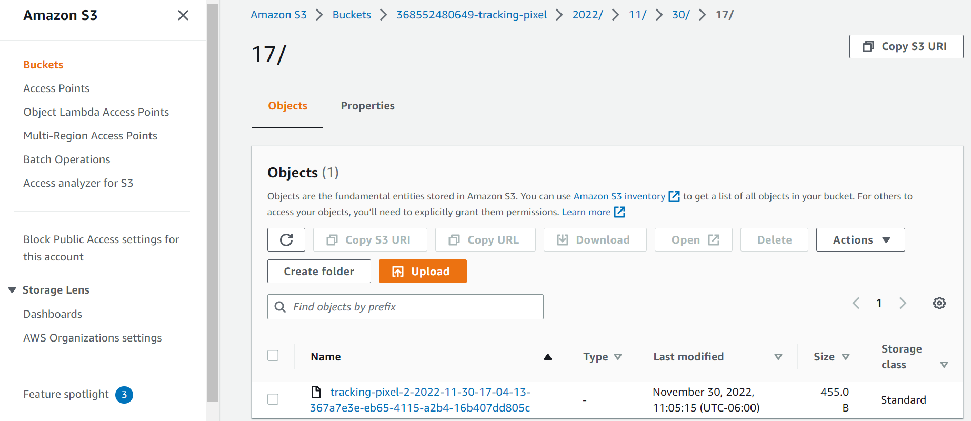

This is the user data fetched:

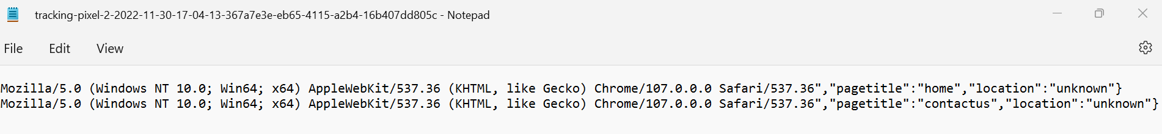
AWS SES:
- A cost-efficient, adaptable, and scalable email service called Amazon Simple Email Service (SES) enables programmers to send email from any application. Several email use cases, such as transactional, marketing, or bulk email communications, can be supported by Amazon SES in a short amount of time.
- The adaptable IP deployment and email authentication options offered by Amazon SES contribute to greater deliverability and the protection of the sender's reputation while sending analytics to gauge the effectiveness of each email. Emails may be sent safely, widely, and efficiently with Amazon SES.
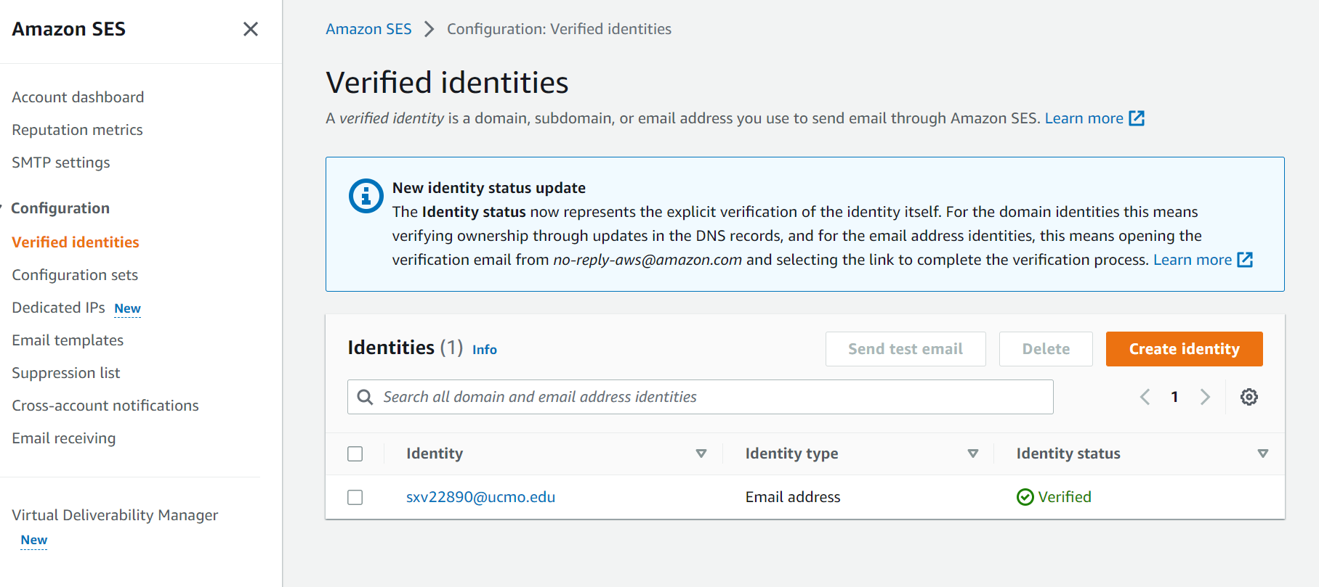
User Interface:



