Project Charter
Date

Project Title: Tourism and Travel Management
Project Start Date: 01-11-2023 Projected Finish Date: 04-24-2023
Budget Information:
Total value of the project - $90000
Cost of the project - $65500
Profit generated in the project - $24500
Project Manager: Sainath Reddy Teneti 6605285170 s555681@nwmissouri.edu

Project Objectives:
- The main goal of the project is to create an application that allows users to manage their travel plans as required.
- To improve efficiency and help save time, cost.
- To provide high quality service and quick response to customers.

Success Criteria:
- Knowledge about accommodations and travel across the globe is needed to build the application, and more teams must be involved in its execution.
- Ensuring customer satisfaction involves providing high-quality products. responding quickly to customer complaints or concerns and creating positive customer experiences.
- Increasing the number of bookings or visitors
- Success also depends on engaged and motivated employees who deliver excellent customer service.

Approach:
The target is to finish the project without any client escalations within the estimated cost and timeline. We design and implement a user-friendly application for reserving a ticket to specific areas, and it also recommends the top tourist destinations. Users have the option to filter the pricing from high to low or from low to high.

Roles and Responsibilities
Name and Signature | Role | Position | Contact Information
Sushmitha Yelamakonda | Project Lead | Scrum Master / Business Analyst | S555058@nwmissouri.edu
Sainath Reddy Teneti | Project Manager | Project Manager / Program Manager | S556186@nwmissouri.edu
Adithya Varaprasad Muppala | Team Member | Stack Holder / Full Stack developer | S555485@nwmissouri.edu
Ramu Unnava | Team Member | Web Application Developer | S554813@nwmissouri.edu
Naga Manikanta Chigurupati | Team Member | Client / Tester | S555681@nwmissouri.edu
Mohan Varasiddi Sai Potti | Team Member | Stack Holder / DB Administrator | S554815@nwmissouri.edu
Raja Shree Bokka | Team Member | Designer / Web Application Developer | SS556127@nwmissouri.edu
Comments:
Expecting application to be easy-to-use, comprehensive, and customizable travel management application that provides connectivity to various travel-related services while prioritizing data privacy. Will let you know if there is any change in the requirements and in the quality of project.

SIGNATURES:

1.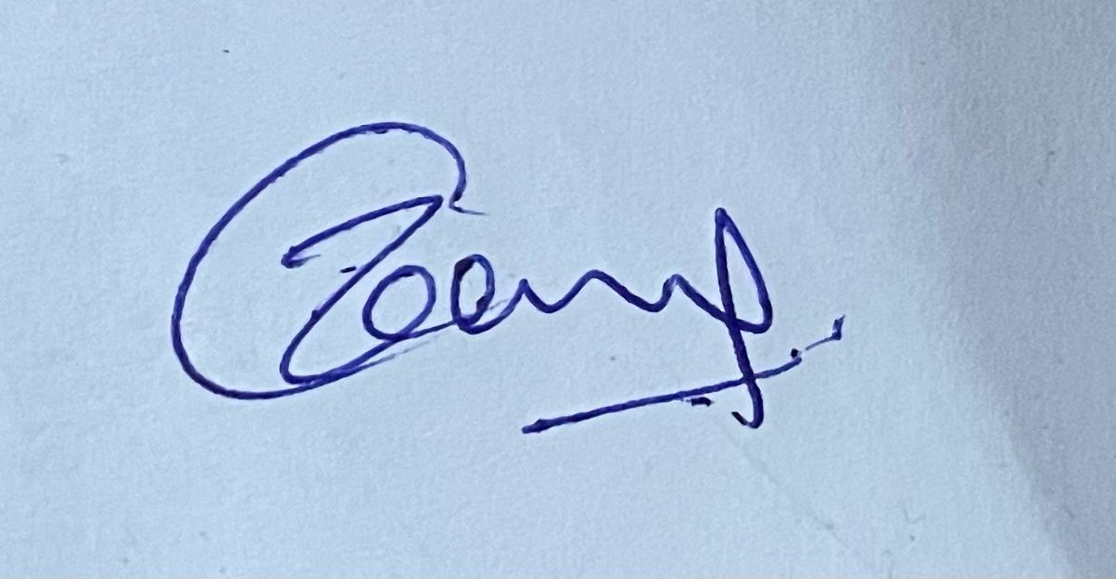

2. 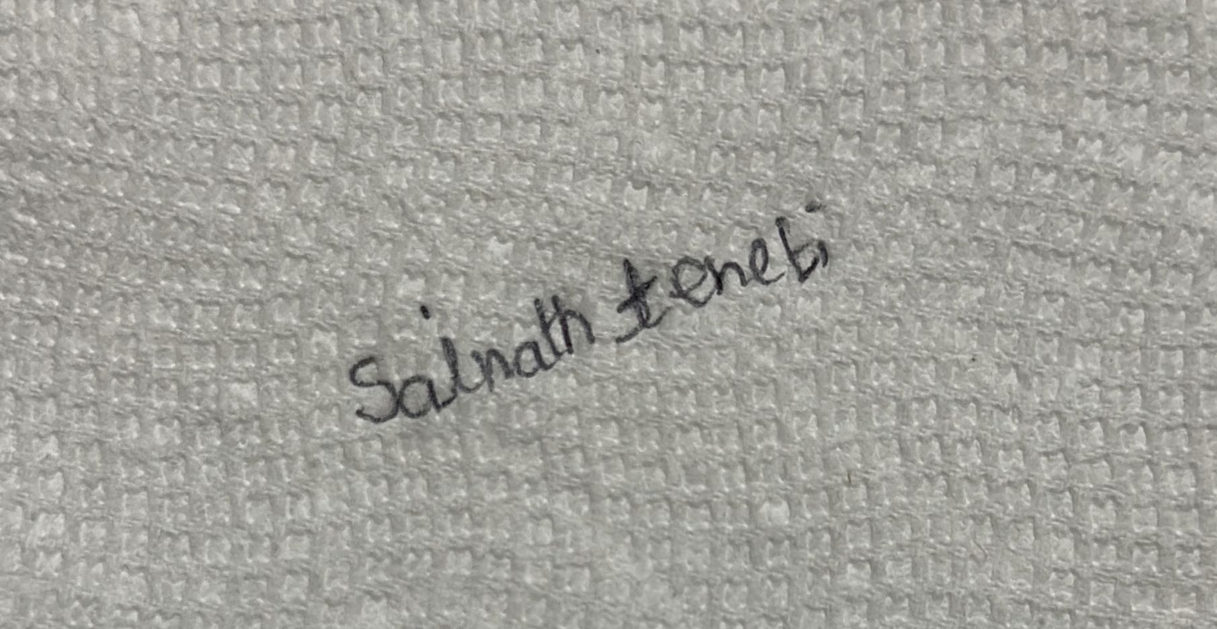

3.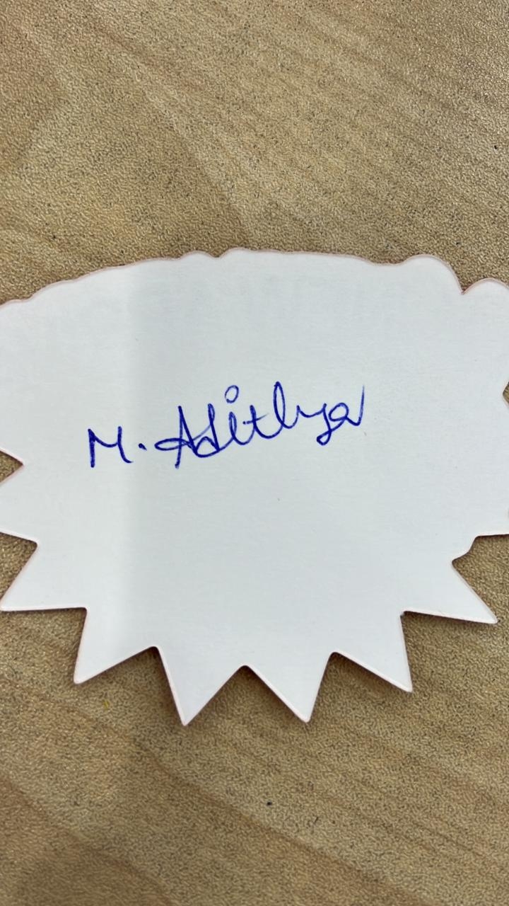

4. 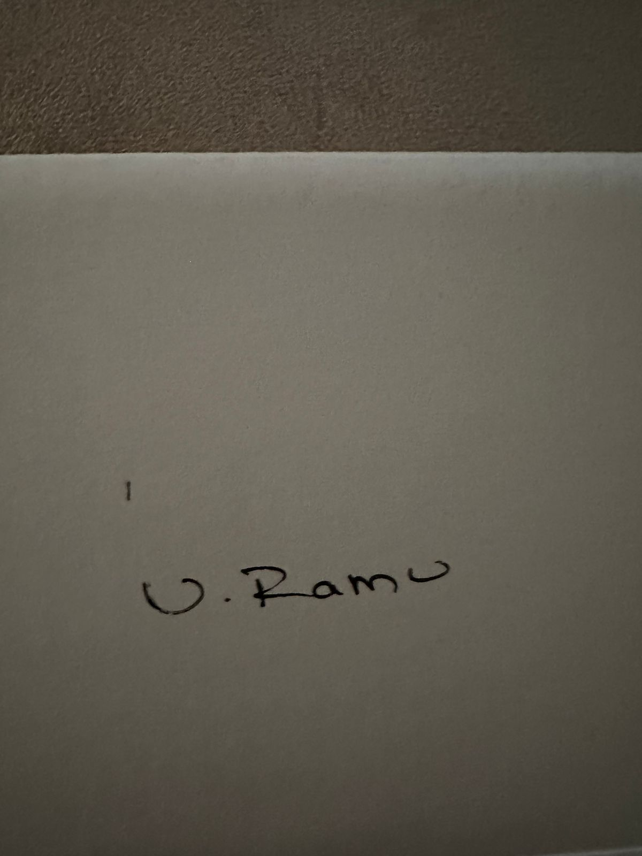

5. 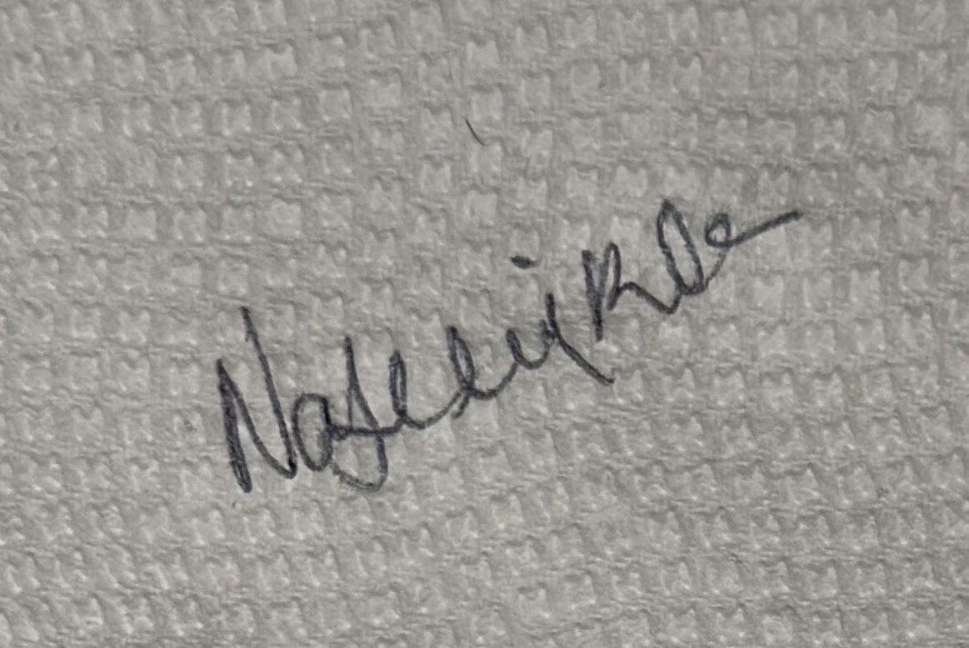

6. 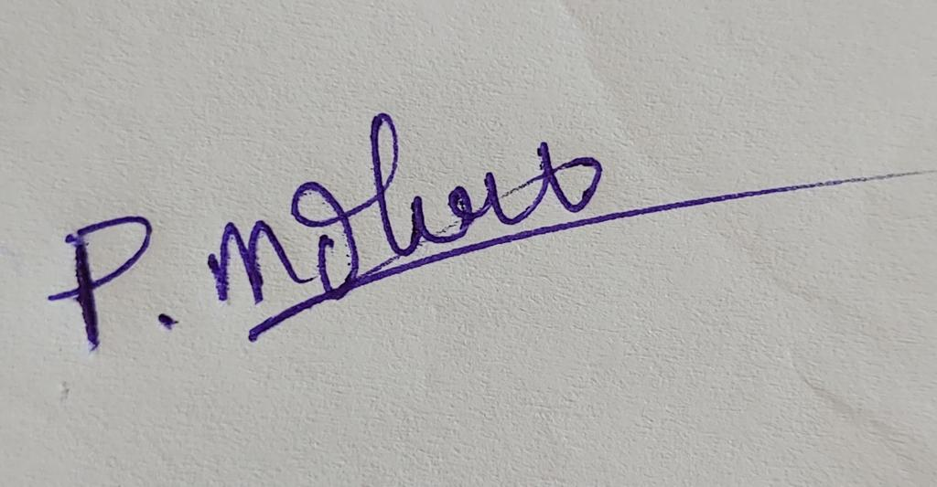

7. 