LAB ACTION PLAN FOR WEEK 10

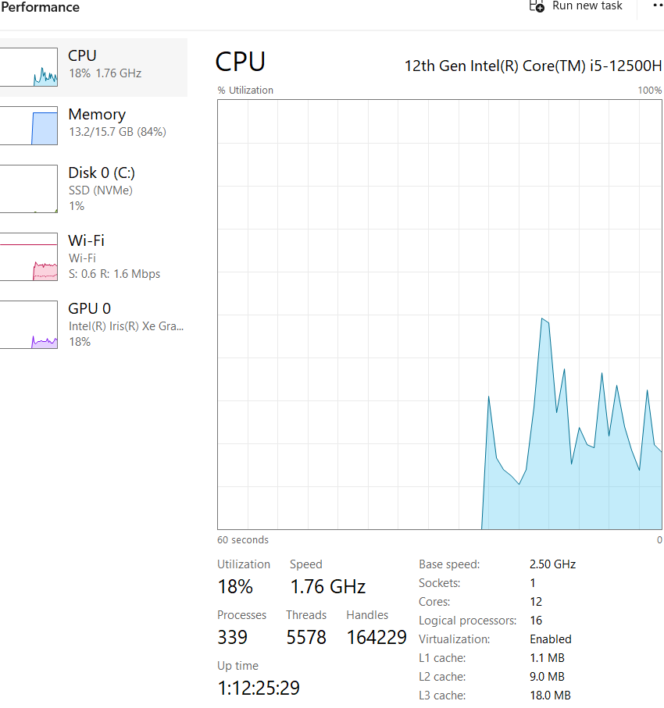
- Open a terminal (PowerShell or CMD). Do the following commands
- Start Minikube with a specified driver (e.g., Hyper-V, Docker, or VirtualBox). For example:
  - Hyper-V:
  - minikube start --driver=hyperv
  - Docker:
  - minikube start --driver=docker
  - 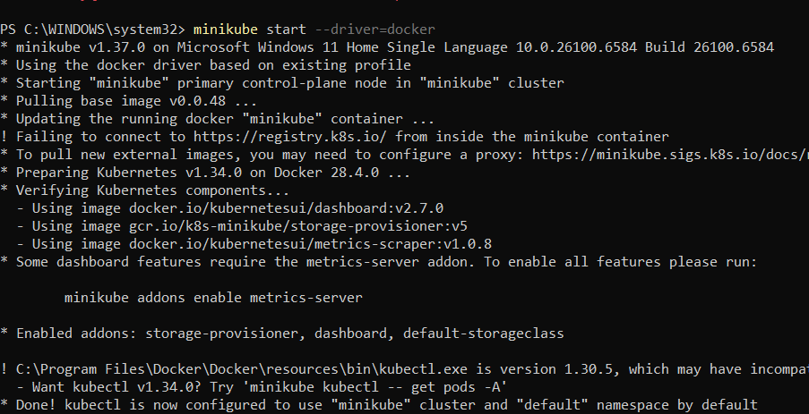
- Verify Minikube is running:
- minikube status
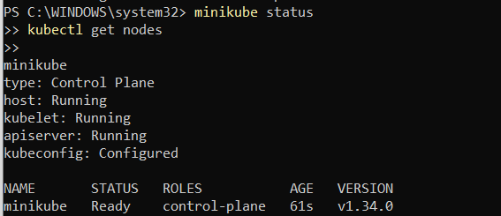

Step 5: Interact with Minikube

kubectl is a command-line tool used in Kubernetes to interact with and manage Kubernetes clusters.
Once Minikube is running:
- Use kubectl to interact with the cluster.
  - Install kubectl if not already installed:
  - minikube kubectl -- get pods -A
  - Or download it separately from the official Kubernetes site.
- Open the Minikube dashboard (optional):
- minikube dashboard

Optional: Check Your Installation
Run the following to verify the installation:
Minikube version
kubectl version --client
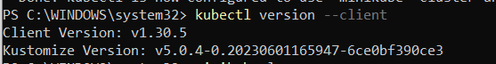

Troubleshooting
- If Minikube fails to start:
  - Ensure your hypervisor (Hyper-V/Docker/VirtualBox) is installed and running.
  - Check the Minikube logs:
  - minikube logs
  - 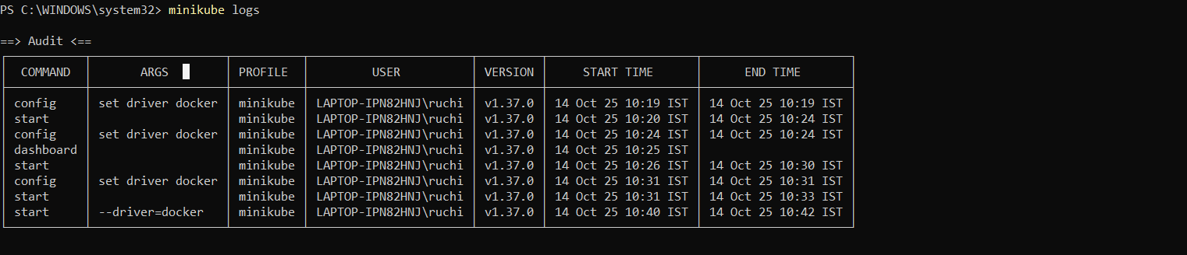

- Updating Minikube:
- minikube update-check
- 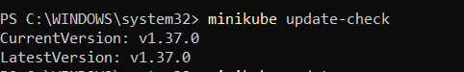
- minikube update

Minikube Automation Steps

Step 1: Start Minikube Cluster
- Open your terminal and run the command:
minikube start
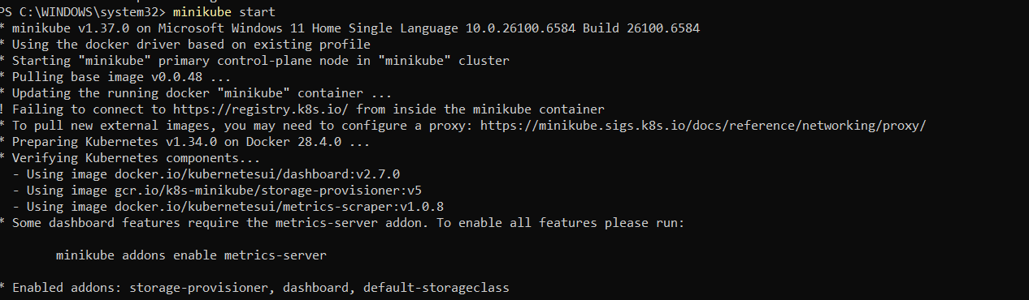

Step 2: Create and Manage Deployment
- Create an application in Kubernetes:
  - Command:
kubectl create deployment mynginx --image=nginx

if already created then
kubectl set image deployment/myngnix nginx=nginx:latest
  - Verify the deployment using: Kubernetes responds by showing you a list that includes the names of your deployment groups
kubectl get deployments
    - Ensure mynginx appears in the output.
Check the following commands:
  - kubectl get pods
  - kubectl describe pods
  - 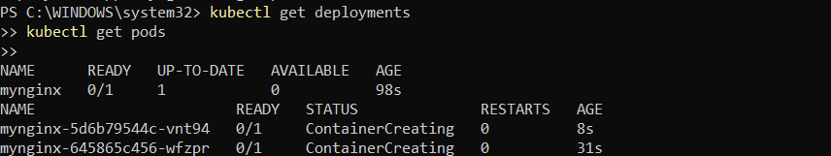
- Expose Deployment as a Service:
  - Command:
kubectl expose deployment mynginx --type=NodePort --port=80 --target-port=80

Step 3: Scale the Deployment
Command:Scales the Nginx deployment to 4 replicas (pods).
kubectl scale deployment mynginx --replicas=4

kubectl get service myngnix

Step 4: Access the Nginx App
- Using Port Forwarding:
  - Command:
kubectl port-forward svc/mynginx 8081:80

    - Access the app via http://localhost:8081.
If Error, use this option, Using Minikube Tunnel:
  - Start the tunnel:
minikube tunnel
  - Retrieve the service URL:
minikube service mynginx --url
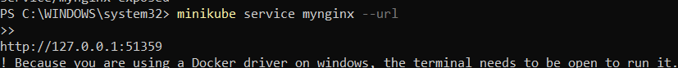
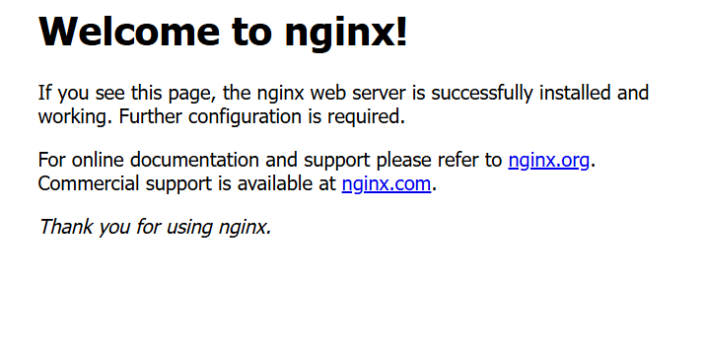
  - Open the provided URL in your browser.
  - Open the kubernets dashboard
- Open the minikube dashboard
Minikube dashboard

Step 5: Stop and Clean Up
- Stop Nginx Deployment:
  - Commands:
kubectl delete deployment mynginx
kubectl delete service mynginx
- Stop Minikube (Optional):
  - Command:
minikube stop
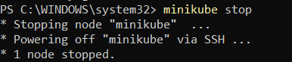
- Delete Minikube Cluster (Optional):
  - Command:minikube delete

Nagios Automation Steps

Step 1: Pull the Nagios Docker Image
- Open a terminal and run:
docker pull jasonrivers/nagios:latest
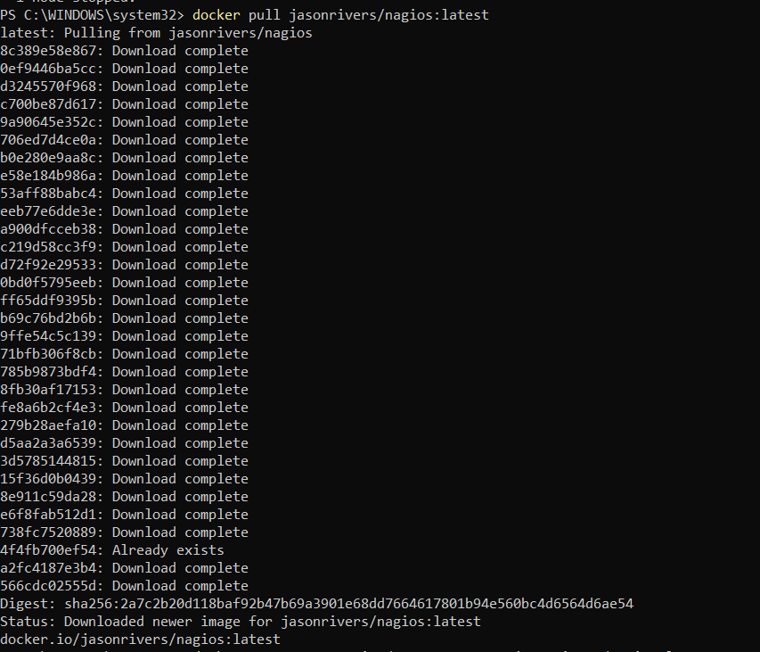

Step 2: Run Nagios
- Command:
docker run --name nagiosdemo -p 8888:80 jasonrivers/nagios:latest
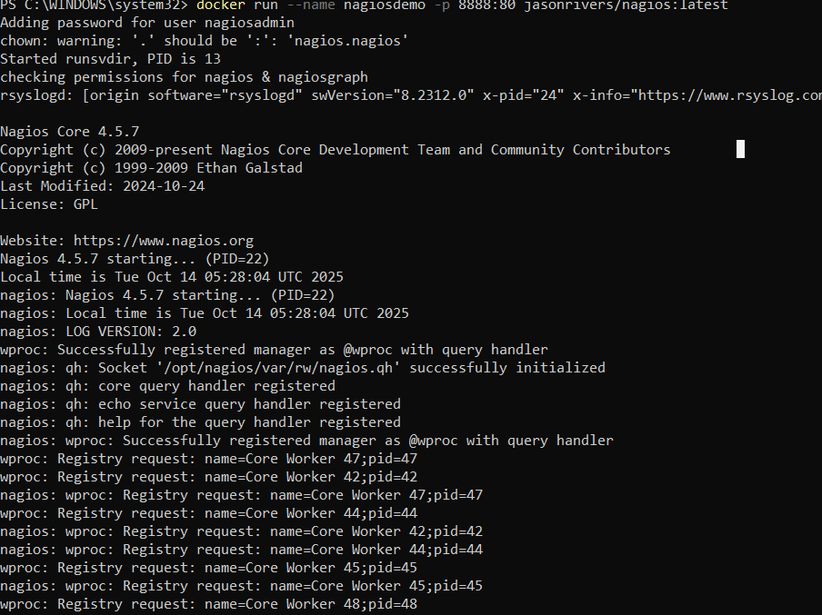

Step 3: Access Nagios Dashboard
- Open your browser and navigate to:
http://localhost:8888
  - Login Credentials:
    - Username: nagiosadmin
    - Password: nagios
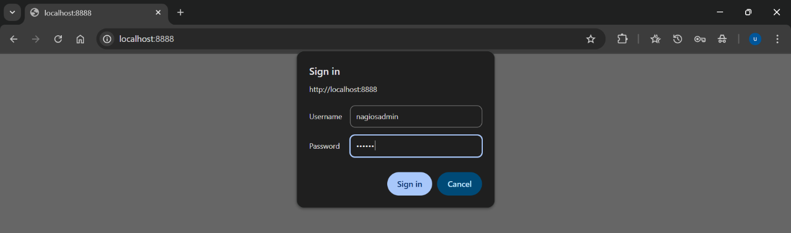
    - 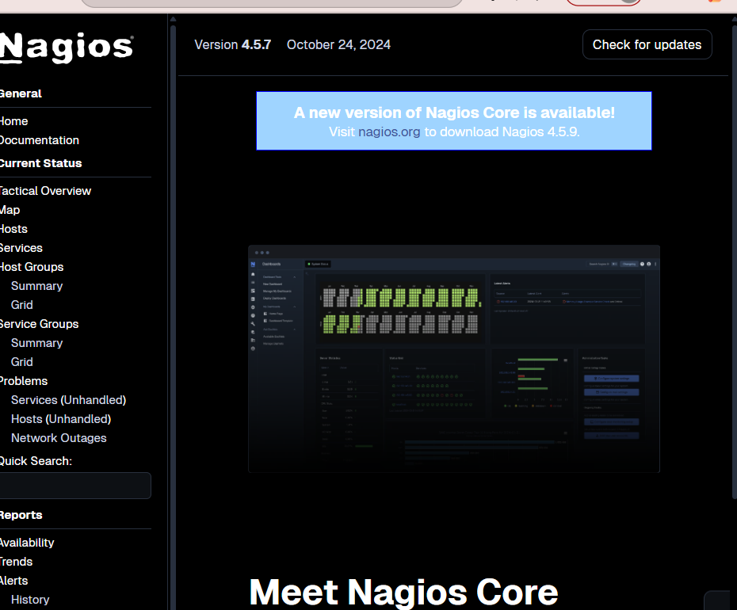
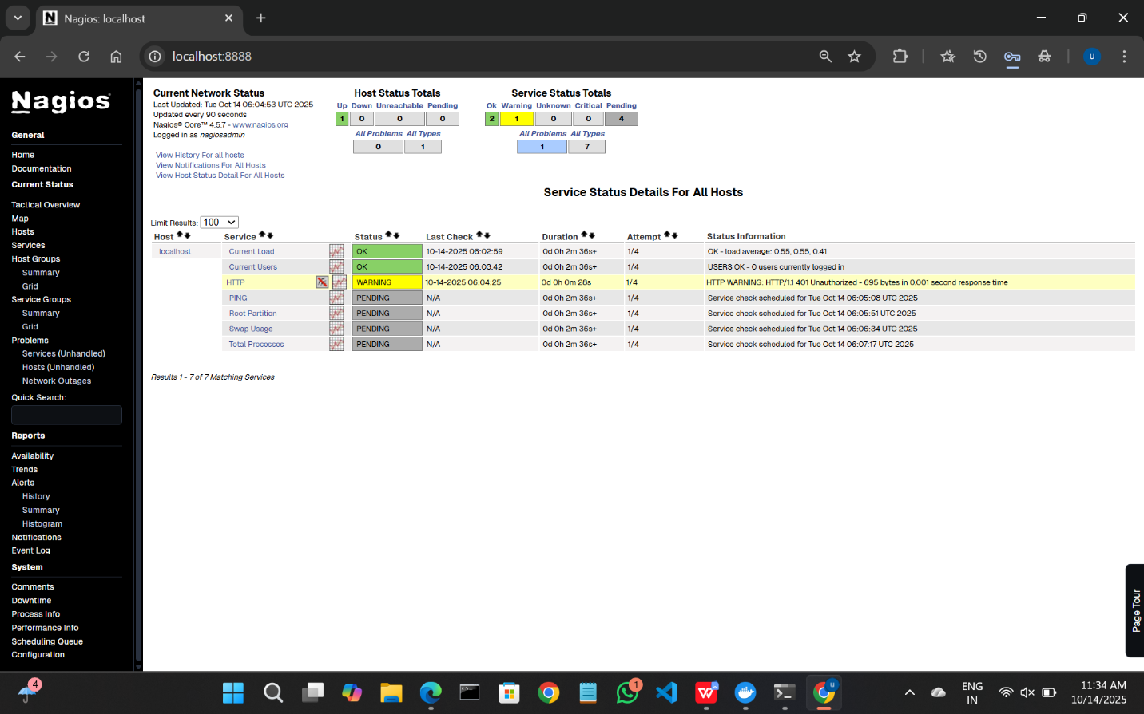
  - Once logged in, explore:
    - Hosts: View systems being monitored.
    - Services: Check tasks being monitored (e.g., CPU usage).
    - Alerts: Access recent notifications.
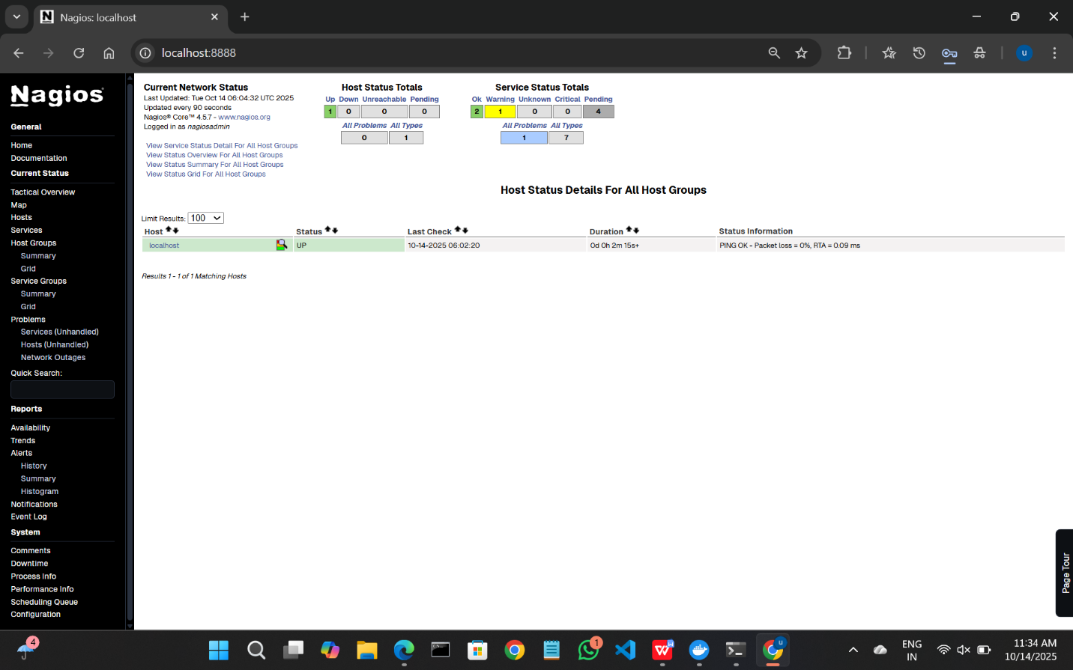

Step 4: Monitoring Host Details
- Navigate to the Host Information Page:
  - Select a host from the Hosts menu.
- Key Details:
  - Host Status: Indicates if the system is UP or DOWN.
  - Metrics: View CPU usage, memory status, and network activity.
  - Actions: Reschedule checks, disable notifications, or schedule downtime.

Step 5: Stop and Remove Nagios
- Stop the Container:
  - Command:
docker stop nagiosdemo
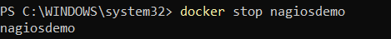
- Delete the Container:
  - Command:
docker rm nagiosdemo
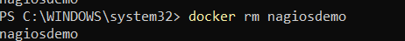
- Remove the Image (Optional):
  - List images:
docker images

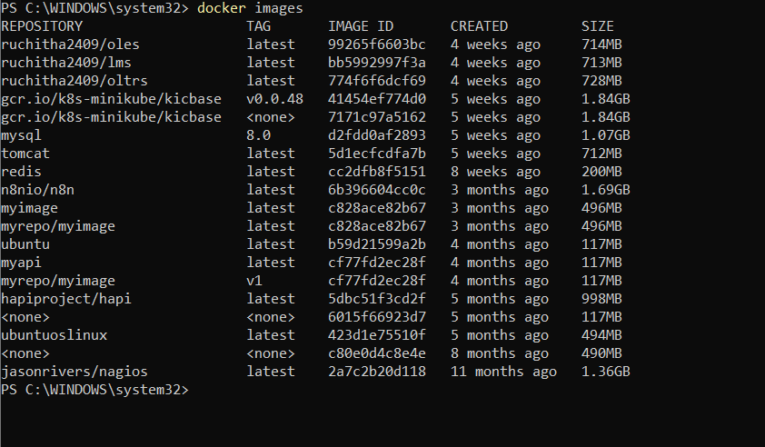
  - Delete the Nagios image:
docker rmijasonrivers/nagios:latest

- Observe the docker containers in DockerHub, we can see the latest Nagios Installed running on port:8888

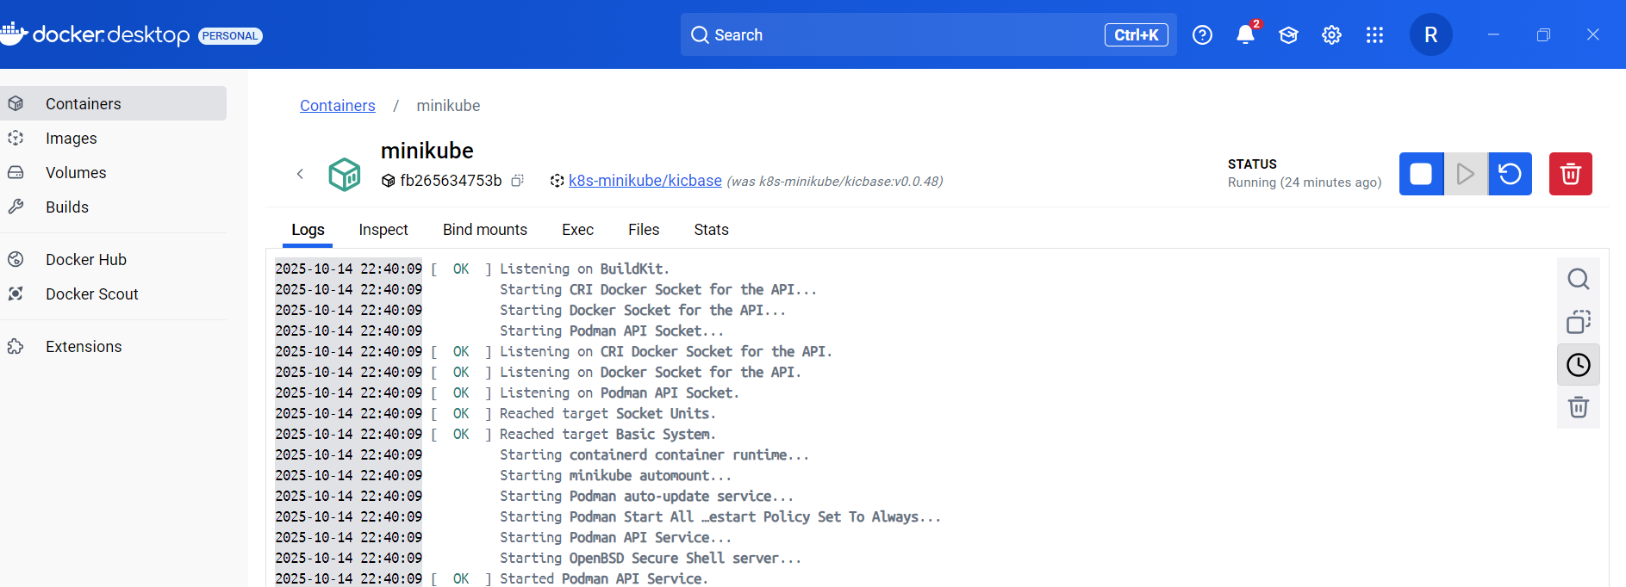

SBQ: Kubernetes & Nagios

1. Your Pod keeps restarting repeatedly. What will you do?
Check the pod status and events:
kubectl describe pod <pod-name>
kubectl get pod <pod-name> -o wide
View container logs:
kubectl logs <pod-name>
Possible issues:
Application crash or runtime error
Failed liveness probe
Missing configuration or environment variables
OOMKilled (out of memory)

2. A Kubernetes pod is stuck in a "Pending" state. What could be the possible reasons, and how would you troubleshoot it?
kubectl describe pod <pod-name>
kubectl get events
kubectl get nodes
kubectl describe node <node-name>

3. How would you debug a failed deployment in Kubernetes?
kubectl get deployments
kubectl describe deployment <deployment-name>
kubectl get pods -l app=<label>
kubectl logs <pod-name>
Check for:
ImagePull errors
Failed probes
Misconfigured environment variables

4. You have a Kubernetes Deployment with multiple replicas, and some pods are failing health checks. How would you identify the root cause and fix it?
Check pod status and logs:
kubectl get pods
kubectl describe pod <pod-name>
kubectl logs <pod-name>

5. How do you roll back a faulty deployment?
kubectl rollout undo deployment/<deployment-name>
kubectl rollout status deployment/<deployment-name>
kubectl rollout history deployment/<deployment-name>

6. How do you debug a running Pod?
kubectl logs <pod-name>
kubectl logs -f <pod-name>
kubectl exec -it <pod-name> -- /bin/bash

7. You need to expose a local service externally. How to do it?
kubectl expose deployment <deployment-name> --type=NodePort --port=<port>
kubectl get svc
minikube service <service-name>

8. How to start and stop Nagios
Commands (Windows PowerShell):
Start-Service nagios # Start Nagios
Stop-Service nagios # Stop Nagios
Restart-Service nagios # Restart Nagios
Get-Service nagios # Check Nagios status

9. You installed Nagios but the web interface shows “Unable to connect to Nagios process”. How to resolve this?
Check and restart the Nagios service:
Get-Service nagios
Restart-Service nagios
If on Linux:
sudo systemctl status nagios
sudo systemctl restart nagios

10. You added a new host in Nagios, but it’s not appearing on the web interface. How to check?
Verify Nagios configuration:
sudo /usr/local/nagios/bin/nagios -v /usr/local/nagios/etc/nagios.cfg
If no errors, restart Nagios:
Restart-Service nagios

11. How can you check whether Nagios is running properly?
Get-Service nagios

12. How do you view Nagios logs in real-time?
Windows:
Get-Content "C:\Nagios\var\nagios.log" -Wait

13. What are the advantages of using Nagios?
Monitors hosts, services, and network devices in real-time
Sends alerts via email/SMS when issues occur
Scalable and extensible through plugins
Tracks uptime, performance, and availability
Open-source and widely supported
Provides web-based dashboards for easy monitoring

