**Common Operations in the Software:**

Close Click the button to close the Form.

http://localhost:9090/pred/help/Help%20For%20PRED_files/image004.gif  Click the button for online context help.

          Home Click the button for Main Page.

          Back   Click the button for previous page.

          Print    Click the button for Printable Version.

          Excel   Click the button for Excel Version.

#### Mobile - >Mobile Entry- >Tanker Volunteer Mapping Form

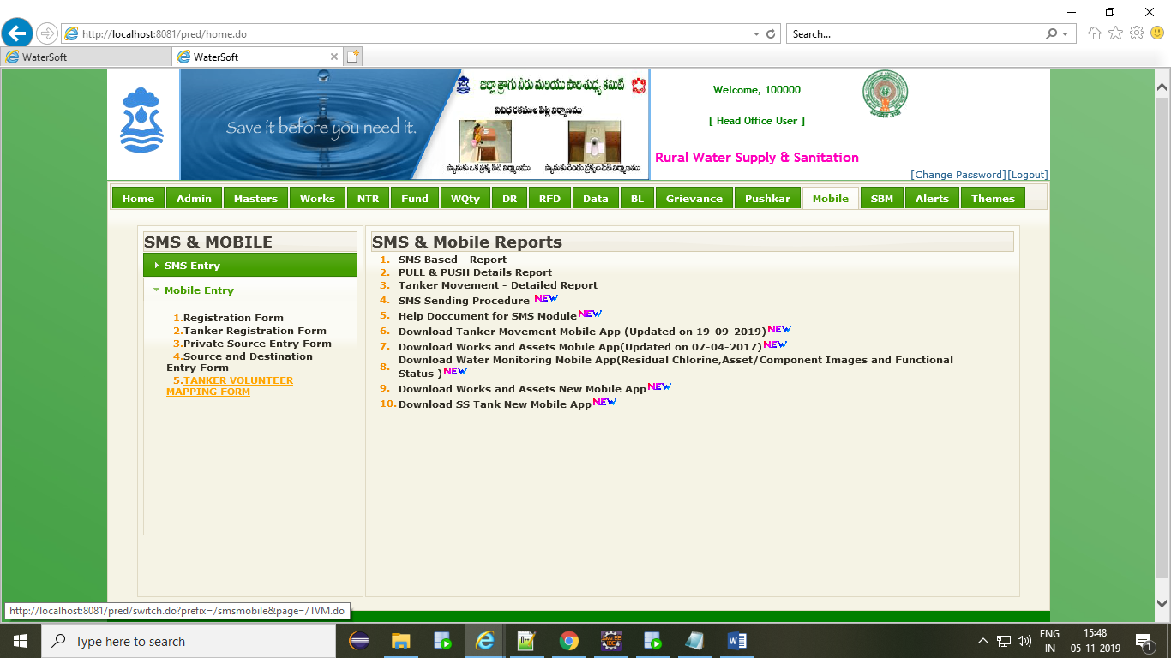

### Tanker Volunteer Mapping

* Select District (Fixed For District user).
* Select Mandal.
* Select Panchayat.
* Select Village.
* Select Habitation.
* Select Volunteer.
* Check the Tankers
* Click ‘Save’ Button.

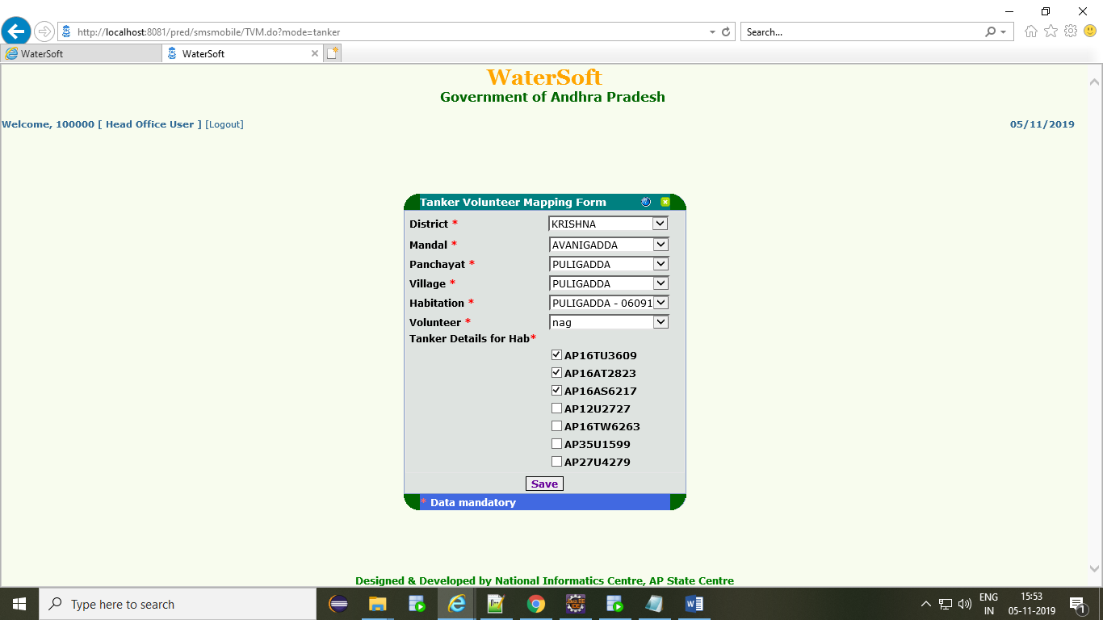

### To View Mapped Tankers

* Select District (Fixed For District user).
* Select Mandal.
* Click ‘View’ button.

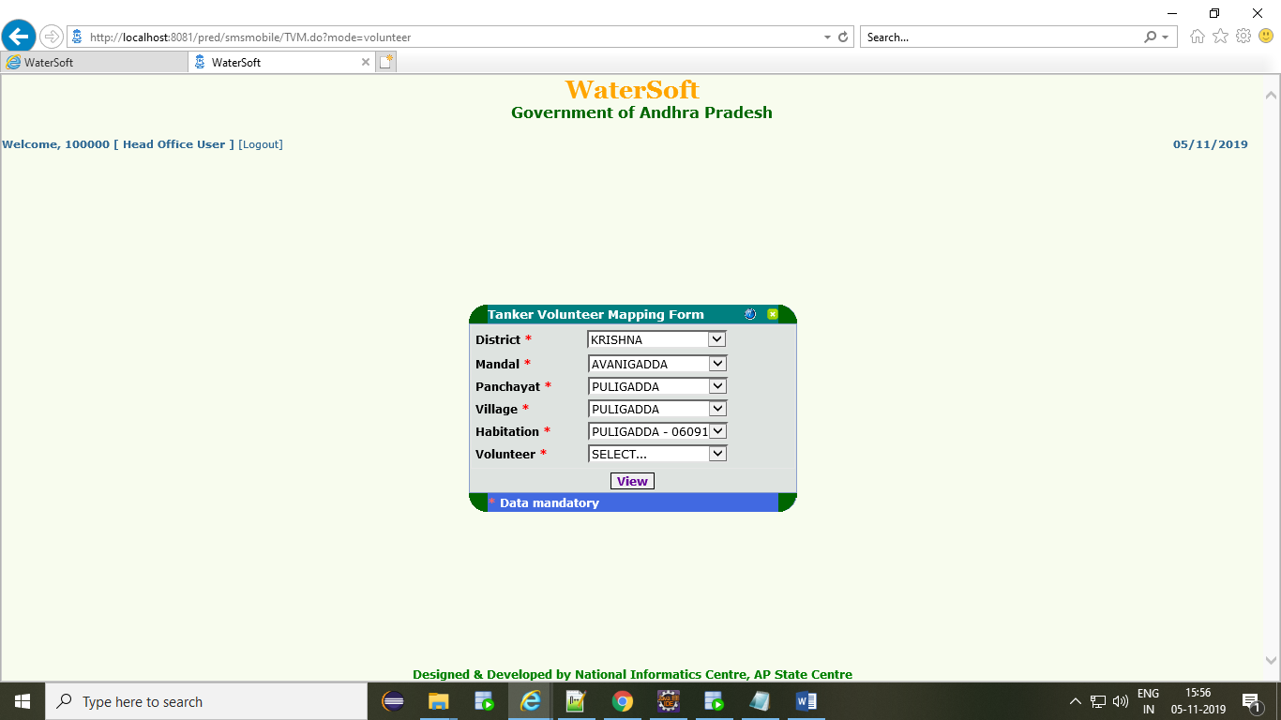

### To View Mapped Tankers

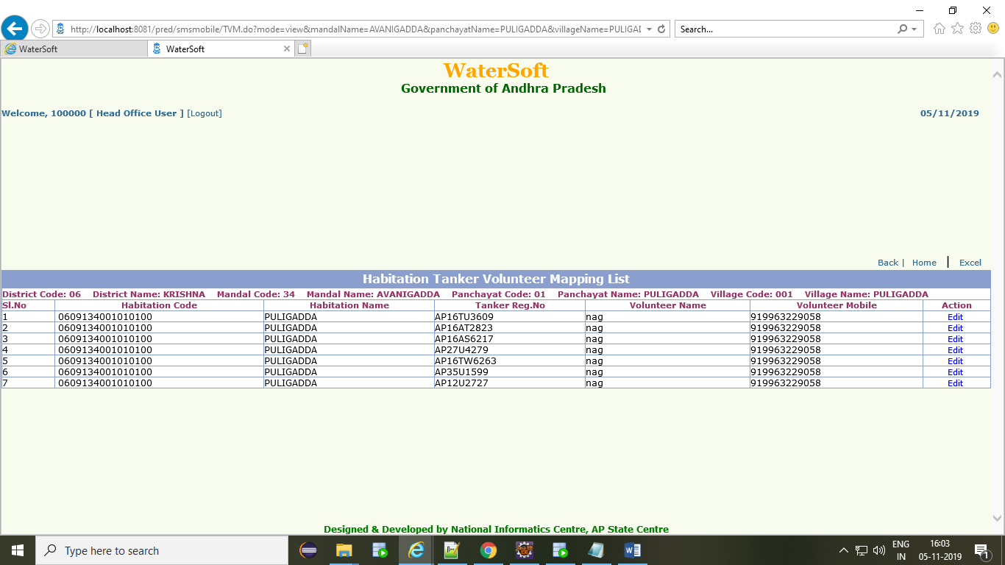

### To Update Mapped Tankers

* Check The Check boxes, How Many Records We Want To Update
* Click ‘Save’ Button.

