USER MANUAL FOR ADMINISTRATIVE SANCTION

WaterSoft

(For the Department of Rural Water Supply Sector and Sanitation, Govt. of AP)

National Informatics Centre
Department of Information Technology
Ministry of Communications and Information Technology
Government of India
WebSite : www.ap.nic.in

PREPARED BY :

PROJECT TEAM ,
APDVIII, NIC APSC,
HYDERABAD.

REVIEWED BY:

HEAD OF THE DEPARTMENT,
APDVIII, NIC APSC,
HYDERABAD.

APPROVED BY :

STATE INFORMATICS OFFICER
NIC APSC,
HYDERABAD.

Amendment Log

Version Number | Date | Change Number | Brief Description | Sections Changed
2.1 | 20.06.2011 | - | Twelveth  Release | Change in Administrative Sanction Form Labs and Schools are added  Based upon User requirements

Sl No | CONTENTS | Page No
1 | Common Operations in the Software | 5
2 | Administrative Sanction | 6 – 18

Common Operations in the Software:

Click the button to close the Form.

 Click the button for online context help.

Home Click the button for Main Page.

Back Click the button for Previous page.

Print Click the button for Printable Version.

Excel Click the button for Excel Version.

Note : Amount is to be considered in Rs lakhs

Note I:- Depending on login Circle is Fixed . Fields marked with ‘ * ’ are Mandatory Fields.

Amount Should be entered in Rs. Lakhs in Administrative sanction Form

WorkFlow - > Works Monitoring - > Administrative Sanction

Administrative Sanction

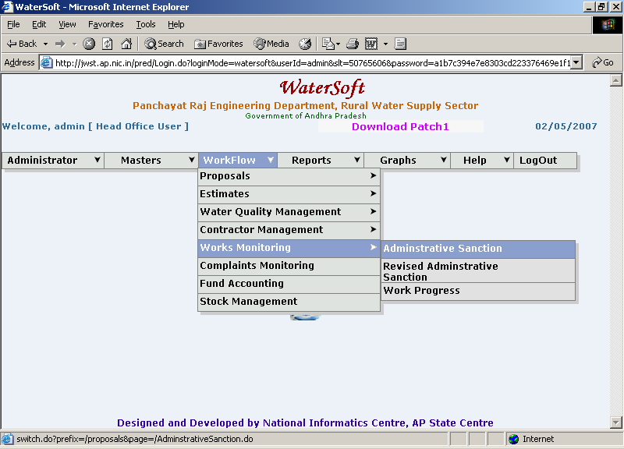
Figure. 1

Administrative Sanction

Basic operations for View /Save

- Head Office is fixed .
- Select Plan or Non – Plan ( default option is plan)
- Select Work Category ( For Eg. Normal ,District Level , Projects )
- Select Scheme . ( For Eg. Pws , Sustainability , Lab and Schools etc., ).
- Select Main Stream , Augmentation( Default is Main Scheme).
- Select Maintenance ( For Non-Plan ).
- Select Programme.
- Select Sub Programme.
- Select Circle (fixed based on Login).
- Select Division.
- Select Sub Division (Optional)
- Select Approved Under (For Eg. Normal Coverage, Submission - Water Quality, Sustainability)

1: Work Category Selected as Projects

Scheme : CPWS is displayed in Selection combo

2: Work Category Selected as Normal
- If type is Plan:
Scheme: PWS, SUSTAINABILITY and SCHOOLS is displayed in
Selection combo
- If type is Non - Plan:
Scheme: PWS, SUSTAINABILITY AND LAB is displayed in
Selection combo

3: Work Category Selected as DISTRICT LEVEL

Scheme: PWS, HANDPUMPS, OPEN WELLS AND SCHOOLS is displayed in Selection combo

Scheme selected as Lab the following Screen shot( Figure 2.1 ) is displayed
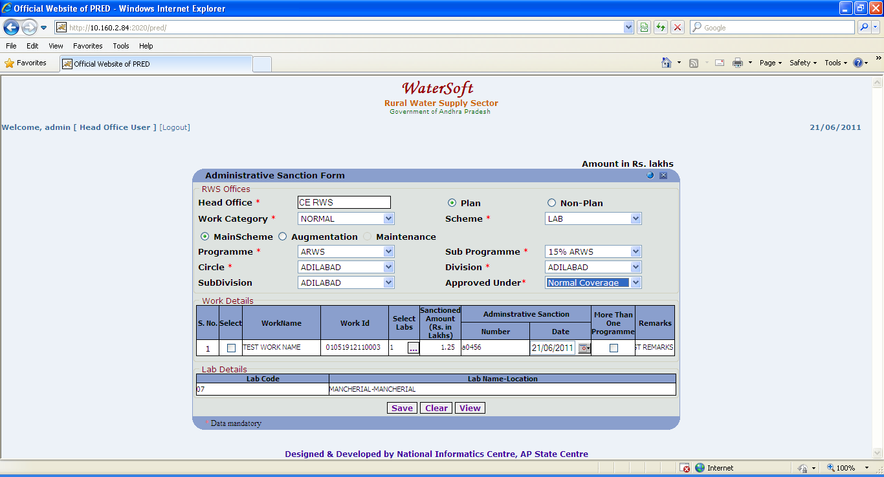
Figure 2.1

Scheme selected as School the following Screen Shot ( Figure 2.2 is displayed

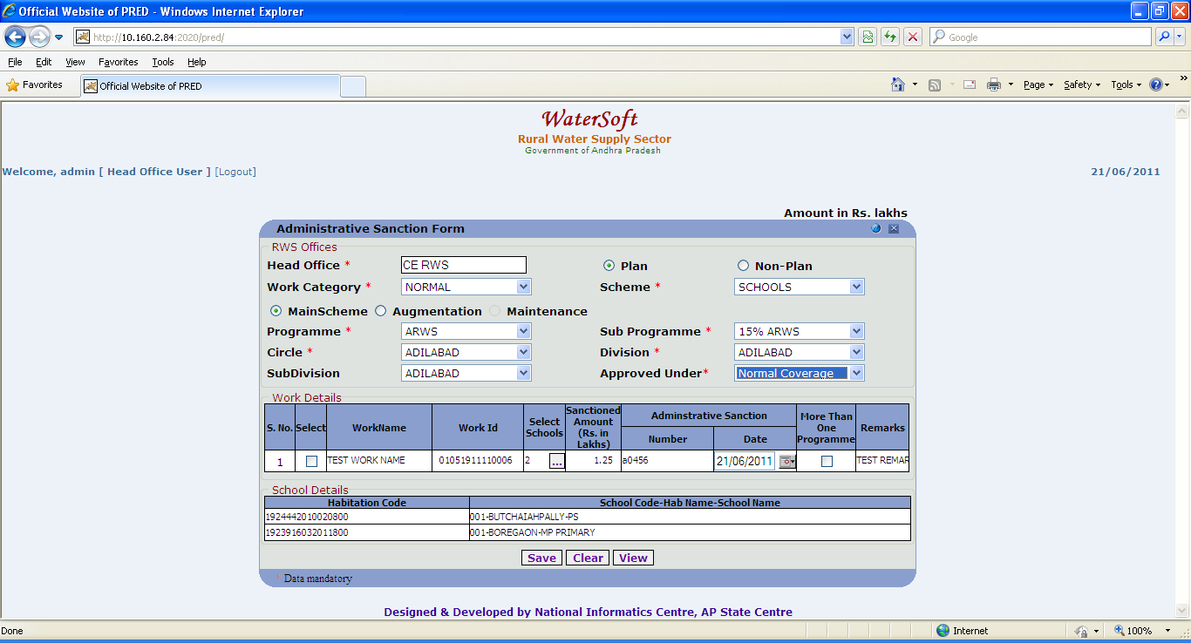
Figure 2.2

If Augmentation is selected series of steps follows… figures 3 & 4…. explain the process.

Click on ‘ Augmentation Link ‘ - > Works List Form is displayed .
Works List Form -> Select Circle -> Select Financial Year -> Select Scheme -> Works List details will be displayed -> Select Work.

The selected work will be automatically attached to augmentation link.

Works List

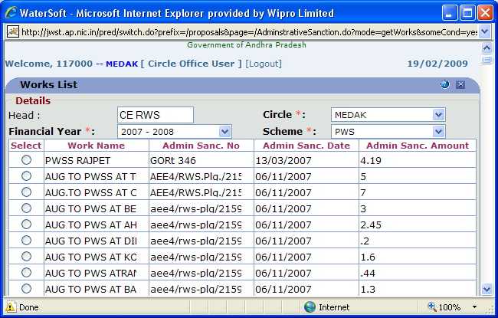
Figure 3.

Administrative Sanction Form

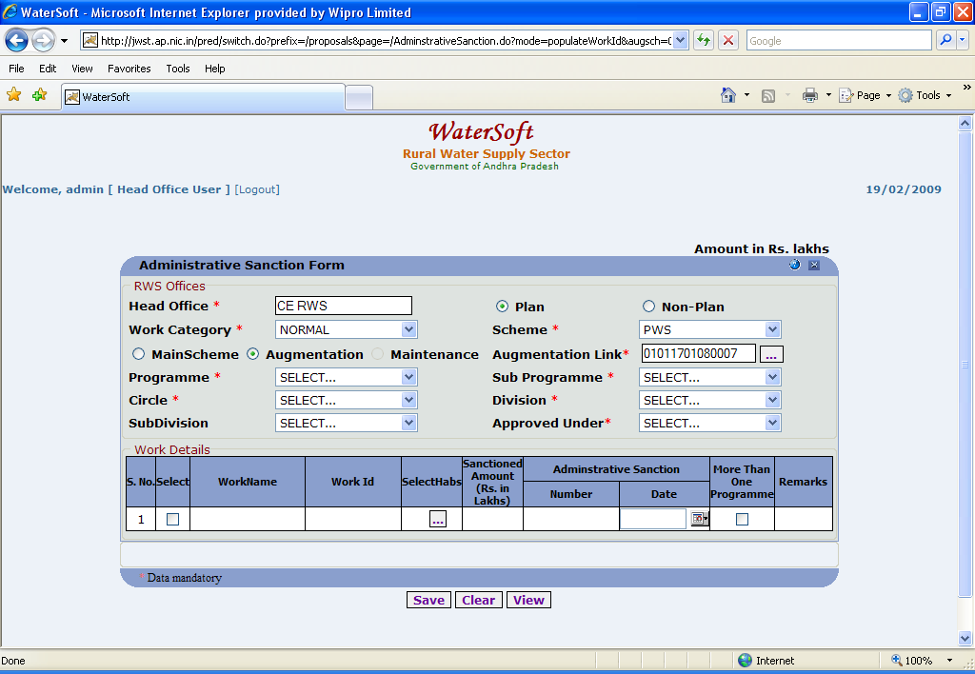
Figure 4.

Note: This information is required eigher to Save a New Work or to View/Modify Existing Works.

Basic operations for View / Save

- Head Office is fixed .
- Select Plan or Non – Plan ( default option is plan)
- Select Work Category ( For Eg. Normal ,District Level , Projects )
- Select Scheme . ( For Eg. Pws , Sustainability , Lab and Schools etc., ).
- Select Main Stream , Augmentation( Default is Main Scheme).
- Select Maintenance ( For Non-Plan ).
- Select Programme.
- Select Sub Programme.
- Select Circle (fixed based on Login).
- Select Division.
- Select Sub Division (Optional)
- Select Approved Under (For Eg. Normal Coverage, Submission - Water Quality, Sustainability)

Case 1:( For Scheme selected as Schools )

Select Schools button the following screen shots explain the process
To Select ‘ Multiple Mandals ’ and Habitations Use CTRL Button.

Note:- To Select Schools – Select ‘ Mandals ’ → Click ‘ Get Habs>>> ’ button→ Habitations are displayed. Select ‘Habitations’ → Click ‘ Get Schools ’ -> School details are displayed ->Click ‘ Add Schools ‘ button -> School details are added.
Press ‘OK’ wherever required.

( The screen shots are displayed figure 5.1 , 5.2 & 5.3 … explain the process )

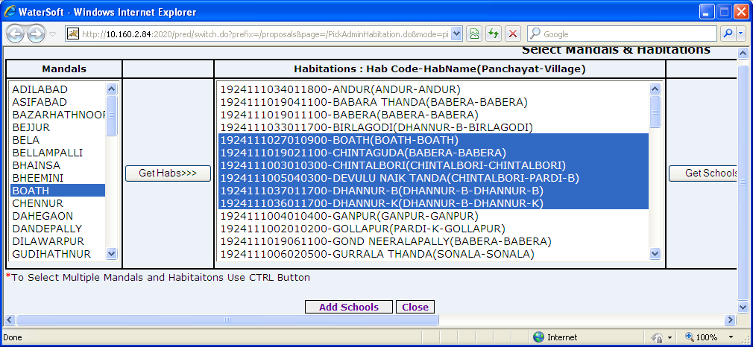
Figure 5.1

Figure 5.2 is contd.. of Figure 5.1
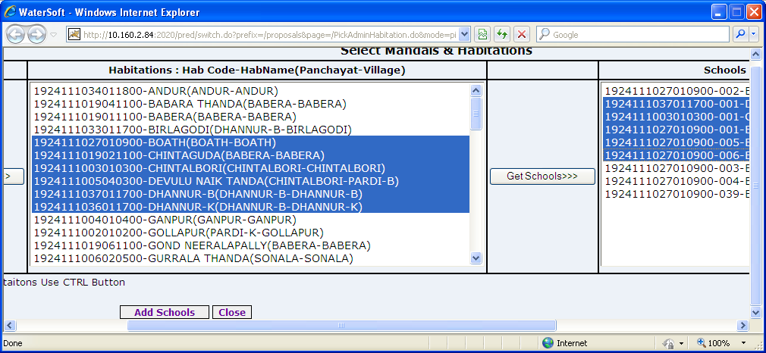
Figure 5.2

Add Schools

Click ‘Add Schools’ button.

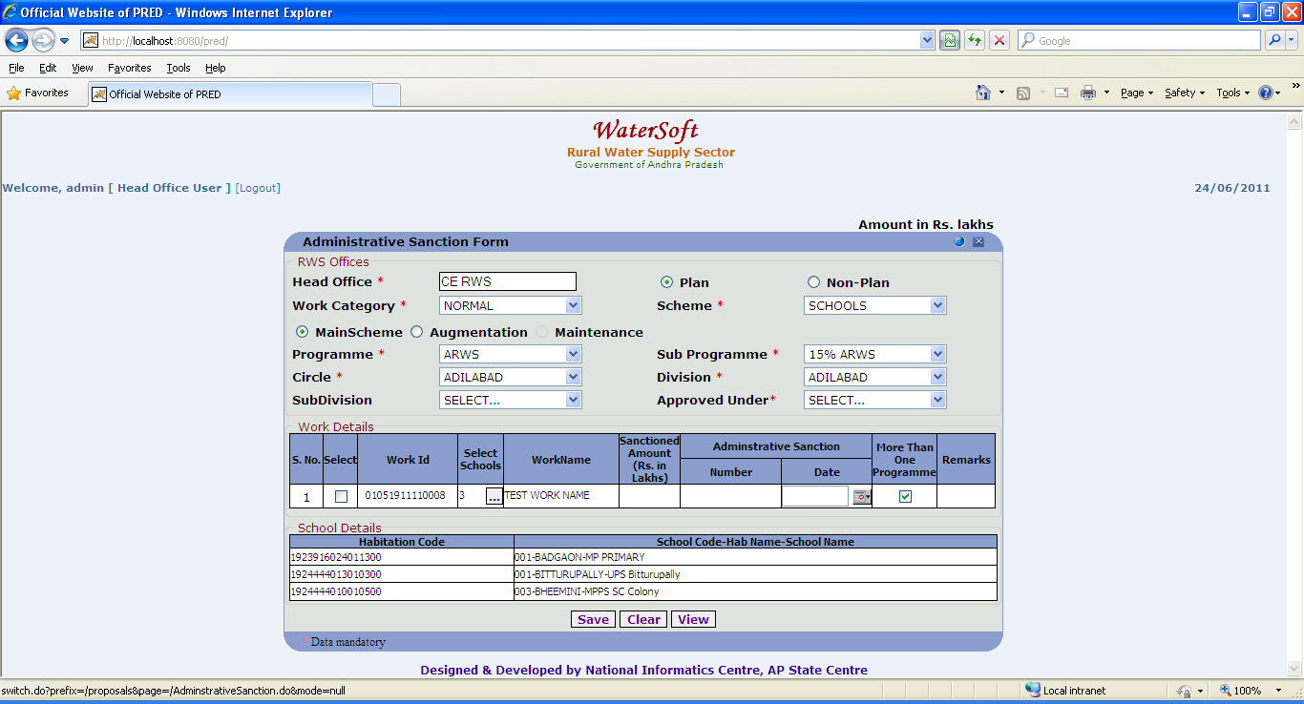
Figure 5.3

Case 2: Scheme Selected as Lab

Select Lab button the following screen shots( Figure 5.3 ) explain the process
To Select ‘ Multiple Mandals ’ and Habitations Use CTRL Button.

Note:- To Select Labs – Select ‘ Divisions ’ → Click ‘ Get Labs ’ button→ Labs are displayed. Select ‘ Labs ’ → Click ‘ Add Labs ’ -> Lab details are are added.
Press ‘OK’ wherever required.

(The screen shots are displayed figure 6.1 & 6.2 … explain the process

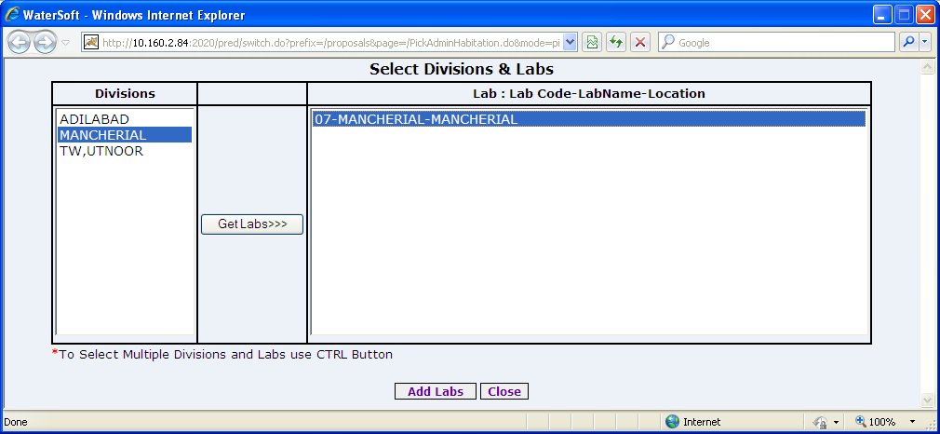

Figure 6.1

Add Labs

- Click ‘Add Labs’ button.

Case 3: Scheme Selected as PWS,CPWS,HANDPUMPS,OPEN WELLS)

Select Habs button ( For PWS , CPWS , HANDPUMPS , OPEN WELLS , SUSTAINABILITY )

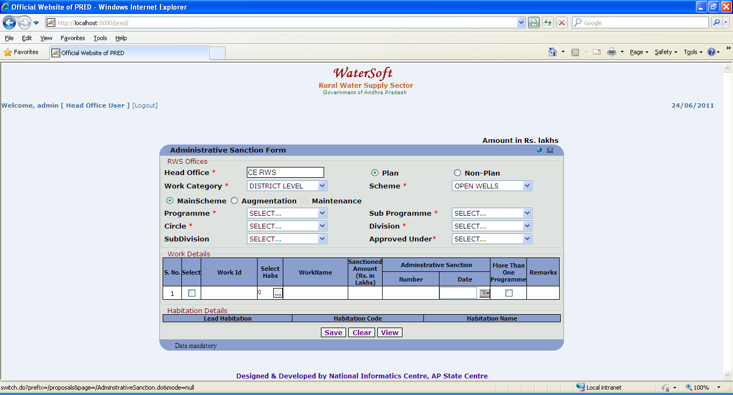
Figure 7.1

Note :-To Select ‘ Multiple Mandals ’ and Habitations Use CTRL Button.

Note:- To Select Habs – Select ‘ Mandals ’ → Click ‘ Get Habs>>> ’ button→ Habitations are displayed. Select ‘Habitations’ → Click ‘ Add Habitations ’
Press ‘OK’ wherever required.
(The screen shots are displayed figure 7.2 & 7.3 … explain the process

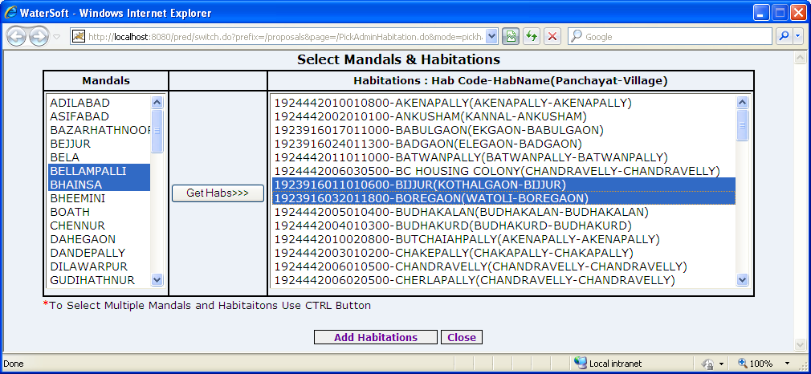

Figure. 7.2

Get Habs>>>

- Click ‘Get Habs>>>’ buttons.

Add Habitations

- To select Multiple Habitations use (CTRL button)
- Click ‘Add Habitations’ buttons.

Finally Save :

- Enter Work Name.
- Work Id is Auto Generated.
- Select Habs / Select Schools / Select Lab .(For this Case 1,2,3 explain the process).
- Enter Sanctioned Amount(Rs. Lakhs).
- Enter Administrative Sanction Number.
- Select Administrative Sanction Date.
- Select More Than One Programme ( in case if the work is sanctioned for more than one Programme). (Case 4 explain the process).
- Enter Remarks.
- Click ‘Save’ to save the Work details.

For Entering the works which are Sanctioned under More than One Programme

Add Programs

- Select Programme.
- Select Sub programme.
- Enter Sanctioned Amount(Rs. In Lakhs)
- Enter Admn Sanc No.
- Select Admn Sanc Date
- Click ‘Add Programs’ to save

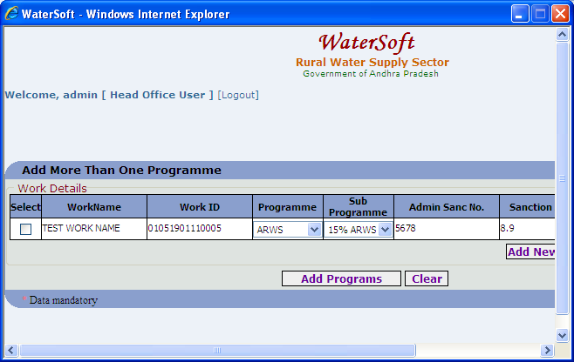
Figure. 8

View

- Click ‘View’ button.

Administrative Sanction details are displayed
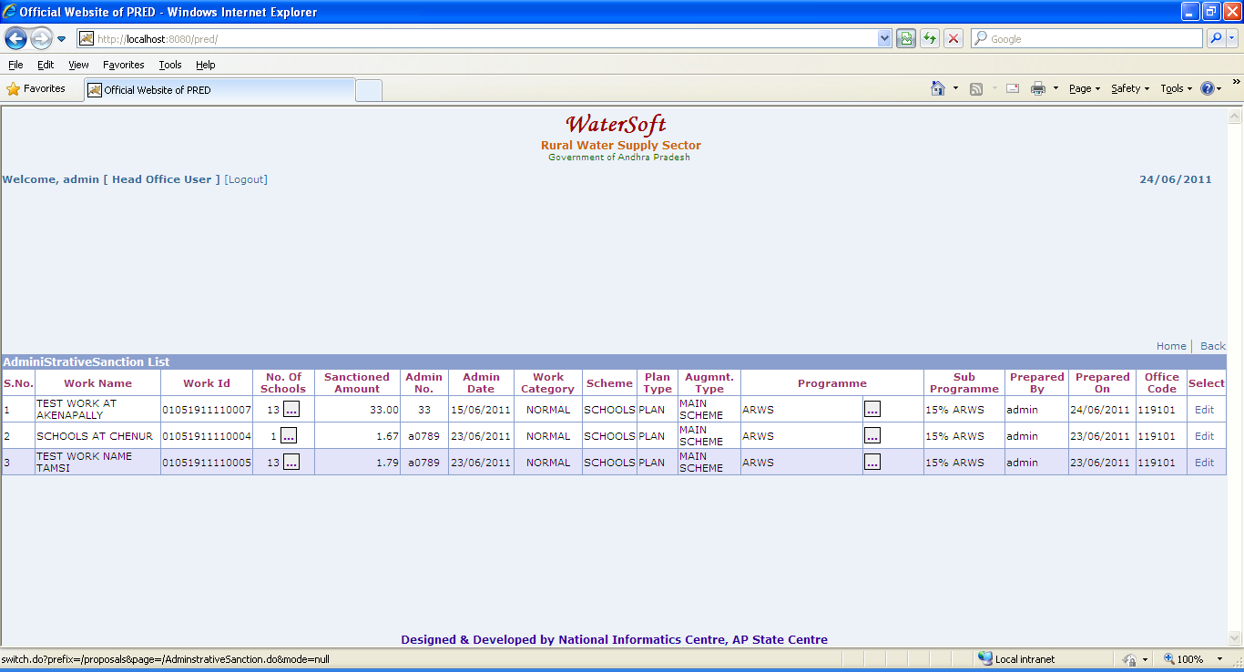
Figure 11.

Note:-To make any changes ->Click ‘Edit’ button ->Administrative Sanction form is displayed->Click ‘Update’ button

