USER MANUAL

Prajapatham Software

(For the Department of Panchayati Raj & Engineering Department, Rural Water Supply Sector, Govt. of AP)

National Informatics Centre
Department of Information Technology
Ministry of Communications and Information Technology
Government of India
WebSite : www.ap.nic.in

PREPARED BY :

PROJECT TEAM ,
APDVIII, NIC APSC,
HYDERABAD.

REVIEWED BY:

HEAD OF THE DEPARTMENT,
APDVIII, NIC APSC,
HYDERABAD.

APPROVED BY :

STATE INFORMATICS OFFICER
NIC APSC,
HYDERABAD.

Amendment Log
Version Number | Date | Change Number | Brief Description | Sections Changed
1.0 | 20.4.2007 | - | First Release

Sl No | CONTENTS | Page No
1 | Common Operations in the Software | 5
2 | PrajaPatham | 6
3 | Forms - Prajapatham | 7-9
4 | PrajaPatham Reports | 10-28
5 | Logout | 29
Common Operations in the Software:

Click the button to close the Form.

 Click the button for online context help.

Home Click the button for Main Page.

Back Click the button for Previous page.

Print Click the button for Printable Version.

Excel Click the button for Excel Version.

Amount will be considered in Lakhs throughout the Software

PrajaPatham

- Select PrajaPatham radio button.

- Enter UserName.

- Enter Password.

- Click on ‘Submit’ button.

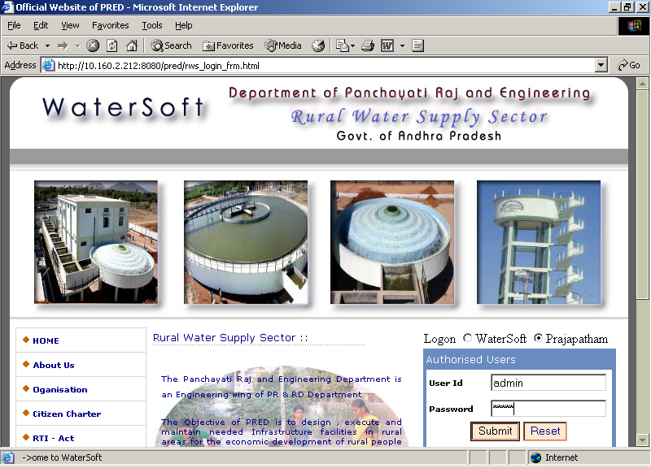

Under Forms -> PrajaPatham

`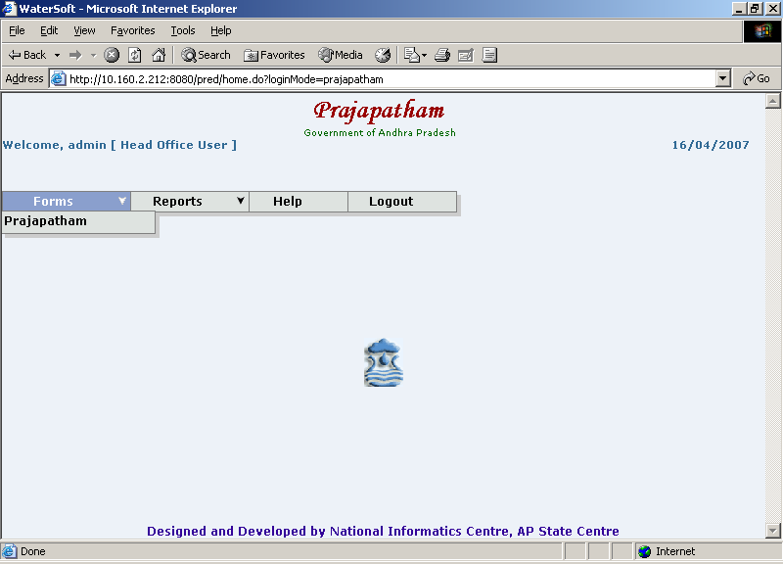

PrajaPatham

- Select Prajapatham option.

PrajaPatham

Save button.

- Head Office is fixed depending on Login
- Select District.
- Select Mandal.
- Select Habitation.
- Select Constituency Name.
- Enter Status As On(1-4-2006)
- Select Existing Water Facilities.
- Select CheckBox(Cpws,Pws,DirectPumping,Borewells,Others.
- Enter Name of Work.
- Enter Estimated Cost(Rs.in Lakhs).
- Select AssetType.
- Select Programme.
- Select SubProgramme.
- Select Sanctioned Authority(By Selecting eigher State or District)
- Enter Admin Sanction Reference No.
- Select Admin Sanction Date.
- Select Date of Grounding.
- Select Date of Completion.
- Enter Expenditure Up To Previous Month(Rs. in Lakhs).
- Enter Expenditure During The Month(Rs. in Lakhs).
- Enter Expenditure To Be Incurred(Rs. in Lakhs).
- Enter Physical Stage of Work.
- Enter Remarks.
- Click on ‘Save’ button.

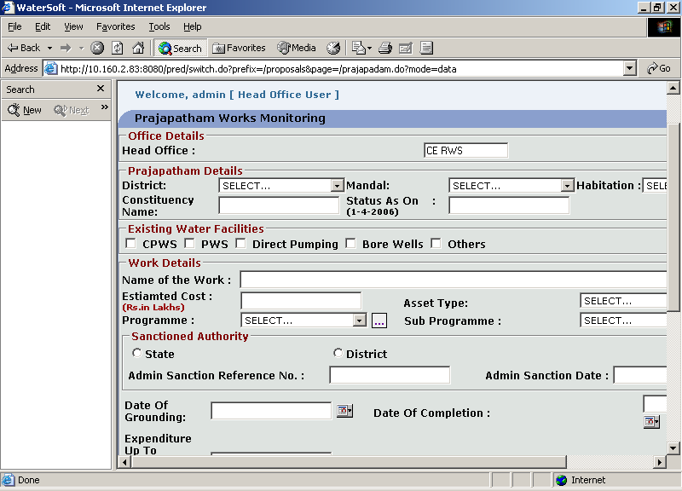

View button.

- Click on ‘View’ button.

Reset button.

- Click on ‘Reset’ button.

Under Reports the Options are

- Consolidated Drill Down
- Habitation Wise
- Sanction Scope
- Programme Wise

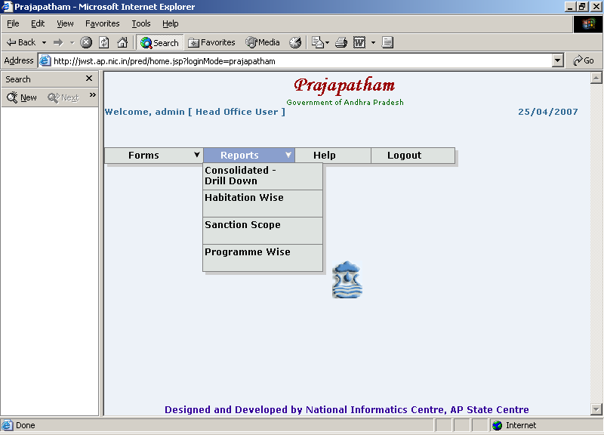

Consolidated Drill Down

- Select Consolidated Drill Down

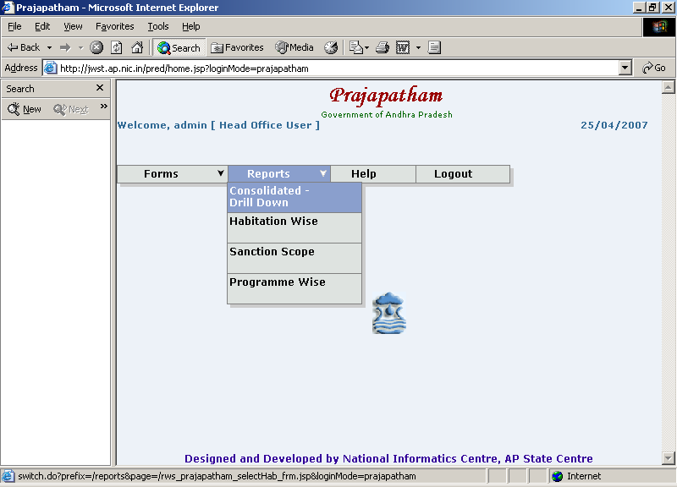

View Report button

- Select District.
- Select Constituency.
- Select Mandal.
- Select Panchayat.
- Select Village.
- Select Habitation.
- Click on ‘ View Report’ button.

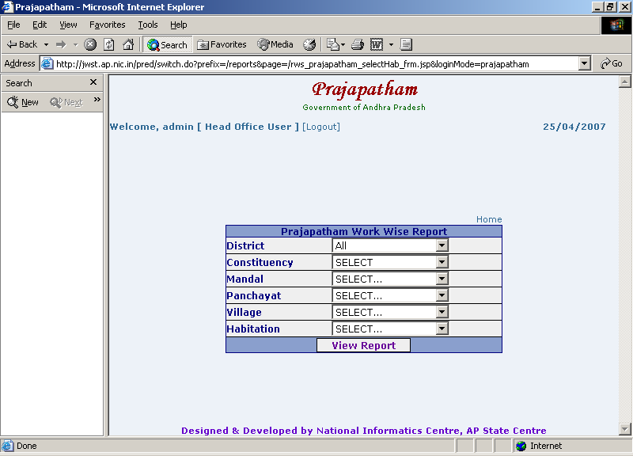

Prajapatham Works Report is Drill Down Report

- Click on District.

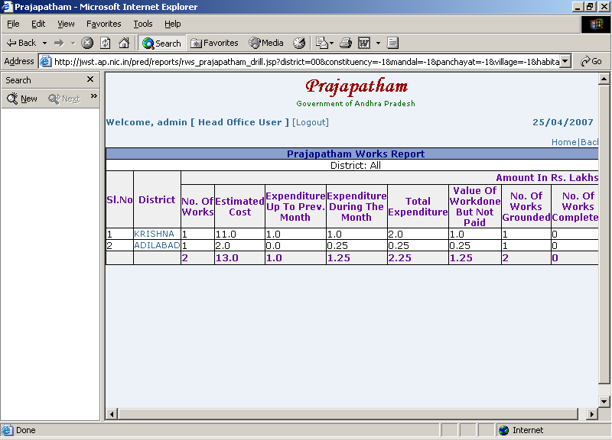

Prajapatham Works Report is Drill Down Report

- Click on Constituency.

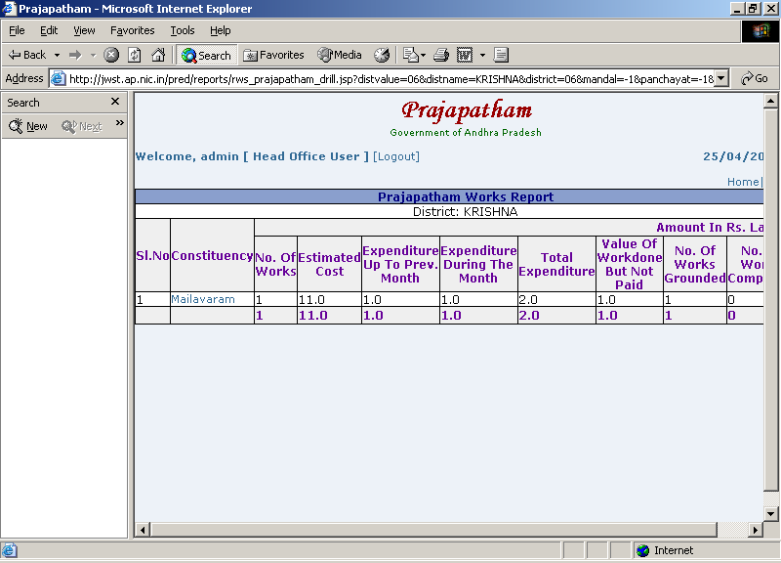

Prajapatham Works Report is Drill Down Report

- Click on Mandal

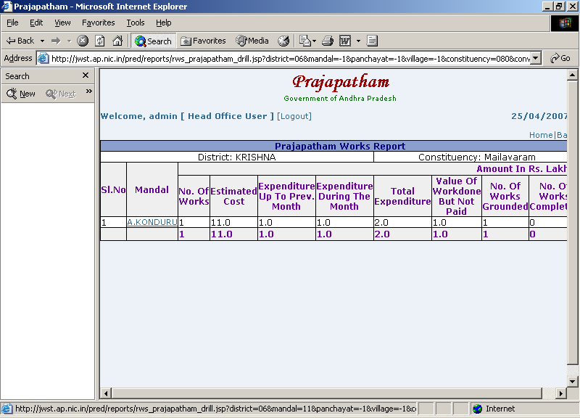

Prajapatham Works Report is Drill Down Report

- Click on Panchayat

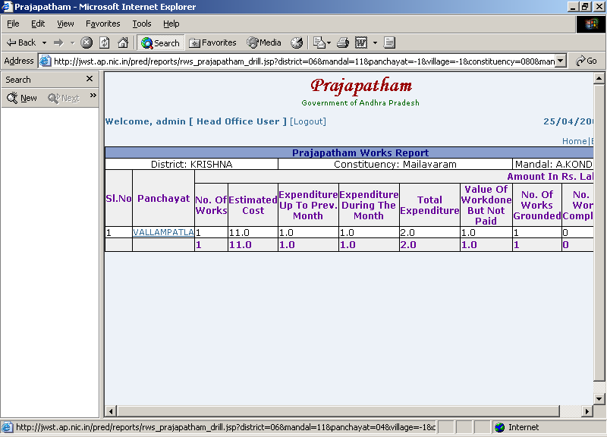

Prajapatham Works Report is Drill Down Report

- Click on Village

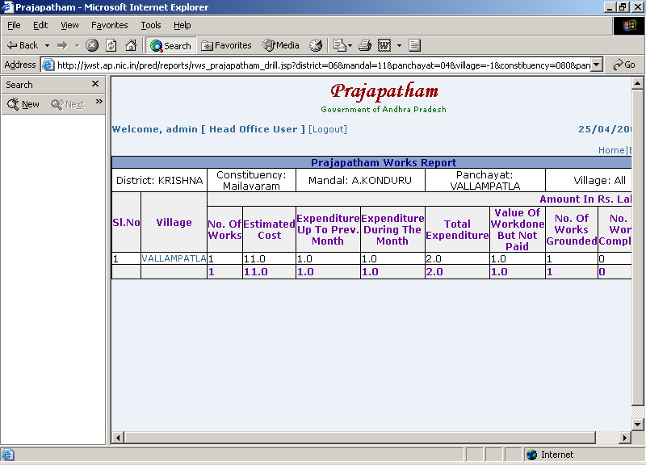

Prajapatham Works Report is Drill Down Report

- Click on Habitation

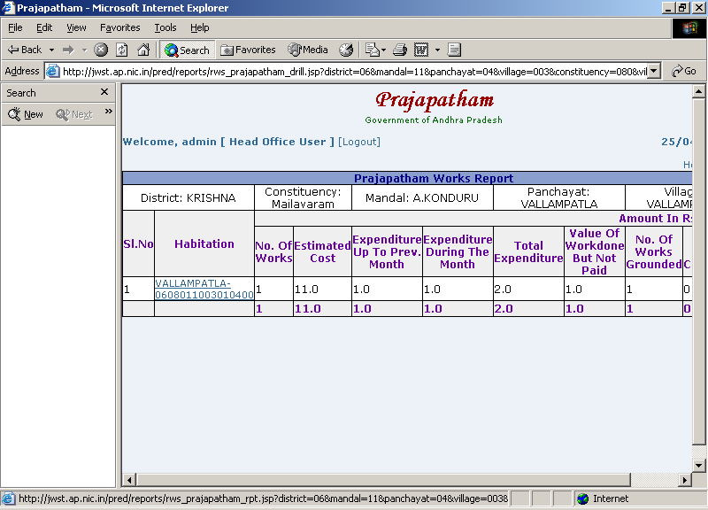

Prajapatham Works Report

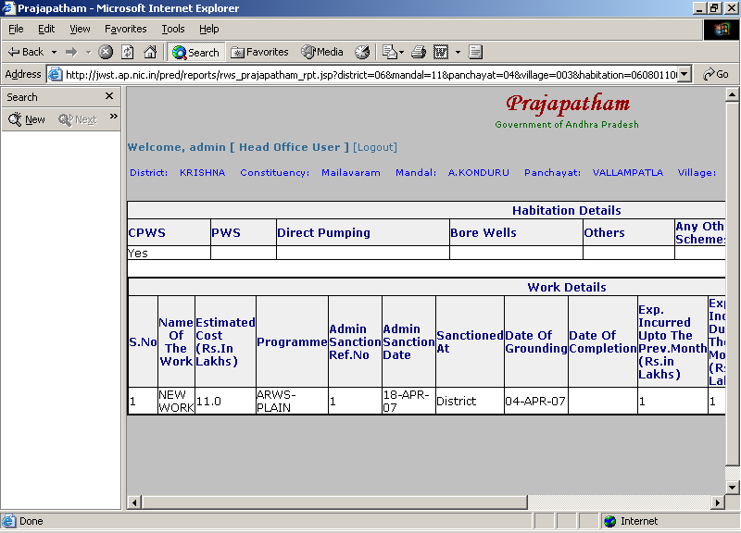

Habitation Wise

Habitation Wise

- Select Habitation Wise.

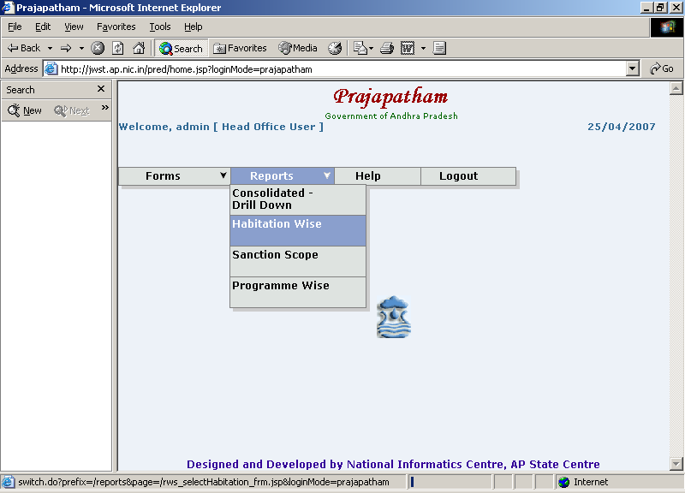

Habitation Wise

View Report

- Select District
- Select Mandal
- Select Habitation
- Click on ‘View Report’ button.

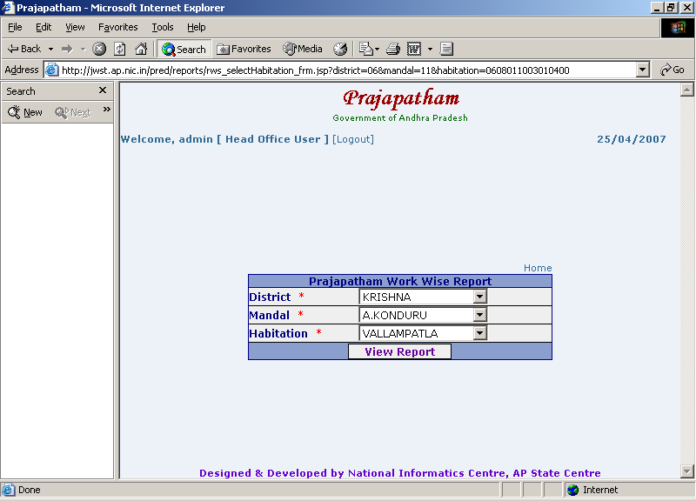

Habitation Wise

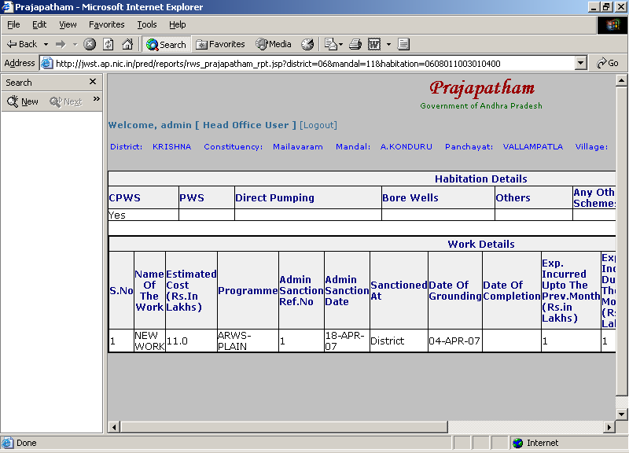

Sanction Scope

Sanction Scope

- Select Sanction Scope.

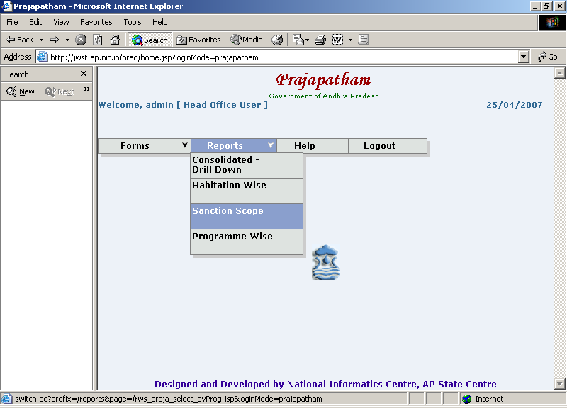

Sanction Scope

View Report button

- Select District.
- Select Programme.
- Click on ‘View Report’ button.

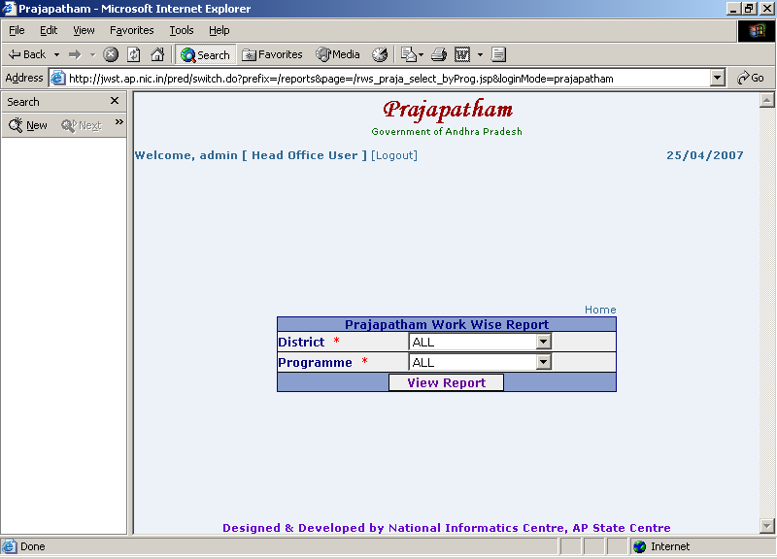

Sanction Scope is Drill Down Report

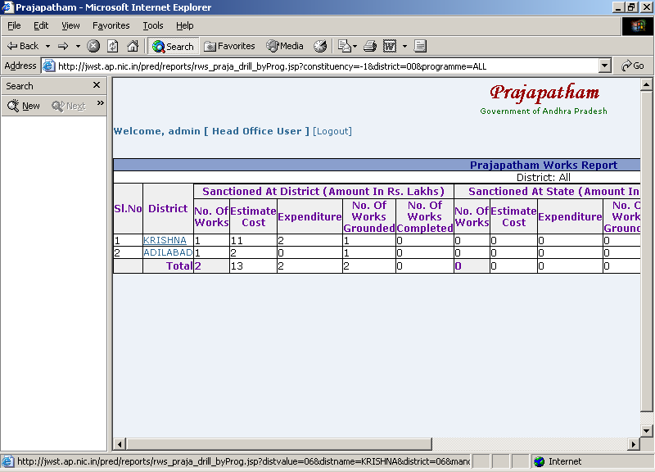

Programme Wise

Programme Wise

- Select Programme Wise.

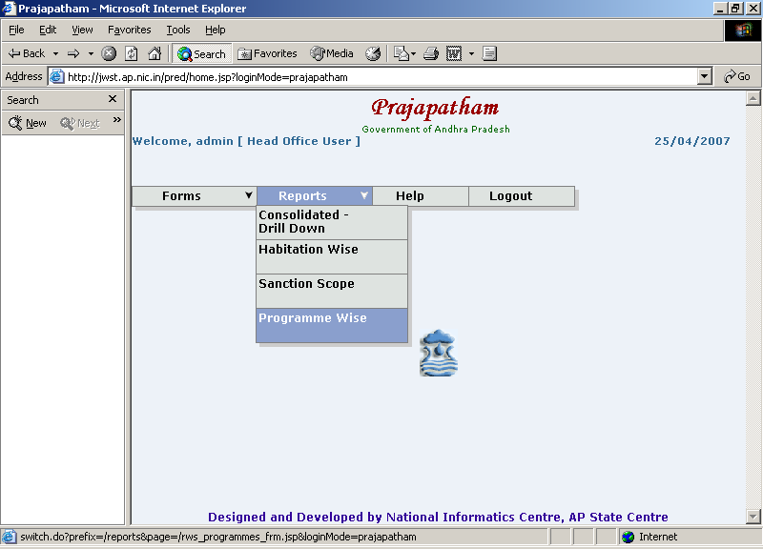

Programme Wise

View Report button

- Select District.
- Select Programme.
- Click on ‘View Report’ button.

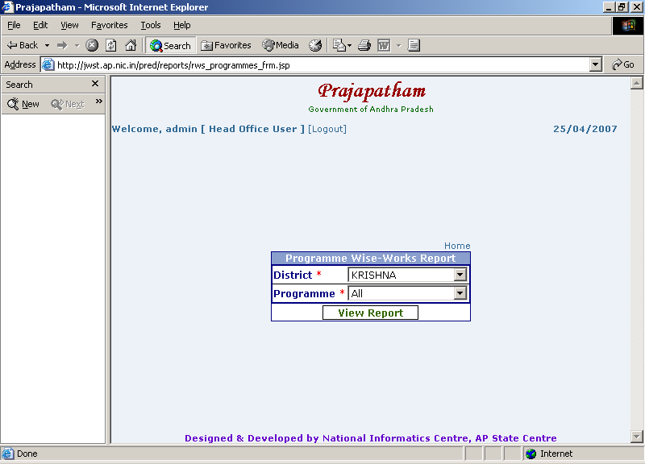

Programme Wise is Drill Down Report.

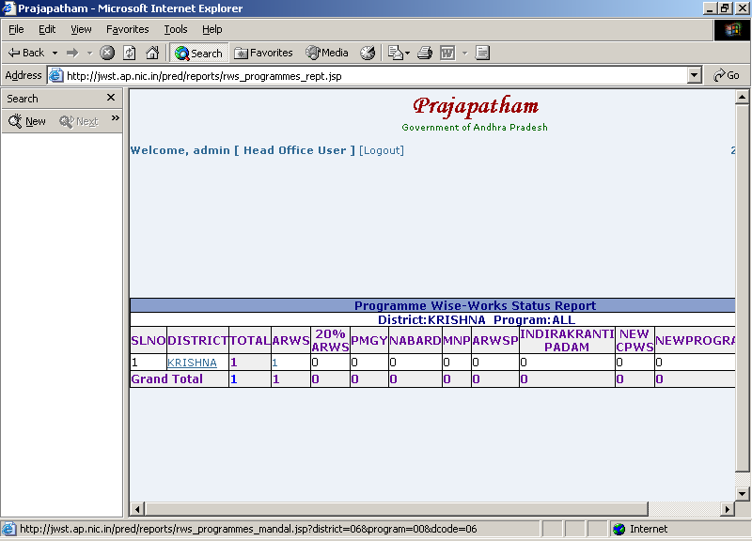

Logout

- Select Logout to exit from PrajaPatham Web Application.

